Institute of Tourism Studies

The Impact of Freedom of Movement in Malta from the Kitchen Point of View

Steven Pisani

Bachelor Degree in Culinary Arts

May 2019

# Abstract

The freedom of movement is really easy when you are part of the European Union. However, there are several issues that arise from freedom of movement and people may not be monitoring such issues. This dissertation looks at these issues and specifically, aims to look at how the influx of legal foreigners affects the quality in the kitchen sector. Are the foreigners worth investing in or will freedom of movement lead to extra expenses for the employers and loss of time in training? From this question, the researcher can identify some problems that others might prefer not to speak about.

To carry this study, 130 questionnaires were handed to various hotels and restaurants. The questionnaire was distributed all around Malta, and since it was confidential, all people from the kitchen were encouraged to answer, both men and women, and from all age groups from various nationalities.

From the results gathered, it shows that foreigners tend to come to Malta for various other reasons apart from work. This can be either for weather, family or because of good economy in the country. Some people tend to join the hospitality sector because they cannot find a job in their line and choose to start a new one. The percentage of people that come to Malta for its culture and cuisine is very minimal; therefore this may lead to unwanted changes to the sector.

To avoid a loss in quality, more enforcement needs to be done from the authorities with more spot checks to reduce the abuse of people working illegally. Employers need to follow a standard which defines what they are looking for and what qualities they want their employees to have. The European skills passport is a good start, but Malta needs to step up and increase such measures to keep the hospitality standards high, especially in its cuisine.

Well done.

# Acknowledgements

I would like to thank firstly my family who gives me continues support and guided me through the research.

I would also like to thank my tutor Dr. Noel Buttigieg for his guidance, support and most of all his time to instruct me in how to build such dissertation and improve it.

Furthermore, I would like to thank all the people who answered my questionnaire or in any way gave help during this dissertation, as without them I could not complete my research.

Contents

Abstract 2

Acknowledgements 3

1. Introduction 6

2. Literature Review 8

2.1 Freedom of movement and how it affected economy 8

2.2 Overcoming European Language Barriers 12

2.3 Employment within the Tourism Industry 15

2.4 Conditions 16

2.5 The kitchen sector in hospitality 17

2.6 Malta in the European Union 19

2.7 Conclusion 21

3. Methodology 23

3.1 Introduction 23

3.2 Coding 23

3.3 Mixed Methods Research 23

3.4 Primary and Secondary Data 25

3.5 Analysis 25

3.6 Strengths 25

3.7 Limitations 25

3.8 Conclusion 26

4. Data Analysis 27

4.1 Introduction 27

4.2 Participants 27

4.3 Findings 28

4.3.1 Question 1 - “What is your gender?” 28

4.3.2 Question 2 - “How old are you?” 30

4.3.3 Question 3 - “What is your Nationality?” 32

4.3.4 Question 4 - “If foreigner, how long have you been staying in Malta? Or If Maltese, N/A.” 34

4.3.5 Question 5 - “If you are a foreigner, was employment one of the reasons you decided to come to Malta? If yes, please specify why? Or If Maltese, N/A.” 35

4.3.6 Question 6 - “Are you registered on a Full time or part time basis?” 38

4.3.7 Question 7 - “How long have you been working in the hospitality industry?” 39

4.3.8 Question 8 - “What is your job position registered name?” 40

4.3.9 Question 9 - “In which establishment are you employed?” 41

4.3.10 Question 10 - “Are you planning to stay in Malta? If no where do you wish to go and why.” 43

4.3.11 Question 11 - “What level of education have you acquired with regards to the hospitality sector?” 46

4.3.12 Question 12 - “If you have obtained a Level 4 education in hospitality or higher, which institute did you attend? If Level 3 or less write N/A.” 48

5. Conclusion 50

Recommendations 51

References 52

Appendices 60

# Introduction

Hospitality is a vast industry and combines a lot of sectors. It is linked to luxury, leisure, experiences and entertainment. All these are done for the customers and to satisfy their needs. The sectors that make up hospitality can be;

* Accommodation: this needs to provide the customers a safe shelter where they can stay for a temporary time. The tourism industry is the most common industry to make use of various accommodation places as people book trips and/or holidays. It can also be used by locals as a break from their normal routine. Different accommodations include: bed and breakfasts, hotels, motels, hostels, and resorts.
* Food and Beverage: this sector is needed by everyone from locals to tourists; this helps the sector to develop a better economy as constant improvements are made for people’s leisure and feel-good factor. Apart from that, people socialise and combine it with other activities to form an experience. Some establishments that fall under this sector are: restaurants, caterers, bars, cafes, nightclubs and take-aways.
* Travel and Tourism: this sector is a big part of hospitality. It is linked with leisure, customer satisfaction and creating a service and an experience for the people; therefore it forms part of hospitality. Some people who form part of this sector are: travel agents, tour operators, online travel agents, cruises, and car rentals (Revfine.com 2019).

Since the population is growing, the hospitality sector keeps on being a key aspect of the economy as it targets the customer’s market and aims to reach the increasing demands. Joining the European Union (EU) gave people the choice to have easier travel and a vaster choice of travel. This is because the EU has the freedom of movement within its countries. This also opened a door for employers to recruit more people from all over the EU, since the number of local employees is not enough to meet the demands of the industry. Maltese locals do not wish to work certain jobs, especially manual jobs, due to poor wage or long hours. Since the demand is much bigger than the labour turnover, members from EU states were not enough and this led recruiters to search for people from other countries, including developing countries. This solves some problems but opens up a lot more issues, such as language barriers, work conditions, and low quality of work although few tend to notice or try to solve them.

Malta is part of the EU since it joined back in 2004, and it has increased both in population and demand when it comes to hospitality and catering. Hospitality was always a key factor in Malta as there have always been a large number of foreign influences in Malta.

The catering industry, especially the kitchen sector is definitely one of the jobs that is crucial in hospitality and helps a lot in the economy but there is not a lot of rule and quality enforcement in it. Some recruiters prefer to employ a youngster or an inexperienced person rather than an experienced chef in order to decrease their wage budget. An experienced chef might struggle to find the appropriate job. This may divert a chef’s dream and ends up finding another path in his career. The number of employees who form the kitchen brigade is getting smaller year on year (culinary lore). All these factors lead to a lack in quality of food and service.

The objectives of this dissertation are to highlight some issues that are affecting the kitchen sector and whether or not the EU’s freedom of movement has helped for better exposure, as initially planned, or if it is being abused. In the chapters below, hospitality is seen in its different aspects and the challenges that are being faced in the hospitality industry and the kitchen sector in particular are highlighted and spoken about more widely and in detail.

In this dissertation, the writer outlines problems in the hospitality sector in the literature review, in particular the economy and the freedom of movement, language barriers, challenges that the kitchen sector is facing, and employment and unemployment in this sector. Then the writer focuses on Malta’s hospitality sector and how it is affected particularly, the kitchen sector. Later on during the methodology, the writer gives an idea on how the research is distributed and tackled. During the data analysis, the writer compares data to what is already published and presents his own findings and statistics.

# 2. Literature Review

This chapter explores how the freedom of movement is divided into multiple aspects in hospitality. First of all, there is a focus on the economy which is an important sector that people look for before moving to a new location. Secondly, the language barriers which people are facing daily and the problems when communicating is looked at. Finally, I look at the employment in the tourism industry and then delve deeper into the conditions that people face in the hospitality sector and specifically in the kitchen sector. Then, more information about Malta’s place in the EU is given.

## 2.1 Freedom of movement and how it affected economy

The European Union is one of the major trading powers, having the United States and China as its biggest competition. The European Union combines 28 countries – Austria, Belgium, Bulgaria, Croatia, Republic of Cyprus, Czech Republic, Denmark, Estonia, Finland, France, Germany, Greece, Hungary, Ireland, Italy, Latvia, Lithuania, Luxembourg, Malta, Netherlands, Poland, Portugal, Romania, Slovakia, Slovenia, Spain, Sweden and the UK (gov.uk, 2019) as of January 2019 – in one single market. By this method of single market, it gives courage to other European countries to join in. During a speech in Amsterdam back in 1948, the British Prime Minister Winston Churchill said, “We hope to see a Europe where men of every country will think as much of being a European as of belonging to their native land, and that without losing any of their love and loyalty of their birthplace. We hope wherever they go in this wide domain, to which we set no limits in the European Continent, they will truly feel "Here I am at home. I am a citizen of this country too"” (cvce.eu, 2016). The European Union has a total GDP value of goods and services produced in 2017 of €15.3 trillion (European Union, 2019). The European Union has been working hard over the past years to achieve such results today. Apart from goods and services, the EU focuses mostly on the movement of people and capital.

Most of the countries that apply to join the European Union want to take the most obvious benefit: that is, to have the freedom of movement of goods, people, capital and services within the EU (Government.nl, n.d). People have an opportunity to work, open and expand business companies abroad. People are able to move to any European Union country as borders do not exist anymore. On a lot of the articles and blogs that are published, authors always include the importance of the freedom of movement and how it helped the economy of the country. Places, such as Lithuania and Estonia, are a good example of countries that took EU values seriously and flourished. By joining the EU, the growth of the Lithuanian economy was strengthened and many new jobs were created. An increase in the level of foreign investments also helped the national economy growth. Such countries enjoy the social guarantee they are accustomed to at home even when working, studying or visiting any other EU country (Urm.lt, 2018). Estonia is another country where freedom of movement resulted in more stability and growth in the economy due to the introduction of the Euro as a currency. Investing in the Euro coin attracts more trust in the country’s economy and attracts more investments with an increase in new jobs. With European Union funds, Estonia focused greatly on buildings, highways and further infrastructure, and the Government is now also able to focus more on education and employment as its future development (Vm.ee, 2014). Apart from these benefits, Estonian entrepreneurs can find new opportunities with better wages and gain experiences in bigger cities such as London, Berlin, Paris, etc. Students can also study in higher education institutions without paying the massive fees that non-EU students normally pay.

As with anything, there are some negative aspects of the European Union as a unified body of different countries. The Czech Republic and Finland, with their national economy benefitting by joining the EU, agree that travel and trade are the most important benefits of the EU but do not always agree with the EU legislations which are sometimes felt as if they are being imposed onto the country. However, younger generations are keen to expand their knowledge for their personal and professional opportunities and both studying and working abroad is facilitated due to the freedom of movement given around the EU. Youths tend to make use of EU benefits without any problems and learn to evaluate all situations (Richter, 2014). Apart from one’s ability to move abroad, foreigners can come to one’s country with their culture, skills and knowledge and thus a personal development can also be attained through meeting with other people without leaving one’s country. Even though the European Union might have to cope with some issues and struggles, countries should work hard to achieve a better European Union (Browne and Hawkins, 2018). Nevertheless, there are particular aspects of the EU that encourage a sense of community among the member states.

Introducing the Euro currency in a European Union country helps the economy of that country and facilitates the issues of exchanging money with different rates, making travelling easier and creating benefits of lower loan interest rates; but some countries might disagree and find that sharing currency might become harder for such countries and introduce problems in EU countries which do not have the Euro.

Some countries that wish to join the European Union nowadays, such as Serbia and Albania, also see the European Union with the same vision as the rest and focus on the freedom of movements and better jobs. This is the reason why these countries start to support the European Union, in the hopes that later on, they can join it. Apart from immediate employment benefits and other economy growth, they see the EU as a better future for their youths, one which can open more opportunities for them in the future (Simić, 2018). On the other hand, some are still concerned and ask whether the European Union is getting stronger by time or is instead being faced with a lot of problems that are not easy to solve, such as Brexit. Montenegro is debating whether to join the EU; it has a good economy and there tourism sector is already flourishing with a huge amount of tourists coming from Russia. The people of Montenegro might feel that they have had a good government system since 1991 and do not know whether joining the EU will benefit them. They think that political and socioeconomic progress will remain the same even if they join the EU (Bechev, 2018).

Apart from countries that wish to join the EU for its benefits, there are countries that want to leave the EU, such as the United Kingdom which voted to leave the European Union. An article published in the UK says that “Talent is the lifeblood of business growth, but businesses are not getting the answers they need on future access to skills and labour” (Brooking, 2019). Training local British people is not enough for the business on its own but hiring solely from overseas is also not the most effective way, therefore, the business aims to build teams of both local and foreign employees. Some businesses in the UK do not agree and instead claim that the EU immigration scheme is not an adequate solution. They say that EU immigration and freedom of movement allows people who have not been properly trained to work in the UK. Employing unskilled people will still decrease the growth rhythm and furthermore, foreigners who find work in the UK sometimes opt to go back to their home country, or to a different country, despite the time taken to train these people. For instance, it is commonplace for foreigners to go to their home country over the holidays and some of this workforce has stayed home without returning back to work. As a consequence, this leaves higher labour costs and labour turnover especially in the hospitality sector. In some cases the United Kingdom needs to go beyond the European Union and recruit from outside. The UK is not the only country that needs to adapt to work with this system. Having said that, if the freedom of movement is not that easy, one ends up automatically introducing restrictions on the skills and abilities of the employees of companies and hinders achieving the potential that can be attained.

Keeping this in mind, the freedom of movement also offers the European Union a more variety of talent, more business leaders of the future, investments and better chance to develop careers within the area of the EU. Some might go and study in a different country and come back with further knowledge and investments in the local business but some might find a better opportunity abroad and tend to stay abroad. In this way companies might be investing in training for new employees only for these employees to leave their job and go to a different country (Brooking, 2019). In another article, a study concluded that there is no evidence that England improved its economic growth since joining the EU (Gudgin and Coutts, 2017). Even though statistics are showing this, people in North Ireland predominantly chose to remain in the European Union, especially since 97% of the younger population aged between 18 and 24 years old voted to stay in (Smyth, 2014). Statistics also show that North Ireland reduced the amount of unemployment by implementing more jobs: 978,000 jobs have been created in North Ireland since the UK joined the European Union (Ireland - European Commission, 2019).

Although most countries feel that the benefits outweigh the negatives and therefore, wish to stay in the EU, it is not just the UK that is considering to leave the EU: Italy and France are also uncertain of their place and their advantages of staying in the EU and the heads of states are finding greater pressure from anti-EU groups to hold a referendum like the UK. Again, the main issue is with how the European Union is mishandling legal migration and illegal refugees (Anderson, 2017). Legal migration struggles that the European Union countries face relate to the national welfare system and include the integration of legal migrants within the national country and a fear that the migration or an influx of illegal refugees can threaten the country, as seen in Denmark. Netherlands are saying that if they want the country to survive as a nation, legal migration needs to stop.

Another issue is economy growth. France for instance is facing a lot of problems where unemployment rates are still high but the economy growth is being weakened. Apart from the economy, terrorism threats are being done and the security of the country is in a great danger. France is blaming EU conditions that were implemented by its members for these situations. Greece, on the other hand, might get pushed out by the EU for the benefit of the remaining countries rather than because it wishes to leave, as in the case of the UK. Although Iceland forms part of the European Economic Area, it has a majority of people who are against joining the EU with 59.8% against it (Gudmundsson, 2017). Unfortunately after the Brexit referendum, the EU was pushed into great uncertainty and more countries are thinking about leaving the European Union, while other countries are thinking twice about joining (Noack, 2016).

## 2.2 Overcoming European Language Barriers

Apart from joining countries as one single market, multilingualism is a core value of the European Union as it helps the integration of individuals and enables the freedom of movement. However, since each country has its own language, the EU needs to keep in consideration the respect for the culture, religions and policies of each country. This raises some challenges which need to be tackled and some problems might need a lot of time and investment to improve (euractiv.com, 2015).

One of the problems that the European Union is continuously facing is language barriers. This is a crucial problem of the European Union that decreases the growth of the economy. So far, the European Union has invested in machine translations and multi-language search capabilities. With these methods the European Union benefits its economy as it increases cross-border e-commerce, better quality in the industry, and more opportunities in the work industry. Unfortunately, only the big companies can afford this as it is highly expensive. In most cases, individuals who go to other countries to find jobs are looking for better wages so most probably they will not be able to afford such equipment. To overcome this, people can download translators to communicate better, however this is sometimes a struggle as words are not translated properly or a word is not detected properly (ISA² - European Commission, 2019).

While the EU is still trying to fix these communication problems, Japan is investing in more advanced technologies such as robots which reduce labour cost. These robots have face detection which detects an already registered person and immediately starts speaking in his or her native language. These robots are used in hotels where languages do not pose a problem anymore and therefore increase the quality of service for people from a lot more countries (Rankin, 2018).The obvious downside to this is that there will be less need for people to work in the hospitality sector if these multi-lingual robots take their place.

Language barriers can be seen everywhere – even when purchasing online. Euractive also mentioned that 40% of people in the EU never buy products or services if the language online is not their native language. MEP Jill Evans from the United Kingdom also stated that this is a huge challenge and if this is solved, one can easily buy more online from other EU countries and the quality and the growth of the economy rises (Europarl.europa.eu, 2018). Evans also suggested technology training to be adopted in school curricula so that students can learn to use their own languages and also translations, speech recognition, and so on from an early age. With an investment in technology, programs can be developed and be widely implemented where one can write in their own native language, and others can see it in their own language. If the language barrier in the EU is broken, the European Union becomes more united in its diversity (euractiv.com, 2015).

Again, youths of the younger generation are the ones who need to continue to improve in this sector for the benefit of the EU. Studies have proven that younger generations are less keen to learn a language than before. These studies conclude that only 28% of non-native English speaking youths that are part of EU speak English while if you consider also native English speakers, only 41% speak English. Compared to other languages, 10% of youngsters aged from 15 years to 34 years speak German. French is the 3rd language that youngsters tend to learn (Poulsen, 2017). Although these numbers are not high, over 85% of students that attended higher secondary education in the European Union in 2015 were studying English, 19.7% studied French and 17.6% studied German as a foreign language. Students therefore realise that they should learn more European languages to invest in their future (Poulsen, 2017). 80% of primary school children in the EU learn English before any other language and 95% learn English in at secondary school level (Dikov, 2018).

Apart from online shopping, finding a job in a different country might be a bit of a challenge if you do not know the language. This might also lead to demoting the worker or making it harder to obtain higher positions in companies abroad. In the tourism and hospitality sector there is a huge lack of awareness regarding which opportunities and career paths to graduate in. This sector is one where employees should know a variety of languages. However, some institutes tend not to offer languages as part of their curriculum.

Having the United Kingdom as the 5th most touristic destination in 2017, tourists contributed an estimate of £25 billion worth in economy so tourism is very important. Those working such jobs in hospitality need to communicate properly with international visitors: tour operators need to communicate in different languages to visitors and many other jobs that might need to negotiate overseas operations and supplies. There are many foreign employees across the EU, especially in the tourism sector, but now employees are going back to their country. In a Maltese article, less than one in ten of the thousands of foreigners remained on the island (Martin, 2017). It is harder to find an employee to recruit with the qualifications and quality you want and if they do not know multiple languages, this makes it even harder (UKinbound, 2018).

Due to the fact that the United Kingdom might go out of the European Union, some say that the European Union must adopt a Euro-English language. Some, such as French socialist MEP Sylvie Guillaume think that French must be the future language should Brexit happen but a former Italian prime minster Dr Mario Monti said Euro-English should still become the EU’s main official language once the UK leaves the EU (Baume, 2018). This will mean that no one has to fight for a language and no language will be dominant on top of any other language. Everybody will be speaking one form of English, universally in the EU.

The EU has 552 different language parings allowing languages to be translated in 24 other official languages (Dikov, 2018), (Ginsburgh, Moreno-Ternero and Weber, 2018), (Rankin, 2018). Inside the European Union in Brussels, the translations and interpretations services will remain in English and will not change (Mohdin, 2018), (Rankin, 2018). English speakers are 12.8% of the European Union people which amount to 511 million people in total.

Some employers suggest that having knowledge of language skills for the profession before going to another country to work is essential (Van der Jeught, n.d.). In jobs such as hospitality, the value of communication is truly important. Some companies are trying to find mutual practices that are useful for all countries and can be used in all establishments. To have certain language skills, it does not only come from school but it also comes from the management and the implementation of training within the business so the employers should give on-the-job training. Employers can also use different methods to help communication. Colour coded tags can be used to identify what an item is used for, for instance. The supervisors or managers still need to check on employees to verify that they are using the right item (Hotel management, 2009). A project that was done in 2016 by the EuroCatering implemented a 12 language training program so people especially from the hospitality industry can learn free languages to help upgrade their language skills. This was beneficial in training and to prepare workers in the hospitality industry when dealing with customers. This project had its own challenges: to see whether people where understanding or not and if they can reach deadlines. In the same study, they said that foreigners might have a negative experience which can affect their character such as confidence and being uncomfortable speaking in front of other people if they do not know the language (Shergill, 2016).

In 2014, an estimate of 3.8 million illegal refugees and legal migrants arrived in the European Union and the legal migration flow is planned to remain at about 1.5 million people per year until 2036. This will create an increase in language barriers and cultural barriers. Both refugees and legal migrants might suffer from social isolation. Health officers are usually the first to meet illegal immigrants and legal foreigners. Unfortunately, they might not understand everything the doctor says, and might still attend work without having the right medicines. This will leave a negative impact especially in the hospitality sector (Vocal Europe, 2017). When dealing mostly with people from poorer countries outside the EU, they might not have enough money to buy such medicines or go to a doctor; therefore this may lead to health problems when entering an EU country (Elliott, 2004).

## Employment within the Tourism Industry

In terms of employment, the hospitality sector is a major part of the European economy and also European tourism. The EU gives the liberty to move between countries and work freely. However, some countries are finding it hard as lots of their employees are moving away while more foreigners are relocating into the country so most EU countries do not want more legal migration. There is a worldwide trend of a rise in population due to longer life spans; however according to a Quartz article, in the EU there were more deaths than births. Still the population of EU countries is rising due to net legal migration, where a country faces more immigrants coming in than emigrants going out of the country (Mohdin, 2018). The thirst for employment is always increasing and it is harder to find the right person for the right job. Tourism and hospitality are one of the strongest pillars in a country; therefore this sector needs employees to be skilled and professional to do their job well. This is a result of having European countries as the number one tourist destinations (Scjaart, 2018). The industry of hospitality gives support to around 16.6 million jobs. This is around 4.7% of the total employment in the EU. This results in a contribution of 3.7% of the total GDP in the EU (HOTREC, 2018).

Hospitality also gives students a chance to start working their first job. Many students find their first job in the hospitality sector as this makes it easy for students to follow a study program and work part-time. In many cases, they join the hospitality sector even if they are studying in a different sector just to earn some money and have their first job experience. This might not lead to their future job but at the end they are earning money and improving their skills. In the EU, the rate of unemployment in people older than 25 years was 8.3% in 2015 while that of people aged less than 25 years was 20.3%. Overall only 8.2% of the people employed were aged below 25 years old. In hospitality this amounts to 19.6% of all employees. This shows that students help the tourism sector to grow and encourages the hospitality sector to recruit more students (HOTREC, 2018). Students who learn in a hospitality or culinary institute have got more opportunities to study abroad and also receive help and support through the Erasmus program.

Since the demand in hospitality is high and there is always a turnover, the industry also gives an opportunity for people who either finished secondary education and wish to work immediately or for those who want to change their job and start looking at jobs in the hospitality sector. Such people can work long hours with less wage to prove that they are capable to work such jobs and wish to succeed and develop further. Apart from the people mentioned, the hospitality sector is also more open for gender equality; in fact the hospitality sector is one of the biggest sectors which recruit females when compared to other sectors.

Since hospitality is flexible and there are different shifts and services, one can work his full time job in any particular sector while working part time in hospitality to earn a bit more money. This is getting abusive as recruiters sometimes prefer a part timer rather than a full timer because they can stop a part-timer if there is no work during the low seasons, while they can work the same hours as the full timer without full-timers benefits (HOTREC, 2018.).

When considering to move abroad to work in hospitality, one needs to equate things properly as it is not just work you need to look at but also the environment and with whom you will be working. The importance of such conditions in such jobs is always increasing and apart from the background history of the working establishment, nowadays a person needs to check the social area and place and its ongoing news. In some cases, one needs to check the unemployment rate of that particular country, economy and the general state of things. This can also leave a negative impact where a skilful person will think twice about travelling to a foreign country due to security reasons or meagre working conditions. This will also affect the employment and the turnover of an establishment, especially when the recruiter has invested in training, time and his strength to teach new employees about the establishments, quality and procedures.

## 2.4 Conditions

When talking about hospitality, something that preoccupies a lot of minds is the long hours, having to work on weekends and public holidays and the wage conditions. This is something that both employers and employees think about constantly from different perspectives. Employees need to balance the hours of work with their level of life. Apart from that, employees need to have a pay check which is enough to sustain their daily needs. On the other hand, the employers need to calculate the revenue, production that is being made and the competition around them for the company to survive.

A survey was done within the 27 countries of the European Union and concluded that countries are divided in 5 groups. The first group had the longest working hours (1,900 or more) which are Greece, Poland, Hungary, Czech Republic and Estonia. The second group’s working hours are approximately 1,800 to 1,900 hours and include Latvia, Ireland, Romania, Cyprus, Lithuania, Italy and the United Kingdom. The third group with working hours of 1,600 to 1,800 hours includes Malta, Portugal, Slovakia, Slovenia, Finland, Austria, Bulgaria and Spain. The fourth group with annual working hours around 1,500 to 1,600 are Luxembourg, Sweden, Belgium, Denmark and France. And the last group with the least amount of working hours (1,500 or below) are Germany, Norway and the Netherlands (Morley and Sanoussi, 2010). This can affect people’s decision when choosing which country to move to if they wish to work abroad with better conditions and working hours.

Hand in hand with the working hours, people always consider the associated earnings. Here, it is apparent that people from developing countries are accepting any offers that the European Union provides. Firstly, they take over the most labour-intensive jobs such as in hospitality and construction even with low pay-checks. The wages are still better than in their country so they will be happy to work hard to secure their own jobs with minimum pay. This can be seen in places like Serbia which has a €308 per month minimum salary, Albania which has €330 per month and Montenegro with €288.05 per month (countryeconomy.com, 2019), (Independent Balkan News Agency, 2015), (Tradingeconomics.com, n.d.) This will leave the local workers with a problem: either accept lower wages as offered to foreigners who accept these conditions or find another job. Posted workers in foreign countries are forced to accept temporary jobs without having their minimum rights met. People with these conditions are afraid to speak up as they might lose their job. Some foreigners also cannot ask for help as their language skills are limited and they might not be able to speak up (Wagner, 2019). The EU is faced with many issues and some arrangements are in process in order to improve these conditions. Some countries such as France, Germany and the Netherlands agree with new laws to make an equality pay for both foreigners and locals but some countries such as Poland and Hungary prefer to refuse in order to take more advantage from the European Union and cheap-labour foreign workers (Wagner, 2019).

## 2.5 The kitchen sector in hospitality

Being a chef working in a kitchen has never been easy, but nowadays more problems need to be tackled. A chef already has physical problems such as back pain caused by doing long hours working on a short workbench and lifting heavy pots and pans, and Chef’s Foot due to working long hours. Apart from that, a chef often faces problems in their personal life. Stress problems are common found as chefs tend to always have tight deadlines to finish their jobs in the safest but quickest time. Some might develop high blood pressure or start an excess abuse of smoking, drugs or alcohol to tend to their stress. Apart from this, the lifestyle of a chef is hard; there is a lack of exercise and development of negative eating habits as they turn to more junk food after a day’s work. This may cause more heart disease and diabetes. Apart from such problems, nowadays a chef needs to face more labour turnover: looking for skilled people to recruit but remaining short of staff due to people quitting without notice, lack of communication because of language barriers. This might reduce consistency and quality in the chef’s work (Total Food Service, 2013).

When a person from a young age thinks about being a chef, the ambition comes from either a family member or a friend or a chef who they follow and they like. This may cause them to see the positive and good parts of the industry, such as wages when owning a self-employed business, but they may not know what happens beforehand and all the sacrifices he or she had to do to achieve their name in that kitchen. Some do not realize the capital they need to invest in equipment and staff. It takes a lot of time and patience when recruiting a person. Nowadays it is harder to recruit a person, especially if it is a small or a medium food establishment, which are the majority. The small restaurants tend to not have a human resource department, which leaves chef having to face all employees’ problems. Therefore, a chef needs to focus more on recruiting as hiring the wrong person can be an expensive expense (Gallace, 2016). This will result in high labour turnover for the establishment (Medium, 2018).

Gender equality in hospitality has increased to 53.7% which is a good percentage considering other sectors which have 46.7% women working (RegiOtels, 2019). In the kitchen, however, the rate might not be the same as the rest of the hospitality industry. When comparing to United States culinary school, where more than half of the students are female, only seven per cent are chef owners (Hartke, 2018). This shows clearly that gender inequality in the kitchen is still high and it needs to be addressed. A lot of women face problems especially when they have a family. Apart from that, issues of sexual harassment in the kitchen have increased and this may lead to slowly decreasing numbers of females working in kitchens. Some male chefs may think that women are inferior and cannot work such jobs; they presume that they cannot lift heavy pans or cannot handle the heat (Thornell, 2018). Some females like Pérez Kennealy and Tracy Borkum advice, teach and empower their employees to stand with confidence in a male-dominated kitchen. Some also implement zero tolerance harassment policies to break the normal men’s mentality. Gender pay gaps are also addressed and equated to encourage more women in the kitchens (Thornell, 2018).

Another problem in the kitchen is language barriers. Germany came up with an idea to address these language barriers. The German Federal Employment has recently announced a huge investment in the industry and proposed a new way forward. Due to the fact that most of the problems in employment are based on language barriers, the Germans invested around 40 million Euro in programmes that will teach German language to Europeans aged between 18 years to 35 years. This is an incentive to learn a new language and find a job in Germany. With this type of education, knowledge that was acquired in the home country can be applied in more areas of Europe as people who form part of this program will have knowledge of another basic language. Spain is one of the countries where this program was applied: out of 4.7 million unemployed citizens, around 5000 people have left Spain to work in Germany. Despite this, most Spanish people still choose to find jobs in South America as both culture and language is similar to Spain. This means that skilled people from the European Union are still moving outside the EU and the labour force is decreasing further. It will be a lot harder to attract people from far away countries like America to replace the workers that are leaving the EU so governments must invest in more appealing ways to retain labour (Kuip, 2019).

These problems may lead to chef shortages and less skilled people as motivated people may lose interest in such sectors due to the challenges they constantly face. These problems lead to an alarming situation where the population is rising daftly, more people are needed to be fed and the hospitality sector is growing. Therefore, more chefs are needed to reach the demand and if the problems are not solved, the demand will never be met.

## Malta in the European Union

* 1. Malta is the smallest country in the European Union and the 5th smallest country in Europe with only 316 square kilometers of land. Malta is situated in the middle of the Mediterrean Sea between Sicily, west of Tunisia and north of Libya. Malta has two official languages which are Maltese and English. Malta received its independence from the UK back in 1964 (Ali's Adventures, 2019). Malta has always been a popular destination for tourists to visit due to its historical places and the influences gained from its past which resulted in a multicultural island. Malta has always been very helpful to foreigners. Due to Malta being a very small country, only a few people knew the language apart from the Maltese themselves, therefore, the Maltese people used to try to communicate with foreigners in their language.

Malta joined the European Union in 2004, this allowed more tourists to learn about Malta, and travelling to Malta became easier due to the freedom of movement. By time, the different governments saw an increase in the economy, mostly through the tourism sector. Due to this fact, Malta is continuously facing an economic boom, and so sectors such as tourism, are being affected. Luckily enough the percentage of local unemployed people is at a minimum level (Times of Malta, 2016). Although the tourism sector is very important in Malta, Maltese people prefer not to work jobs that require “little” skills and manual handling. Consequently, the government had no choice but to bring people from the European Union for employment in order to keep up with the growth of the economy (Times of Malta, 2016). Malta, like other European countries, is facing a huge amount of people coming in from all over the world. Some are happy and some are still in doubt about it. The Jobsplus CEO Clyde Caruana and the Prime Minister Joseph Muscat are in favor of bringing more foreigners in Malta so that economy development does not stop (Sansone, 2018). In an article published by the Times of Malta in 2019, the number of jobs that were taken by foreigners in 2016 was 11,000, 12,000 in 2017, 13,000 in 2018 and another 13,000 in 2019. 68% of the people coming to Malta are from the European Union, while the rest are from other developing countries. The number of EU immigrants in Malta is decreasing while the number of immigrants from other countries is always increasing. The CEO also indicated that 80% of the foreigners are single aging between 30 to 31 years and 45% are female. From his conclusion, they tend to spend two to three years in Malta to gain experience and then move out again. This will leave a bigger labour turnover and restaurants and hotels will never settle. (Macdonald, 2019). In another article published, 45% of the employers have at least one foreigner working for them. Caruana is also saying that with more foreigners, the Maltese wages will increase, but the wages seem to stay constant (Maltachamber.org.mt, 2019) (Times of Malta, 2019). On the other hand, the Finance minister Prof. Edward Scicluna is saying that Malta wasn’t prepared for this economic growth. He said that the economy growth rate needs to go down to 5.7% from 6% as the country is starting to collapse under the pressure and it is becoming too crowded (Maltachamber.org.mt, 2019) (Hudson, 2019).

The minister of Employment, Evarist Bartolo on 15th September 2015, had observed that 50% of the new jobs that were issued were filled by foreigners and foreigners were also employed in approximately 40% of high end jobs which require high level of skills. The government revenue also increased as a result of the amount of revenue that the Maltese collected from foreign workers. This increased by nine times during the period of 2000 till 2014, while during the same time period Maltese workers’ revenue doubled (Times of Malta, 2016). While foreigners taking jobs from the Maltese could be a disadvantage, the head of Economic Research Department at the Central Bank, Aaron Grech, also pointed out that foreign workers are elevating the average potential GDP growth by 0.6% during a four year period, between 2010 and 2014 (Times of Malta, 2016). This led to a 6.6% GDP real growth rate in 2017. Overall, the Maltese people are happy in the EU; only 12% said they would vote to leave the EU and 71% tend to vote for the MEP elections (Times of Malta, 2019).

The chefs in Malta are facing a struggle to survive in this career and a breath of fresh air is needed. Due to the growth in economy, the pressure on the kitchens due to the shortages of labour and skills is increasing and becoming a huge headache (Maltachamber.org.mt, 2019). There are people from developing countries competing with inferior wages to get employed while the Maltese tend to want more pay therefore few jobs are being given to them (Micallef, 2018). The constant change in staff that chefs are facing is decreasing their time to expand their skills as more time is wasted doing paperwork and other jobs not related to the kitchen.

## 2.7 Conclusion

All over Europe, there is a shortage of employees in the hospitality sector especially in the kitchen industry, having most of them without certain skills. Although there is a shortage of workers in the hospitality sector in all 28 EU countries, there is still a high rate of unemployment. In April 2014 statistics revealed 5.26 million people aged under 25 registered as unemployed. The hospitality sector itself created 25 million jobs for skilled and unskilled people between 2000 and 2010 but this is not enough. The European Commission in association with HOTREC, and other associations representing restaurants, hotels and cafes or similar establishments have come to an agreement to invest in the European Skills passport. This passport can be obtained in all EU languages and can be accessed by job seekers and employers. Employees need to register skills, education, training and any work experiences. This skills passport goes hand in hand with the standard C.V. when applying for a new job and can help the employers to find the best candidate for the job based on his or her needs and match the skills he/she has to the job required. This can also be supported and attached with a recommendation letter from previous employers. (Eubusiness.com, 2019) This can help to retain quality in the work establishment and obtain an optimum standard.

From the information gathered in the research, most foreigners are using the freedom of movement in the EU, but might be abusing it. A lot of foreigners are legally going to another country to work any job as long as it is better than their country. In most cases they join the hospitality industry, in which the kitchen as a small sector is being affected. This will affect the quality of the produce, resulting in huge labour turnover, and a lot of money wasted on training.

The following chapters in this study will explore further the impact that legal foreign workers have on the kitchen sector in the hospitality. Everyone is aware that the economy in Malta is evolving and that a lot of foreigners are entering our shores and are legally working in Malta. The following chapters in this study will explore further the impact that legal foreign workers have on the kitchen sector in the hospitality. Is the freedom of movement of the EU achieving positive results in the kitchen or not? To answer this question, an anonymous questionnaire was needed to identify the gender, age, nationality, employment and level of education of foreigners working in the kitchen industry in Malta. This will aim to give the researcher some feedback on what the employees think about hospitality in Malta, the kitchen sector and whether they see a chef’s profession as an important position in the sector or simply as a job to fill in an empty vacancy.

# 3. Methodology

## 3.1 Introduction

This chapter is a brief of the methodology used to finalise this study. The purpose of this study is to see whether or not there is an impact in quality in the hospitality sector especially the kitchen industry in Malta due to the freedom of movement in the European Union. A mixed method research approach was used to identify any patterns and then compare the data to other European countries to get the final results.

## 3.2 Coding

After all the articles were read, a coding system was set up by dividing the articles’ material into 3 important factors: Government and Economy, Employer Issues, and Employee. Government articles highlight an improving economy. When seeing it from the recruiter’s point of view, recruiters tend to cut expenses which were identified by poor wages, employees working illegally. Recruiting people with necessary skills and the problems arising from shortages of such employees is another theme that was noticed. Apart from that the problems they face from different conditions such as languages, wages, and turnover will result in inferior quality. From the employee point of view, Maltese do not wish to work in such jobs doing manual jobs while the foreigners want to work such jobs but since the wage is poor they tend to find other alternatives. This gave an idea of what the various views about the situation and the origins of said factors. Once the articles were divided, it was possible for the researcher to identify potential areas for further research. The questionnaires were build from these themes gathered in the articles and applied to a small sector in the hospitality, which is the kitchen.

## 3.3 Mixed Methods Research

The data collection method chosen was a mixed method approach. This is ideal to compare statistics that where published in the European Union to Maltese statistics gathered during this study. For a more reliable outcome, the researcher felt the need to go beyond the quantitative approach to also consider person’s opinions and thoughts. Although an individual’s opinion cannot be summed up statistically, a qualitative approach opens up a lot of questions, ambiguities, and gaps. Therefore, a phenomenological and a narrative approach were chosen as the type of qualitative research done. This allowed the researcher to also explore the possibility of drawing a comparative analysis between the narrative and the statistical data in view of the various information that has dominated this debate in the last decade.

Discourse analysis was also not used since there was no contact with the employees. Grounded theory was not used since there was no new theory created to solve the problem, but rather questions that were asked to fill the gap in the information. Intuitive inquiry was also not used to get to the results as it is used better when one knows the full background of the participants.

A pilot study was first sent for sampling to 15 people, who were both locals and foreigners, including family members and some people chosen at random to see whether the answers received were what I was looking for and if the participants understood the questions. From the responses, some short answer questions were transformed to multiple-choice questions as this could lead to more accurate data and to avoid spelling mistakes which skews the results as each answer would be different.

The questionnaires were all designed online on Google forms. This method was chosen to be as anonymous and confidential as possible, as some people might feel shy or pressured to answer some of the questions. The questionnaires that were handed by hand were given to restaurant managers to be passed to the kitchen staff in order for the employee to remain anonymous. The questionnaires are made from only 12 questions based on the problems which were found in the articles. Life in the kitchen sector is always busy, and to take a lot of a person’s time might be a struggle, therefore an easy five minute questionnaire was the best option in order to get the most responses.

The questions were formed out of seven multiple choice questions, one multiple choice with a short answer question and four more questions which required short answers to acquire some more in-depth data from the people answering. The participants chosen were all of a working age from 16 years to 66 years, although the pension in Malta is of 62 Years. A random sampling was used so it can be answered by any gender, nationality and any level of education.

The questionnaires were sent electronically to hotels and restaurants’ human resources departments or their head chefs in order to be distributed to their employees. In this way, only a few replies came back or they took a long time to reach the right people. Therefore, questionnaires were distributed by hand to establishments to get more feedback. To achieve my final results, around 450 questionnaires were distributed, out of which 130 completed questionnaires were received.

## 3.4 Primary and Secondary Data

Primary data was collected from the employees through the filling up of the questionnaire given, data was analysed from the responses and results gathered. Secondary data was collected mostly from government websites, European Union websites, online information, blogs, articles related to the subject, books, local gazettes, Unions’ material and T.V. programmes.

## 3.5 Analysis

As a method of analysis, Google Forms was used to build a summary of all the responses by forming charts with the statistics. Individual responses were also used to identify if there are any links, and to compare locals with legal migrants to see if there are any similarities. A textual analysis is also used to gather a brief background of the foreigners in Malta and what their visions are. A small historical analysis was given since the culture of Malta’s past influenced the hospitality sector.

## 3.6 Strengths

From this research a lot of subjects were pointed out that other people may tend to cover-up issues instead of addressing them. This research also provides a good comparison between employees in Malta to other employees as outlined in the literature review. Another strength is that the research made it possible to explore the quality of the workers in Malta, both foreign and local. The data to further understand this phenomenon influenced the choice of the participants in the focus group. Special attention was paid to have a broad spectrum and not limited to a couple of jobs in the kitchen industry. This led to a wider range of perspectives and results making this research more reliable

## 3.7 Limitations

The first limitation was the way that the questionnaires were treated. As soon as employers see the paper they dismiss it, thinking it is a C.V., then when I started explaining what it was, they thought that it was related to Jobsplus or a government office. Some did not even give it to their employees as they said that it is against their policy to ask such personal questions, even anonymously.

Another limitation was collecting the responses: some Human Resources departments and head chefs ignored the email as they were always busy and did not have time to fill or send it to the appropriate people. A physical distribution was therefore needed as it could not be as easily dismissed.

One limitation that I struggled with the most was the language barrier as some employees could not fill the questionnaire since they did not know English. The number of such cases from countries like Serbia and Albania or even China was higher than expected.

A limitation restricted to the physical distribution of the questionnaire was that some employees did not feel safe to answer the questions since the questionnaire was handed at the place of work, and they might have thought that their boss was seeing their responses. This means that some answers might differ to what the person actually thinks.

## 3.8 Conclusion

With this methodology in mind, the research can be better focused on the individual themes brought out. The mixed method chosen is ideal to fill in the gaps in previous studies. In the following chapter, each question’s responses will be analysed and the results compared to what has previously been said.

# 4. Data Analysis

## 4.1 Introduction

In this chapter, the reader can understand more the impact of legal migrants on the kitchen sector and see the responses that were answered. The responses gathered are then discussed with information from other articles related to the questions and compared to other European Union countries that might be facing the same problems or issues. All answers are presented in charts, mostly pie charts or bar graphs. All responses gathered are compared to other findings from online sources and are linked to the literature that has already been presented to strengthen the results.

## 4.2 Participants

The people who answered the questionnaire were mostly Males (78.5%) while 21.5% were female. The ages ranged from 16 years to 66 years. From my analysis the nationalities were:

* 87.9% from Europe, 69.2% being local Maltese, 9.4% come from an EU country and 9.3% of which come from countries not in the European Union,
* 10% from Asia,
* 1.6% from Africa, and
* 0.8% from Australia.

The percentages are rounded to one decimal place.

## 4.3 Findings

### 4.3.1 Question 1 - “What is your gender?”

The hospitality sector is generally more open for gender equality when compared to other sectors with 53.7 % of those employed being women while the overall percentage of women employed in other sectors is 46.1% (RegiOtels, 2019). This is a good proportion of the working-age population in employment. After the impact of the global economic crisis and the Eurozone turbulence back in 2008, the general employment rate rose over the next years (European Union, 2019).

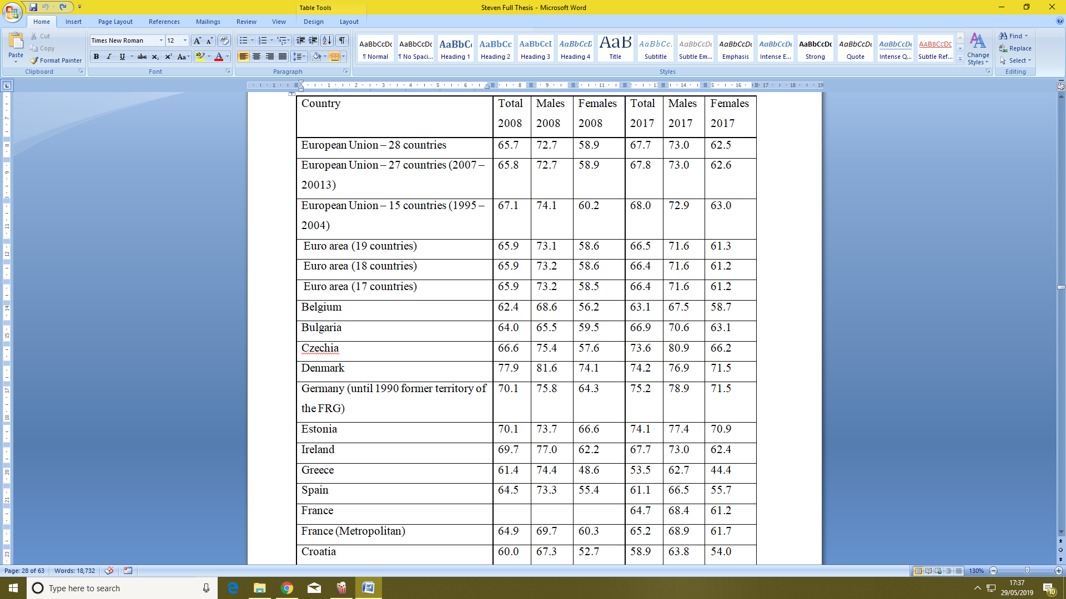

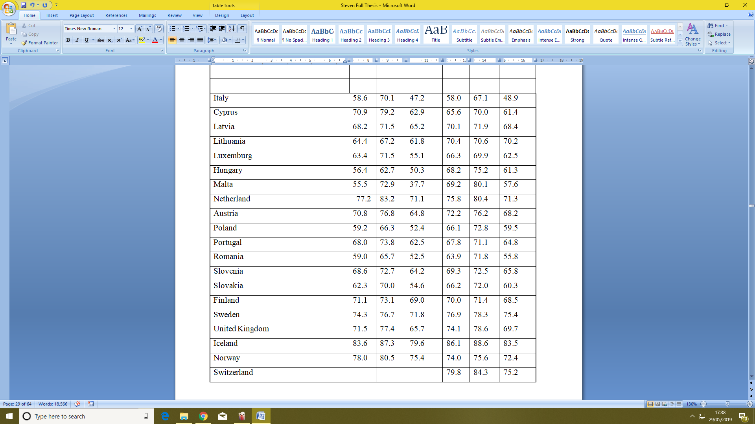

*Table 1: Employment and activity by gender – annual data; last updated 01-02-2019. Age class: From 15 to 64 years. Employment indicator: Total employment - resident population concept – LFS (European Union, 2019).*

The chart above shows the percentage of working men and women of working age. One can easily see the growth of employment between different countries and within each country between 2008 and 2017. Another point that one can easily see is the increase of working women, although while women are nowadays working more in general, in certain countries, still more men tend to work than women. The reason might be religion or the traditions of the country. Others countries like Lithuania, Sweden and Norway tend to have a more modern approach and emphasize no difference between people who are doing the same job, as seen by the close numbers in the statistics.

Comparing the 53.7% of the women who work in hospitality with the responded data, one can see that the kitchen sector in Malta does not carry the same percentages. Comparing the general gender equality as seen in Table 1 to the findings figure 1, one can clearly say that in Malta there is still a lack of women in the kitchen sector as in all other sector. From the answers collected through the questionnaire, 78.5% that responded where male while 21.5% where women, as seen below. Compared to other countries, Malta is still falling behind in gender equality. This is also reflected in statistics done by the EuroZone, figure 1 (European Union, 2019). This may be for various reasons such as family and long hours, as stated earlier in the literature review.

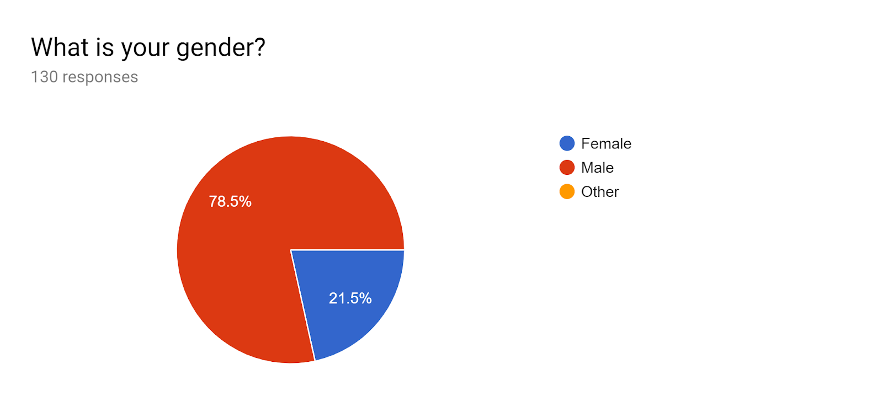

*Figure 1: Responses from question 1 of the questionnaire.*

### 4.3.2 Question 2 - “How old are you?”

From the statistics gathered, there is a pattern that might be worrying as there is a decline of employees in the kitchen sector in the older age brackets. The results were 30.8% aged 16 years to 25 years, 34.6% aged 26 years to 35 years, 20.8% aged 36 years to 45 years, 10.8% from 46 years to 55 years and only 3.1% aged 55 years to 65 years. This means that people are finding other jobs later in life and do not choose the kitchen sector as their main career path. This will be further confirmed when asked how long they have been working in the hospitality sector (question 7). The most common age group was 26 to 35 years. When comparing to the United States of America the average age for chefs is 39.5 years (Datausa.io, n.d.), 40 years in UK, 37 years in China and 41 years in Spain (Mac Con Iomaire and Allen, 2016). The results of my study in Malta have shown that statistically, there is already a decrease of employees before they reach this average age, again confirming that people who become chefs are not staying as chefs permanently.

Apart from the problem where older people tend not to continue their career in the kitchen, younger generations are also finding it a struggle to get attracted to such sector. Some articles also mentioned the fact that students are not looking forward for such jobs due to the fact that there are long hours. In fact youths under 25 do not make up the biggest fraction of employees as expected.

In the most common age group, most people were foreigners. This might be because foreigners at this age decide to come to Malta and pursue a job in the kitchen industry. In an article from the Times of Malta, the CEO of jobsplus Mr. Clyde Caruana also stated that most foreigners come at an age of 30 to 31 years (Macdonald, 2019). When having such a high number of employees in this age group due to the influx of foreigners but then a drop in following age groups, this means that these foreigners are leaving their job in the kitchen or leaving Malta.

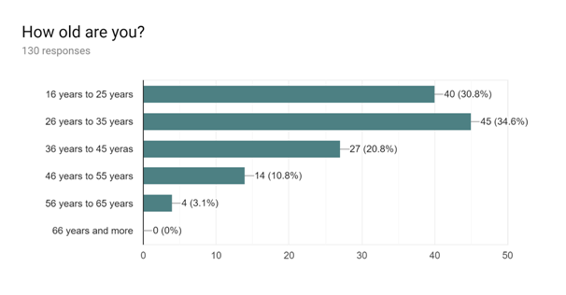

*Figure 2: Responses from question 2 of the questionnaire.*

### 4.3.3 Question 3 - “What is your Nationality?”

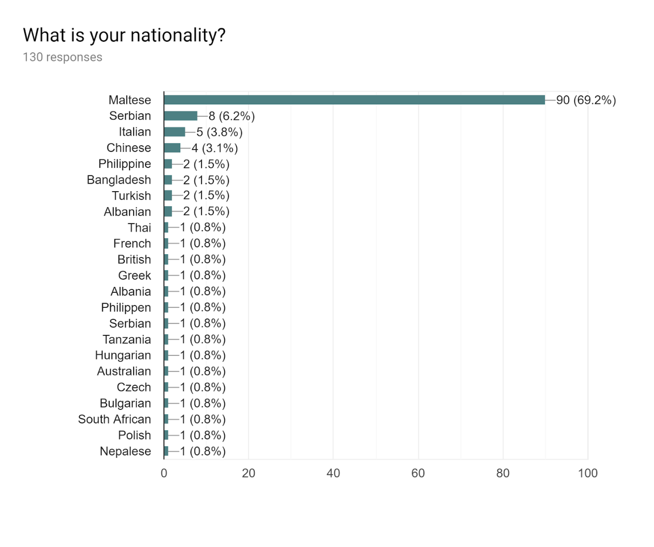

*Figure 3: Responses from question 3 of the questionnaire.*

The percentages of the chart above are rounded up to the nearest decimal place. Most respondents were Maltese (69.2%). The high number of Maltese respondents gives an indication that Maltese people really want to work such jobs, however the answers might be skewed due to the number of foreign employees who do not feel comfortable answering a questionnaire in English as they do not know the language well. Had they answered, the results might have been far different to the answers gathered. Apart from this, foreigners who have recently become Maltese nationals might have marked their nationality as Maltese even if they have not been living here for a very long time. This question could have been better phrased as: ‘In which country where you born?’

Foreigners have an extreme impact on the Maltese economy, and the numbers of foreigners is still increasing annually (Times of Malta, 2016). From the information gathered, Malta has got a mixture of nationalities forming its kitchen sector in the hospitality industry. Due to the freedom of movement and ease of travelling in the EU, one would expect that most foreigners in Malta would be coming from the EU. However, this was not the case in the results gathered from this questionnaire. Surprisingly, most foreigners came from Asia (10%) rather than the EU (9.4%). Another 9.3% of respondents come from countries in Europe that do not form part of the EU, 1.6% from Africa, and 0.8% from Australia. This gives a clear indication that Malta is targeted from different continents and that the freedom of movement of the EU is not the key to foreigners coming to Malta and many other foreigners come here even if it is not as easy.

An article that was published on the Times of Malta (<https://www.timesofmalta.com/articles/view/20160209/local/italians-lead-surge-in-foreign-workers-in-malta.601769>) states that the majority of foreigners in Malta are Italians, British, and Bulgarian. The article also outlined an increasing number of foreigners coming from developing countries such as Philippines, Libya and China. This is reflected in the data gathered from the research, and again does not limit the influx of foreigners to countries within the EU only.

Even within the EU, it seems that foreigners do not travel to another country just because it is easy to do so. An Italian researcher observed the reasons why Italians are moving to Malta and concluded that lack of work in Italy, and higher tax rates were two fundamental reasons why Italians were immigrating to Malta especially from the south of Italy (Times of Malta, 2016). The Italians are also comfortable to speak in Italian as Maltese people are helpful and most of them understand Italian and communicate well. Therefore, they do not need to learn another language such as English or Maltese and can continue to speak with their native tongue even at their place of work. Moreover, Maltese people like Italian cuisine, therefore this is attracting more Italians to come work here, since their culture is so similar and they are familiar with the food that is in demand. The case of Italy is a perfect example of the many other reasons apart from the freedom of movement, that an EU national might chose to come to Malta.

### 4.3.4 Question 4 - “If foreigner, how long have you been staying in Malta? Or If Maltese, N/A.”

*Figure 4: Responses from question 4 of the questionnaire.*

An article published in 2017 by JobsPlus mentioned that a lot of foreign workers who came to Malta in the past years have already left the country. In fact, from all the people that came before 2010, only one tenth of the thousands have stayed in Malta (Martin, 2017). An article from UK has pointed out that only 3% European people of a working age live in a country that is different from where he or she were born.

One can easily notice that more people decided to come to Malta after Malta joined the European Union 15 years ago (1st of May 2004) as there has been a very large increase incoming foreigners. This can either be because they learnt about our country or because they see that Malta has a better economy and more opportunities.

A job in the kitchen sector is also the first job that most foreigners seem to go for once they arrive in Malta. This can be seen because the highest numbers of foreigners answering this questionnaire have only been here for less than 6 months. For an employer to have a small labour turnover, s/he needs to ensure that these new foreign employees stay in Malta and remain working in the kitchen sector in their own establishment.

### 4.3.5 Question 5 - “If you are a foreigner, was employment one of the reasons you decided to come to Malta? If yes, please specify why? Or If Maltese, N/A.”

One of the main pillars when talking about foreigners is the economy. Due to the good economy and since it is always improving; the Maltese could not handle such demand and wanted to recruit foreigners from other countries to keep the economy growing. Apart from that, the Maltese refuse to work such jobs that consists a lot of manual handling, so foreigners took over in most trade jobs (Times of Malta, 2016), (Times of Malta, 2016). Some employers also recruit foreigners as they give lower wages to foreigners and therefore increase their profit (Times of Malta, 2016).

Another point that foreigners check upon before moving to another country is the unemployment rate. Malta’s rate in 2017 was 3.7%. From the chart below, one can see the rates of unemployed people in different countries and how they have been decreasing in most countries but still there are still a high percentage of unemployed people. The unemployment rate is calculated by looking at the percentage of unemployed people in the total population. It is an indication of the social and economic status of the country.

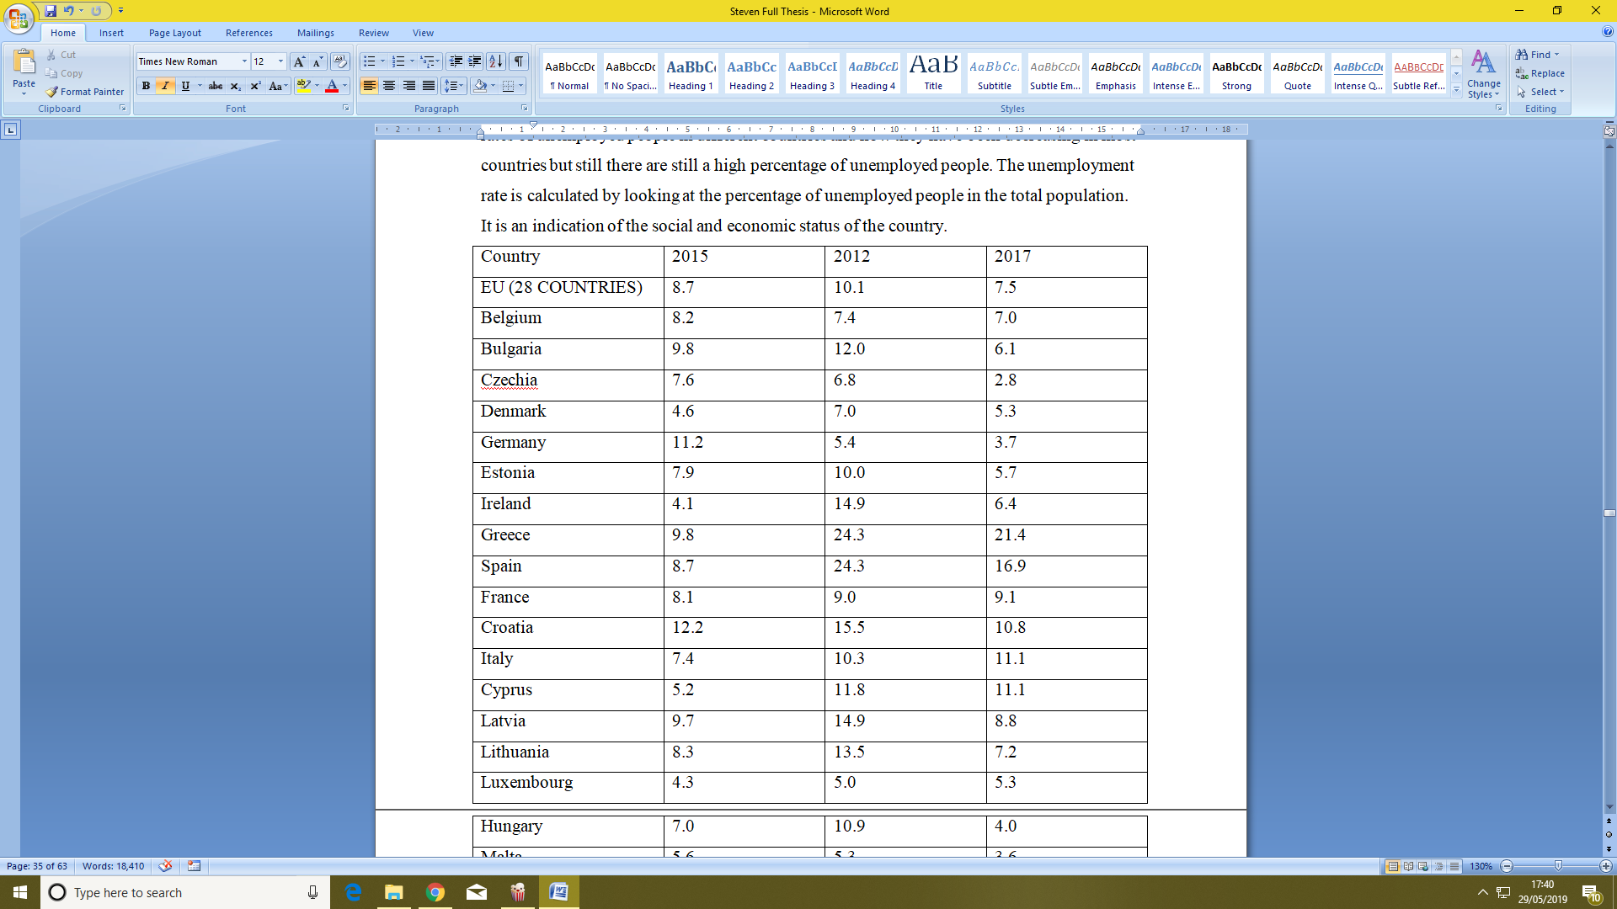

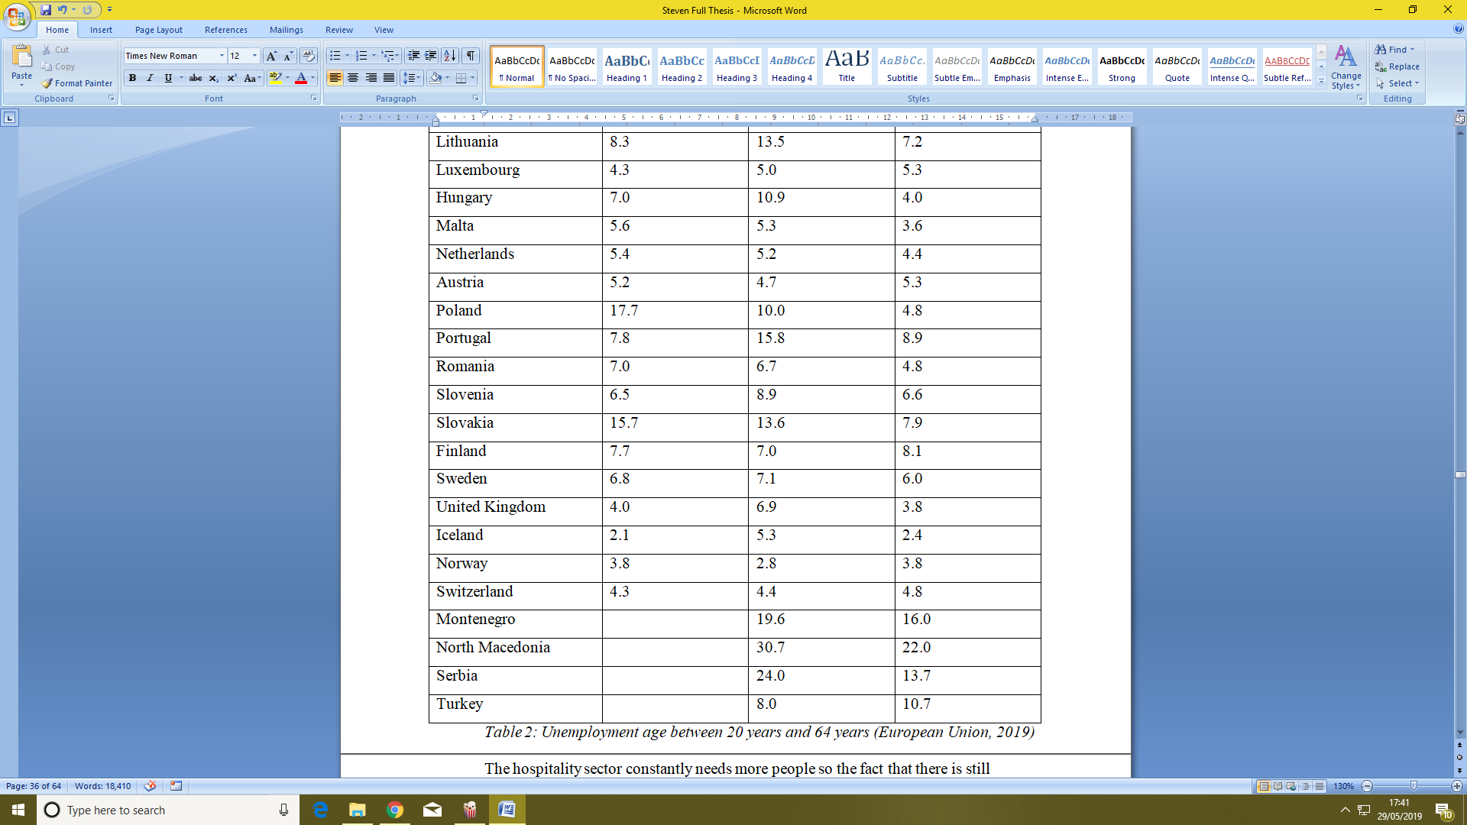

*Table 2: Unemployment age between 20 years and 64 years (European Union, 2019)*

The hospitality sector constantly needs more people so the fact that there is still certain high rate of unemployment means that if employers tried to recruit local people they did not want to work in the hospitality sector or they were not skilled enough.

As per the previous question, 70% have chosen not applicable as they were answered by the Maltese, therefore this question is not applicable for them. One person of Chinese nationality chose not to answer this question. The results from this question showed that 19.2% came to Malta for employment reasons while 10.8% came for other reasons and not for employment. While the local people do not want to work such jobs because of the inferior wage, 9.2% out of the 19.2% came Malta for the good economy and better wages compared to their country, 2.3% came to Malta as they like the lifestyle that Malta has to offer. The following table shows the rest of the replies.

|  |
| --- |
| There is no unemployment |
| Yes, Malta likes Italian food |
| Yes, This gives me the opportunity to showcase my art of cooking and the cuisine to a larger Global audience while earning a competitive wage |
| Yes, I like to meet new people and living new experience. Malta is great place to meet international people |
| To get the visa to work in EU |
| For experience, to change, something different, but sorry not for the money |
| Yes for experience and sea |
| Yes |
| Yes because I want to become an internationally recognised chef and I want to learn more things which I didn’t learn in my country |
| Yes, Malta likes Italian food |

*Table 3: Table of replies from question 5*

On the other hand, the other foreigners replied No as an answer, without giving any reason why which cumulate to 5.4%, 1.5% came Malta because there family came to Malta or got married here, 1.5% came because the weather in Malta is nice and 1.5% came Malta to learn English and work part time for an income. Another 0.8% came to Malta for a holiday and they enjoyed it and decided to stay here.

This can conclude that the level of the quality of work in the hospitality sector is not increasing, even though there are foreigners from many diverse cultures, as there are only a few foreigners who are coming to work because they are passionate about the job. Instead, they are coming for the other benefits. It might be the case in the future, that if the economy goes down, foreigners will choose to leave again and this leaves a worse impact. On the other hand, the people who genuinely like their job and are actually coming to Malta for experience are going back to their country to showcase the knowledge they have got.

### 4.3.6 Question 6 - “Are you registered on a Full time or part time basis?”

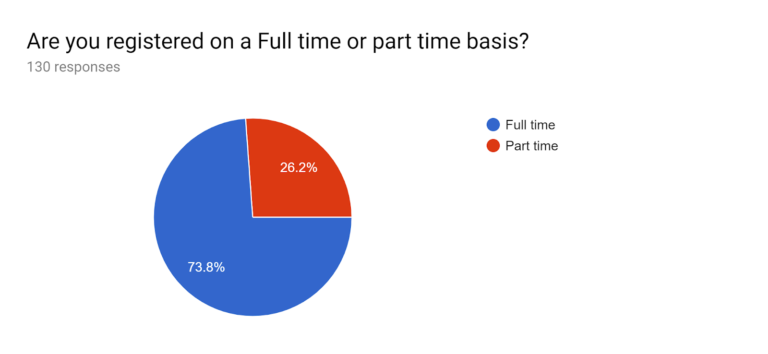

*Figure 5: Responses from question 6 of the questionnaire.*

The figures that where published by the Tourism in Malta back in 2017 showed that in 2016 more part-timers worked in the hospitality sector than full timers, with 6,628 people registered as part time and 5,902 people registered as full timers (Times of Malta, 2016). An explanation for this might be that a lot of students are full time students at the institute or university, and have to work part time, or people do not want to work such jobs and do it only part time as an extra means of income for a better living. Another reason is that employers do not find full timers who want to work full time in the hospitality industry so the only solution is to recruiting part timers.

Apart from the people that are registered, the number of unregistered people working in the hospitality is increasing drastically, mostly from developing countries that risk and work illegally (Martin, 2017). In Malta, between January 2012 and May 2015 11,996 employees were caught working without permit and 4,284 of them were foreigners. The more time passes, the number of foreigners working illegally is increasing and is outnumbering the Maltese employees (Times of Malta, 2016).

From the questionnaires that were given, 73.8% of the people who answered were full-timers while 26.2% were part-timers. This difference in the results can be due to the fact that the management did not pass the questionnaires to all of the employees and most of them were filled by the full-timers who had more chance of being at work when the questionnaires were given. In addition, the managers themselves filled a questionnaire and these are almost always full-timers. . Another issue was that a lot of foreigners who do not know how to speak or understand English are mostly part timers and therefore they could not fill the questionnaire. These reasons may have been the cause of the unexpected twist to the answer and therefore the actual statistics might differ.

### 4.3.7 Question 7 - “How long have you been working in the hospitality industry?”

From 130 questionnaires that where gathered the majority of people have worked in the hospitality industry for 10 years with a percentage of 9.2%. Although there were respondents who have worked in the industry for 50 years, the average length of employment in the hospitality sector is just 20 years. Only 18.5% of the people asked have worked for a number of years above the average and 2.3% have worked 20 years so far. The majority, 79.2% have worked for a number of years below the average.

Normally in Malta, the employee needs to work around 42 years to have the full pension scheme. The pension is normally calculated according on the wage of the highest-paid 10 years in the last 40 years. Since kitchen employees are only staying for an average of 20 years, this means that either chefs are fed up with working in the hospitality sector or the pay might not be as good and a different job may lead them to a better pension. As Kurt Sansone mentioned in his article (Sansone, 2017), employees in the kitchen industry have no union to work for their rights and even employers are not willing to compensate a chef’s working hours by paying better or increasing vocational leave, even though it is not the norm to work on Sundays and public holidays. These can be some of the reasons why a chef might not stay in this career and opt for a different career.

From the results that were received 5.4% have just started in catering and have been working for 6 months or less, 1.5% between 6 months and 12 months, 5.4% between 1 year and 2 years, 23.1% been working between 2 years and 5 years, 24.6% been working between 5 years to 10 years, 21.5% been working between 10 years to 20 years and 18.5% been working over 20 years.

*Figure 6: Responses from question 7 of the questionnaire.*

### 4.3.8 Question 8 - “What is your job position registered name?”

When you are passionate about something, you do it more from your heart. Normally a person studying in hospitality has a dream to run his or her own restaurant. But nowadays it seems that everyone wants the good positions but they do not want to work to achieve such positions. Is it true that all you need to succeed is a good attitude as the human resources departments say? An article online mentioned that to be successful a chef needs to be punctual, has professional etiquette, be honest and respect the work ethics, keep a positive attitude, stay organized with a goal in one’s mind to achieve, be able to work with others, leave problems at home, and work hard (JOBS, 2019). Will this really improve quality in our hospitality if everyone wants to reach the top without climbing the stairs properly? Abroad, this might happen quicker as employees change positions more frequently, therefore there are more opportunities to improve oneself and get a better position. In Malta since it is an island, one tends to stay at the same workplace if he or she are comfortable with their surroundings. This might leave younger generations struggling to achieve more advanced jobs.

From the results that were gathered, even though the average length of time spent working in the sector was quite low, the positions were fairly high. Chef de Partie was the most common reply with 17.7%. 16.9% were Sous Chefs, the same amount as head chefs. Commis chefs which are mainly beginners or students were only 14.6% of those that answered the questionnaire and Demi Chef de Parties next with 10.8%. Six people that answered the questionnaire were junior sous chefs with a percentage of 4.6%. 3.1% were pastry chefs and chef tournants accumulated to 2.3%. Senior sous chef, Banqueting chef, executive head chefs and Pizzaiolo answered with a percentage of 1.5%. The rest were individuals with 0.8% each, these include; pastry demi chef de partie, pastry chef consultant, kitchen helper, training manger, sole trader, senior lecturer, senior chef de partie and pastry sous chef. Having said this, one needs to keep in mind that the reason that there are a lot of high positions is that such top positions are always present in every establishment, whereas lower positions, such as kitchen helpers and consultants are only present in larger establishments.

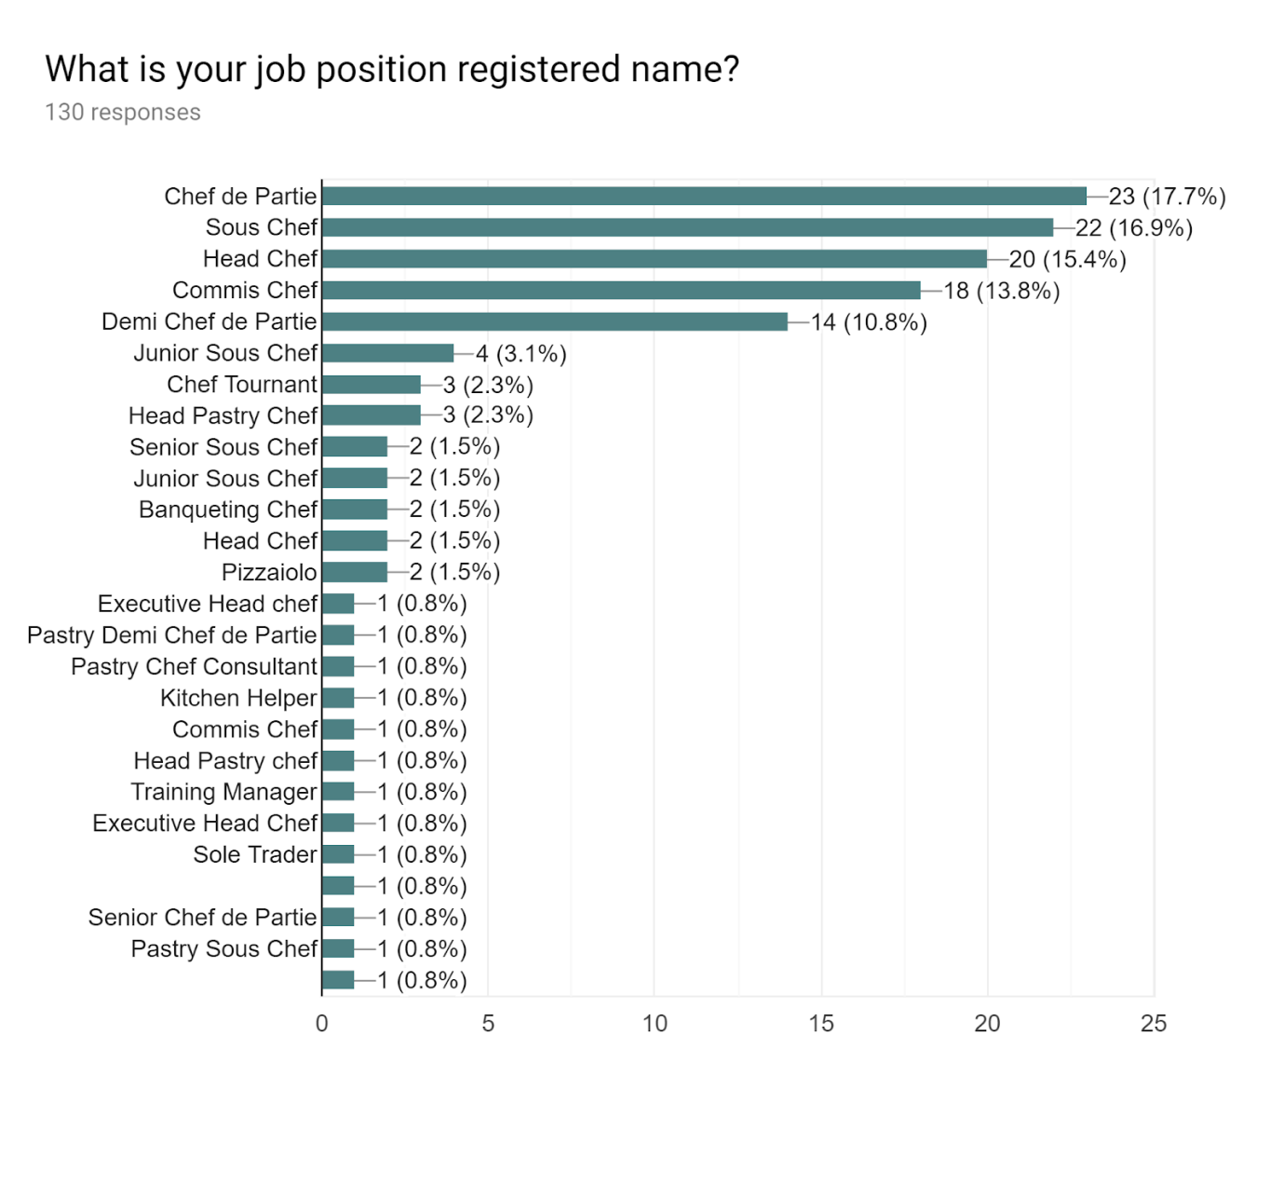

*Figure 7: Responses from question 8 of the questionnaire.*

### 4.3.9 Question 9 - “In which establishment are you employed?”

In every village or city in Malta, one can easily notice the increase in restaurants in Malta. Various restaurants may vary from take away, to bistros to fine dine restaurants. Apart from the different types of restaurants and cuisines, there are in total, 138 hotels in Malta. The table below shows a description of hotel grades in Malta (Tourism in Malta facts and figures 2017).

|  |  |
| --- | --- |
| Number of hotels | Rated |
| 15 | 5 stars |
| 41 | 4 stars |
| 58 | 3 stars |
| 24 | 2 stars |

*Table 4: Number of registered hotels in Malta*

From the responses gathered, most employees worked in a restaurant with a percentage of 66.2%. The reason can be because most of the establishments are restaurants and they are keener to recruit more people to keep moving forward in order to succeed since they are smaller than the larger industries such as hotels, from which there are different types of income. In most cases restaurants tends to pay a bit higher wages since the roster and staff might be tighter. In fact 19.2% have chosen to work at a hotel; this can be because time is more flexible and the exposure might be bigger when writing a popular hotel name on a CV. 2.3% work in an elderly care - this may be to reduce the pressure and keep working in the same environment, without the stress of a busy restaurant. Some employees are trying to opt for a different background, some working with a company, other outside catering or in a club, and some working as a bakery or bakery and confectionaries in which Malta is renowned for its bread and is found in our everyday shopping list. Some might have a more adventurous vision and be looking for a challenge and therefore opt for a more exciting establishment or something different, such as wedding companies, airports, banqueting, chocolate confectionary, or as a hospitality lecturer in the same sector.

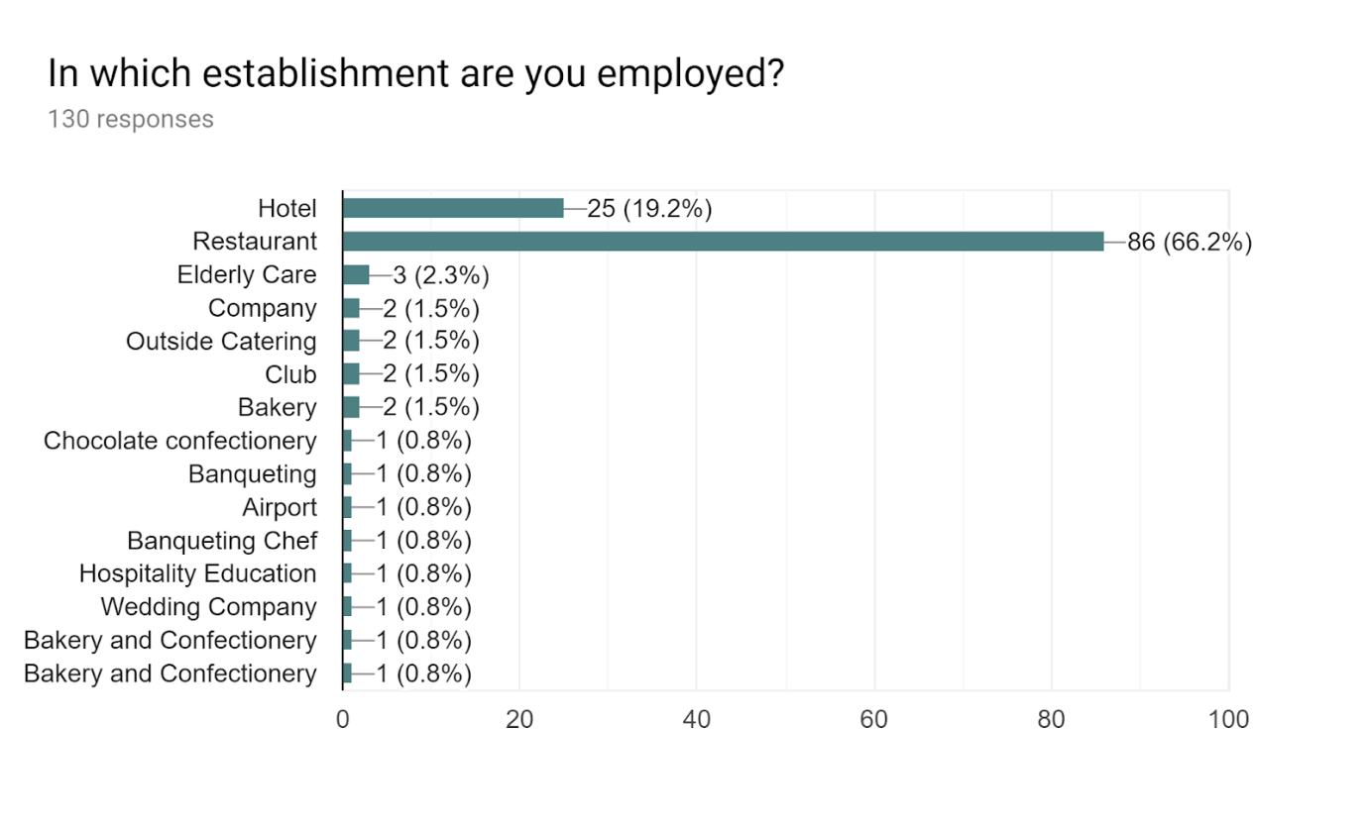

*Figure 8: Responses from question 9 of the questionnaire.*

### 4.3.10 Question 10 - “Are you planning to stay in Malta? If no where do you wish to go and why.”

In a question raised by the World Economic Forum in 2018, people were asked where they would go if they had to move abroad to work. Just under half of them responded that they would stay in the same country and prefer not to move while the rest chose United States (34%), Germany (26%), Canada (24%), Australia (21%), UK (20%), Spain (14%), France (14%), Switzerland (13%) , Italy (11%) and Japan (10%). People still commonly chose the United States even after the US Government changed the policies regarding immigration making the US less welcoming to immigrants. The UK was second most-favourite choice in 2014 but Germany replaced U.K in 2018 as people from Spain, Denmark, Poland and Romania were more interested in Germany rather than the UK. Germany has already accepted many foreigners in recent years and the economy is doing really well. Canada was placed only in third place as even though they are welcoming of young and well-educated people, they must know English or French. Australia is the new target for people living in the UK as they prefer to move to this country, rather than more traditional countries such as India and South Africa, which are now less popular with new English immigrants.

A reporter from the Times of Malta, Ivan Martin, wrote several articles that all pointed out the increase in foreign employees in Malta. A particular report from the National Statistics Office states that the population will keep on rising, and by 2055 the population will have increased by 40,000 people (Martin, 2017). A report made by the same reporter in August 2017, used a sub-title stating that there were ‘Plans hatched to import unemployed from other European Union countries’, although he mentioned that the Head of State Employment Agency, Jobs Plus (Clyde Caruana) gave a different perspective, because according to his findings and employment statistics, most of the foreign workers that entered Malta had left, and to be more precise, only less than tenth of the thousands of workers that arrived in Malta since 2010, are still on the island. Although several reasons for leaving Malta were outlined, such as, their contracts ending, not wishing to stay in Malta any longer, not choosing the right career path here, getting a better work contract elsewhere, etc., the main reason remains unknown. Ivan Martin gave a twist, saying that ‘This suits our purposes perfectly’. This was said with an outlook that the foreign employee came to Malta, filled an empty vacancy, paid taxes just like the locals but left no heavy load on the island’s welfare system, since they did not stay long enough to be able to accumulate any pension, since they just came to Malta to work (Martin, 2017).

Although foreigners leaving soon after can have an advantage on the local welfare state, six days later another report made by Ivan Martin, gave a perspective from an economist’s, Dr. Von Brockdorff, point of view back in September 2017, stating that due to the fact that the economy is still growing, the private sector is still keen to get more employees to be able to work with this demand. He also stated that in his perspective, the private sector is trying to build pressure on the government to release some restrictions on third world country nationals, especially in the tourism sector. Although the government was looking into ways to ease the private sector’s thirst, which include both skilled and unskilled personnel, it also gave an indication that could result in a new ad hoc entity. In this article, Dr. Von Brockdorff also mentioned the fact that the majority of these foreign employees are transitory and have already left the country. This can result in more problems and the economy might slow down.

Another point that Dr. Von Brockdorff stated is that the foreign labour was making an influx on the wages, due to the fact that since more foreigners are coming in, the private sector can compete with the wages by lowering wages in some sectors. At the end of the report he compared the issue that the United Kingdom faced due to economic crisis back in 2008, when foreigners were driving locals out of England, but so far since the economy is still growing there is no risk for Maltese people. The reporter also mentioned that, “What would happen, however, if the economy slowed down had yet to be seen”; this indicates that there is no plan in place regarding such measures (Martin, 2017).

An interesting fact that arose was that Ivan Martin had written another report in November, with a title that states, ‘New deals to import non-EU foreign workers to Malta’ and below, a sub-title that contradicts, ‘Less than 10th of foreign workers in 2010 remain on island’. This report was linked to the one that was made in August by Ivan Martin, with the difference that Mr. Caruana stated that agreements are made with Serbia and Montenegro. This is due to the fact that few foreigners are staying; therefore employees from outside of Europe are required to fill the vacancies. In the middle of the report, Mr. Caruana also gave the impression that Maltese people are being prioritized, but they are declining to work. The reporter ended by mentioning that employees coming from third world countries are working part time jobs illegally, and that these same positions could be filled by a Maltese citizen (Martin, 2017).

In my study, something interested that stood out is that in fact, 80.8% of the foreigners said that they will stay in Malta. The reason they might want to stay here however, might not be related to their job and how well they are doing, but for other reasons. The table show some comments from the people staying in Malta.

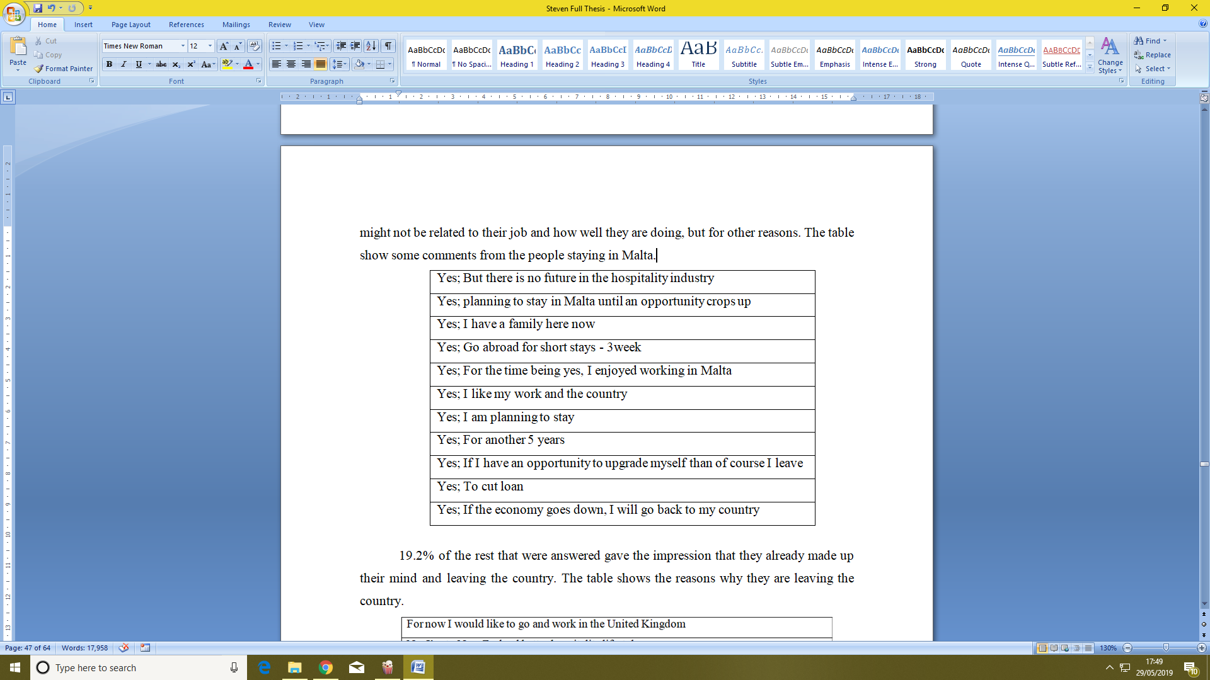

*Table 5: Answers for question 10, reasons why staying in Malta*

19.2% of the rest that were answered gave the impression that they already made up their mind and leaving the country. The table shows the reasons why they are leaving the country.

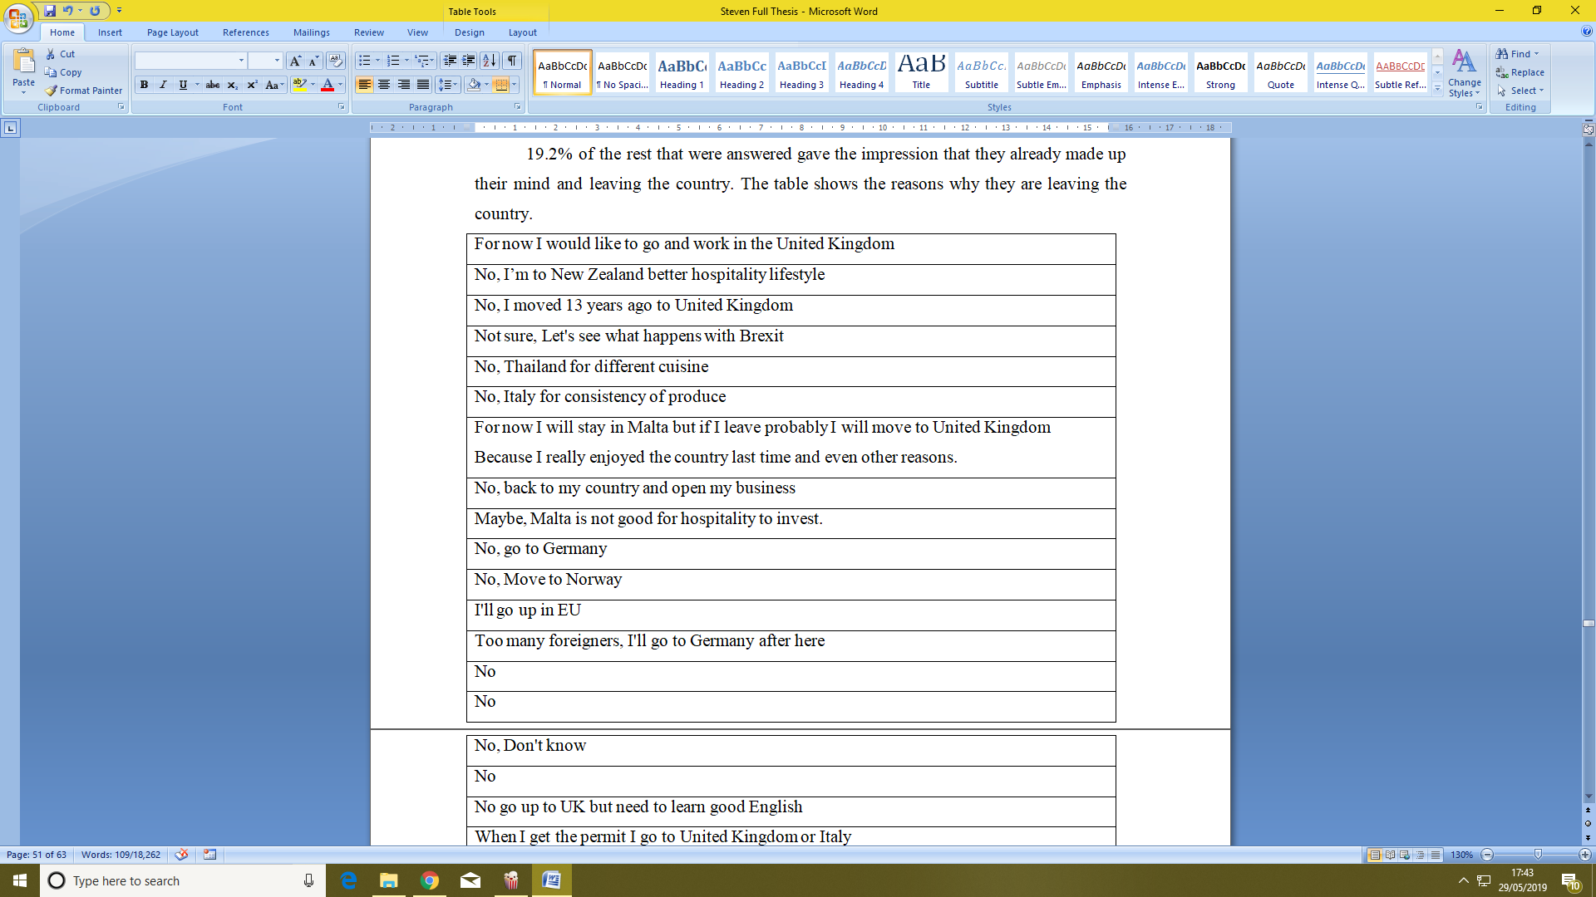

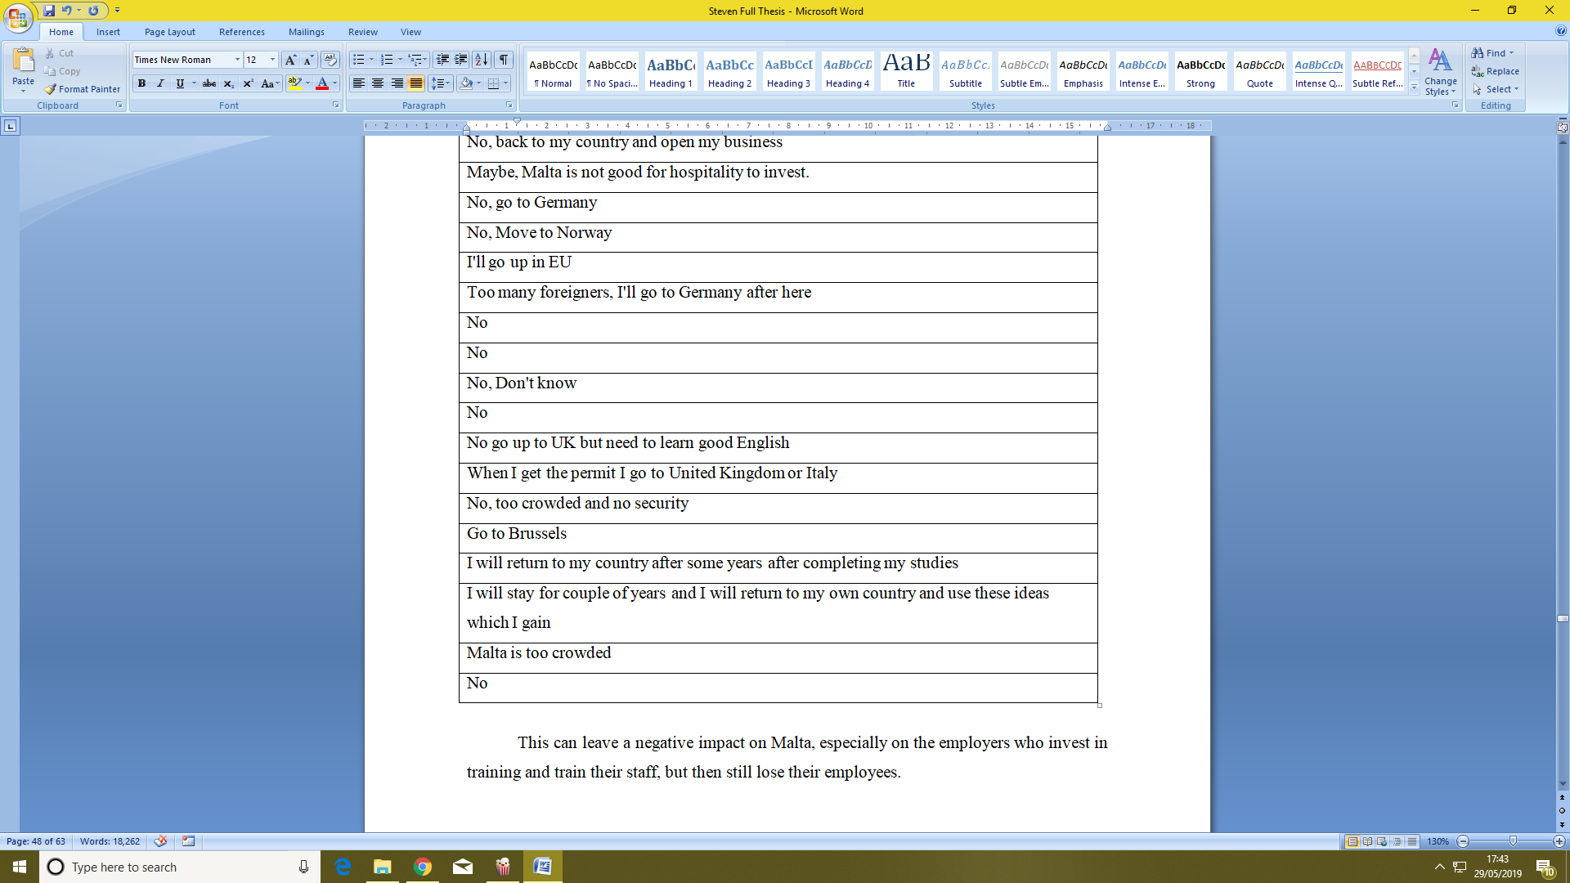

*Table 6: Answers for question 10, reasons why they are not staying in Malta*

This can leave a negative impact on Malta, especially on the employers who invest in training and train their staff, but then still lose their employees.

### 4.3.11 Question 11 - “What level of education have you acquired with regards to the hospitality sector?”

30% of those employed in hospitality completed up to a maximum of a lower secondary education while in the overall employment sector, the number of employees with the same level of education falls to 18%. There is also a higher number of people working part-time in the hospitality sector when compared to the rest of the employment sectors: 33% of people in the hospitality sector work on a part time basis, while a total of 20% work part-time in all the other jobs (HOTREC, n.d.).

These statistics do not agree with the results from the questionnaire. The majority of the people who answered the questionnaire were Maltese an MQFlevel 5 was the highest academic level one can get in the hospitality sector till 2018[unless opting to study abroad]. Studies at level 6 have since been introduced but they are still new to the locals. Level 7 and Level 8 are still not introduced in Malta. From the statistics gathered, 10.7% have got level 2 MQF or less. This means that after finishing their secondarily school, these people opted to start working immediately without any further studies. 23.8% have either finished secondarily level with O’ Levels in hand or a certificate from the ITS. 16.2% have got a diploma level in hospitality while 40.8% - almost half of those who responded - have got a maximum of a higher national diploma which is MQF level 5. These could either be because they started working after this level or because they are still completing further work. 6.2% have reached the new degree level, which is obtained from either the local institutes or abroad and 2.3% have obtain MQF level 7 from abroad or from the University of Malta in an area not directly related to kitchen, such as management.

In Malta there is a higher percentage of people working in the industry who continue to study after their secondary education due to incentives such as stipends amongst others. The Institute of Tourism Studies[ITS] offers other incentives to encourage people to continue studying in hospitality studies for instance, studying and working abroad is supported by the I.T.S. as part of the curriculum. These opportunities are not offered in a lot of other courses but are very beneficial to the student because they gain a lot of experience.

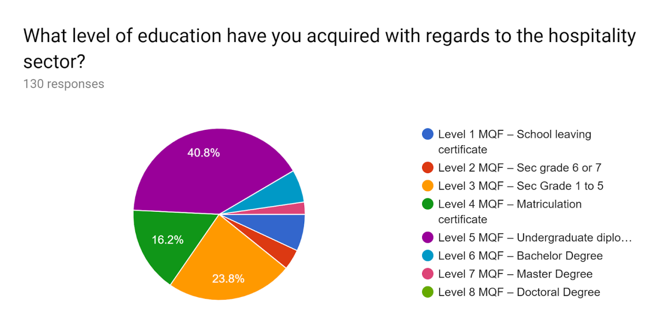

*Figure 9: Responses from question 11 of the questionnaire.*

### 4.3.12 Question 12 - “If you have obtained a Level 4 education in hospitality or higher, which institute did you attend? If Level 3 or less write N/A.”

While a lot of chefs have a background in education, award winning chefs which are both male and female are mostly self-taught and learned most of the items on their own after their work or on the days off (Mac Con Iomaire and Allen, 2016). This may also affect the wages as people with higher education tend to get paid more than those that stopped their studies (Judge et al., 1995). (Against all Odds, Head chef profiled). Mesh 2012 had indicated that people that graduate with higher educational grades had higher industry rates (Mac Con Iomaire and Allen, 2016). Although they get paid more due to their higher educational grades, this does not mean that they are more knowledgeable in practice. Now it is becoming a trend with some newly graduate chefs that after they finish their graduate studies, they start working from the bottom tiers to gain more practice (Mac Con Iomaire and Allen, 2016). In Malta, 40% of high end jobs that require a high level of skills are taken mostly by foreigners. (Times of Malta, 2016). One of the reasons may be that 40% of immigrants that come to Malta already have a university degree compared to only 23% of Maltese who have that same level. 46% of the immigrants have got a skilled job while 49% of the Maltese have got similar jobs. Foreigners in Malta are taking both types of jobs: skilled jobs and also those that need fewer skills, some with a lot of manual handling with less wage and bad conditions. (Times talk 9th February 2016)

In my study, most of the locals that studied in Malta obtained their studies from the Institute of Tourism Studies with 48.5% of the people. 34.6% have not been to any schools after they finished the secondary level. Some Maltese who answered the questionnaire have completed higher levels in education but not in hospitality studies. This will help them to work that extra bit and gain a bit more money due to their qualifications, but does not restrict them to work in the hospitality sector all their lives. The following is a list showing the different institutes that the people who have answered the questionnaire have studied at.

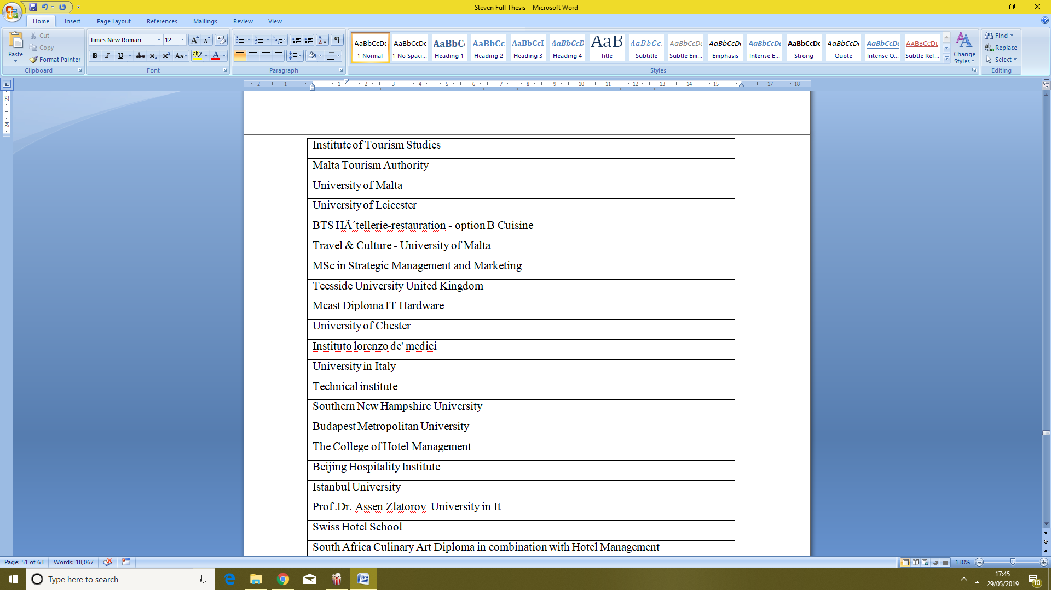

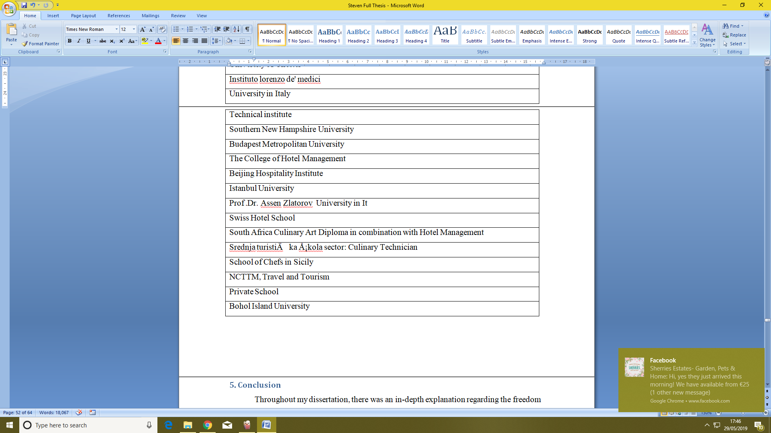

*Table 7: Answers for question 12, the results for different institutes*

# 5. Conclusion

Throughout my dissertation, there was an in-depth explanation regarding the freedom of movement and what the different EU countries think about it. After analyzing the results that were gathered from the questionnaire, it was concluded that locals still work in the kitchen but this sector it is getting affected by a lot of foreigners. Unfortunately, the issues surrounding the influx of foreigners are often not solved, such as the language barrier. In fact, some kitchen employees could not answer the questionnaire as they do not know any English.

One of the conclusions that came out from the questionnaire was the gender issue in Malta from the kitchen sector point of view. This sector still lacks in gender equality. In this sector, both men and women come to Malta but few are women who make it to management levels, as from the questionnaires gathered anonymously most managerial positions were all taken by men.

Something that also stood out was the average years a person stays in the kitchen as chef, which was only 20 years. This gives an indication that working in the kitchen might not be a secure job and the labour turnover is quite high. This means that a lot of recruiters spend a lot of money in training, and they will be investing in the wrong people. In this matter nowadays, a chef needs to do most of the management jobs especially in small restaurants as no human resource managers are there. This was also because as a sector, it gives an opportunity to young students to work as part time to earn an income, even if they are only interested in that job for the money and not as a start for their career. This leaves more experienced students or chefs without proper jobs as they might be asking for a higher wage which also stood out in Times Talk on the 9th of February 2016 where a director of a number of various restaurant establishments in Valletta mentioned that the employer cannot find skilled people to work. While Maltese people are not necessarily angry when they are served by a foreigner rather than a Maltese, there are problems due to language barriers that make the quality and service drop down drastically; therefore the customer is paying for an inferior service.

During this dissertation, something else stood out. Most countries have improved their economy thanks to the EU, both financially and also in labour forces. Malta is an island which is always growing both in economy and also in population. Unfortunately, nowadays quantity is regarding more importantly than quality. This was shown from the research gathered from the questionnaires where the level of education in hospitality was either poor or not directly related to the culinary arts. Another aspect was that most foreigners which came to Malta joined the kitchen sector while they were in Malta; therefore they had little or no experience in the subject. This means that the freedom of movement in Malta does not have any benefits for the local establishments to increase quality of service but only to increase labour forces. Again, it is clear that foreigners might not see a chef position as a professional job but more as an income to fill a vacancy. This problem is continuing to increase as Malta is not finding enough people from the EU and is recruiting people from developing countries.

## Recommendations

As a recommendation, recruiters should make greater use of the employee’s skills passport when choosing who to recruit based on their skills rather than recruit foreigners just to fill the vacancies. Apart from choosing with skill, one should also obey the National Occupational Standards before recruiting to identify the criteria needed for the job, recruit the right person and define what job position they might need to fill the gap in their brigade. Apart from that, the Malta Tourism Authority gives restaurants a quality assurance award that is displayed outside the restaurant to identify it as a good-quality establishment. More monitoring by the authorities should be done as some places that are given this award do not continue to adhere to all the regulations, therefore the quality assurance is not always up to standard and loses its meaning.

While this study answers to the challenges mostly from a recruiter and an employee point of view, further research can be done on the subject. There is room for more studies on the subject, for instance, focusing on the Government’s point of view. What is the Government doing to keep the quality of hospitality in Malta on the increase? It is important for these questions to continue to be asked so that we do not reach a situation where politicians pay more attention to the growth of the economy in place of the quality of the hospitality sector.

# References

* Ali's Adventures. (2019). *10 Smallest Countries in Europe - Ali's Adventures*. [online] Available at: https://www.aliadventures.com/the-7-smallest-countries-in-europe/ [Accessed 25 Apr. 2019].
* Anderson, E. (2017). *Spaniards most likely to want their own EU referendum, poll shows*. [online] Thelocal.es. Available at: https://www.thelocal.es/20170616/spaniards-most-likely-to-want-their-own-eu-referendum [Accessed 20 Feb. 2019].
* Baume, M. (2018). *As Britain leaves, English on rise in EU — to French horror*. [online] POLITICO. Available at: https://www.politico.eu/article/french-english-language-brexit-european-parliament-ecj-commission-eu-next-waterloo/ [Accessed 28 Feb. 2019].
* Bechev, D. (2018). *Meet the EU's next member state: Montenegro*. [online] Aljazeera.com. Available at: https://www.aljazeera.com/indepth/opinion/meet-eu-member-state-montenegro-180418115545134.html [Accessed 20 Feb. 2019].
* Brooking, P. (2019). *Planning for Brexit: Access to skills | CBI*. [online] CBI. Available at: https://www.cbi.org.uk/articles/planning-for-brexit-access-to-skills/ [Accessed 25 Apr. 2019].
* Browne, R. and Hawkins, E. (2018). *Finland and the European Union: “It’s Complicated”*. [online] Yle Uutiset. Available at: https://yle.fi/uutiset/osasto/news/finland_and_the_european_union_its_complicated/10197162 [Accessed 20 Feb. 2019].
* Datausa.io. (n.d.). *Chefs & head cooks | Data USA*. [online] Available at: https://datausa.io/profile/soc/351011/#skills [Accessed 20 Mar. 2019].
* Demicoli, K. (2018).*Don't young Maltese people want to work in tourism? - TVM News*. [online] TVM English. Available at: https://www.tvm.com.mt/en/news/dont-young-maltese-people-want-to-work-in-tourism/ [Accessed 14 Feb. 2019].
* Dikov, I. (2018). [online] European-views.com. Available at: https://www.european-views.com/2018/07/eu-must-adopt-eu-english-as-its-official-working-language-after-brexit-heres-why/ [Accessed 28 Feb. 2019].
* Elliott, L. (2004). *EU language barrier 'costing lives'*. [online] the Guardian. Available at: https://www.theguardian.com/business/2004/jul/28/politics.europeanunion [Accessed 1 Mar. 2019].
* Eubusiness.com. (2019). *The European Hospitality Skills Passport — EUbusiness.com | EU news, business and politics*. [online] Available at: https://www.eubusiness.com/focus/skill-passport/ [Accessed 20 Mar. 2019].
* euractiv.com. (2015). *The European Language Cloud, or how to enable a multilingual Europe*. [online] Available at: https://www.euractiv.com/section/languages-culture/opinion/the-european-language-cloud-or-how-to-enable-a-multilingual-europe/ [Accessed 27 Feb. 2019].
* Europarl.europa.eu. (2018). *Multilingualism online: "Language barriers are a major challenge" | News | European Parliament*. [online] Available at: http://www.europarl.europa.eu/news/en/headlines/economy/20180621STO06335/multilingualism-online-language-barriers-are-a-major-challenge [Accessed 27 Feb. 2019].
* European Union. (2019). *The economy | European Union*. [online] Available at: https://europa.eu/european-union/about-eu/figures/economy_en [Accessed 7 Feb. 2019].
* Gallace, N. (2016). *On the challenges facing the food industry in recruitment*. [online] New Food Magazine. Available at: https://www.newfoodmagazine.com/article/23510/food-industry-recruitment/ [Accessed 26 Apr. 2019].
* Ginsburgh, V., Moreno-Ternero, J. and Weber, S. (2018). *The English language in the EU after Brexit | VOX, CEPR Policy Portal*. [online] Voxeu.org. Available at: https://voxeu.org/article/english-language-eu-after-brexit [Accessed 25 Mar. 2019].
* GOV.UK. (2019). *Countries in the EU and EEA*. [online] Available at: https://www.gov.uk/eu-eea [Accessed 20 Feb. 2019].
* Government.nl. (n.d.). *The Netherlands: EU member state*. [online] Available at: https://www.government.nl/topics/european-union/the-netherlands-eu-member-state [Accessed 20 Feb. 2019].
* Gudgin, G. and Coutts, K. (2017). *Did EU Membership Accelerate UK Economic Growth? • Social Europe*. [online] Social Europe. Available at: https://www.socialeurope.eu/eu-membership-accelerate-uk-economic-growth [Accessed 20 Feb. 2019].
* Gudmundsson, H. (2017). *[Opinion] Iceland: further from EU membership than ever*. [online] EUobserver. Available at: https://euobserver.com/opinion/140228 [Accessed 20 Feb. 2019].
* Hartke, K. (2018). *NPR Choice page*. [online] Npr.org. Available at: https://www.npr.org/sections/thesalt/2018/08/31/639398136/women-chefs-still-walk-a-fine-line-in-the-kitchen?t=1557441323979 [Accessed 20 Feb. 2019].
* Hotel Management. (2009). *Topple the language barrier*. [online] Available at: https://www.hotelmanagement.net/housekeeping/topple-language-barrier [Accessed 1 Mar. 2019].
* HOTREC. (2018). *Facts & Figures - Hospitality industry contributions to EU economy society*. [online] Available at: https://www.hotrec.eu/facts-figures/ [Accessed 16 Mar. 2019].
* Hudson, D. (2019). *Update 2 | Economic growth came fast, Malta wasn't prepared for it - Finance Minister*. [online] MaltaToday.com.mt. Available at: https://www.maltatoday.com.mt/news/national/94533/economic_growth_needs_slow_down_malta_wasnt_prepared_for_it__finance_minister#.XO54tYgzaUk [Accessed 25 Apr. 2019].
* Independent Balkan News Agency. (2015). *Salaries in Albania, drastic gap between the minimum and maximum pay*. [online] Available at: https://balkaneu.com/salaries-albania-drastic-gap-minimum-maximum-pay/ [Accessed 25 Mar. 2019]. Scjaart, E. (2018). *Most Europeans want less migration: survey*. [online] POLITICO. Available at: https://www.politico.eu/article/europe-migration-survey-most-europeans-want-less-migration-survey/ [Accessed 8 Mar. 2019]countryeconomy.com. (2019). *Serbia National Minimum Wage - NMW 2019*. [online] Available at: https://countryeconomy.com/national-minimum-wage/serbia [Accessed 25 Apr. 2019].
* Ireland - European Commission. (2019). *Ireland in the EU - Ireland - European Commission*. [online] Available at: https://ec.europa.eu/ireland/about-us/ireland-in-eu_en [Accessed 20 Feb. 2019].
* ISA² - European Commission. (2019). *Overcoming language barriers - ISA² - European Commission*. [online] Available at: https://ec.europa.eu/isa2/actions/overcoming-language-barriers_en [Accessed 8 Feb. 2019].
* Kuip, E. (2019). *Language Barrier preventing EU Relocation*. [online] Kwintessential. Available at: http://www.kwintessential.co.uk/blog/news/language-barrier-preventing-eu-relocation-2 [Accessed 26 Nov. 2018].
* Mac Con Iomaire, M. and Allen, H. (2016). *'Against All Odds': Head Chefs Profiled*. Dublin Institute of Technology.
* Macdonald, V. (2019). *‘The economy cannot do without foreign workers’*. [online] Times of Malta. Available at: https://www.timesofmalta.com/articles/view/20190120/business-news/the-economy-cannot-do-without-foreign-workers.699661 [Accessed 24 Mar. 2019].
* Maltachamber.org.mt. (2019). *Malta's Economic Growth Needs To Slow Down – Finance Minister*. [online] Available at: https://www.maltachamber.org.mt/en/malta-s-economic-growth-needs-to-slow-down-finance-minister [Accessed 25 Apr. 2019].
* Martin, I. (2017). *New deals to import non-EU foreign workers to Malta*. [online] Times of Malta. Available at: https://www.timesofmalta.com/articles/view/20171118/local/new-deals-to-import-non-eu-foreign-workers-to-malta.663371 [Accessed 29 Feb. 2019].
* Martin, I. (2017). *New deals to import non-EU foreign workers to Malta*. [online] Times of Malta. Available at: https://www.timesofmalta.com/articles/view/20171118/local/new-deals-to-import-non-eu-foreign-workers-to-malta.663371 [Accessed 14 Feb. 2019].
* Martin, I. (2017). *Foreigners leading to Malta's population boom*. [online] Times of Malta. Available at: https://www.timesofmalta.com/articles/view/20170325/local/foreigners-leading-to-maltas-population-boom.643296 [Accessed 12 Feb. 2019].
* Martin, I. (2017). *Thousands more foreign workers are needed to keep economy on track*. [online] Times of Malta. Available at: https://www.timesofmalta.com/articles/view/20170827/local/more-foreigners-are-needed-to-build-the-economic-railroad.656537 [Accessed 10 Mar. 2019].
* Martin, I. (2017). *New deals to import non-EU foreign workers to Malta*. [online] Times of Malta. Available at: https://www.timesofmalta.com/articles/view/20171118/local/new-deals-to-import-non-eu-foreign-workers-to-malta.663371 [Accessed 5 Mar. 2018].
* Martin, I. (2017). *Thousands of non-EU workers likely to be needed – economist*. [online] Times of Malta. Available at: https://www.timesofmalta.com/articles/view/20170902/local/thousands-of-non-eu-workers-likely-to-be-needed-economist.657018 [Accessed 18 Feb. 2019].
* Medium. (2018). *Staffing Challenges in the Restaurant Industry*. [online] Available at: https://medium.com/@voixai/staffing-challenges-in-the-restaurant-industry-19b01084108b [Accessed 26 Apr. 2019].
* Micallef, K. (2018). *Migrant workers controversy: Have any studies been carried out?*. [online] Times of Malta. Available at: https://www.timesofmalta.com/articles/view/20181030/local/migrant-workers-controversy-have-any-studies-been-carried-out.692928 [Accessed 22 Mar. 2019].
* Mohdin, A. (2018). *The EU countries that desperately need migrants to avoid shrinkage—and those that don’t*. [online] Quartz. Available at: https://qz.com/1325640/the-european-countries-that-desperately-need-migrants-to-avoid-demographic-decline-and-those-that-dont/ [Accessed 8 Mar. 2019].
* Mohdin, A. (2018). *Even after Brexit, English will remain the language that holds the EU together*. [online] Quartz. Available at: https://qz.com/1270508/even-after-brexit-english-will-remain-the-language-that-holds-the-eu-together/ [Accessed 28 Feb. 2019].
* Morley, J. and Sanoussi, F. (2010). *Comparative analysis of working time in the European Union*. 1st ed. [ebook] pp.1-10. Available at: https://www.eurofound.europa.eu/sites/default/files/ef_files/docs/ewco/tn0803046s/tn0803046s.pdf [Accessed 4 Apr. 2019].
* Noack, R. (2016). *These countries could be next now that Britain has left the E.U*. [online] The Washington post. Available at: https://www.washingtonpost.com/news/worldviews/wp/2016/06/23/these-countries-could-be-next-if-britain-leaves-the-e-u/?utm_term=.d636ebc3c43c [Accessed 20 Feb. 2019].
* Rankin, J. (2018). *EU has no plans to downgrade use of English after Brexit*. [online] the Guardian. Available at: https://www.theguardian.com/politics/2018/may/04/eu-has-no-plans-to-downgrade-use-of-english-after-brexit [Accessed 28 Feb. 2019].
* RegiOtels. (2019). *Women and the Hospitality Industry - RegiOtels*. [online] Available at: https://www.regiotels.com/2019/02/11/women-and-the-hospitality-industry/ [Accessed 20 Mar. 2019].
* Revfine.com. (2019). *Hospitality Industry; Everything You Need to Know About Hospitality*. [online] Available at: https://www.revfine.com/hospitality-industry/ [Accessed 20 Feb. 2019]. Richter, J. (2014). *How has 10 years of EU membership impacted Czech society? | Radio Prague*. [online] Radio Praha. Available at: https://www.radio.cz/en/section/special/how-has-10-years-of-eu-membership-impacted-czech-society [Accessed 20 Feb. 2019].
* Poulsen, S. (2017). *How do Europeans move and work across the continent despite so many language barriers? - Quora*. [online] Quora.com. Available at: https://www.quora.com/How-do-Europeans-move-and-work-across-the-continent-despite-so-many-language-barriers [Accessed 28 Feb. 2019].
* Sansone, K. (2017). *Nothing 'extraordinary' about working on Sundays, hospitality sector tells GWU*. [online] Times of Malta. Available at: https://www.timesofmalta.com/articles/view/20170906/local/blanket-plan-for-extra-pay-on-sundays-public-holidays-ignores-reality.657335 [Accessed 18 Feb. 2019].
* Sansone, K. (2018). *‘Economy has no pause button’, Joseph Muscat tells social partners*. [online] MaltaToday.com.mt. Available at: https://www.maltatoday.com.mt/news/national/87324/economy_has_no_pause_button_joseph_muscat_tells_social_partners#.XO53BogzaUk [Accessed 18 Mar. 2019].
* Shergill, S. (2016). *Case study: European catering & hospitality language training - EPALE - European Commission*. [online] EPALE - European Commission. Available at: https://ec.europa.eu/epale/en/blog/case-study-european-catering-hospitality-language-training [Accessed 1 Mar. 2019].
* Simić, J. (2018). *Most Serbs support EU membership, cite job opportunities, in new poll*. [online] euractiv.com. Available at: https://www.euractiv.com/section/enlargement/news/most-serbs-support-eu-membership-cite-job-opportunities-in-new-poll/ [Accessed 20 Feb. 2019].
* Smyth, P. (2014). *More than 90% of Irish people want to stay in EU, poll reveals*. [online] The Irish Times. Available at: https://www.irishtimes.com/news/politics/more-than-90-of-irish-people-want-to-stay-in-eu-poll-reveals-1.3488112 [Accessed 20 Feb. 2019]. (Smyth, 2014).
* The Guardian. (2015). *Japan's robot hotel: a dinosaur at reception, a machine for room service*. [online] Available at: https://www.theguardian.com/world/2015/jul/16/japans-robot-hotel-a-dinosaur-at-reception-a-machine-for-room-service [Accessed 8 Feb. 2019].
* Thornell, C. (2018). *How To Fix Kitchens' Gender Inequality Problem*. [online] Restaurant Insider. Available at: https://upserve.com/restaurant-insider/female-chefs-offer-ways-combat-gender-inequality-kitchen/ [Accessed 25 Apr. 2019].
* Times of Malta. (2016). *The impact of foreign workers*. [online] Available at: https://www.timesofmalta.com/articles/view/20161102/editorial/The-impact-of-foreign-workers.629751 [Accessed 25 Apr. 2019].
* Times of Malta. (2016). *Foreign workers contribute 'significantly' to economy: Central Bank*. [online] Available at: https://www.timesofmalta.com/articles/view/20160623/local/foreign-workers-contribute-significantly-to-economy-central-bank.616410 [Accessed 21 Mar. 2019].
* Times of Malta. (2016). *Italians lead surge in foreign workers in Malta*. [online] Available at: https://www.timesofmalta.com/articles/view/20160209/local/italians-lead-surge-in-foreign-workers-in-malta.601769 [Accessed 25 Apr. 2019]. JOBS, S. (2019). *7 Techniques to Get Promoted Quickly in Hospitality industry*. [online] Global Hospitality Portal. Available at: https://www.soegjobs.com/7-techniques-get-promoted-quickly-hospitality-industry/ [Accessed 20 Mar. 2019].
* Times of Malta. (2019). *Only 12% of Maltese would vote to leave EU*. [online] Available at: https://www.timesofmalta.com/articles/view/20190425/local/71-of-maltese-likely-to-vote-in-european-parliament-elections.708215 [Accessed 28 Apr. 2019].
* Times of Malta. (2019). *Malta will need another 13,000 foreign workers this year*. [online] Available at: https://www.timesofmalta.com/articles/view/20190120/local/malta-will-need-another-13000-foreign-workers-this-year.699691 [Accessed 28 Apr. 2019].
* Total Food Service. (2013). *The Potential Health Risks of Being a Chef - Total Food Service*. [online] Available at: https://totalfood.com/the-potential-health-risks-of-being-a-chef/ [Accessed 26 Apr. 2019].
* Tradingeconomics.com. (n.d.). *Montenegro Gross Minimum Monthly Wage | 2019 | Data | Chart | Calendar*. [online] Available at: https://tradingeconomics.com/montenegro/minimum-wages [Accessed 25 Mar. 2019].
* UKinbound. (2018). *Tourism language skills crisis uncovered in new report | UKinbound*. [online] Available at: https://www.ukinbound.org/industry-news/tourism-language-skills-crisis-uncovered-ukinbound-research/ [Accessed 26 Mar. 2019].
* Urm.lt. (2018). *Membership | Lithuania - member of the European Union | Lithuania in the Region and the World | Foreign Policy | Ministry of Foreign Affairs*. [online] Available at: https://www.urm.lt/default/en/foreign-policy/lithuania-in-the-region-and-the-world/lithuania-member-of-the-european-union/membership [Accessed 20 Feb. 2019].
* van der Jeught, S. (n.d.). *Language barriers to the free movement in the EU: what is done and what remains to be done?*. [ebook] Available at: https://beucitizen.eu/wp-content/uploads/PP-presentation-Stefan-Van-der-Jeught.pdf [Accessed 4 Apr. 2019].
* Vm.ee. (2014). *Estonia – 10 Years in the European Union | Ministry of Foreign Affairs*. [online] Available at: https://vm.ee/en/estonia-5-years-european-union [Accessed 20 Feb. 2019].
* Vocal Europe. (2017). *LANGUAGE BARRIERS AND THE RIGHT TO HEALTH IN THE EUROPEAN UNION | Vocal Europe*. [online] Available at: https://www.vocaleurope.eu/language-barriers-right-health-european-union/ [Accessed 1 Mar. 2019].
* Wagner, I. (2019).*Why freedom of movement is causing divisions – across Europe | Ines Wagner*. [online] the Guardian. Available at: https://www.theguardian.com/commentisfree/2019/jan/16/freedom-movement-euroep-foreign-posted-workers-eu [Accessed 25 Apr. 2019].

# Appendices

**Date**: 22/03/2019

**Name**: Steven Pisani

**Address**: 9, ‘Shalom’,

Windmill Street,

Lija, LJA 1806

To whom it may concern,

I would like to invite you to participate in this research as part of my dissertation at the Institute of Tourism Studies. My research title for this dissertation is: The impact of freedom of movement inhospitality.

In accordance with the recommendations outlined by the Institute of Tourism Studies, I would like to remind you that anonymity and confidentiality will be strictly observed and that there is the possibility to withdraw from the research process any time.

Should you require further information please do not hesitate to contact on the following email (stevenpisani95@gmail.com) or on telephone/mobile no: (79221515). You may also wish to contact my supervisor Dr. Noel Buttigieg on (noel.buttigieg@um.edu.mt).

Thank you.

Regards,

Steven Pisani