Save the Bees!

A study on the problems that are affecting the local apiculture industry, the Maltese Honey Bees (Apis Mellifera Ruttneri), the art of beekeeping and suggestions to what could be done to stop the extinction of the bees.

Bachelor in Culinary Arts (Hons)

May 2019

Thomas Camilleri Mallia 199696 (m)

Declaration of Authenticity

I, the undersigned,___________________________________, declare that this dissertation is my original work, gathered and utilized especially to fulfil the purpose and objectives of this study, and has not been previously submitted to any other university for a higher degree. I also declare that the publications cited in this work have been personally consulted.

_______________________________

Signature

______________________________ ________________________________

Date Name in Block

**Abstract**

A small insect hops from one blossom to another, scattering nectar and pollen across our fields while producing a golden liquid full of health benefits. This insect is the Honey Bee. Honey Bees have been helping mankind in various ways including the pollination of crops. In the past years honey bees` population has declined, including that in the Maltese Islands. This research is based on the problems that the local apiculture industry is dealing with and searches for a solution to prevent the extinction of the busy honey bees. In this study fifty-nine local beekeepers participated in a survey to share their difficulties, explain what the honey bees are facing and suggest solutions to prevent a further decline of the honey bee population. Two interviews were conducted one with the Malta Beekeepers Association in order to have an inside look on their work on promoting the local apiculture industry and supporting the local beekeepers, and the other interview was with a member of the SmartBees project, whose aim is to safeguard the characteristics of the Maltese honey bees so that it does not lose its identity. With the data collected the author determined various problems deriving from diseases, pests, vandalism, financial difficulties, climate change, land development and the EU funding system not being suitable for the Maltese beekeepers because of its small scale. The beekeepers suggested various options which if applied in the near future the apiculture industry can improve and the Maltese honey bee can be saved.

**Acknowledgements**

If it was not for some people this dissertation would have been difficult to write so from the bottom of my heart I would like to thank them all. ITS lecturer and my tutor Mr. Simon Borg for guiding me on this dissertation and helping me with any difficulties. The Malta Beekeeping Association for providing with their knowledge and information in beekeeping especially beekeeper Mr. Jorge Spiteri. My class colleagues who throughout the challenges faced during this past year worked together and shared ideas to improve our work. Ms Clara Agius for her support.

Last and but not least I would like to thank to my family, especially my mother who has had the patience to drive me around Malta to conduct interviews and meetings with beekeepers.

**Table of Contest**

Abstract……………………………………………………………………….………2

Acknowledgements……………………………………………………………….…..3

Table of Contents………………………………………………………………….….4

Chapter 1- Introduction…………………………………………………………….…6

Chapter 2- Literature review……………………………………………………….…9

2.1: Bees and Mankind…………………………………………………….….9

2.2: What is a Beekeeper and what is this role?...............................................11

2.3: Maltese honey production…………………………………………….....12

2.4: Health Benefits and other uses oh Honey Bee`s products……………....13

* 2.4.1: Pure Honey……………………………………………………13
* 2.4.2: Propolis………………………………………………………..14
* 2.4.3: Royal Jelly…………………………………………………….14
* 2.4.4: Bee Pollen……………………………………………………..15
* 2.4.5: Beeswax……………………………………………………….15

2.5: Diseases and pest that effect the Honey Bees…………………………...16

* 2.5.1: Colony Collapse Disorder…………………………………….16
* 2.5.2: The Varroa Mite……………………………………………....17
* 2.5.3: American Foulbrood…………………………………………..18
* 2.5.4: European Foulbrood…………………………………………..18
* 2.5.5: Chalkbrood……………………………………………………19
* 2.5.6: Nosema………………………………………………………..19
* 2.5.7: Viruses………………………………………………………...19
* 2.5.8: The Invasion of the Asian Hornet……………………………..20

2.6: Bees and Pesticides……………………………………………………....22

2.7: The importance of Honey Bees in Agriculture and the Environment…....24

2.8: EU, Commonwealth, Local Government and NGOs

contribution in Apiculture………….………………………………………...25

* 2.7.1: Commonwealth members concern of Bees and Pollinators.…...25
* 2.7.2: EU Bee Partnership ……………………………………….…...26
* 2.7.3: Local NGOs support for Honey Bees Health and Beekeepers....28
* 2.7.4: SmartBees Project…………………………………………..…..29

2.9: Honey Fraud…………………………………………………………...…..30

Chapter 3- Methodology…………………………………………………………...…...32

3.1: Research design………………………………………………………...….32

3.2: Research question …………………………………………………….…...32

3.3: Interviews and mix surveys………………………………………..……....32

3.4: Sample selection……………………………………………………..….....33

3.5: Question design………………………………………………………..…..33

3.6: Limitations…………………………………………………………………33

3.7: Conclusion…………………………………………………………………34

Chapter 4- Analysis and discussion of the results…………………………………......35

Chapter 5: Conclusions and Recommendations………………………………….…….57

References……………………………………………………………………….……..60

Appendices…………………………………………………………………….…….....66

Appendix 1: Consent Form for Undergraduate Research Study…….………....66

Appendix 2: Beekeepers Survey Questionnaire………………………………..67

Appendix 3: Interviews questions……………………………………………...71

Appendix 4: Photos reference………………………………………………….72

**Chapter 1 – Introduction**

Honey Bees are very important for the hospitality and agricultural industry. As Albert Einstein stated, *“If bees become extinct, mankind will have only four years to live”* (Rodgers, 2017). This is because bees are pollinators that play a crucial role on the growth of thirty-five percent of the global fruit and vegetables that we consume (Wilson-Rich, 2014), by hopping from one flower to the other, therefore spreading nectar and pollen throughout the fields.

Apart from pollinating and producing honey, Honey Bees give us many other beneficial ingredients that could be useful to our health, such as Propolis, Beeswax, Bee pollen, Royal jelly and more. Researchers are finding that some may be used to cure cancer and other medical treatment (Visweswara Rao Pasupuleti, 2017).

Throughout the years Honey Bees and beekeepers have been struggling with many problems that could extinct them from the face of the Earth. Climate and environmental change, economy, black market, chemicals, diseases, pests such as Varroa mite and Asian hornet, vandalism and misleading the role of the honey bees from the public are some of the main causes.

In Malta, beekeepers have been practising their profession for hundreds of years which left a mark on the name of this small island in the middle of the Mediterranean Sea. Throughout these years local honey bees and beekeepers have faced many challenges that have caused harm, such as the introduction of foreign bees, mislabelling of the honey, Asian hornet invasion, deadly varroa mite, pesticides, less foraging area because of construction and climate change (warmer climate)

The author has selected this area of study to continue on a long essay that he started during the Higher National Diploma. During the long essay the author focused his research on Maltese Honey, and by the end of his research the author noticed quite a few problems and has now taken the opportunity to continue the research.

The aims of the research

The aim of this research under study is based on the problems that are affecting the local apiculture industry, the Maltese Honey bee (Apis Mellifera Ruttneri), the art of beekeeping and suggestions to what could be done to stop the extinction of the bees

Structure of the thesis

This thesis is made up of research that has been conducted around the world , a survey and interviews that have been conducted by the author. The structure of this thesis is based as followed

* Chapter 1- Introduction: In the introduction there is brief information on what the author is going to discuss throughout this research, the primary role of the Honey Bee in our daily life, the problems that are currently affecting the honey bees and the author’s inspiration to research on this subject.
* Chapter 2- Literature Review: In this chapter the author is going to discuss what is going on in other countries regarding the apiculture industry and any research that is currently being done. The author will be covering the following:
* A brief history of Honey bees and mankind.
* The role and job of the beekeeper.
* Harvest seasons of the Maltese honey production
* What are the health benefits of honey bees’ products?
* Type of pest and diseases that are harming the honey bee world-wide.
* What are the impacts of honey bees on the agricultural industry and the environment.
* What are the authorities in the EU and Malta are doing to safeguard the apiculture industry.
* Honey Fraud.
* Chapter 3- The methodology will provide information on the research methodology employed for this thesis .
* Chapter 4- This chapter presents the analysis of the data gathered and puts forward key discussions of the results: this section will analyse the survey that was sent to the beekeepers and including an interview with the Malta Beekeepers Association.
* Chapter 5- Conclusion and Recommendations
* Appendices- In this chapter the author will include the survey that was sent to the beekeepers, figures (photos taken by the author) related to the study.

**Chapter 2 – Literature Review**

*“No more bees, no more pollination, no more plants, no more animals, no more man”* (Ollerton, 2015). This statement by Albert Einstein is core to the discussion on the importance of the Honey bees and their contribution towards a community everyday life. This statement is emphasising on how bees are an essential insect that is very important to mankind, however we are still ignoring the fact that one day these will no longer exist.

**2.1: Bees and Mankind**

Bees have been pollinating our fields for thousands of years. There are around twenty thousand different bee species that are mainly divided into four groups; Bumble Bees (Figure 1), Solitary Bees (figure 2), Stingless Bees (Figure 3) and Honey Bees, Apis mellifera (Figure 4) which is the scientific name for the European or Western Honey Bee (Wilson-Rich, 2014). The Honey Bees are known to have originated in Africa and over the years, they have spread throughout the world.

Bees and humans have been associated for thousands of years, a relationship which can be seen in paintings on Neolithic caves walls. In 1921 archaeologists discovered La Araña Caves in Spain (Figure 5). In these caves, we can see the connection between Honey Bees and humans, human figures can be seen climbing trees while hunting for honey and religion ceremony by offering to their gods (Selin, 2008). In 2013, a group of archaeologists that were excavating inside an ancient tomb in the Egyptian Pyramids, found clay pots full of honey that had been sealed for thousands of years, and surprisingly it was still edible since it was pure honey (Geiling, 2013). Other discoveries found with the same connection are in Europe, Africa and South America (Selin, 2008)

Malta has a strong bond with Honey Bees and honey production. The Maltese Islands has its name derived from the word “meli” in Greek, that referees to Land of Honey, or as the Romans called it “Melita” (Ayling, 2010). Honey production in Malta has been going on for thousands of years but has increased while Malta was under the Roman Empire. At that time, honey was a noble ingredient, so noble that if someone was caught stealing honey, these were sent straight to prison, is it was used as a form of currency to trade with. A conversation with the grandmother`s author, shared her experience during the World War Two when her family were pour and they did not have sugar on their kitchen shelfs because it was expensive, so honey was the substitute since honey has natural sugars.

Under the Roman Empire, beekeeping in Malta was enriched with new systems, and remnants of these have been found in the Northern side of the Maltese Islands, next to the Red Tower in Mellieħa, Xemxija, Imġiebaħ Valley and Ħal Safi. These structures are called “Roman Apiaries” (Figure 6). The “Roman Apiaries” are small caves with holes, in which the bees would have gone through, and on the other side there were pottery pots were the bees built their hive (Anon., 2010).

As already stated earlier, Honey Bees are extremely important since they aid in the growing of crops including fruit and vegetables for consumption that depend on animal pollination, in fact, they contribute to around thirty-five percent of our Global Food Supply. Because of high food consumption the bees are having a hard time keeping up with the agricultural industry (Wilson-Rich, 2014). In Malta, the agriculture sector benefits from around eight million euros a year from the bee pollination (Leone-Ganado, 2015). Other crops such as cereal are not managed by bee pollination, therefore we can still consume wheat products, but still we cannot depend on stable ingredients because they might finish as well, and the farmers may lose their income.

A decline in the bee population will also affect animal husbandry since bees help pollinate meadows for the cattle and sheep to feed on so they can produce milk. Alfalfa is a type of crop that animals feed on, which grows with the help of bee pollination (Wilson-Rich, 2014).

**2.2: What is a beekeeper and what is his role?**

Beekeeper is a person who has a strong link with the bees. This practice has been done for thousands of years. In the past fifteen years beekeepers across Europe has increased from four hundred thousand to six hundred thousand (Commission, 2017).

There is a common say about beekeepers when asking for an advice which is “ask ten beekeepers a question and receive eleven different answers” (Wilson-Rich, 2014), this was later proven during interviews where each beekeeper had his own way and opinion about his job.

Reading and watching videos is not enough to learn about the art of beekeeping, but one has to go out and meet professional beekeepers who have been doing this for years. One particular beekeeper who was interviewed in the previse study 4th generation beekeeper, who has adapted old practices and evolved new ones as well. He has almost one hundred hives, that are either pottery hives or nucleus hives, from which he estimated that there are around one million bees. He calls these bees his children as he takes care of them and they take care of him. During the interview the beekeeper said that to be a beekeeper you need to be calm and gentle.

The job of a beekeeper is not easy, he needs to continuously inspect the hives to check for varies things such as; the health of the bees , identify any diseases, check if there is still an active Queen Bee (Figure 7) and that is laying regularly, check how many Queen cells there are because it could identify any swarming coming soon, check on the honey production, and also check if they need any liquid sugar to survive dryness and as well as make sure that all maintenance is under control. (Wilson-Rich, 2014)

It is important that the beekeepers keep records of everything, as inspections are regular, and this also helps them to identify the system of their production better. No inspections can lead to the hive being infested with diseases and causing it to die. (Wilson-Rich, 2014).

Throughout the years beekeepers used different methods for beekeeping and hives. These varies from pottery beehives also known in Maltese as “qolla” (Figure 8) to nucleus beehives which are a modern version built from wood (Figure 9).

The pottery hives have a different method of inspection. This is because bees can build their honey comb (also known as bee`s wax) (Figure 10), in any direction they want and on the other hand the nucleus hives are easier to inspect as the bees produce their wax horizontally on a wooden frame or on a wax foundation.

**2.3: Maltese Honey production**

Malta is a small island, in which fields are mostly found next to each other and have a vast variety of flowers and trees which helps the bees for foraging nectar and pollen. Honey harvest in Malta take place during three seasons; spring, summer and autumn. Each season gives the honey different aromas, flavour, nutritional benefits and colour.

Spring honey is mostly known as “Multi-flora Honey”. It contains various traces of flowers such as, “Red Clovers”, “Citrus”, “Bore Thistle” and “Starflower”. Spring honey gives out a light-yellow colour and it get crystallises.

The second harvest is done during summer season which is known for its quality and benefits and it comes from the “Wild Thyme”. This is mostly found in the northern areas of Malta (Douglas, 2017). Wild thyme honey does not normally crystalize, and it has an orange colour.

The final harvest of the year is done in Autumn. This comes from two main flowers; “Eucalyptus” and “Carob”, and it has creamy and dark colour. Carob honey is mostly used for its medical purposes, especially when someone has a fever (Douglas, 2017).

**2:4 Health Benefits and other uses of Honey bees` products:**

Other than pollination, we also benefit from the products that honey bees produce, such as; honey, propolis, beeswax, bee bread, bee pollen, royal jelly and bee venom. Mankind has been using bee`s products for thousands of years. Honey is made up of glucose, carbohydrates, fructose, vitamins, minerals, organic and amino acids (Visweswara Rao Pasupuleti, 2017).

The Food and Agriculture Organization defines honey as; *“Honey in the natural sweet substances of living parts of plants or excretions of plants sucking insects on the living parts of the plants, which the bees collect, transform by combing with specific substances of their own, deposit, dehydrate, store and leave in the honey comb to ripen and mature”* (Apimondia, 2019)

2.4.1: Pure honey

Pure honey is used for many things; to keep cakes and bread moist for a long period, it can substitute sugars since it is a natural sugar in its self, an energy boost for athletes which can be consumed before and after the sport activity for their muscles. Honey can also be applied to burn and wounds for a speedy recovery since it has anti-inflammatory properties. It is also used to stabilise digestives system disorder since it contains enzymes that aids the digestive system (Geleta, 2016).

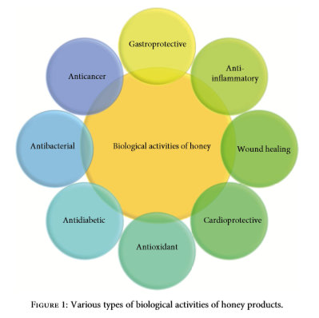Researchers from the University in Romania, established that honey is an antididiabetic agent, and therefore it can be consumed by people who suffer from diabetes. Some people are not aware of this because they associate honey with other sugars since it is the main cause of diabetes. It can help in control hyperglycaemic condition and preventing any metabolic disorder (Otilia Bobis, 2018). Honey can be applied towards other medical uses such as: skin infection, sore throat, diarrhoea, liver diseases and cancer including breast, liver and colorectal cancer (Visweswara Rao Pasupuleti, 2017). Figure 11 highlights the uses of honey in biological activates

Figure 11 (Visweswara Rao Pasupuleti, 2017).

2.4.2: Propolis

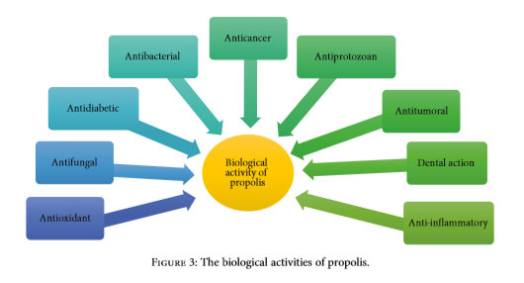Propolis (blue glue) (Figure 12) is typically found on the edges of the beehives. Honey bees gather propolis from trees and plants, mix it with beeswax and saliva, and use it to seal any cracks within the hive which is gathered from trees and plants that is mixed with beeswax and bee`s saliva (Annie Price, 2018). Propolis is also known for its medical uses; it is used as a cancer treatment such as breast cancer, Gastrointestinal disorder, Gynaecological cure, added to mouth wash and toothpaste to heal surgical wounds and to maintain a lower growth of bacteria, and it is also found in creams to aid in closing wounds (Visweswara Rao Pasupuleti, 2017). Figure 13 highlight the uses of Propolis in biological activities.

Figure 13 (Visweswara Rao Pasupuleti, 2017).

2.4.3: Royal Jelly

Royal jelly (Figure 14) is a white jelly lookalike material that is produced by the working bee to feed to the Queen bee while it is developing from a larva, therefore acting as its “superfood”. Royal jelly is used mainly to treat chronic health illnesses. It is made up of water, carbohydrates, protein, vitamins, minerals salts, liqids and royalactic protein. Royalactic protein is a very important substance that has many bioactive properties. It is used to treat Alzheimer`s disease, which is a disease that affects elderly people`s mental function. Researchers found that royal jelly can aid mental health and like other honey bee products, it can also be applied to wounds (Visweswara Rao Pasupuleti, 2017). Figure 15 shows the biological properties of Royal Jelly

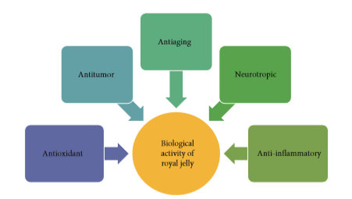

Figure 15 (Visweswara Rao Pasupuleti, 2017)

2.4.4: Bee Pollen

Bee pollen, like other honey bee products has medical properties (Figure 16). It is made up of water, protein, fats, carbohydrates, vitamins, antioxidants, minerals and antibiotics. Bee pollen is gathered by the foraging bee when collecting nectar and pollen from the plants, therefore pollen has different benefits depending from which flowers it comes from. It is beneficial to treat chronic diseases, lower high blood pressure, wounds healing, boosts immunity and improves liver function (Raman, 2018).

2.4.5: Beeswax

Beeswax (Figure 17) is a product that is not only used for medical purposes but also for decorative purposes, bath soap, waxed papers, inks, furniture and cosmetics. Beeswax is a material made by the worker bee to build their honey comb, constrict the cell of the egg and covering the cells when filled with honey. Honey bees need to consume around three to four and a half kilos of honey to produce four hundred and fifty grams of beeswax, therefore the beekeeper needs to be careful as to how much honey he takes from the hive, so that the bees do not starve since it`s like he is stealing their livestock. Beeswax can be removed from the honeycomb frame when the beekeeper extracts the honey. The honeycomb is then melted at sixty degree-celsius and can be utilized as needed (Britannica, 2018).

**2.5: Diseases and pests that affect the Honey Bees.**

Across the globe reports of Honey Bees colonies declining have been going on for many years. The main reasons behind this are diseases and pests such as; Varroa Mite, European and American Foulbrood, Chalkbrood, Nosema, amongst others. (Maria Spivak, 2016)

Beekeepers need to stay alert for such diseases and pests to keep their colony healthy, or else they risk their colony to collapse. A strong and healthy colony might resist such problems, but it still needs a helping hand from its beekeeper. The major problem however is that over time diseases will become resistant to any present chemicals, therefore constant monitoring is especially important to avoid this situation (Maria Spivak, 2016).

2.5.1: Colony Collapse Disorder

Colony Collapse Disorder (also known as CCD) is type of a disorder that causes a swift death to a honey bee colony. This is a nightmare for all beekeepers and harms the agricultural sector regarding pollination. Until now, no one has identified its exact origin, however researchers have determined certain issues such as; navigation system where adult bees forget their way back to the hive when out foraging nectar, other colonies stealing honey from another hive which is weaker or death and pest & diseases such as the viruses and varroa mite (Hood, 2018).

Colony Collapse Disorder can cause as well “colony stress” which harms the immune system of the bees and makes them more vulnerable to pest and diseases (Hood, 2018).

The first report of the CCD was in Pennsylvania, US in 2006 during winter season when the bees are more vulnerable because of the weather. Three years before the beekeepers had suffered the same effects, however be they assumed that was a temporary issue and decided to ignore it. In 2007, the disorder continued to spread, and that almost fifty to ninety percent of the hives in the US were suffering from the CCD. Later during the same period, more beekeepers from different continents including Europe such as Poland, Germany, Spain, Italy were reporting losses with the same symptoms (Hood, 2018).

Up to this day, there is not any cure against the disorder (Hood, 2018), so it is up to the beekeeper to monitor his hives frequently and if there are any signs of CCD he must report and seek advice at once.

2.5.2: The Varroa Mite

The Varroa Mite, also called the Varroa Destructor (Figure 18), is one of the biggest enemies that the honey bees and beekeepers have been battling for the past one hundred and fourteen years. It was first reported on the Island of Indonesia in Asia and seen in Europe at around 1977 in Germany (GmbH, n.d.).

So, what is this mite and what harm is it doing to the honey bees?

Varroa mite is a small parasite, the size of a needle head and reddish. For the beekeepers its presence is a big headache because they need to take more detailed inspections and treat any harmed bees with specific chemicals. They also need to use straps to kill the varroa. If no treatment is applied, all the colony will have less than two years to survive, at which stage it might be too expensive for the beekeeper to cure his bees. (Wilson-Rich, 2014).

In the hive, the Varroa usually approaches the Worker Bees and mainly the Drones since they are the ones which take prolonged period to develop in the pupal stage, at around twenty-four days (GmbH, n.d.). The varroa mite lays its their eggs with the bees` eggs (Figure 19). At this stage, the mite is already harming the bee, and causing it to be born deformed, losses its wings, bad stomach as well as it may affect the navigational system when going out of the hive to forage. (GmbH, n.d.).

Treatments have been developed throughout the years to terminate the varroa mite, such products are; Formic Acid, Amitraz, Coumaphos, Tau-fluvalinate, Thymol and Flumethrin (GmbH, n.d.).

Formic acid is in the form of a vapour that is ingested by the mite. Once inside, it dissolves its skeleton. This acid is the only way that kills the mite inside its sealed egg cell. When the beekeeper is applying formic acid to his beehive he needs to make sure that the brood is not old, and also the Queen bee. This is because it might harm or kill them, and it must be used after each honey harvest so it doesn`t contaminate the honey itself. The temperature is another important element that it must be applied when the temperature is about twenty-five-Degrees Celsius or else it will not be effective. (Vejsnæs, n.d.).

Flumethrin, Coumaphos, Tau-fluvalinate and Amitraz are in the form of a plastic strip that is hanged inside the hive. When the bees pass next to the strip, the chemicals on the strip are transferred onto the bees. This results in the mites attached to the bees to die due to the chemicals. Amitraz however does not kill the mites, but paralysis them. Continuous usage of these chemicals has caused mites to build resistance, in fact, according a study that was made in the USA, Coumaphos had to be removed from the market because varroa mite was starting to resist it (Maria Spivak, 2016).

Thymol comes in liquid form, as a gel or cellulose wafers. It is toxic to the mites and kills them at a fast rate. The best time to apply the thymol is when the temperature is between fifteen and twenty-five Degrees Celsius (GmbH, n.d.).

2.5.3: American Foulbrood

American Foulbrood (Figure 20) is on of the most destructive diseases to destroy a beehive colony. It can spread to other beehives that are as close as three to five miles away (Maria Spivak, 2016).

This disease is caused by *Paenibacillus larvae*, a type of bacterium that attacks young larvae and kills them in their cells after they are sealed. This causes the cell to become rancid, gooey and turn brown. Eventually it spreads throughout the brood and kills all the colony (Maria Spivak, 2016).

The only way to keep this disease from spreading to other colonies is by burning the infected hive. Therefore, to prevent the spread from happening, the beekeeper needs to conduct frequent inspections to identify any threats and replace old comb frames regularly while making sure not to mix frames within other beehives. Antibiotics are another option, however the most effective way is by burning the hive. (Maria Spivak, 2016).

2.5.4: European Foulbrood

European foulbrood (Figure 21) is another type of bacterium, called *Melissococcus pluton,* which unlike the American Foulbrood, the larvae is killed before the cells are sealed. This disease accelerates when the bees are stressed (Maria Spivak, 2016).

The beekeeper can identify the European Foulbrood when the cells turn yellow to brown and have a bad odour. One way to prevent this disease is to keep the bees well fed with sugar after harvesting honey, to avoid the bees from getting stressed (Maria Spivak, 2016).

2.5.4: Chalkbrood

Chalkbrood is a type of fungus, *Ascosphaera Apis*, that rarely kills a hive (Figure 22). Symptoms appear after a honey harvest when the bees are stressed. This disease is temporary, and often clears after honey harvest. Chalkbrood is identified when dead bees are found outside the hive or at the bottom of the hive board, and when they turn black or white inside their cells. This disease could be prevented by maintaining a strong hive, regular inspections, replacement of old frames and by exercising caution when buying products and other hives (Maria Spivak, 2016).

2.5.5: Nosema

Nosema is a disease that mostly effect the adult bees. It is a fungal disease that could be found in the bee`s guts and can easily spread throughout the beehive. This disease is effective during winter period, when the hive is full house because of the cold days. Nosema could be one of the reasons for an increase of winter losses during the past years. A young and strong colony is more resistible to the disease. Researchers are still trying to find a way on how to prevent the disease from contaminating the hive. (Maria Spivak, 2016)

2.5.6: Viruses

Bees can be affected by various types of viruses which can do harm in different levels. Such viruses are; “Israeli Acute Paralysis Virus”, “Black Queen cell virus”, “Deformed wing virus” (this virus effects both adult bees and new born, causing them to emerge without wings and therefore dying a couple of days later), “Acute Bee Paralysis Virus” and “Sacbrood Virus” (Maria Spivak, 2016).

Viruses spread easily when the hive is being attacked by the Varroa mite, since it could carry the virus from one bee to another. The best way to decrease the viruses in the hive is to eliminate the risk of varroa mites (Maria Spivak, 2016).

2.5.7: The Invasion of the Asian Hornet

Asian Hornet holds a huge threat to the honey bees, native wildlife, pollinators, agriculture and humans since their sting can be fatal. Asian Hornet forms part of the Vespidae wasp family (Figure 23) which is taking over the wasp community in many countries including, Malta. According to Dr Gavin Broad, a wasp expert in the Natural History Museum in UK quoted that, *“the issue is that they eat honey bees, they are specialised honey bee predators and beekeepers are concerned”* (Osterloff, 2018)*.*

The Asian Hornet originates in Asia, but it was introduced to Europe by accident, some may say by a cargo (Osterloff, 2018). The Hornet was first spotted in Malta in 2003 (Demarco, 2017), however by 2014 their population has increased causing deaths to many honey bees and attacking people. In 2004 it was seen in France (Ollerton, 2015). During an interview by a local newspaper with Mario Sant from the Malta Beekeepers Association shared his concern on the threat of the hornet and said, *“I have heard from many beekeepers that bees are scared to merely leave their hives and get on with their routine of pollination because of the presence of hornets”.* This is causing the bees to starve to death. Sant explained how the hornet hunt bees, “*they approach the bees apiary as a pair of hornets, called `scouts`, and then they go back to their hive to tell the colony the direction towards the apiary then you see them coming as a whole, to eat the bees and hive”* (Demarco, 2017)*.*

Unlike many insects the hornet does not have any predators, Sant stated that, *“we know that it does not have any enemies, so what is happening is the species are reproducing at a quicker frequency”* (Demarco, 2017)*.* On the author`s survey, beekeepers put forward their concern on the Hornet which is making them worried that they can lose their bees.

Other countries such as the United Kingdom, have reported sights of the hornet in recent years. Their government is working against the hornet invasion by exterminating their hives, which till now, researchers have not determined any other options. This situation needs to be taken care of as fast as possible before it continues spreading throughout the country. In France, the hornet has caused substantial harm, which has resulted in loss of up five to eighty percent of the beehives (Knapton, 2018).

To locate a hornet hive is not easy since they build their hives in hidden places, therefore researchers have had to come up with solutions. Dr Peter Kennedy from the University of Exeter has led a project on the tracking of the hornet. He said that,*” our new method of tracking offers a really importance new tool to tackle the spread of the invader, providing an efficient means of finding hornets nest in urban and wooded environment”* (Knapton, 2018)*.* The Deputy Director for Plant and Bee Health in the Department for Environment, Food and Rural Affairs (DEFRA), Nicole Spence also emphasised on the importance of this research and said, *“this work is key for ensuring a rapid response to Asian Hornet when sightings are confirmed and in future bee inspectors will be able to use this technique to take swift action”* (Knapton, 2018)*.*

The research made by Dr Kennedy and his colleagues is based on a tracker which was produced by the RECCO radar system. This system is also used to track other animals such as birds, mammals and fish. The process starts when the researchers plot various traps on the last location the hornet were seen. Once a hornet has been trapped, they apply the tracker on the hornet and follow it to the hive. The advantages of this systems are that it is fast and only few handlings are needed. This which will reduce time to search for the hornet and avoids any spread of the invasion in the long run (Peter J. Kennedy, 2018). This system can be very efficient to countries which have recently reported the hornet such as the United Kingdom and Malta (as we are a very small country).

**2.6: Bees and Pesticides**

A honey bee`s main source for honey production are pollen and nectar which are obtained during foraging while pollination take place. Honey bees forage on varies flowers of crops and plants from farms to public gardens and whose flowers may have traces of certain pesticides. For agricultural purposes, pesticides are used for the protection of the crops against particular pests, however they have a negative impact on the bees as these could affect their nervous system.

In 2013, three types of “Neonicotinoids” pesticides were put forward for suspension by the European Union (Stokstad, 2018). This was determined after an intense research by the European Food Safety Authority and they concluded that these pesticides are a threat to the health of the honey bees (Stokstad, 2018).

When the three pesticides, “clothianidin”, “thiamethoxam” and “imidacloprid” (Stokstad, 2018)are applied to the seeds, these stay on it until the crop is developed and flowers, yet it may extend to the pollen and nectar. Therefore, last year the European Commission after a vote was taken, the ban of these pesticides was established throughout all European Countries. The only exception where these pesticides can be used is inside greenhouses where bees are less expected. However, this pesticides ban did not go down well with the agricultural business, especially farmers such as the Sugar Beet Growers in the United Kingdom (Stokstad, 2018).

Michael Sly, the Sugar Board Chairman of the National Farmers Union (NFU) UK, explained that this ban can impact the sugar beet yield since neonicotinoids are the only sustainable use to protect the crops from pests (Union, 2018). The Managing Director of British Sugar, Paul Kenwand quoted that, *“we are actually aware that bees play a crucial role in food production in UK, however as sugar but is a non-beet attractive crop this decision would negatively impact farm biodiversity and we lose decades of advances in sustainability and yield improvement*” (Centre, 2018).

An alternative to the three banned neonicotinoids is being researched and until now, the safest product is *Flupyradifurone* (Julius-Maximilians, 2018)which is a bee safe chemical and can be applied to many crops from vegetables to fruit.

Last year, France stepped forward to be the first European country to ban these three pesticides including another two, “thiacloprid” and “acetamiprid”. France has also banned these pesticides from being used in the greenhouse as well (Samuel, 2018).

The Maltese NGO, Friends of the Earth has encouraged the Maltese government to support the ban on pesticides. Maltese beekeepers stated in a survey conducted by author, that there is not enough pressure against the use of pesticides.

**2.7: The impact of Honey Bees in Agriculture and the Environment.**

For thousands of years, bees have been contributing to our food security, sustainable & ecosystem of crops and the biodiversity of plans and trees and their pollination acts as a helping hand to farmers (Nations-FAO, 2018). The decline of bees and pollinators is a global threat to the agricultural industry and the environment. This decline could also cause fruits and vegetables to lose their natural vitamins and nutritional benefits and therefore causing an unstable daily diet in our health. It is estimated that more than five hundred billion US dollars is earned from crops per year thanks to insect and animal pollination (Nations-FAO, 2018).

Farmers can contribute to saving the bees and pollinators. They can do this by maintaining a well-managed farming system. For example, in the forest of Kakamega in Kenya, farmers leave their fields uncultivated, so other herbs and shrubs can grow, and bees can forage on. Apart from this, they do not use us any form of pesticides on their fields (Nations-FAO, 2018). In California, farmers who cultivate almonds also benefit from bee pollination. These farmers have around 2.9 million beehives, which have left a revenue of more than three hundred million dollars in the past years, in the US commercial beekeeping industry (Champetier, 2018).

Bees in a forest environment help in various ways the ecosystem of the forest; by helping in the preservation of any plant species, development in biodiversity and by keeping a balanced sustainable environment. Another environment which is has seen an increase in beekeepers, is in urban areas. Beekeepers are, keeping their hives on top of city buildings. Urban beekeeping contributes to the city`s environment since bees pollinate public gardens and parks, therefore increasing the biodiversity in cities (Nations-FAO, 2018).

**2.8: EU, Commonwealth, Local Government and NGO`s contribution in Apiculture.**

2.8.1: Commonwealth members concern of bees and pollinators.

During the 2015 CHOGM summit held in Malta, leaders from the Commonwealth with the Civil Society Organisations, put forward the problems of bees and pollinators from each member state on their main affair to resolve and discuss further ways to decrease the threats that the bees are facing (Friends of the Earth, 2015).

They went through various subjects such as; food security, the benefits of bees to the biodiversity, social and cultural values, the effect on the economy, crop planting of certain plants that are beneficial of pollination and case studies in Commonwealth member countries (Friends of the Earth, 2015). Attending this meeting were experts that work in the agricultural sector and NGO’s, including Friends of the Earth (Council, 2015). Mr. Paul de Zylva from Friends of the Earth suggested that *“We have to be the generation that saves the bee”,* (Council, 2015) he highlighted the work of the UK government, who applied strategy to regenerate their surrounding environment by planting bee friendly flowers (Council, 2015).

At the end of the CHOGM, aims were set for each member country to decrease the threats of extinction of their native bee in their country. Actions that were taken include, launching national bee action plan that includes the strategy needed to preserve the native bee, involving the society, business and researchers, engaging young people to take action on their future by educating them, developing polices that help solve the managing of crop, urban pollination and up-to-date and ongoing research to keep all members on track (Friends of the Earth, 2015).

2.8.2: EU Bee Partnership

According to the European Food Safety Authority (EFSA), the main causes for bee decline are; the high demands of the agriculture industry, pesticides that are being used in fields and public gardens, Varroa Mites, Asian hornet, The Small Hive Beetle and environmental and climate change (EFSA, 2018).

In 2017, the European Parliament came to an agreement to set up anEU Bee Partnership Discussion Group aiming for *“a platform run by stakeholders for the benefits of society to ensure that bees in the EU can thrive”* (EFSA, 2018)*.*

The Discussion Group was made up of professional in beekeepers, scientists, farmers and veterinaries. The main goals in the EU Bee Partnership were to enhance the collection of data, communication and sharing research on the health of bees between European Union members and associations including beekeepers, farmers and scientists (EFSA, 2018).

All the research that is being done does not only benefit the apiculture industry, but also the agricultural industry, ecosystem and biodiversity.

Collaborating in this partnership were different entities including;

* *“European Professional Beekeeper Association”* which supports all beekeepers in the European Union both in professional and commercial beekeeping practices.

*“International Federation of Beekeeping Association”* also known as “Apimondia”which highlights any scientific research in the apiculture industry (EFSA, 2018)

* *“Association of Veterinary Consultants”* supporting ongoing research on the health of bees and produce cures against diseases and pesticides (EFSA, 2018).
* *“European Crop Protection Association”,* an association that puts forward awareness and campaigns on the good uses of pesticides in a suitable way and research *on* “colony larvae” and “honey bee behaviour” (EFSA, 2018).
* *“International Confederation of European Beet Growers”* is a group that collaborate both agriculture and apiculture which in this case is beet growing and it provides data on good agriculture management (EFSA, 2018).
* *“European Network of Scientist for Social and Environment Responsibility”,* where scientists are providing high quality research on apiculture and agriculture (EFSA, 2018).
* *“BeeLife European Beekeeping Coordination”*, researching on how to protect the honey bees better with regarding to GMOs and pesticides (EFSA, 2018).
* *“Pesticide Action Network-Europe”,* a network of scientists working to minimise the harm of pesticides on bees (EFSA, 2018)
* *“COLOSS-Prevention of honey bee colony losses”,* an NGO aiming to expand the welfare of the honey bee especially the Apis Mellifera (Western Honey Bee)

(EFSA, 2018)

The “EU Bee Partnership” aims for all these although it is not simple because entities to work and gather and share any useful information, confidentiality, funding and scarcity of motivation amongst the associations (EFSA, 2018).

2.8.3 Local NGO`s support for Honey Bees.

In the past years some of the local NGO`s have been doing their part towards awareness of the health and importance of honey bees by launching campaigns. A particular NGO, Friends of the Earth Malta have been organizing seminars and activities for a long time, including the Bee Cause campaigns and the Bee Aware 6-week seminar which also the author attended to gain some knowledge (Figure 24). The seminar is based on various workshops, theoretical sessions and beehive visits by university professors and professional beekeepers. The aim of this seminar was to, share knowledge and giving the public an opportunity to start the beekeeping journey. The NGO launched other activities such as “Bee Sustainable- School of Sustainability Active Camp” and Bee Hotels (Friends of the Earth Malta, n.d.).

The Malta Beekeepers Association is another local NGO that oversees the honey production industry of Malta. It was founded in 1983 by Arnold Grima and last year, after a long period of negotiation, the association was officially announced as an NGO. It is made up of around one hundred and thirty members, which consists of local beekeepers and others that are interested on the safeguard of the native honey bee. The author last year has joined the association to gain more knowledge about the local honey industry.

The objectives of the association are vast, but with one aim, to protect the local honey bee and the beekeepers, to enhance the protection and welfare of the beekeeper, to watch over the honey production and other substitutes, raise public awareness on the importance of the native honey bee, inform the local authority and government with the difficulties that they are facing and present any advice to tackle them and to safeguard and encourage beekeepers to breed local native honey bee rather than the foreign honey bee (Association, 2019).

In the last year of being an NGO, the association applied for EU funds that could help them protect the local honey bee such projects are; SmartBees and Smart Hive Smart hive is a technology monitoring system attached to the hive. On the 7th till 10th May the association is collaborating with the International association, Apimondia to organize the International Symposium on Bee Products, a week of workshops on the importance and benefits of honey bee`s products and more (Spiteri, 2019).

2.8.4: SmartBees Project

The Maltese Honey Bee, Apis Mellifera Ruttneri, is a unique species that is only found in the Maltese Islands. The Maltese Honey bee has adapted to the Maltese climate which is mainly harsh sunny climate and can be resistible to some pest including in some cases, the Asian Hornet.

In recent years local beekeepers started buying more foreign queen bees to start a fresh hive, and a Sicilian beekeeper exported hundreds of hives from Sicily. This has caused the foreign bee to take over the majority of the honey bees in Malta. Therefore in 2016, Maltese beekeepers applied for a project, European Union SmartBees, which is a project that could save the native bee from becoming extinct. The project aims to restock bees within their characteristics in particular European Union countries native bees (Dr Aleksandar Uzunov, 2018 ).

Dr Ralph Blucher a Bee Breeding Expert who is part of the project, pointed out that the Maltese Honey Bee is endangered because of the foreign bees and parasites, During an interview by a local newspaper he stated that, *“Malta is a very interesting spot, because you have your own bee race, and it is heavily endangered because they keep on bringing bees from other races and they mix up the race”* (Muscat, 2016). Other European countries who are contributing with SmartBees project are the major countries such as United Kingdom, Portugal, Germany, France.

The project in Malta is being done by the local beekeepers, the University of Malta and the Bee Institute Kirchhain from Germany. The latter working on ongoing DNA testing of the native adult honey bee which was found in the mist of the foreign bee colonies by conducting an *“Mitochondirial DNA and Morphometric analyses”* (Dr Aleksandar Uzunov, 2018 ). Through these testing , scientists extract the characteristics of the native bee and enhance their attitude, performance and honey production so that eventually, local beekeepers can ignore the foreign bees and start breeding native bees that are healthy and strong.

Since Malta is a small island, the foreign bee has invaded almost all of it. Therefore, the testing and mating of queen bees and drone bees is being done mainly in Comino, where there is more control on the breeding of native bees. This was suggested by beekeepers that participated in the author`s survey.

**2.8: Honey fraud**

A major problem that not only affects honey bees but also beekeepers, business and economy is Honey Fraud. According to the European Union and the U.S Pharmacopeia`s food fraud data-base, honey is the most food product that is fraudulent (Apimondia, 2019). Honey fraud is an act of crime to gain more money by selling fake honey or mislabelled at the same price as pure honey. The EU Coordinated Control Plan published their results on the purity of the European honey market, and it indicated that around fourteen percent of the tested honey was not pure (Commission, 2018).

There are many ways how one can fraud honey, such as; diluting other syrups to the honey to obtain more yield, for instance cane syrup, corn syrup and beet syrup, feeding the bees artificial products during foraging, harvesting immature, unripe and early honey which makes the honey bees produce more honey (Apimondia, 2019) and the most common, mislabelling on the packaging the origin of the honey. This is a big problem in Malta and has been emphasised by many local beekeepers that contributed in the author`s survey.

Apimondia, an international association that aims to destroy fraudulent honey, stated that the situation is one of the major problems that beekeepers are facing world-wide, and as long as this problem is not solved, the proper beekeepers` reputation is on the line of extinction because business wise it is effecting them badly (Apimondia, 2019). For example, small countries such as Malta have a small honey production compared to other EU countries, therefore the industry can decline easily.

In 2016, honey production in America recorded a thirty-five percent decrease in 20 years. Because of this decrease many honey producers were reported of diluting honey with sugar syrup, rice syrup and corn syrup which is cheaper (Economist, 2018).

For many years, the local honey industry has faced the fake honey issue. In 2012 a local food manufacturer was accused of selling fake Gozitan honey but because the Agriculture department did not proceed legal actions according to the law, the producer was cleared from this accusation and never investigated again, and it is therefore possible that he is still selling this product (Agius, 2016). In 2018, a member of the Malta Beekeepers Association was accused of importing foreign honey and selling it as local honey. He was discharged from the association (Spiteri, 2019).

To control and try to decrease this situation, the local authority has introduced a new scheme for the quality of honey and other products. A spokesperson for the Parliamentary Secretary for Agriculture in 2018 stated that *“we launched the “Prodott ta` Kwalita” or Product of Quality Scheme, whereby a number of new standards have been and are still being formulated, including for honey”* (Clarke, 2018). The main specifications are based on the taste and quality of the honey, environment conditions, price and more.

Misleading honey is a big problem therefore traceability is one of the ways to control the quality of the local honey. During an interview on a local news website, Professor Attard Said stated the importance of certain details on labels which in this case on filtration, he stated, *“it should be written because if honey is filtered, then all the pollen and therefore the origins of the flower, and by proxy the locations are untraceable. If filtered honey is imported from China, then it is difficult to trace it back”* (Chetcuti, 2015)*.*

The European MEP`s are calling for a pressure on honey testing for its purity because it is harming the European beekeeping industry (Parliament, 2018). However according to Dr, Stephan Schwarzinger from the University of Bayreuth, there is no way until now that authentifies honey for its purity. He compared honey testing to sport doping, *“people who are testing for doping never know if there is a new drug on the market. When you consider the variety of syrup available, there is a single technology that cover them all”* (Tamma, 2018).

Imported Chinese honey to the European market is said to be one of the major causes of fraudulent honey because they practice honey by early harvesting. A few years ago, Chinese honey was banned from EU, but as the Roman MEP explained, honey production in Europe is always on high demands, therefore honey from third world countries is needed to keep up with the demands, despite that some may be mixed with syrup. Therefore, the European Commission needs to come up with control measures to decrease any chances of counterfeits (Tamma, 2018)

**Chapter 3: Methodology**

In this chapter, the author is going to explain how and what tools were used in order for him to conduct his research. He aims to discuss on how the material has been collected, the approach taken to gather the data analysis, calculations and measurements and limitations that the author encountered during his research.

In order to decide on the type of methods to be used in this research, the author used information gathered during the previous chapter, along with that from the Malta Beekeepers Association and from a short course on beekeeping help to find a good way to do so.

**3.1: Research design**.

The type of research methods that have been used in this study to identify and answer the research question are both qualitative and quantitative methods. The qualitative method will aid the author to understand the participants perspective, objectives, opinions and behaviour towards the study, while on the other hand, the quantitative method combines the data into statistics, groups and numerical information which will be displayed into pie charts and graphs. The author opts to conduct a mix surveys and in-dept interviews.

**3.2: Research question.**

The objective of the research is to locate the problems that the local beekeepers are having and with the help of the results the author hopes that in the future it will be used to improve the apiculture industry in Malta,

**3.3: Interviews and mix surveys**.

Since the author is using both qualitative and quantitative approaches in order to gather information, he opts to base his research by using mix surveys questionnaires and interviews. Mix survey is used to ask multiple questions from fill-in, yes or no and long or short answered questions. The author chose specific individuals to collect data from; the local beekeepers so that he can have their perspective. The in-dept interviews were conducted with one of the council members of the Malta Beekeepers Association and with a SmartBees Malta project member. Bought were presented with a Consent Form for confidentiality. The survey was sent to the beekeepers by mail and on social media with the help of the Malta Beekeepers Association.

**3.4: Sample selection.**

According to the apiculture programme made in 2016, Malta has around two hundred and eight registered beekeepers (Development, 2016). The author determined the sample size on thirty percent of the beekeepers which amounts up to sixty-one beekeepers.

**3.5: Question design**

The survey is made up of twenty-seven questions. The first four are demographic questions to separate them into specific groups based on their gender, age, education level and employment status. The next seven questions ask about their background information and their knowledge and experience, locations of hives and the amounts of owned hives. The next questions are specifically on the problems that beekeepers are finding with some yes or no and fill-in questions, and the last two questions being about the beekeepers` opinion to elevate the apiculture industry and save the Maltese honey bees and what are the other problems that they are facing except the ones that the author highlighted. The data collected in the survey is presented in the next chapter with textual analysis, graphs and pie charts. Before the questions were sent to the beekeepers, the author conducted a draft survey to small group of beekeepers so that he could adjust the final version.

The interviews conducted with the association is based on their aims, projects, support to the beekeepers, future plans and government support. The other interview which was conducted with the SmartBees project member, the questions were based on the aims and objectives of the project, how does it function, latest results of their research, future projects and support from local government and EU funds .

**3.6: Limitations**.

Throughout the research the author encountered various limitations. In the literature review the author found it difficult to find specific information such as documents, statistics and dissertations that are within the same research of other countries and Malta.

When the author come to search about the apiculture industry in Malta mainly about the difficulties, he found little information, mainly from local newspaper websites and leaflets` of local NGOs. The author also visited the library of the University of Malta to search on other students` dissertation about the Maltese Honey Bee but did not find a lot of information. Also books on Maltese beekeeping the author could not find.

During the collection of data, other limitations were encountered such as; beekeepers found it difficult to answer the questions because they were not able to read so the author has to fill the questionnaire with them and other do not have any access to a computer device, confidentiality since honey production is a business some beekeepers did not share information and long waiting for the beekeepers to answer emails and questionnaires. In the survey, the author generalised most of the questions, for example, the amount of beehives owned by the beekeepers which they had to choose from a multiple range, therefore the result did not specify the exact amount, consequently it limited the author to obtain a better result.

**3.7: Conclusion.**

To conclude this chapter, the author hopes that the methods used to collect data and interpretation of the data will help the author to identify and answer the research question.

**Chapter 4-****Analysis and discussion of the results**

**Transcription of data obtained from questionnaires and interviews .**

The questionnaire’s and interview`s analysis is based on the study which focused on the problems that the local beekeepers and honey bees are facing, and other general information about the beekeeper and honey production.

The study was conducted through a survey that was sent electronically to the beekeepers within the Malta Beekeepers Association and shared on Social Media group of Maltese beekeepers who may not be part of any association.

The population size of the survey was determined to be thirty percent of the Maltese registered beekeepers which according to the study carried out by the Maltese authority under the name of “*Notification of Apiculture Programme 2016”* (figure 25)which was regulated by the European Union Agriculture and Rural Development ISAMM CM (Development, 2016) summed up the beekeepers` population to be around two hundred and eight beekeepers which may have changed during the past two years. This made the target about sixty-two local beekeepers. At the end fifty-nine beekeepers responded to the survey, but unfortunately not all the participants responded all the twenty-seven questions.

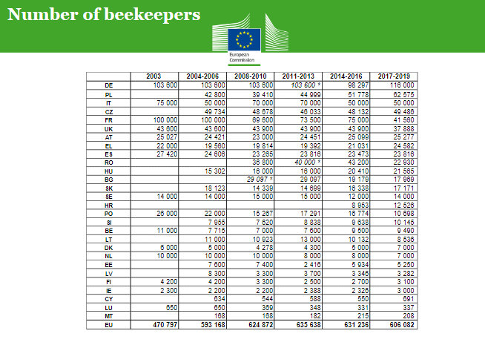

Figure 25 (Development, 2016)

General information on the beekeepers.

The age gap of the participants is vast, the youngest participant is twenty years old while the oldest participant is eighty-one years old. Most of the participants are over 40 (Figure 26). 94% of the beekeepers are males and 5% are females (Figure 27). The participants are mostly full-times (63%) and only 1% are part-timers, while 9 % are elf-employed, 23% of the beekeepers who answered the survey are retired (Figure 28). The education level of the beekeepers is diverse, with the majority having a Diploma (32%), 17% having an A-level, and 18% a Masters certificate. However, 2% have no qualification, 32% have Secondary school certificate and 10% have o-level only (Figure 29), this could be because most beekeepers are either retired or farmers who have more practical experience rather than educational knowledge.

Figure 26

Figure 27

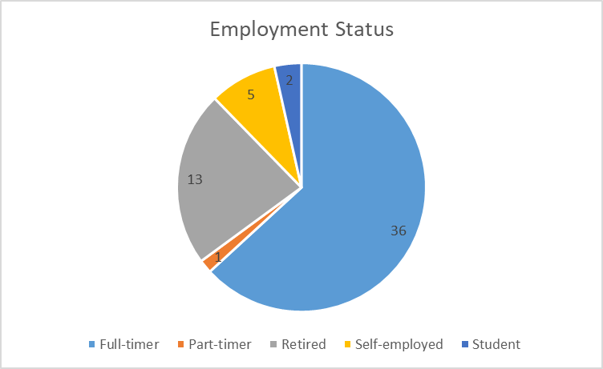

Figure 28

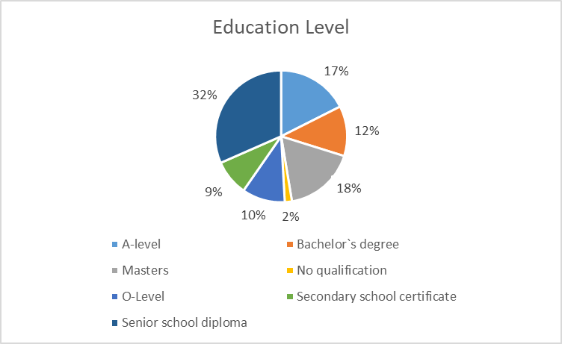

Figure 29

The level of beekeeping, the reason of practicing beekeeping and full-time or part-time beekeepers

The level of beekeeping of the participants was determined as, Hobby (64%), Beginners (16%) and Professional (20%) (Figure 30). The majority practice beekeeping for personal use (65%), others for business use (14%) and 21% practice beekeeping for pollination benefits in their farm (Figure 31). 88% of the participants are part-timers’ beekeepers while 12% are full-timers beekeepers which the majority are retired (Figure 32).

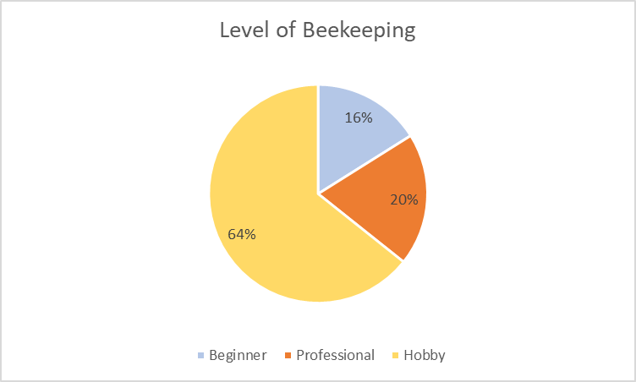

Figure 30

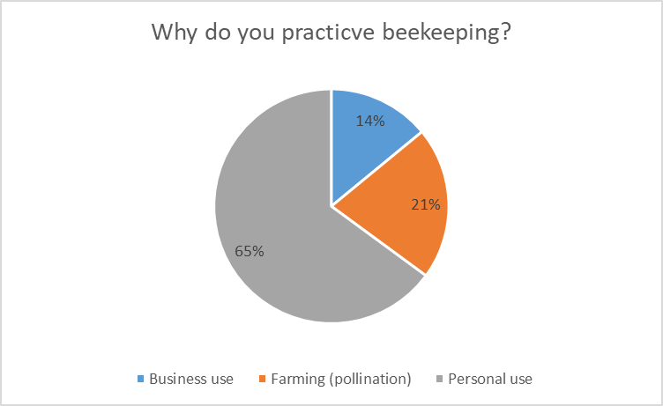

Figure 31

Figure 32

Beekeepers experience and generation inherited profession.

The experience of the beekeepers varies with the majority being between six months to fifteen years, while only 7% of the beekeepers have more than thirty years of experience (figure 33). 30% have inherited the beekeeping profession by their previous generations (figure 34), therefore they obtained their knowledge from other family members.

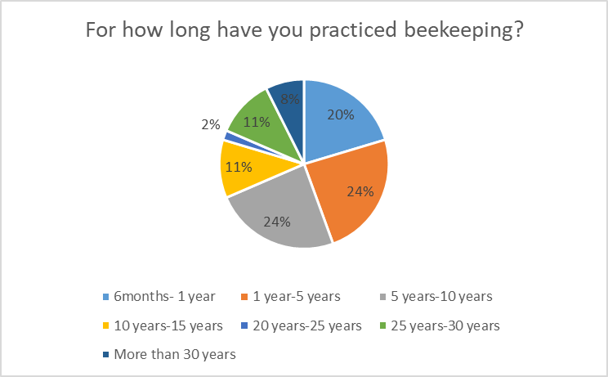

Figure 33

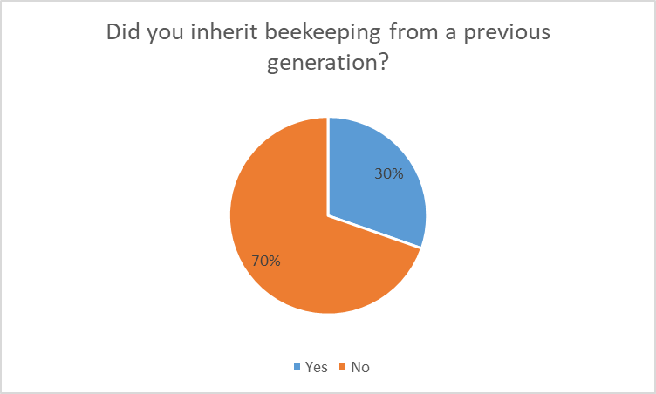

Figure 34

Beehives owned by beekeepers and their location across the Maltese islands.

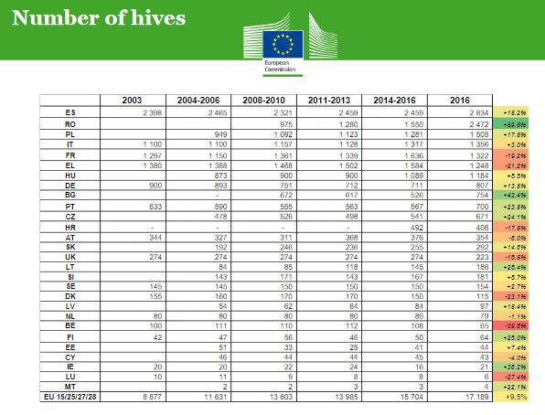According to 2016 EU statistics in Malta there was about four thousand beehive colonies (Figure 35), however this might have altered over the past few years. Amongst the fifty-nine beekeepers, the majority own between one to ten hives, and three beekeepers have over one hundred hives which are used for the production of honey and other substances for business and farming (figure 36).

Figure 35 (Development, 2016)

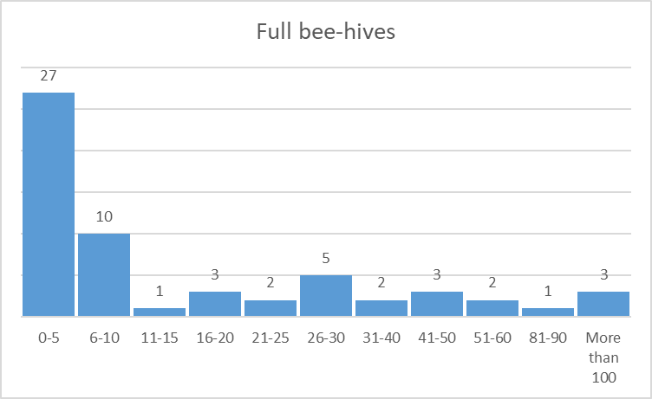

Figure 36

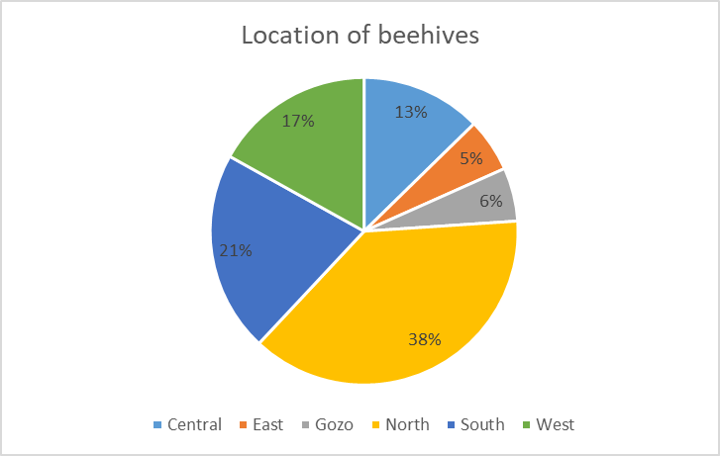Since the northern side of the Maltese islands has more floral fields such as Wild Thyme during summer, beekeepers prefer to place their hives in this area. 38% of the beekeepers place their hives in the northern side, 21% in the south, 17% in the west, 5% in the east, 13% in the central and 6% in the island of Gozo (figure 37). The majority of beekeepers that own more than fifty hives have them across all areas of Malta.

Figure 37

Beehive colony loss and their reasons.

In recent years, Maltese beekeepers have suffered from colony losses for many reasons. 74% of the beekeepers who took the survey have lost colonies (figure 38), some from one to ten hives others about thirty and even one beekeeper lost eighty-three colonies in the past years.

The participants highlighted various reasons as to why they have lost their colonies, climate change is the biggest problem that they are facing according to 84% (Figure 39), which could be possible since in the last five years Malta has had harsh warm and windy weather, therefore causing dry and less foraging areas. Diseases, pests and pesticides are other reasons for colony loss, including Varroa, Asian Hornet and Bee-eaters (also known as “Qerd in-Naħal”).

All of these losses unfortunately caused a decrease in honey yielding as some beekeepers did not harvest, the extract could cause the bees to starve. In order to survive, the honey bees need nectar and pollen to produce honey to feed on. If there are no flowers to forage on, the solution is to give sugar substitutes, but in a controlled measure because some may use this method to increase honey yielding for business, which would be an act of fraud. 85.7% of the beekeepers gave sugars to their bees in order to survive the harsh weather conditions (Figure 40).

Vandalism is another cause for beehive losses, 21% (Figure 41) of the beekeepers have had their beehives vandalised these were due to robbery (50%), poisoning by pesticides(30%), one beekeeper was vandalised by a person who sprayed pesticide directly into the hive, fire (10%) and construction near the area (10%) (Figure 42). Apart from the beekeepers that conducted the survey, in 2018 honey bees` vandalization was reported in Comino (Cilia, 2018). Thousands of bees were killed by “venomous traps”(Figure 43). Arnold Sciberras as Pest Controller and Biologist in a local website blog explained what might have happened, *“ there could be the possibility that someone is trying to control some pest species in an irresponsible way, trying to trap German wasps and hornets, but it is of my opinion that the culprit is killing the endemic Maltese bee on purpose”,* he continued “*it could be either because the bees are attracted to the sugary rubbish such as ice cream, or because they are an insect that is going around and being nuisance to tourists and customers”* (Cilia, 2018). In light of this situation, during an interview with one of the council members of the Malta Beekeepers Association, he said that the association is trying to do their best to safeguard the Maltese honey bee and is suggesting to the authority to make the Honey bee as a protected insect by law to avoid 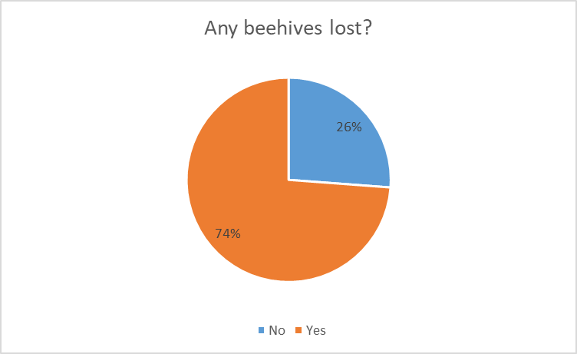vandalism and any sort of harm. However, until know nothing has happened.

Figure 38

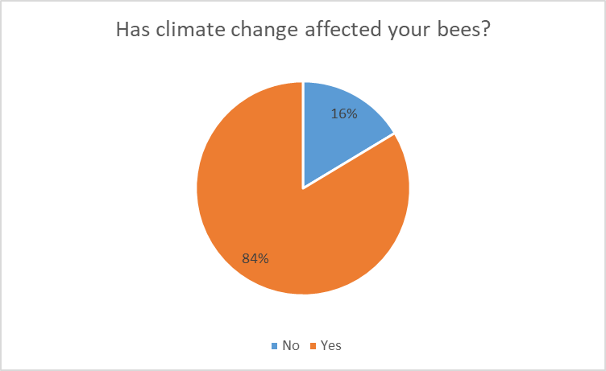

Figure 39

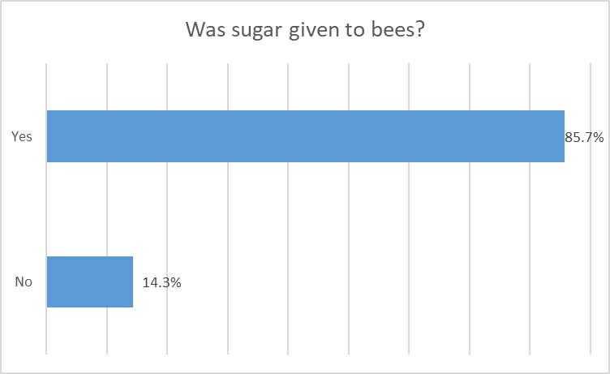

Figure 40

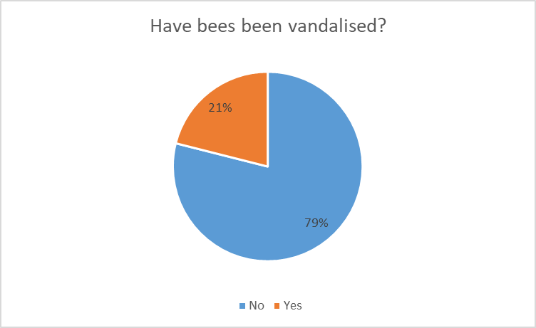

Figure 41

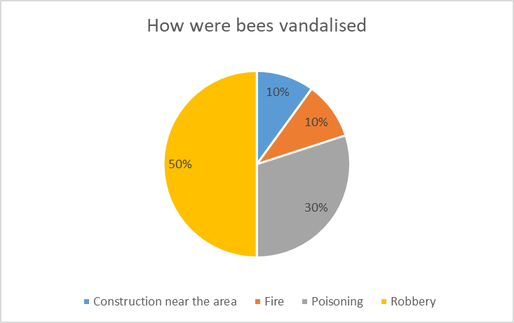

Figure 42

Disease and pest

As emphasised in the literature review by the author, diseases and pests are causing a decline of honey bees, not just in Malta but also world-wide. The participants were asked if in the last years their bees were infected or attacked by any diseases or pests through a list, and some even included other pests.

The majority of the beekeepers stated that Varroa Mite (47%), a small pest that is capable to destroy the whole colony has infected their hive. 5% were attacked by Nosema and Deformed wing virus, 4% Chalkbrood, 3% Acute bee paralysis virus, 2% European foulbrood and 1% Black queen cell virus. Two pests that were added by the beekeepers, the Wax moths (31%) and the Small hive beetle (1%)(figure 44).

Wax moths are a type of pest that eats beeswax such as “unprocessed wax”, “remains of larval honey bees”, “honey bee cocoon silk”, pollen and “enclosed honey bee faeces” on the brood cells (bee egg cells) (BeeAware, n.d.) (Figure 45). The moth might be active as soon as another disease is infesting the hive to take advantage from the situation. The moths are also highly motivated in warm countries such as Malta, since summer is normally a harsh warm season. To locate the larvae of the moths in the hive is not an easy task, as they lay their eggs in dark spots were the bees might not reach and on uncapped bee egg cells (BeeAware, n.d.). This pest could be prevented by maintaining a strong bee colony, a Queen bee that is active and healthy and frequent monitoring for any signs of the moth. A healthy and strong colony can protect themselves from the moth (BeeAware, n.d.).

The Small Hive Beetle (Figure 46) is a small insect that can live inside the beehive and is not easily identified. It can lay its eggs in dark spots. It is similar to the Wax moth, it eats beeswax and larvae, but also eats pollen and honey. When the beetle is consuming honey it will affect it, making it fermented and produce an unpleasant odour (Maria Spivak, 2016). To prevent its population from increasing the beekeeper can place a queen excluder in the middle of the hive(figure 47). The queen excluder (like a grill) will prevent the Queen bee from going to the top part, therefore there will be no eggs instead only honey stored cells which would leave the beetles in the bottom part, since the beetle prefers staying next to the egg cells (BeeAware, n.d.) . When the beekeeper is extracting the honey, he needs to double check that there are no traces of the small hive beetle within the honey comb because it could contaminate the extraction area (Maria Spivak, 2016). During the interview with the Malta Beekeepers Association one of the council members said that when there is a sign of the small hive beetle the beekeeper needs to report it because it could be a disaster to many Maltese honey bee colonies. However, it seems that they were not notified by the beekeeper in the survey, even though he stated that his beehive was affected. It may be because the beekeeper does not have enough experience or knowledge on what to do it this situation.

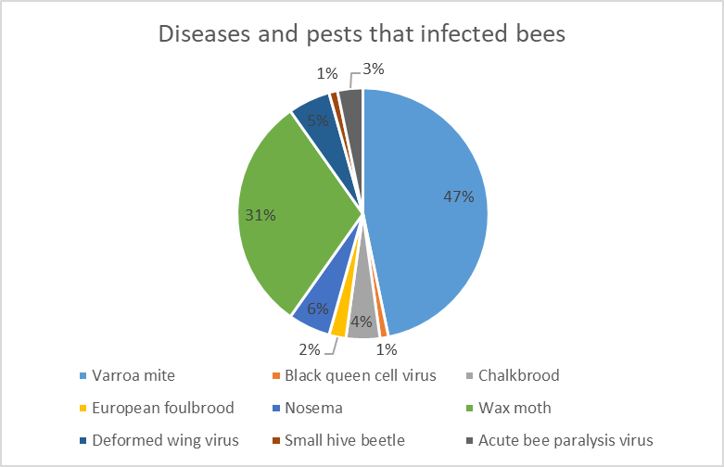

Figure 44

Since the varroa mite is one of the most effective pests that is causing harm to the bees in Malta, the participates were asked on what type of treatment and products they used to cure their hives, including remedies such as formic acid, amitraz, tau-fluvalinate, coumaphos and flumethrin. The majority of the beekeepers use strips to threat their bees such as Flumethrin (8). Figure 48 shows the type of products they use. Some products are very expensive, therefore some beekeepers may not afford to treat their hive.

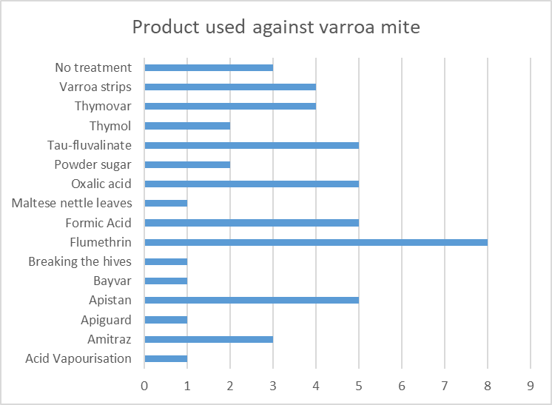

Figure 48

Maltese honey bees or foreign honey bees

Since 2014, when a foreign beekeeper started to import beehives to Malta and other beekeepers imported foreign queen cells, foreign honey bees started slowly taking over the majority of the bee colonies in Malta (Diacono, 2015). The Maltese honey bee is a small dark bee (Figure 49) which can be identified within a foreign colony because these are yellower and slightly bigger(Figure 4). The participants were asked if they have Maltese Honey bee, Foreign Honey bee or both (Figure 50). 66% of the beekeepers said that they have Maltese Honey bees, 30% have foreign honey bees and 4 % have a mix of both which some said that this could be because since Malta is small island it is easy to find a trace of foreign bees within the Maltese colony.

Figure 50

To promote more the Maltese honey bee, a group of local beekeepers applied for the SmartBees project, as said in previous chapter. The SmartBees is an EU project which in this case is used to reproduce the amount of Maltese native honey bees by solidifying its genetics and characterises such as getting less effected by diseases, adopting with the Maltese climate and producing more honey. In the past two years the results have been a success. However, the beekeepers have a financial disadvantage. In an interview with one of the beekeepers of the SmartBees project, he explained their situation, that they do not find direct help with any funds because the latest applications are not eligible for the Maltese beekeepers since these are based on the amount of land and hectares that the beekeeper owns, which in Malta is not applicable since fields are small. This is because the EU funds are based their measures on foreign countries, therefore ended up with the Maltese beekeepers using their own money for applications and equipment with the edition of those that were provided by the SmartBees EU. The Malta Beekeepers Association are also doing their part on promoting the Maltese Honey bee by proposing ideas to the authority including changing the context of the funds to make them eligible for Malta and awareness to the general public .

Beekeeping knowledge and awareness

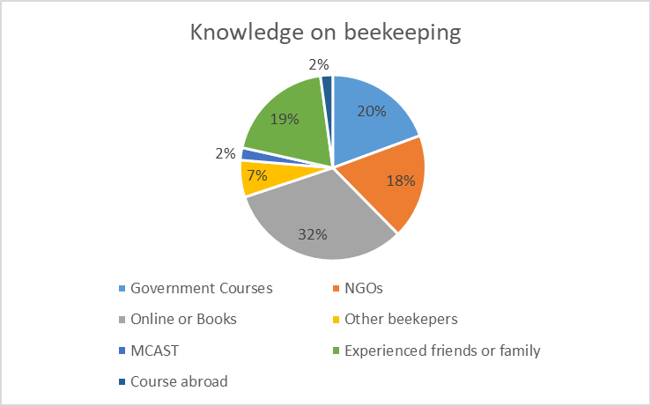To practice good beekeeping requires knowledge on how things run, which is very important. Local NGOs such as the Friends of the Earth and the Malta Beekeepers Association are trying their best to give information and advice beekeepers and beginners. The participants were asked from where they gained their knowledge (Figure 51). The majority of the beekeepers used books and the internet as their source(32%), but it could be that the information that they are getting is about foreign beekeeping and not local as there are not a lot of online sources and limited amount of books about the beekeeping in Malta. 20% of the beekeepers attended government courses which could be given by MCAST (2%) since it is under the education department. 19% of the beekeepers got their knowledge from experienced friends and families which according to a previous question, 30% have inherited beekeeping from other generations. 18% of the beekeepers have attended NGOs course such as Friends of the Earth, which provide yearly courses, the author attended to gain information and it could be that some are part of the Malta Beekeeping Association, so they obtain information from there. 7% gain knowledge from experienced beekeepers and one beekeeper which is one of the most experienced beekeepers in the survey attended courses abroad in countries like Italy, UK and Israel.

Figure 51

The local authority on the safeguard of the Maltese honey bees.

To safeguard the Maltese Honey Bees, the beekeepers can not do it by themselves, they need the full support of the local authority to step in if there are any legal actions or funding needed. One of the objectives of the Malta Beekeepers Association is to raise any concerns and problems to the authority, nevertheless they try their best to do so, but sometimes they are ignored. Such situations are; stopping importation of foreign bees, honey fraud and adjusting funding requirements that could be used by the Maltese Beekeepers.

The participants were asked if they think that the authority is doing enough to save the Maltese Honey Bees. 95% of the beekeepers (Figure 52) stated that they do not think there is any support by the authority in the apiculture industry.

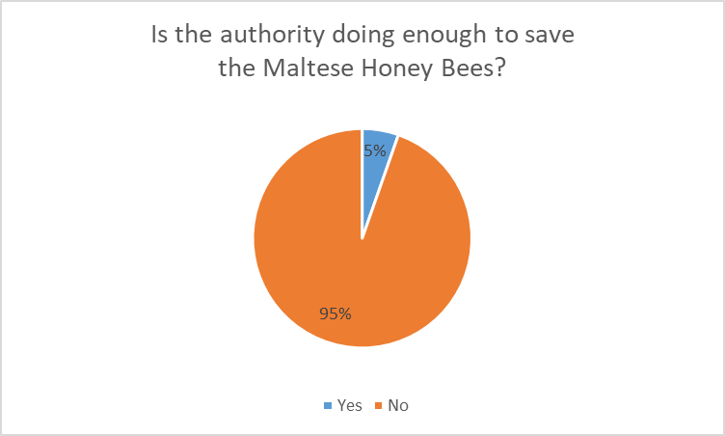

Figure 52

As pointed out in the literature review, pesticides are doing a great deal of harm to the Honey Bees. In 2018, the European Food Safety Authority published their research on the pesticides test that they been doing on fruit and vegetables. The results show that fruit and vegetables that were grown in Malta have the highest traces of pesticides in the EU. *“More than one in 10 local greens taken to the lab in 2016 were sprayed with chemicals over the legal limits”* (Martin, 2018). Farmers who were using pesticides over the legal limit were being charged in court since this causes health problems to whoever consumes the sprayed items. The European Commission emphasized that Malta is lacking on not having a system of testing for any pests and diseases on crops to avoid farmers from using excessive pesticides (Martin, 2018). Therefore, in March 2019, the Malta Competition and Consumer Affairs Authority (MCCAA) launched a national plan on the “Sustainable use of pesticides” (TimesofMalta, 2019), it aims to raise awareness, training and other varies control measures for the agricultural industry.

The participants were asked if they think whether the authority is putting enough pressure on pesticides (Figure 53). 54% of the beekeepers said that there is no pressure, 9% said yes while on the other hand 37% said that there is not enough pressure. However, these results were obtained before the MCCAA launched their plan, therefore some may have changed their mind.

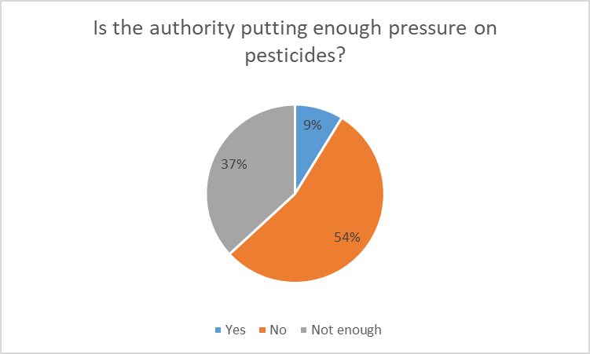

Figure 53

Public awareness on the honey bees

To spread the importance of the honey bees, public awareness is a vital tool. As highlighted throughout this research, honey bees play an essential role in our daily life and health, therefore the general public should be educated on this.

An annual event that is done in the 20May, which celebrates the World Bee Day in the United Nations where they organise seminars and activities related to the honey bees and other pollinators (TimesofMalta, 2018). Last year (2018), the Malta Beekeepers Association opened an exhibition for the public to see the work of the honey bees. The association is always on the go to raise awareness. One of the council members said that when there are any cultural events, they always try to put up a stand and generally the public are interested on the subject.

Friends of the Earth and other companies are also contributing. A local insurance company last year gave a jar of Maltese honey to its customers to promote the local products (TimesofMalta, 2018). However, there is much more to be done. The participates were asked if they think there is enough awareness (Figure 54). 16% of the beekeepers said that there is, while 44% said no and 40% said that there so not enough awareness.

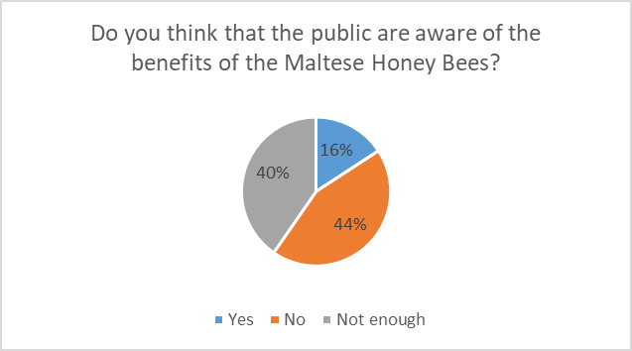

Figure 54

Beekeepers opinion on saving the Maltese honey bees

In this question the beekeepers were asked on their opinion on what can be done to prevent the Maltese honey bee from extinction. Mainly there were four subjects that the beekeepers emphasized on;

1. **The introduction of interbreeding of foreign honey bees in the Maltese island**. The majority of the beekeepers urge for the government to stop the importation of foreign bees because it is taking over. The Maltese honey bee has adopted the Maltese climate and if the foreign honey bee continues dominate and erase the native, they could become extinct because the weather is harsher than other countries that they are used to. The beekeepers` main suggestion is that since Malta is a small group of islands, control measures can be easily applied with strict border control.
2. **Education and awareness.** Education and awareness should be given to the general public, farmers and beginners in the apiculture industry. Beginners should search for advice from professional beekeepers to learn the proper ways. Educating the next generation especially in schools when students are still at a young age.
3. **The local authority supports**. The beekeepers suggest varies suggestions such as;

* Stopping foreign bee and Queen bee importation,
* Changing the funding scheme so that it will be suitable for Maltese beekeepers and instead subsidise with €50 per hive,
* Subsidise farmers on crops that are beneficial for honey bees such as clover,
* Increase harsh penalties on vandalism and honey fraud,
* Action from the MCCAA on pesticides abuse, government veterinary support,
* A government apiculture department,
* Obligatory registration (free) for Maltese beekeepers to keep monitoring the beekeepers
* quarantine on imported goods to check for any dangerous pests,
* Protection of native honey bee by the law,
* The government can build their own apiary which breeds only native bees,
* One beekeeper suggested that Comino can be used to breed only native bees, applying strict biosecurity measures to an area that can be further re-enforced by encouraging beekeepers in the Mellieħa (Malta) and Qala (Gozo) zone to also keep their native bees in the government breeding area, and the authority can secure EU funds to finance to the whole operation involving NGOs.

1. **The last point is about breeding native bees**. Here is already the SmartBees project in place, but they need the funding support from the authority to increase their research and tests.

Beekeepers` opinion on other problems that themselves and the Honey Bees are facing.

In another question, the author asked for the beekeepers` opinion on what are the other problems that themselves and the local honey bees are facing in edition of the problems highlighted by the author.

The beekeepers pointed out these problems;

* People and businesses are selling fake honey which is damaging the reputation of the Maltese honey. Many beekeepers have reported a man selling EU and non-EU honey as Maltese while not giving a receipt in the island of Gozo, but no authority has taken any action. In 2018 within the members of the association a beekeeper was caught committing honey fraud, which the association toked further actions.
* Farmers using pesticides that are not found any more on the market and spraying during pollination season.
* Honey bees are finding it difficult to gather pollen and nectar due to the reduction of foraging area that made way for non-controlled construction development including on ODZ land.
* The authorities are cutting down the eucalyptus trees, which for the bees is a great source of nectar and pollen since during autumn, as it is one of the few trees that bees depend on.
* Intensified agriculture practices which do not enable wildflowers to thrive, monoculture practices and not enough land-owners willing to help beekeepers.
* Lack of knowledge of crop growing that is beneficial for the bees by farmers, government environment entity (ECL), local councils and the general public.
* In the past years the Maltese islands had lack of rain, long droughts, dry and windy period that reduced the nectar yielding of melliferous flowers.
* Some beekeepers find it difficult to have beehives in urban environments without neighbours complaining or damaging the honey bees` life cycle, due to their reputation and misconception that these insects are aggressive.
* Invasion of the Asian hornet, migration of the bee-eaters and the varroa mite.
* The natural and/or induced increase in honey bees within a particular location which intensifies their density and thus strangling to find nectar and pollen availability.
* Low honey prices on the commercial market and a practice that can be experience for the beekeeper because of low honey yielding in Malta.

To conclude, the author got a clear picture on what is happening to the local apiculture industry regarding the problems that the industry is facing from pest, diseases, colony losses, government support and climate change. Therefore, with the data collected the author can present recommendation on what can aid the industry and other suggestions on what can be applied so that in the future, the apiculture industry can flourish throughout the Maltese islands. Overall the author is satisfied with the data obtained but for the next research the questions need to be more specifying to have a better result.

**Chapter 5: Conclusions and Recommendations**

Honey bees have adopted a crucial role in our life by through the pollination of crops for consumption, creating a diverse environment and providing honey and other products that are beneficial for our health. However, during the past years, the apiculture industry has faced a devastating decrease in honey bee population across the world by thousands.

In the literature review, the author draw attention on various factors that are causing the decrease and what we are doing to prevent honey bees` extinction from around the world mainly in the EU countries.

Such problems are the invasion of pests, diseases, pesticides sprayed in the fields, human vandalism, climate change and honey fraud. The EU has been working hard to put forward the apiculture industry with research and innovation ideas, but there is still much more work to be done to educate the man in the street to appreciate the hard work of the honey bees.

In Malta, beekeeping has been practiced for thousands of years through generations, but as other countries, it has also experienced a decrease in honey bees. The Maltese honey bee, *Apis Mellifera Ruttneri* is a unique species that can only be found in this small island, therefore we need to protect it from extinction. With the results obtained from the research carried out, the author identified the problems that beekeepers are facing within the apiculture industry.

As seen in chapter 4, about 74% of the beekeepers from the survey have lost a percentage of their honey bees for various reasons such as;

* The Maltese climate which harsh weather for the bees but some have adopted these conditions, still for the bees to survive the beekeepers have to feed them with sugar substitute,
* Diseases and pests which one beekeeper pointed out that his hive was infected with the deadly small hive beetle which can if spread to other hives, causing a huge damage across the island. Wax moth and varroa mite are the two most common pest that are damaging the Maltese Honey Bee. The beekeepers are using strips to cure their bees from the pests, however these are very expensive to buy.
* Pesticides used by farmers which not only harming the bees but also our health,
* Construction and development destroying the environment and the biodiversity,
* Vandalism caused by robbery, fire, neighbours and poisoning.
* Intensified agriculture practices and lack of land owners helping the beekeepers.

Local NGOs are working hard to promote the apiculture industry with the aid of the government with the introduction of the “Quality Mark” to elevate the quality standard of the local honey and put forward in the EU market. However, the beekeepers are still finding it difficult to practice beekeeping due to financial problems among others, as shown in the data collected.

Recommendations based on the results of the data collected.

* Ban the importation of foreign honey bees because they are taking over the Maltese honey bees.
* Introduce a border control across Malta on importation of good to make sure that no dangerous species are entering.
* Promote awareness and education to the general public especially the young generation on the importance of honey bees and the health benefits of the Maltese honey. In secondary schools, vocational subjects have been introduced, in which agribusiness is taught. An introduction to apiculture should be included in the syllabus.
* Adopting the funding system to make it suitable for the Maltese beekeepers to benefit from and not taking a “copy and paste” approach from other countries which are way bigger than Malta.
* Subsidies to the local farmers on crops that are beneficial for honey bees such as clover.
* Strengthen the government apiculture section and develop an apiary.
* Government aid.
* Agriculture government entities planting flowers that are beneficial for honey bees in public areas and roundabouts.
* Make the Maltese honey bees protected by law to decrease vandalism and give harsh penalties to whoever practices honey fraud, such as, misleading labels and selling of fake or foreign honey as Maltese honey.
* Continues training to all beekeepers, specifically on pest and diseases to avoid from any damage and what can be done when identifying new problems.

Recommendations for future research.

* Research on what the general public are consuming most, whether local or foreign honey.
* Research on the diseases affecting the Maltese honey bees and what can be done to prevent them in the Maltese island.
* Research on the local honey in our cuisine.

The author recommends further research based on this study at a higher level so there could be better improvement in the apiculture industry and to save the local honey bees. Doing this research, the author hopes that it could reach the authority, so that in the future they could implement the ideas to save the bees.

# **References**

Agius, M., 2016. *Jubilee Foods cleared of selling fake ‘Gozo’ honey.* [Online]   
Available at: https://www.maltatoday.com.mt/news/court_and_police/65211/jubilee_foods_cleared_of_selling_fake_gozo_honey#.XIbOfrh7nIW  
[Accessed 8 March 2019].

Angela, 2013. *Royal Jelly.* [Online]   
Available at: https://www.bee-pollen-buzz.com/royal-jelly.html  
[Accessed 20 May 2019].

Annie Price, C., 2018. *Bee Propolis Benefits Immunity in the Fight Against Cancer, Candida & Parasites.* [Online]   
Available at: https://draxe.com/bee-propolis/?fbclid=IwAR1co9G38N3lmVNALUXu4Slifwx4o8evP75DVae1j8QA7usQVRA0hvwlfdU  
[Accessed 04 March 2019].

Anon., 2010. *Electric Universe Forum.* [Online]   
Available at: http://www.everythingselectric.com/forum/index.php?topic=316.0#lastPost  
[Accessed 21 April 2018].

Apimondia, 2019. *APIMONDIA STATEMENT ON HONEY FRAUD.* [Online]   
Available at: https://www.apimondia.com/documents/apimondia_statement_on_honey_fraud.pdf  
[Accessed 9 March 2019].

Apimondia, 2019. *APIMONDIA STATEMENT ON HONEY FRAUD.* [Online]   
Available at: https://www.apimondia.com/documents/apimondia_statement_on_honey_fraud.pdf  
[Accessed 8 March 2019].

Association, M. B., 2019. *Statute of Association.* [Online]   
Available at: https://www.maltabeekeepersassociation.com/  
[Accessed 20 March 2019].

Association, T. B., n.d. *Varroa Mites and Pest Control.* [Online]   
Available at: http://www.tidewaterbeekeepers.net/Varroa-Mites-and-Pest-Control  
[Accessed 20 May 2019].

Ayling, L., 2010. *Malta inside out.* [Online]   
Available at: http://maltainsideout.com/9123/sweetness-and-light-honey-in-malta/  
[Accessed Wednesday April 2018].

Beeaware, n.d. *American foulbrood.* [Online]   
Available at: http://beeaware.org.au/archive-pest/american-foulbrood/#ad-image-0  
[Accessed 20 May 2019].

BeeAware, n.d. *Small hive beetle.* [Online]   
Available at: http://beeaware.org.au/archive-pest/small-hive-beetle/#ad-image-0  
[Accessed 15 April 2019].

BeeAware, n.d. *Wax moth.* [Online]   
Available at: http://beeaware.org.au/archive-pest/wax-moth-18/#ad-image-0  
[Accessed 25 March 2019].

Britannica, T. E. o. E., 2018. *Beeswax.* [Online]   
Available at: https://www.britannica.com/topic/beeswax  
[Accessed 9 March 2019].

Centre, S. M., 2018. *Expert reaction to EU ban on outdoor use of three neonicotinoid pesticides.* [Online]   
Available at: http://www.sciencemediacentre.org/expert-reaction-to-eu-ban-on-outdoor-use-of-three-neonicotinoid-pesticides/  
[Accessed 25 February 2019].

Champetier, H. L. D. A. S. A., 2018. The U.S. Beekeeping Industry and Almond Pollination. *Pollination Markets and the Coupled Futures of Almonds and Honey Bees: Simulating Impacts of Shifts in Demands and Costs,* 101(1).

Chetcuti, K., 2015. *Don’t get stung by sale of fake Maltese honey.* [Online]   
Available at: https://www.timesofmalta.com/articles/view/20150526/local/dont-get-stung-by-sale-of-fake-maltese-honey.569733  
[Accessed 8 March 2019].

Cilia, J., 2018. *Thousands Of Maltese Bees Are Being Killed In Comino.* [Online]   
Available at: https://lovinmalta.com/lifestyle/environment/thousands-of-maltese-bees-are-being-killed-in-comino  
[Accessed 25 March 2019].

Clarke, D., 2018. *A bittersweet tale of Malta’s fake honey industry ends in success.* [Online]   
Available at: http://www.independent.com.mt/articles/2018-05-20/local-news/A-bittersweet-tale-of-Malta-s-fake-honey-industry-ends-in-success-6736190123  
[Accessed 8 March 2019].

Clinton, F., 2018. *The bee world’s lone ranger.* [Online]   
Available at: https://www.ecotricity.co.uk/news/news-archive/2018/the-bee-world-s-lone-ranger  
[Accessed 25 May 2019].

Commission, E., 2017. *EU honey market situation in 2017.* [Online]   
Available at: https://ec.europa.eu/agriculture/sites/agriculture/files/honey/market-presentation-honey_en.pdf  
[Accessed 2 September 2018].

Commission, E., 2018. *How to ensure genuine honey on the market.* [Online]   
Available at: https://ec.europa.eu/jrc/en/science-update/how-ensure-genuine-honey-market  
[Accessed 8 March 2019].

Council, C. H. E., 2015. Bees and Pollinators Event. *Report from the Commonwealth Meetings in Malta November 2015,* Issue 43, p. 5.

Demarco, J., 2017. *Local bee population increasingly threatened by growing number of alien Oriental Hornets,* Malta: Independent.

Development, A. a. R., 2016. *Notification of apiculture programme ,* Malta : Agriculture and Rural Development ISAMM CM .

Diacono, T., 2015. *Beekeepers fear Sicilian threat to local agriculture.* [Online]   
Available at: https://www.maltatoday.com.mt/news/national/48549/beekeepers_fear_sicilian_threat_to_local_agriculture#.XLRB-KRS_IU  
[Accessed 15 April 2019].

Douglas, E. A. a. A. B., 2017. Physicochemical Characterization of Maltese Honey. In: V. D. A. A. D. Toledo, ed. *Honey Analysis.* s.l.:Intechopen, p. 173.

Dr Aleksandar Uzunov, D. M. M. D. R. B. T. G., 2018 . *Conservation of the endemic Maltese honey bee (Apis mellifera ruttneri).* s.l.:SmartBees .

Economist, T., 2018. *The scourge of honey fraud- America’s taste for honey is nectar for con men.* [Online]   
Available at: https://www.economist.com/united-states/2018/08/30/the-scourge-of-honey-fraud  
[Accessed 8 March 2019].

EFSA, E. F. S. A., 2018. *Terms of reference for an EU Bee Partnership.* s.l.:EFSA.

Foods, W. D., n.d. *Bee Propolis Liquid.* [Online]   
Available at: https://www.delimfg.com/product/bee-propolis-liquid/  
[Accessed 20 May 2019].

Fricker, A., 2003. *Plight of the humble bee.* [Online]   
Available at: https://www.nzgeo.com/stories/plight-of-the-humble-bee/  
[Accessed 20 May 2019].

Friends of the Earth Malta, F., n.d. *The Bee Cause.* Malta: FOE.

Friends of the Earth, F., 2015. *Bee and Pollinators; A commonwealth Concern,* s.l.: Friends of the Earth,FOE.

Geiling, N., 2013. *The Science Behind Honey’s Eternal Shelf Life.* [Online]   
Available at: https://www.smithsonianmag.com/science-nature/the-science-behind-honeys-eternal-shelf-life-1218690/  
[Accessed 09 March 2018].

Geleta, M. A. A. a. B., 2016. Medical Uses of Honey. *Biology and Medicine,* 1 February , 8(2), pp. 1-7.

GmbH, b., n.d. *Beecare.bayer.com.* [Online]   
Available at: https://beecare.bayer.com/what-to-know/bee-health/varroa  
[Accessed 10 November 2018].

Hood, M., 2018. *Colony Collapse Disorder.* [Online]   
Available at: http://britannica.com/science/colony-collapse-disorder  
[Accessed 23 January 2019].

Julius-Maximilians, 2018. *Pesticides give bees a hard time.* [Online]   
Available at: https://www.sciencedaily.com/releases/2018/04/180405100143.htm  
[Accessed 25 February 2019].

Knapton, S., 2018. *Scientists sew trackers to Asian Hornets to find and destroy nests before they kill honeybees.* [Online]   
Available at: https://www.telegraph.co.uk/science/2018/07/04/scientists-sew-trackers-asian-hornets-find-destroy-nests-kill/  
[Accessed 10 February 2019].

Leone-Ganado, P., 2015. *€8 million depends on bees annually Times of Malta.* [Online]   
Available at: https://www.timesofmalta.com/articles/view/20151125/local/8-million-depends-on-bees-annually.593440  
[Accessed 8 July 2018].

Lori R. Spears, A. M. M., 2018. *Small Hive Beetle.* [Online]   
Available at: https://www.semanticscholar.org/paper/Small-Hive-Beetle-[Aethina-tumida-(Murray)]-Spears-Mull/7b5fcaa6fb324ee4cc4defc9a4847180886bd081  
[Accessed 20 May 2019].

Maria Spivak, G. S. R., 2016. *Honey Bee Diseases and Pests.* [Online]   
Available at: https://www.beelab.umn.edu/sites/beelab.umn.edu/files/_2016_disease_pdf_version_s.pdf  
[Accessed 15 November 2018].

Martin, I., 2018. *Maltese fruit and veg top EU pesticides list.* [Online]   
Available at: https://www.timesofmalta.com/articles/view/20180731/local/maltese-fruit-and-veg-top-eu-pesticides-list.685527  
[Accessed 15 April 2019].

Muscat, M., 2016. *Efforts to save indigenous Maltese bee.* [Online]   
Available at: https://www.tvm.com.mt/en/news/efforts-to-save-indigenous-maltese-bee/  
[Accessed 20 February 2019].

Nations-FAO, F. a. A. O. o. t. U., 2018. *The importance of bees and other pollinators for food and agriculture.* Slovenia : Republic of Slovenia Ministry of Agriculture Forestry and Food.

Ollerton, J., 2015. *What Einstein didn’t say about bees – UPDATED.* [Online]   
Available at: https://jeffollerton.wordpress.com/2015/03/11/what-einstein-didnt-say-about-bees/  
[Accessed 2 September 2018].

Osterloff, E., 2018. *Why Asian hornets are bad news for British bees.* [Online]   
Available at: http://www.nhm.ac.uk/discover/why-asian-hornets-are-bad-news-for-british-bees.html  
[Accessed 18 February 2019].

Otilia Bobis, D. S. B. a. A. R. M., 2018. *Honey and Diabetes: The Importance of Natural Simple Sugars inDiet for Preventing and Treating Different Type of Diabetes.* [Online]   
Available at: https://www.ncbi.nlm.nih.gov/pmc/articles/PMC5817209/pdf/OMCL2018-4757893.pdf  
[Accessed 27 February 2019].

Parliament, E., 2018. *Protecting bees and fighting fake honey imports in Europe.* [Online]   
Available at: http://www.europarl.europa.eu/news/en/headlines/economy/20180122STO92210/protecting-bees-and-fighting-fake-honey-imports-in-europe  
[Accessed 8 March 2019].

Peter J. Kennedy, S. M. F. J. P. D. T. &. J. L. O., 2018. Searching for nests of the invasive Asian Hornet (Vespa velutina) using radio-telemetry. *Communications Biology,* 4 July, Issue 88, pp. 1-8.

Piek, L., 2016. *Should I Use a Queen Excluder?.* [Online]   
Available at: https://www.farmandfleet.com/blog/should-i-use-a-queen-excluder/  
[Accessed 20 May 2019].

Raman, R., 2018. *Top 11 Health Benefits of Bee Pollen.* [Online]   
Available at: https://www.healthline.com/nutrition/bee-pollen  
[Accessed 08 March 2019].

Rodgers, P., 2017. *Einstein And The Bees. Should You Worry?.* [Online]   
Available at: https://www.forbes.com/sites/paulrodgers/2014/09/09/einstein-and-the-bees-should-you-worry/  
[Accessed 2 September 2018].

Samuel, H., 2018. *France becomes first country in Europe to ban all five pesticides killing bees.* [Online]   
Available at: August  
[Accessed 25 February 2019].

Selin, H., 2008. *Encyclopaedia of the History of Science, Technology, and Medicine in Non-Western Cultures.* 2nd Edition ed. s.l.: Kluwer Academic Publishers .

Simon Hinkley & Ken Walker, M. V., 2009. *greater wax moth.* [Online]   
Available at: http://www.padil.gov.au/pests-and-diseases/pest/main/136311/5845  
[Accessed 20 May 2019].

Spiteri, M. J., 2019. *Interview with the Malta Beekeepers Association* [Interview] (20 February 2019).

Stokstad, E., 2018. *European Union expands ban of three neonicotinoid pesticides.* [Online]   
Available at: https://www.sciencemag.org/news/2018/04/european-union-expands-ban-three-neonicotinoid-pesticides  
[Accessed 25 February 2019].

Tamma, P., 2018. *Honeygate: How Europe is being flooded with fake honey.* [Online]   
Available at: https://www.euractiv.com/section/agriculture-food/news/honey-gate-how-europe-is-being-flooded-with-fake-honey/  
[Accessed 9 March 2019].

TimesofMalta, 2018. *Creating a buzz on World Bee Day.* [Online]   
Available at: https://www.timesofmalta.com/articles/view/20180520/environment/Creating-a-buzz-on-World-Bee-Day.679564  
[Accessed 15 April 2019].

TimesofMalta, 2019. *MCCAA publishes consultation document on Malta’s action plan for sustainable use of pesticides.* [Online]   
Available at: https://www.timesofmalta.com/articles/view/20190317/consumer-affairs/mccaa-publishes-consultation-document-on-maltas-action-plan-for.704769  
[Accessed 15 April 2019].

Union, N. F., 2018. *Sugar industry reaction to vote on neonicotinoids.* [Online]   
Available at: https://www.nfuonline.com/sectors/nfu-sugar/nfu-sugar-news/sugar-industry-reaction-to-vote-on-neonicotinoids/  
[Accessed 25 February 2019].

Union, N. F., 2018. *Sugar industry reaction to vote on neonicotinoids.* [Online]   
Available at: https://www.nfuonline.com/sectors/nfu-sugar/nfu-sugar-news/sugar-industry-reaction-to-vote-on-neonicotinoids/  
[Accessed 25 February 2019].

Vejsnæs, F., n.d. *FORMIC ACID TREATMENT JUST AFTER THE HONEY HARVEST MAKES FOR HEALTHY WINTER BEES.* [Online]   
Available at: http://www.biavl.dk/medlemmer/videnbank/artikler/varroa-in-english/formic-acid-1-freely-applied/  
[Accessed 15 November 2018].

Vermont, U. o., 2018. *Study reveals striking decline of Vermont's bumble bees.* [Online]   
Available at: https://phys.org/news/2018-12-reveals-decline-vermont-bumble-bees.html  
[Accessed 25 May 2019].

Visweswara Rao Pasupuleti, L. S. N. R. a. S. H. G., 2017. *Honey, Propolis, and Royal jelly; A Comprehensive Review of their Biological Actions and Health Benefits..* [Online]   
Available at: https://www.hindawi.com/journals/omcl/2017/1259510/abs/  
[Accessed 28 February 2019].

Wilson-Rich, N., 2014. *the Bee, A natural history.* UK : Ivy Press .

**Appendices**

# **Appendix 1:** **Consent Form for Undergraduate Research Study**

Title of Research- [Include title of your dissertation]

Researcher - [*Insert your name and ID card number*]

Degree - Bachelor in International Hospitality Management (Hons)/ Bachelor in Culinary Arts (Hons)/ Bachelor in Gastronomy (Hons) [remove items as necessary]

Dear Sir / Madam,

I, _____________[*insert name*], a student at the Institute of Tourism Studies am currently in the final year of my *Bachelor in International Hospitality Management (Hons)/ Bachelor in Culinary Arts (Hons)/ Bachelor in Gastronomy (Hons)* [*remove items as necessary*]. I am carrying out research on _________________[*include title of dissertation or a one-line description of your research*]. I would like to explore your views on this matter by asking you some questions. The purpose of this form is to provide you with information so you can decide whether to participate in this study. Any questions you may have will be answered by the researcher.

There are no known risks related with this research project other than possible discomfort with the following:

* You will be asked to be honest when answering questions.

The information in the study records will be kept strictly confidential. All data will be stored securely and will be made available only to those individuals conducting the study. No reference will be made in oral or written reports that could link you to the study.

Your identity will not be revealed in any publications that result from this study.

You can terminate your participation at any time without prejudice. You also do not have to answer individual questions you don’t want to answer. Your name will not be attached to the questionnaire and I will ensure that your participation remains confidential.

**Participant’s declaration**

I have read this consent form and am giving the opportunity to the researcher to ask questions. I hereby grant permission to use the information I provide as data in the above mentioned research project, knowing that it will be kept confidential and without use of my name.

_____________________ __________________ _________________

Participant’s name Participant’s signature Date

_____________________ __________________ _________________

Researcher’s name Researcher’s signature Date

**Appendix 2: Beekeepers survey questionnaire**

Save the Maltese Honey Bees- Apis Mellifera Ruttneri! Dissertation questionnaire

1. Age?___
2. Gender?

* Male
* Female

1. Employment status

* Full-timer
* Part-timer
* Self-employed
* Student
* Retired

1. What is your education level?

* Secondary school certificate
* O-level
* A-level
* Senior school diploma
* Bachelor`s degree
* Master
* No qualification

1. What is your level of beekeeping?

* Professional
* Beginner
* As a hobby

1. Why do you practice beekeeping?

* Personal use
* Business use
* Farming (pollination)

1. Did you inherit beekeeping from previse generation?

* Yes
* No

1. Do you practice beekeeping as a full-time or as a part-time?

* Full-time
* Part-time

1. For how long have you been practicing beekeeping?

* 6months- 1 year
* 1 year-5 years
* 5 years – 10 years
* 10 years – 15 years
* 15 years – 20 years
* 20 years – 25 years
* 25 years- 30 years
* More than 30 years

1. How many full beehives do you own?

* 0-5
* 6-10
* 11-15
* 16-20
* 21-25
* 26-30
* 31-40
* 41-50
* 51-60
* 61-70
* 71-80
* 81-90
* 91-100
* More than 100

1. In which area of the Maltese islands are your beehives located?

* North
* South
* East
* West
* Central
* Gozo

1. Have you lost any beehives colonies?

* Yes
* No

1. In the past two years, how many colonies have you lost?

_____________________________________________

1. In the last two years has been there any changes in the weight of honey, what do you think was the reason?

* Climate change
* Vandalism
* Stopped practising beekeeping
* Other:___________________

1. Has climate change affected your bees?

* Yes
* No

1. Have your bees been vandalised in the past years?

* Yes
* No

1. If your answer to question 15 was yes kindly indicate the kind of vandalism.

* Fire
* Robbery
* Other: ________________________

1. Have you given any sugar to your bees in order to survive because of the harsh weather conditions?

* Yes
* No

1. In the past years, have your bees been infected with any of the following diseases and pests?

* Varroa mite
* American foulbrood
* European foulbrood
* Chalkbrood
* Nosema
* Deformed wing virus
* Black queen paralysis virus
* Acute bee paralysis virus
* Sacbrood
* Other: _____________________

1. Following the last question. If your bees got affected by the varroa mote, which product did you use to prevent the mite?

* Formic acid
* Amitraz
* Coumaphos
* Tau-fluvalinate
* Flumethrin
* Other:__________________

1. Do you use Maltese Honey Bees or Foreign Honey Bees?

* Maltese Honey Bees- Apis Mellifera Ruttneri
* Foreign Honey Bees
* Both

1. From where did you gain your knowledge of beekeeping?

* Other family members which are beekeepers
* Government courses
* Voluntary organisations
* Online or books
* Other:________________________

1. Do you think that the authority is doing their best to save the Maltese Honey Bees?

* Yes
* No
* Not enough

1. Do you think that the authority is doing enough pressure on pesticides?

* Yes
* No
* Not enough

1. Do you think that the public are aware of the benefits of the Maltese Honey?

* Yes
* No
* Not enough

1. What are your opinions to save the Maltese Honey Bees from extinction?

__________________________________________________________________________________________________________________________________________

1. What are the other problems that you and the local honey bees are facing?

__________________________________________________________________________________________________________________________________________

**Appendix 3: Interviews**

Interview questions for the Malta Beekeepers Association

1. When as the association founded?
2. As an association how many members and beekeepers are registers with you?
3. What are the main objectives of the association?
4. As an association what support do you provide for your members and beekeepers?
5. What kind of awareness is the association giving to the general public?
6. What support did you receive from the EU including project?
7. What are the future projects to improve the apiculture industry in Malta and Gozo?

Interview questions for the SmartBees Malta

1. What is the SmartBees project?
2. What was the reason to apply for the project from the EU?
3. What is the support that you reserved from the SmartBees EU?
4. Is the SmartBees Malta benefiting from the EU funding?
5. What tools did the SmartBees EU provided?
6. How many beekeepers are in the project?
7. What are the latest results obtained from the research?
8. The research that SmartBees are doing how is it going to be applied in the future?
9. What is the support that you are being given from the local authority?

**Appendix 4: Photos reference**

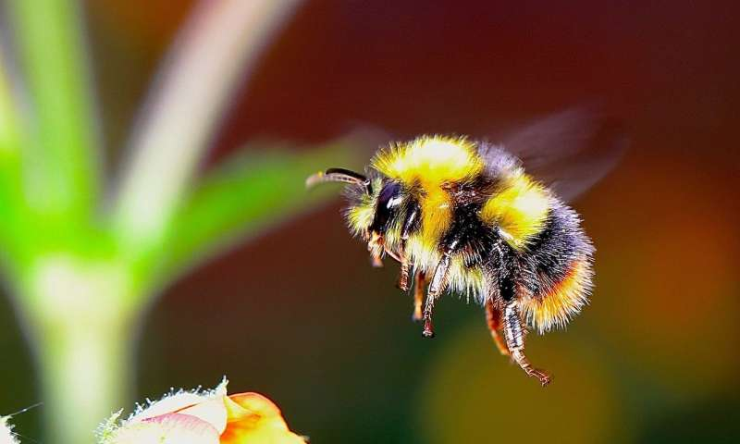Figure 1: Bumble Bee

(Vermont, 2018)

Figure 2: Solitary Bee

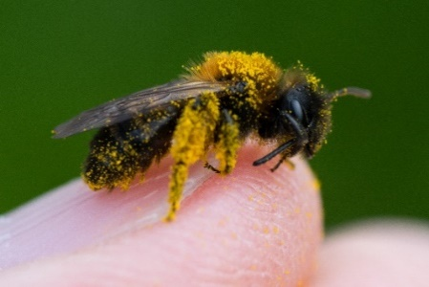

(Clinton, 2018)

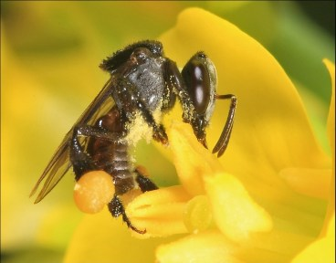Figure 3: Stingless Bee

Figure 4: Honey Bee

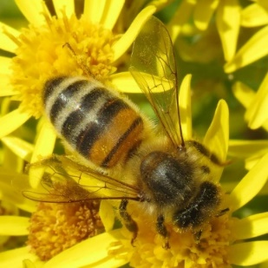

Figure 5: Paintings in the La Araña Caves

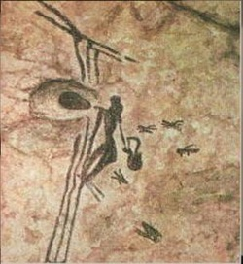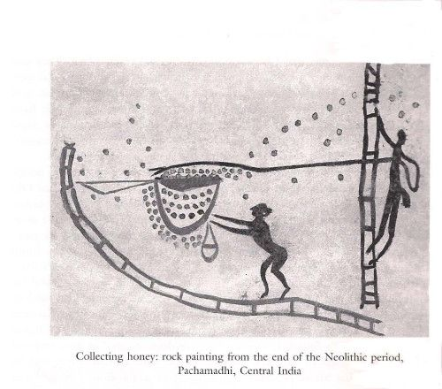

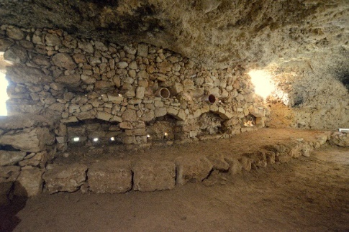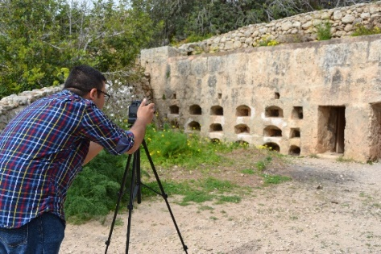Figure 6: Roman Apiaries in Malta (Photos taken by the author)

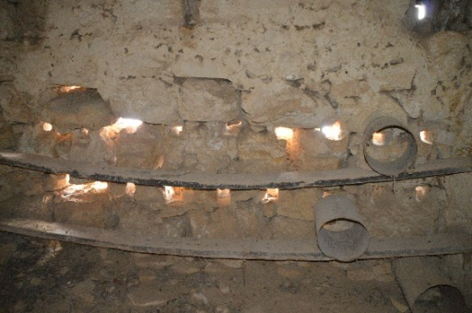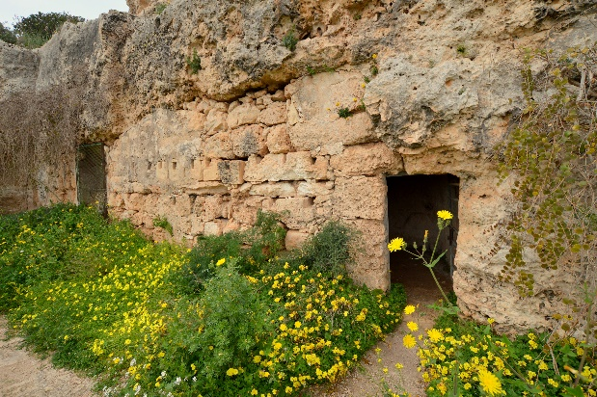

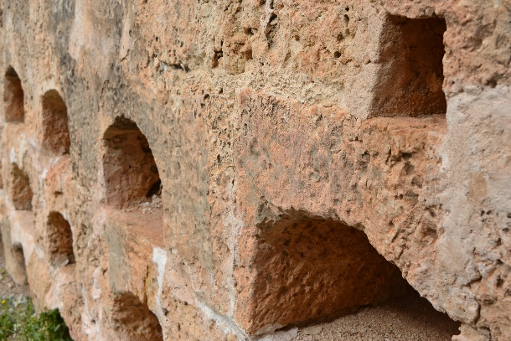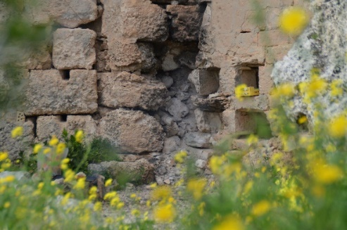

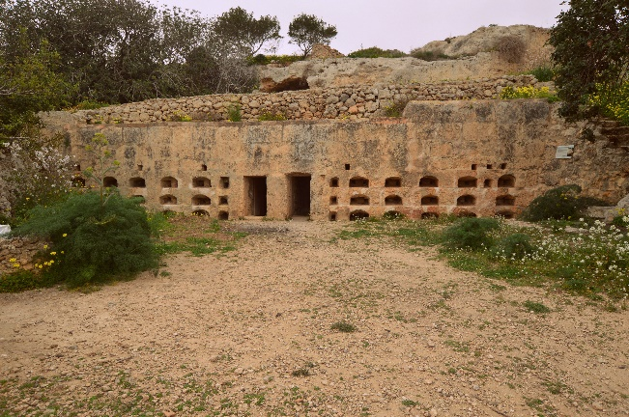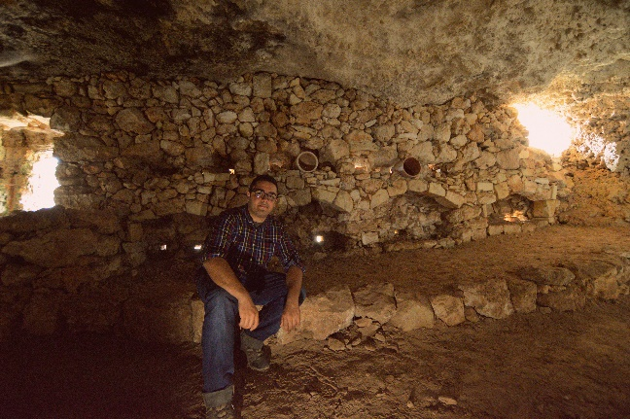

The roman apiaries located in Xemxija and Mellieħa

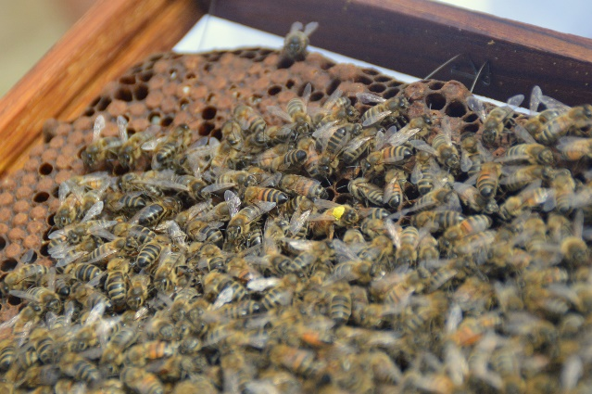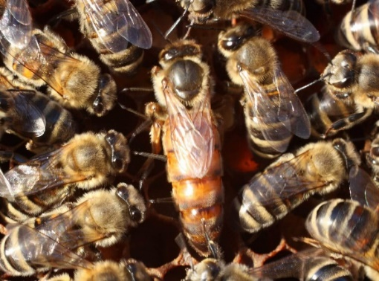Figure 7: Queen Bee

The Queen bee is bigger than the worker bees

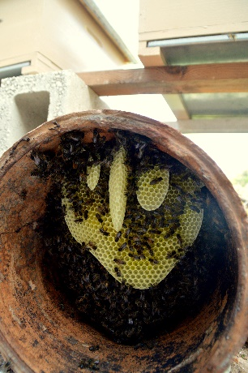Figure 8: Qolla. One of the local beekeepers that still using pottery hives

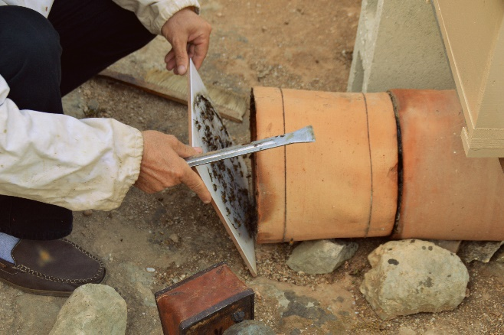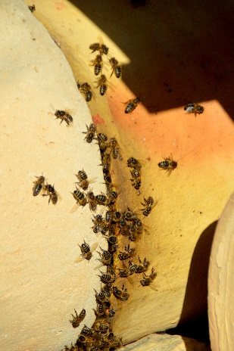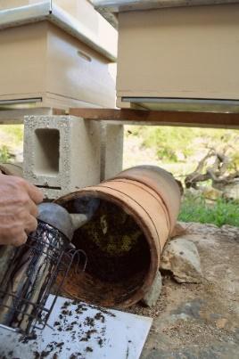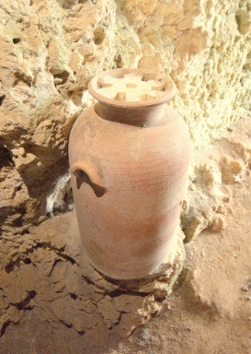

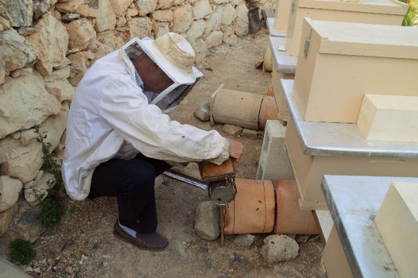

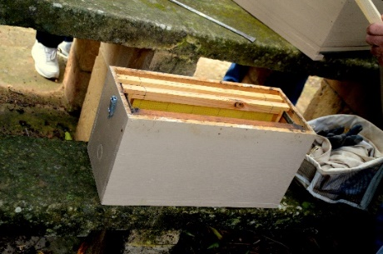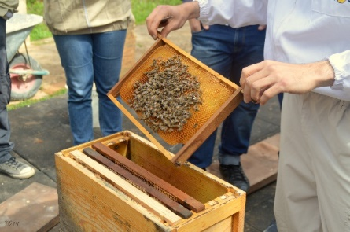Figure 9: Nucleus Beehives (The beekeeper showing the author the nucleus beehives and explaining how it works during the Bee Aware Course)

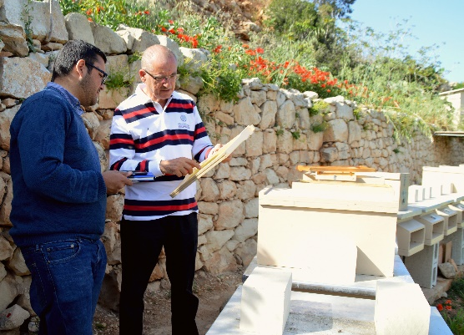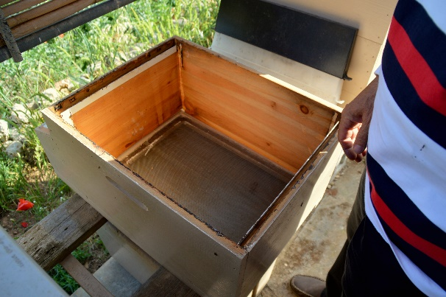

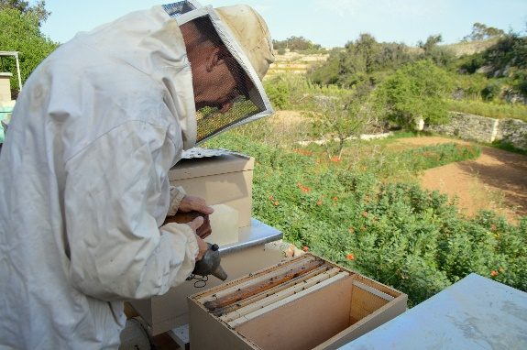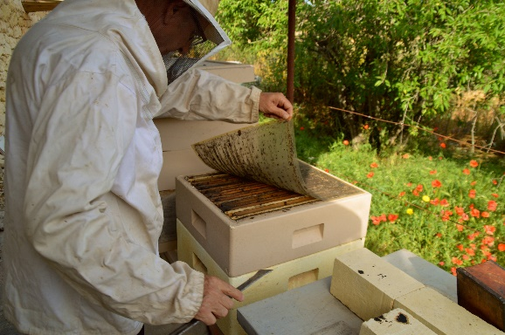

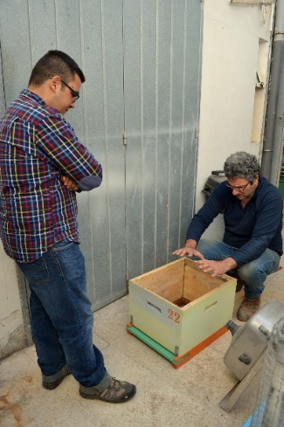

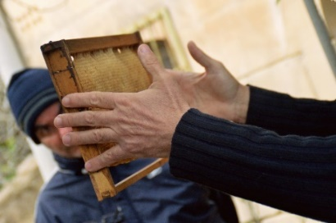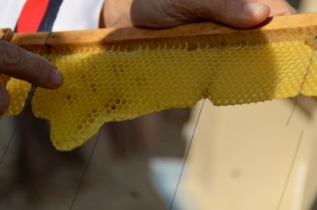Figure 10: Honey Combs and the Frame

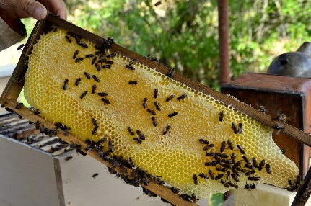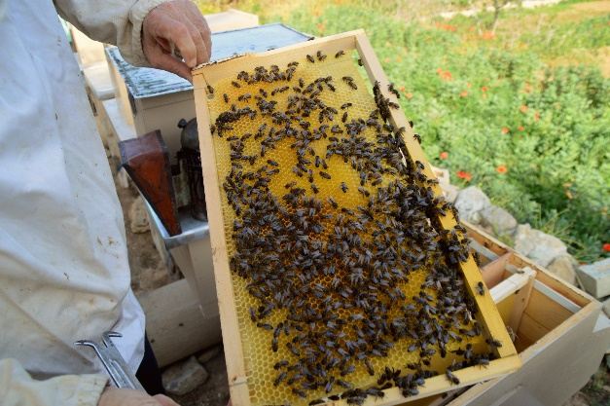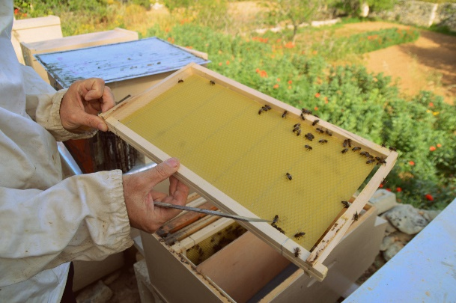

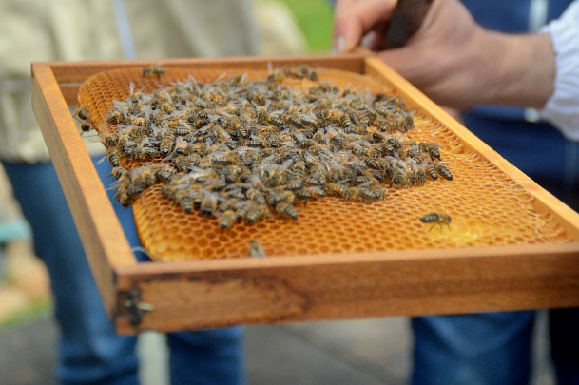

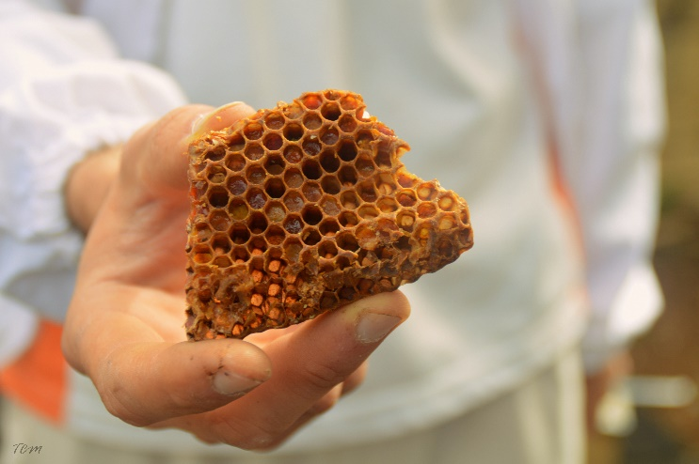

Figure 11: Propolis

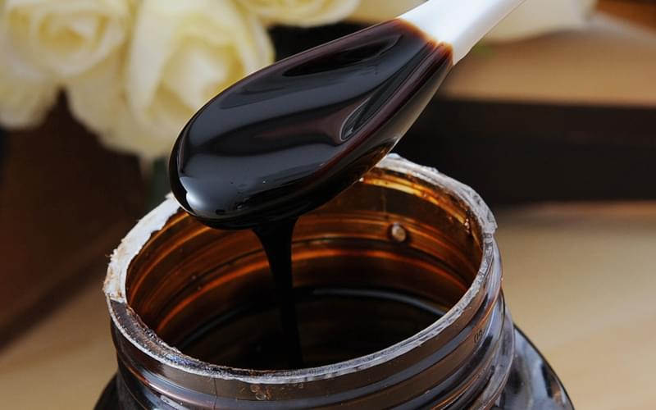

(Foods, n.d.)

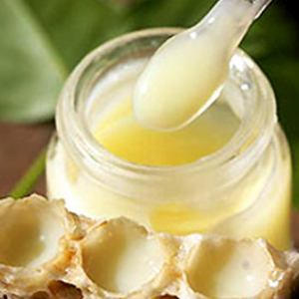Figure 13: Royal Jelly

(Angela, 2013)

Figure 15: Bee Pollen

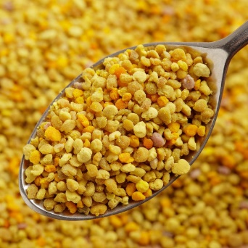

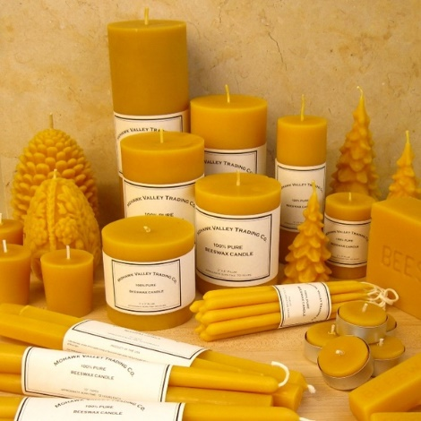Figure 16: Beeswax

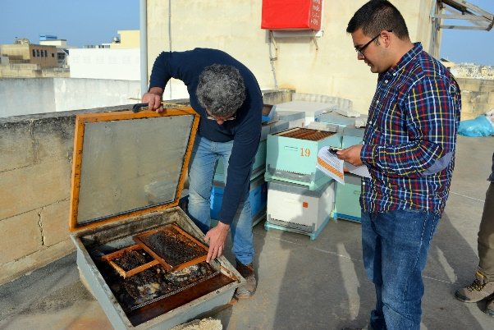

(In this photo you can see the beekeeper explaining the author of how the Solar Wax Melter is used to melt down the honey comb to extract the beeswax

Figure 17: Varroa Mite

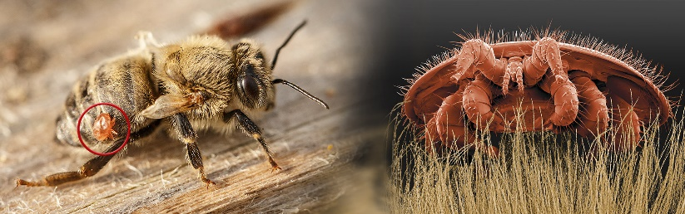

(Association, n.d.)

Figure 18: Varroa mite eggs on honey bee larva

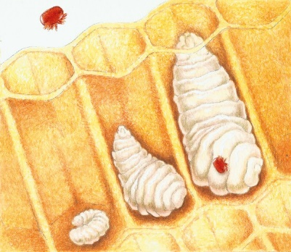

(Fricker, 2003)

Figure 19: American Foulbrood

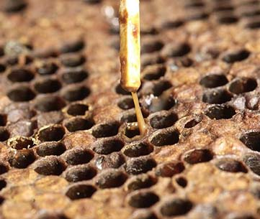

(Beeaware, n.d.)

Figure 20: European Foulbrood

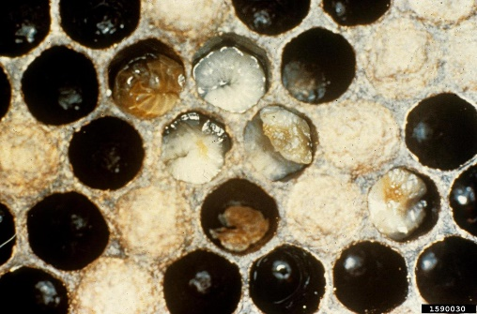

(Maria Spivak, 2016)

Figure 21: Chalkbrood

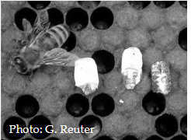

(Maria Spivak, 2016)

Figure 22: Asian Hornet

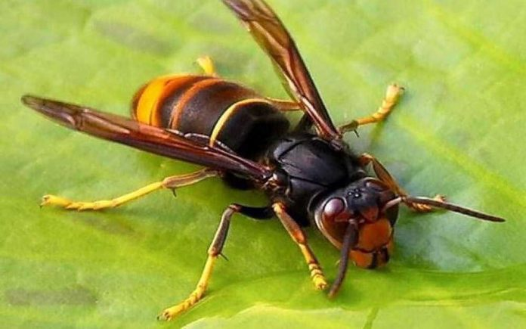

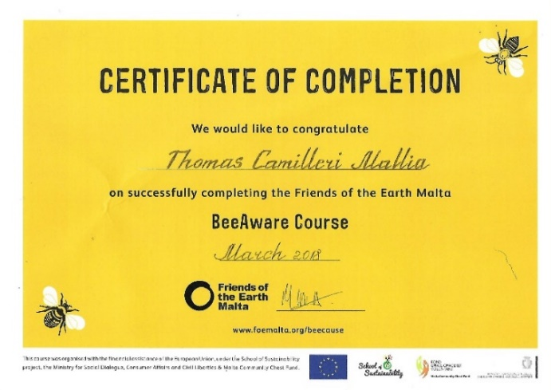Figure 23: Bee Aware Certificate course that the author was given by Friends of the Earth

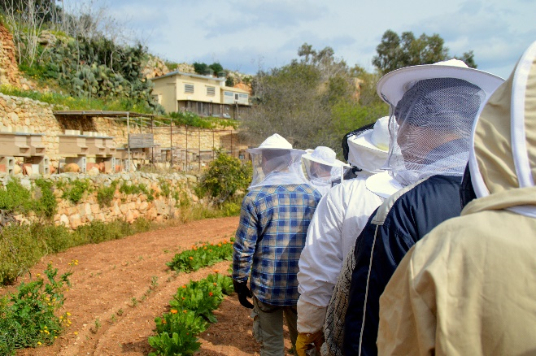

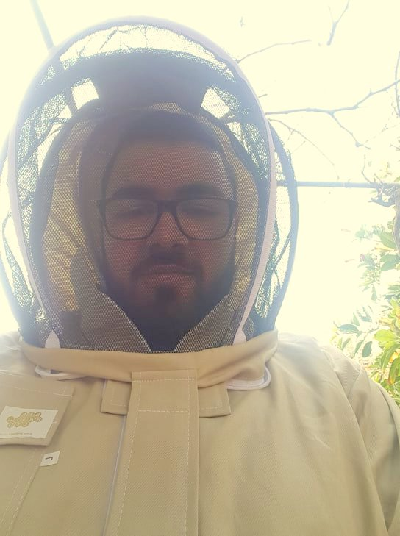

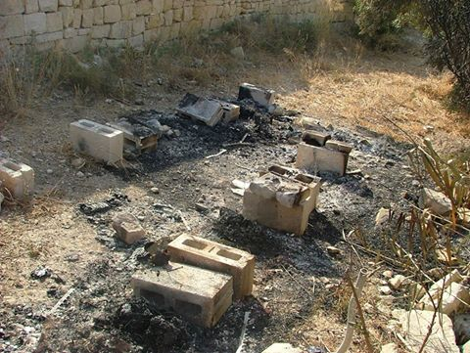Figure 43: Comino Vandalism and burned hives .

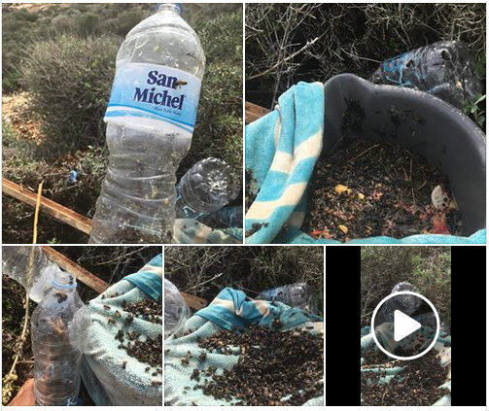

(Cilia, 2018)

Figure 45: Wax Moth in the brood were the Queen lays her eggs

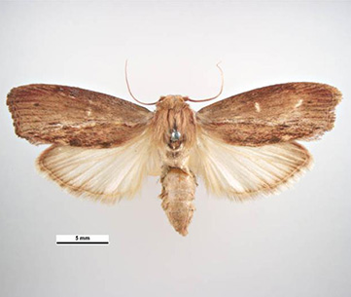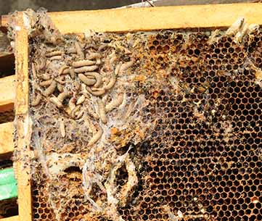

(Simon Hinkley & Ken Walker, 2009)

Figure 46: Small Hive Beetle

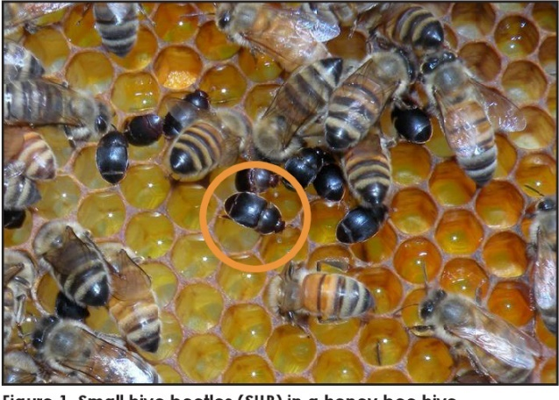

(Lori R. Spears, 2018)

Figure 47: Queen Excluder, this is placed to separate the brood section to the honey section which will be placed on top.

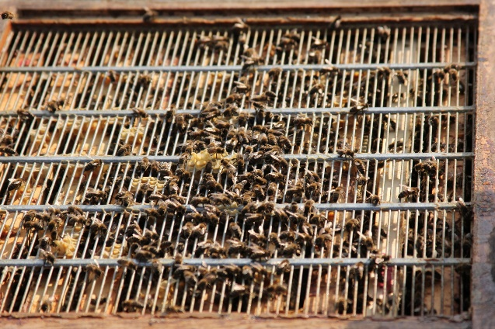

(Piek, 2016)

Figure 49: The Maltese Honey Bee

