

The nutritional, medicinal and health benefits of wild produce in the Maltese islands and their commercial use in local restaurants

Higher National Diploma in Food Preparation and Production Operations. A dissertation submitted in partial fulfilment of the requirements of the Institute of Tourism Studies for the Higher National Diploma in Food Preparation and Production Operations.

By Josef Borg

May 2019

**DECLARATION OF AUTHENTICITY FOR HIGHER NATIONAL DIPLOMA STUDENTS**

Student’s I.D. /Code ____000399G_________________________

Student’s Name & Surname ______Josef Borg________________

Course ___Higher National Diploma in Food preparation and production Operations____

Title of Long Essay

The Nutritional, Medicinal and Health Benefits of Wild Produce in the Maltese Islands and their Commercial use in Local Restaurants

I hereby declare that I am the legitimate author of this Long Essay and that it is my original work.

No portion of this work has been submitted in support of an application for another qualification of this or any other higher education institution.

I hold the Institute of Tourism Studies (Malta) harmless against any third party claims with regard to copyright violation, breach of confidentiality, defamation and any other third party right infringement.

___________________ ___________________

Signature of Student Date (DD/MM/YY)

Abstract

This research was set out to investigate if the edible flora in Malta is still being used nowadays, as it was in times gone by, for both its medicinal properties and for its culinary use. First, the literature review was written so that more information would be gathered, and the researcher would gain more knowledge and a better understanding of the topic. Then, the surveys were prepared and uploaded on a survey database and shared on social media platforms as to gather a larger quantity of responses in a shorter time. After, the surveys were collected, analysed and the results were presented in the research findings. These results show that there are not a lot of people who still forage and use foraged items as part of their dishes or for their medicinal properties. Also, information on such produce is not easy to find and not a lot of information is available to the public, although when the face to face interviews were being conducted, one of the chefs interviewed said that if information would be more available, it might have adverse effects rather than beneficial effects. This might happen because people who read the information and go foraging, might not do so responsibly. He also said that information regarding this topic should be available to aspiring chefs in college, to help build their repertoire of knowledge, on what produce can be found locally. Also, 60% of the participants who took part in the survey said that they have eaten in restaurants which had foraged items on the menu, so the researcher concluded that restaurants are still using some foraged products on their menus.

Acknowledgements

I would like to acknowledge all those who helped me in this research project. A special thanks goes to my tutor, Mr Bernard Micallef for tutoring and assisting me with this research project. My family for their continuous support throughout the year, my eldest sister, Annaliza Borg, for proofreading this dissertation at a very demanding time, and our school librarian Mr Christopher Cilia for going out of his way to help every student.

Table of Contents

1. Introduction……………………………………………………………………………………………………6

1.1 The Importance of the Proposed Research……………………………………………………..7

2. Literature Review………………………………………………………………………………………….8 -11

3. Methodology………………………………………………………………………………………………..12-13

4. Limitations…………………………………………………………………………………………………… 14

5. Analysis and Discussion of Results……………………………………………………………….15-20

5.1 Analysis and Discussion of Interviews with Chefs…………………………………………21-22

6. Conclusions and Recommendations………………………………………………………………23

7. Appendix……………………………………………………………………………………………………..24 29

8. References…………………………………………………………………………………………………..30

* 1. Introduction

Malta is an archipelago consisting of three main islands in the Mediterranean Sea, located in southern Europe with a population of 475,000. In Malta, the official languages are Maltese and English. Maltese is the national language although people in different localities have their own dialects. Maltese are also mostly Roman Catholics since St Paul was shipwrecked on the Maltese islands. Religion is also an important aspect of Maltese culture. Malta has a Mediterranean climate consisting dry hot summers and mild wet winters resembling more to semi-arid conditions found in the eastern Mediterranean. This climate is also what makes Malta a tourist destination all year round.

This study is being carried out to investigate the nutritional, medicinal and health benefits of wild local produce, and if wild produce is being used in local establishments. I will also be investigating why chefs opt to use foreign products instead of local products. Furthermore, this study seeks to explore what wild produce we have available in different seasons that can be used in professional kitchens and establishments.

This research will also investigate if the general public is aware of this produce and see whether they used such produce before. This research will also briefly explain the nutritional and medicinal aspect of these products and how these were used by our ancestors.

This study is also intended to raise awareness to the general public and chefs about produce and products that grow widely in our archipelago. Unfortunately, very few people use produce which in olden days was used routinely for consumption or for their vast medicinal use.

* 1. The importance of the proposed research

Through this study, the general public, professional chefs and other individuals working in different restaurants, will be informed and educated about what edible and nutritional wild produce can be found locally. As well as how they can be used either for consumption domestically or in restaurants or for use as an alternative medicine like they were used in the past.

The Maltese archipelago is rich in flora of which some have been scientifically proven to have medicinal properties. An example of such is the borage flower, which is a tiny star-shaped blue flower with five petals. Since ancient times, this flower has been recognised for its medicinal value. It was widely used in Malta to treat coughs, respiratory problems and also to treat cardiovascular problems.

Way back in time, instead of general practitioners every village had what was known as wise women, and their job was to assist with births, and help injured people. At that time, only herbal remedies and ailments were used. In Malta, wild plants were being used for a very long time and are part of local tradition. When the Knights of St John were in Malta, physicians, staff and surgeons at the Sacra Infermeria used a large number of medical preparations which were based on herbs found locally. In Gozo, there was also a famous healer who used various plant and herbs to treat patients. (Boffa, 2005)

1. Literature review.

The flora in Malta is one of the most stunning aspects of our countryside. It makes our countryside beautiful and sought after by tourists and locals for hiking and for exploring our island’s most scenic and picturesque views. From November to the first few weeks of May, the Maltese countryside is also home to beautiful wild plants and herbs. Some of which were used a lot as natural remedies in olden days. The borage flower has been recognised for medicinal value since ancient times, it was widely used in Malta for treating coughs and for its anti-inflammatory properties before modern medicine was available. In other countries such as France, it is still being used as an antifebrile, anti-depressive and for other treatments such as stress, circulatory heart disease, pulmonary problems and as a laxative. (Abolhassani, 2004)

Another plant whose flowers were widely used is called the cape sorrel. This is found in the countryside and valleys in Malta and Gozo. In Maltese it is known as ‘qarsu, a word describing its sour and bitter taste coming from a substance called oxalic acid which can be very harmful in large amounts. It is not without its benefits though, because it is also high in vitamin C and sailors used to collect this plant before long voyages out at sea. Its roots were used to prevent scurvy, a disease resulting from a lack of vitamin C. Also, the flower of the plant was used to make a paste which was applied on acne and left until it dried. It was known to have healing properties (Independent, 2011)

The carob tree, which is indigenous to the Maltese islands, is also widely spread. It is part of the legume family (beans and peas) and grows in poor soils all over in Mediterranean countries. This tree produces carob pods which start to grow and develop on the tree in November and will take up to august to fully develop and mature. Once the pods are ripe, they can be eaten or given as feed to animals. Locally it is used to make a variety of products such as the carob syrup which is good for coughs and also used to make sweets which are sold on Good Friday, and which in Maltese are called ‘Karamelli tal-ħarrub‘. The seeds are used as a type of natural additive with various food products such as ice cream. Extracts from the pods are also used as a gumming agent in sweets. It can also be dried in the oven, ground up and used added to cakes, breads or sweets, and ice creams. (farmers, n.d.) It is referred to as Carob powder ‘cocoa’. It contains fewer calories, no caffeine and other additives, and has a taste similar to that of milk chocolate. (Batlle and Tous, 2019).

Indeed, one of the most famous and widely used bushes which is spread all over the countryside is the prickly pear cactus. It was first used by the Knights of St John for its moisturising properties, then farmers begun to use it as a boundary to stop intruders from entering. (Jung, 2015) In Maltese it is known as ‘Bajtar tax-xewk’. The prickly pear grows through the hot summer days in the Maltese landscape, and its fruit has a variety of colours with violet, orange, green, and red being the most common. There are various ways one can consume the fruit in preparations such as sorbets, jams, granitas, ice creams and jellies or else carved out of its skin and eaten chilled. Also, one can make what’s known as the ‘bajtra liqueur’. The process to make this is similar to that of wine. It is usually served ice cold at the end of a meal. The prickly pear is also believed to have several medicinal properties, such as to help cure stomach aches, inflammation and as irritation relief from insect bites. (Jung, 2015)

Another common indigenous plant available from spring to summer is the wild fennel, l. Fennel is a herb with a history as long as that of men. In Greek mythology, Prometheus used a dry stalk of fennel to steal fire from the god himself. The herb is widely spread and grows annually from spring to summer. The leaves are used to flavour dishes from fish to meats, cheese and many more. The flavour of the leaves is more subtle than that of its seeds. A healthy aspect of wild fennel is that it grows in abandoned fields and valleys, where there is no use of pesticides. The best time for picking its seeds is in early September before the first rain.

The most important ingredient is called anethole, which also gives the fennel its fragrance. Ages ago, ancient romans used fennel extracts to treat cloudy eyes and in modern times it has been proven effective in the treatment of glaucoma. Fennel extract is considered to be one of the main ingredients used in gripe water as it calms down the intestines. (Independent, 2011). It also has good diuretic properties which help the kidneys remove excess water from the body. At last fennel tea is said to reduce hunger which is beneficial for individuals who are on a diet.

Spread widely throughout our archipelago is the stinging nettle. In Maltese this is known as ‘ħurrieq’. Nettles are mostly known for their very painful sting when one touches or brushes its leaves. Extracts from this weed were used widely to treat anaemia, hay fever, kidney problems and pain (Portelli, 2013).There is also a compound in nettles which some believed to induce lactation, and also clinical tests show that an extract of some species of nettle acts as a diuretic in patients who suffer from congestive heart failure. Nettles are also very rich in vitamins A,C,D potassium, manganese iron and also a good source of nutrients for people who do not consume enough meat and fruit. Folk healers used the stinging nettle to stop bleeding, this is due to the high quantities of vitamin K it contains. (Portelli, 2013) Its leaves and flowers may be used to make herbal teas and a soup made from stinging nettles is considered a delicacy in Scandinavian countries (Portelli, 2013). Nettles also contain various substances which are thought to cure or prevent other conditions. The plant is still being studied for prevention for certain types of cancer.

The beautiful and indigenous caper plant is very common in the Maltese archipelago and it grows on rock faces, old walls and fortifications as well as on the ground in garrigue and disturbed habitats. The plant has large creamy white flowers with long and delicate purple stamens. This plant is very well adapted to the Mediterranean climate and nutrient poor-soils, hence why they are found growing on fortifications and abandoned buildings around the island.

The caper tree flowers from late spring to late summer, this is the time that the caper buds are collected before they bloom. Following preservation in brine, they are served as condiments, in sauces and as an ingredient in several dishes. Also, from the nutritional side they are loaded with antioxidants, have antipyretic properties, which help bring down fevers, cures mild headaches, helps rheumatism by opening the air passages and remove phlegm from airways. It can also have a calming effect, and people who suffer from convulsions may take the infusion of the crushed fruit and leaves twice a day. Also, people with diabetes may benefit from this plant as it helps with controlling sugar levels in the blood (Sharma, 2018)

Another native, evergreen shrub which has an extensive culinary use is the rosemary. Rosemary is a shrub native throughout the Mediterranean. Its name is derived from the Latin word ‘ros marinus’, which when translated means ‘’dew of the sea’’ (Anon., 2004-2019) The rosemary native to Malta has light blue to white flowers, it usually grows within the rocky valleys, although nowadays it’s quite rare to see it in the wild. This shrub is rich in Vitamin A and Vitamin B and is also an antioxidant. It has also been used to treat headaches, colds and for its anti-bacterial and anti-inflammatory properties (Aquilina, 2016). Also, the powerful antioxidant properties present in rosemary, have been used as well for food preservation. In Maltese folk medicine, rosemary has been considered as a good stimulant, antispasmodic and a positive tonic for the heart and the nervous system (Boffa, 2005). It was prepared by boiling the leaves and then given to drink up to three times per day. It has also been said that it helps and acts positively on memory, and its use was recommended during hard exam periods.

3. Methodology

3.1 Introduction

The title of this dissertation is ‘The nutritional, medicinal and health benefits of wild produce in the Maltese islands and their commercial use in local restaurants’. The secondary data finding used were mostly books, online websites and articles in newspapers. Meanwhile, as this dissertation is based on local produce, various melitensia was used, foreign sources were also used and referred to as information on some of the local produce was hard to find.

One of the aims of this dissertation was to find out if the Maltese population is still foraging and using products that in times gone by were being used on a day to day basis, both for their culinary purposes and also for their medicinal use.

In this research, face to face interviews with chefs of local restaurants were carried out to see if local chefs use these products and investigate the reasons behind their decisions. Questionnaires were also be distributed to the general public for collection of data on a larger scale.

A mixed methodology approach was chosen in this dissertation. The main reason for having more than one research method was because the face-to-face interviews with chefs and restaurateurs might have been biased and also subjective. A quantitative survey approach and qualitative designed interviews with chefs from local restaurants were the main research methods used. The survey was uploaded on an online survey database so that unselective samples would be obtained, and the self-constructed questions asked, were designed to find out if the Maltese public has knowledge on what is available to be foraged and if they have ever foraged before. They were also asked if they have ever used some of this produce before as an alternative, natural medicine, like it has been used in the past. Also, as the surveys were published online, there was no need for distribution and collection which was easier and faster and less effort by the public was needed. A total of 39 surveys was collected and analysed.

The qualitative interviews which were conducted with chefs of local restaurants and restaurateurs were designed to investigate if foraged local products are being used in restaurants. In the interview with chefs, the questions asked were also made to investigate if chefs have knowledge of local produce that can be foraged, and if they have ever used such products in their menus and as part of their cooking.

1. Limitations

There were various limitations related to this dissertation, starting from the literature review, some of the plant species that are known to have culinary and medicinal uses, lacked information on which parts of the plant are edible or which can be used for medicinal purposes. An example of such, is the *Giant fennel* or as it is known by its scientific name *Ferrula communis*. Some sources claim that it has culinary and medicinal uses, while other sources claim that it shall not be consumed as it could be harmful.

Another issue with this dissertation was that the surveys that were uploaded online and some of the surveys were filled in by expats or foreigners who may not live in Malta. As a result, not all the surveys which were collected can be analysed and used. Another issue was that when the graphs showing from which part of Malta (North, central, or south) people forage the most, the amount of surveys which were done were not all the same for every locality so percentage can vary and might not be as reliable as previously thought when the survey was designed. Also, as the researcher has been practicing in the culinary industry for the last five years, when the survey was uploaded online and shared on social media platforms, it could have been the case that the survey was biased and a high percentage of, or the majority of respondents, could have been working in the culinary industry or were affiliated with it, therefore the analysis itself could have given an unfair and an unjustified answer. As the surveys were uploaded online, elderly people were a lot less likely to have taken part in the survey, and foraging was a common practice in the recent past. Results might have been different if the surveys were handed out physically to people. Also, the survey could have been done following the cluster sampling technique, which could have provided a more precise and fair answer. Another limitation was that when the interviews were being setup, and emails for permission to conduct face to face interviews were sent, most of the potential respondents never replied, which was a major setback.

5.Analysis and discussion of the results.

Age

The participants were asked to mark the age group in which they belong. Results mapped on the figure below show that more than 40% of respondents were in the 18- 24 age group.

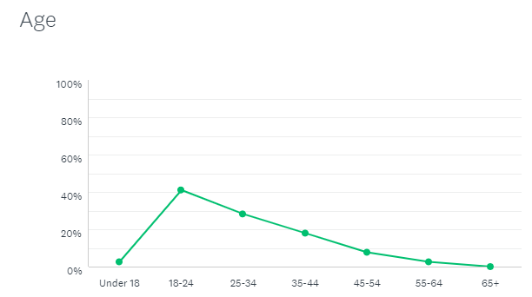

Figure 1

Gender

The pie chart below (Figure 2) shows that 18 (47.37%) of the participants were female, and 20 (52.63%) of the participants were male.

*Figure 2*

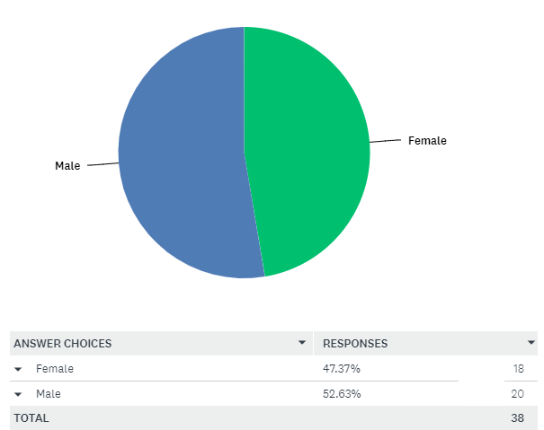

In the fourth question, the participants were asked if they have seen information about edible flora which can be used in cooking or for medicinal use, and to specify if they did. This question was designed with the intent to see if there is information accessible to the public about such topic. Out of the 38 responses, 20 people replied that they have never seen or read information about such produce. This could also be one of the reasons why people do not forage anymore, as information is very limited, and people do not have the knowledge to take decisions on what they can go out and forage for. Also, in today’s fast paced lifestyle, one may find foraging as a waste of precious time, but in fact there are a lot more benefits attributed to foraging that may not come into one’s mind. The remaining 18 participants replied to the question saying that they have previously encountered information, but it’s very limited and scarce, while other participants mentioned the name of the flora they have used or know that can be used for foraging.

Another question which was written in the survey was if the participants have ever foraged before. The result is displayed in *figure 3* below. One can come to the conclusion that there are not a lot of people who see the benefits of foraging for food as 62% of the participants have replied that they never foraged before, and the 38% of the participants who replied in the affirmative, most likely do not forage on a daily basis.

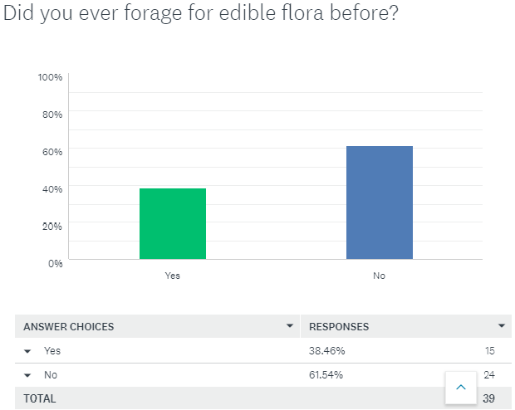

*Figure 3*

The pie chart below shows the percentage of respondents according to geographic location (north, central or south of Malta) and if they have foraged before.

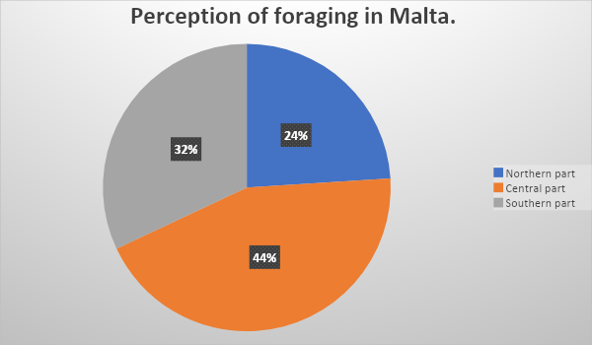

The participants were asked in another question if they had ever used wild produce in their kitchens or as part of their dishes. Results show that the majority, 59% of the participants have previously used foraged foods. So, one can say that foraged foods are used in kitchens but not all the people or chefs who use foraged foods, forage them themselves. The remaining participants wrote that they never used such items before. While one replied that s/he would love to do so if more information would be provided. By this, the researcher finds that if information would be more available, people would use such products more while getting all the benefits they offer and helping the environment itself.

When the participants were asked a more eco-conscious question, if they would consider foraging as a way to decrease the carbon footprint of the environment, most of the participants responded positively. In fact 81% of the participants replied that they would consider foraging as a way to decrease the carbon footprint and help the environment. The results are shown below.

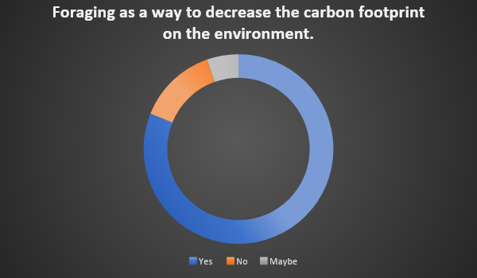

In the last question, participants were asked if they have previously eaten in restaurants which had foraged items on the menu. This question was designed to see if restaurants are using and incorporating foraged food items in their menu. The results show that 60% of the participants have previously eaten in restaurants which had foraged items on the menu. The remaining participants have either never seen such items on a menu or were not sure if they did. By this we can conclude that some restaurants are still using, or are re-introducing foraged foods as part of their dishes and pointing this out on the menus.

5.1 Analysis of the interviews with chefs from restaurants

The following is the analysis of the two interviews, one was with a chef from a small restaurant in a small rural locality of Dingli, while the other was with a chef who works in a restaurant of 5star hotel. The participants are both male and are both over the age of thirty.

When the chefs were asked if they have seen or read information about foraging, one of the chefs replied that he has seen a few articles on newspapers, but most of the knowledge he has, he said he acquired from the years of working in local and also foreign kitchens. The other participant said that he has never read information about such topic, but he has some knowledge of produce which could be foraged. He also said that the knowledge he has was passed down to him from his family as they used to live in a time were foraging was a common practice.

Another question which was asked to the participants was if they know of plants that grow locally, both of the participants had different answers. One of the participants said that he knows quite a few, but explained about the borage, and he said that the flowers were boiled in water and the liquid was left to chill, then this was drunk, and it used to help with sore throat. He also mentioned another plant locally known as ‘xpakka pietra’, which he said was used remove kidney stones. The other chef said that his mum used to make carob syrup, which is said to ease coughing. He also mentioned that prickly pears are very abundant in Malta and most of the Maltese people have tried them before. He added that there are also flowers which are edible, such as the mallow flower, borage flower and also the nasturtium flower. When the chefs were asked if the have foraged before, one of them said that he only forages for wild mushrooms and asparagus when in season. The other chef said that when he is not working, he goes for long walks and if he finds or sees edible flora, he takes it with him to use at home. Both participants said that they only forage occasionally.

When the participants were asked if they would consider foraging to help decrease the carbon footprint on the environment, they both replied that it would be a great idea but due to the small size of Malta, it would not be a viable option. One of the participants also said that some of his friends who work in kitchens abroad, such as Scotland, forage on a minimum of three times per week, but he said that the climate and geography is different then what we have in Malta. The chefs were also asked if there is good quality foods that can be foraged locally, and the researcher analysed from this that there are good quality food items to be foraged, but the problem is once again the limitation in size of Malta is a huge factor, because as the chef said, what you find during a certain day, you don’t find it the following day. This is a negative limitation as chefs strive for consistency and a chef or a restauranteur cannot simply write down a menu to have it changed the following day.

Another question that was asked to the participants was if they would consider foraging if they had more knowledge about the topic. The chef from the small restaurant said that in their restaurant they already forage for some items which they use as part of their dishes, he also added that if more information would be available to the general public, the effects might not be as previously taught. He explained that people might forage irresponsibly, making more harm than good. The other chef from the hotel also used foraged items as part of his dishes but not in the restaurant he is currently working at. The last question asked by the researcher was if they could use foraging as tool to decrease food cost. Both responses were that although having foraged items on the menu, it would not change the food cost but from the customer point of view, it may seem as a luxury.

6.Conclusion and recommendations

The aim of the research was to investigate if the edible flora in Malta is still being used nowadays, as it was in the recent past. From the surveys and interviews conducted, one can see that the researcher has achieved his aim. However, from the researcher’s point of view, there could have been more emphasis on how such foraged plants were used in the past, and how we can start benefiting from these products again. As the aim of this research was to inform and educate the general public and also professional chefs, there should also have been information on which part of our islands is best to go foraging, what flora can be foraged and which seasons are best for such items as well as information on what plants are protected by law.

One can conclude that due to the word limit of this dissertation, the research itself and the quality of the results presented were also of a good standard.

This research can be reproduced by using a different technique for distributing surveys for obtaining a more precise and equal answer, providing more detailed information about the flora available in different locations and in different seasons in Malta and Gozo. This research can also be reproduced, but rather than about foraging, it could be about promoting and safeguarding the use of local produce as imported produce is being passed off as local.

7.Appendix

Questionnaire to the general public about edible flora in Malta.

1. Age 45-54
2. Gender Male
3. Which locality in the Maltese islands are you from?

Siġġiewi

1. Have you ever read or seen information about edible flora which can be used in cooking or for medicinal use? If yes can you please specify?

No

1. Did you ever forage for flora before?

No

1. Do you know of any plants that grow in Malta that are used or have been used before for their medicinal properties or for consumption?

No

1. Have you ever used wild produce in your kitchen or as part of your dishes?

No

1. Would you forage for such produce, if there would be more information available?

No

1. Would you consider foraging as a way to help decrease the carbon footprint of the environment?

No

1. Have you eaten in restaurants before which had wild produce on the menu?

Yes

Interviews with chefs and restaurateurs.

1. Age 39

2. Gender Male

3. What is the name of the establishment?

Diar il-Bniet

4. Have you ever read or seen information about edible flora which can be used in cooking or for medicinal use? If yes can you specify?

Yes, a few articles on newspapers, but most of the knowledge that I have on this subject, I acquired through my career working in local and foreign kitchens.

5. Do you know of any plants that grow in Malta that are used or have been used before for their medicinal properties or for consumption?

Yes, there are quite a few. Borage has been used in the past for sore throat, it used to be boiled and the water was left to chill and drunk to help alleviate the symptoms.

Another plant is the Maltese savoury, or as it is known in Maltese as ‘xpakka pietra’. People used to say that it helps for kidneys stones.

6. Did you ever forage for flora before? If yes, do you forage on a regular basis or once in a while?

Personally, I have only foraged for mushrooms and asparagus, and I only do it once in a while.

7.Would you consider foraging as a way to help decrease the carbon footprint of the environment?

Yes, I would consider it but unfortunately, we are limited to a small area here so it is not a viable option. I have friends who are also chefs in other countries such as Scotland, who forage for produce on a minimum of 3 times per week, but the climate and geography is different from what we have here in Malta.

8. Do you think there is good quality food to be foraged?

Yes, there is good quality food to be foraged, but what you find one day, you might not find the other, so you cannot be consistent.

9. Would you consider foraging if you had the knowledge of the produce available?

We already forage for certain produce here, but definitely there should be more knowledge about this topic. Unfortunately, if there would be more knowledge available to the general public, there could be adverse effects rather then beneficial, as people might forage irresponsibly. This topic should be taught in school to aspiring chefs, so that they have the knowledge on what could be foraged locally in different seasons.

10. Have you ever used foraged produce in your kitchen as part of your dishes?

Yes, we use foraging often here, some items we use are nettle, wild fennel, thyme, mushrooms, borage, carob and wild asparagus.

11. Would you consider foraging as a way to decrease food cost?

Not really, we use such products more because they are local rather as a way to decrease food cost.

Interviews with chefs and restaurateurs.

1. Age 32

2. Gender Male

3. What is the name of the establishment?

Not specified

4. Have you ever read or seen information about edible flora which can be used in cooking or for medicinal use? If yes can you specify?

I haven’t read information on foraging, but I do know of a few items which could be foraged, the knowledge I have on this topic was passed down from my family as they used to live in a time were foraging was a common practice.

5. Do you know of any plants that grow in Malta that are used or have been used before for their medicinal properties or for consumption?

Carrob pods have been used for a long time, and my mum used to make carob syrup with it, and we used to take it when we had coughs, also prickly pear is abundant in Malta. There are also other flowers such as the mallow flower, borage and the nasturtium.

6. Did you ever forage for flora before? If yes, do you forage on a regular basis or once in a while?

Sometimes, when I am not working, I enjoy going for a long walk and yes if I see edible flora, I pick it up and use it at home, I only do so occasionally.

7. Would you consider foraging as a way to help decrease the carbon footprint of the environment?

I personally believe it would be a great idea, as we would be helping the environment, but I do not think this would be a viable option due to the small area we have in Malta.

8. Do you think there is good quality food to be foraged?

Yes, I think there are good quality food items to be foraged locally, but once again, due to the size of our island and the fact that some rural areas are being built, foraging can also be limited to a few places.

9. Would you consider foraging if you had the knowledge of the produce available?

If I had more knowledge about this topic, time permitting I would go foraging more often, but only to use personally for home. As I believe that in my line of work, I must be consistent and I cannot put an item on the menu and run out of it in a few days.

10. Have you ever used foraged produce in your kitchen as part of your dishes?

Yes, I have used foraged produce as part of my dishes, although not here in this restaurant, when I used to work at a certain place locally with lower seating capacity, we used to have a lot of foraged items but due to the size and a higher volume of seating capacity in this restaurant, it would not be an idea that would work.

11. Would you consider foraging as a way to decrease food cost?

No, I do not think this would be possible, at least locally. In my 20-year career as a chef I had the opportunity to work in restaurants abroad where foraging was a common practice, where we as chefs used to go in the fields and forage, but still we were being paid to forage, so the food cost decreased but then the wages went up. Foraging was rather a luxury from the customers’ point of view.

# 8.References

Abolhassani, M., 2004. [Online]   
Available at: http://www.scielo.br/scielo.php?pid=S1413-86702004000500008&script=sci_arttext

America, T. C. I. o., 05/01/12. *garde manger.* s.l.:Wiley.

Anon., 16/12/18. *Moussaka ,* s.l.: Wikipedia .

Anon., 2004-2019. *Phytopharmaceutical Cooperation.* [Online]   
Available at: https://www.koop-phyto.org/en/medicinal-plants/rosemary.php

Anon., n.d. [Online]   
Available at: http://www.medicinehunter.com/rosemary

Aquilina, M., 2016. [Online]   
Available at: https://www.eve.com.mt/2016/09/04/native-wild-herbs-of-the-maltese-islands/

Boffa, D. C. J., 2005. *The Maltese family doctor.* [Online]   
Available at: https://www.um.edu.mt/library/oar/bitstream/handle/123456789/21359/Maltese%20Family%20Doctor%2014(1)%20-%20A7.pdf?sequence=1&isAllowed=y

Boffa, D. C. J., 2005. The use of plants and herbs in medicine. 01 Gune , p. 6.

Borg, S., n.d. *Nouvelle cuisine.* s.l.:s.n.

farmers, M., n.d. [Online]   
Available at: http://www.manikatafarmers.com/download/CarobTree.pdf

Independent, M., 2011. [Online]   
Available at: http://www.independent.com.mt/articles/2011-09-11/news/wonder-weeds-fennel-298356/

Independent, M., 2011. [Online]   
Available at: http://www.independent.com.mt/articles/2011-04-03/news/wonder-weeds-3-cape-sorrel-290095/

Jung, S., 2015. [Online]   
Available at: https://www.airmalta.com/destinations/malta/blog/detail/prickly-pear

Myhrvold, N., Februeary 2015. Nouvelle Cuisine.

Portelli, P., 2013. *naturalmalta.* [Online]   
Available at: http://naturalmalta.blogspot.com/2013/01/the-medicinal-nettle.html

Sharma, A., 2018. [Online]   
Available at: https://www.medicinalplantsanduses.com/caper-plant-benefits-side-effects

Sheraton, M., September 15 1979. Not-So-New Nouvelle Cuisine. *New York Times .*