

Human Tour Guides and Electronic Tour Guides:

A comparison on the future of the Tourism Industry

Higher National Diploma in Tour Guiding

2020/1 Semester 1

Xiaoke Cheng

Institute of Tourism Studies

**DECLARATION OF AUTHENTICITY FOR HIGHER NATIONAL DIPLOMA STUDENTS**

Student’s I.D. /Code: 1900045/1

Student’s Name & Surname: Xiaoke Cheng

Course: Higher National Diploma in Tour Guiding

Title of Long Essay: Human Tour Guides and Electronic Tour Guides:

A comparison on the future of the Tourism Industry

I hereby declare that I am the legitimate author of this Long Essay and that it is my original work.

No portion of this work has been submitted in support of an application for another qualification of this or any other higher education institution.

I hold the Institute of Tourism Studies (Malta) harmless against any third party claims with regard to copyright violation, breach of confidentiality, defamation and any other third party right infringement.



Signature of Student 23/10/2020

# 1. Abstract

The aim of this research is to compare the advantages and disadvantages of human guides and E-guide on the premise of understanding the market demand, to provide some references for the future career of human tour guides. This survey mainly adopts the method of questionnaire, it does not use the conventional internet survey method, but adopts the method of targeted distribution of questionnaires to collect data. The questionnaire design includes subjective questions and objective choices. In this way, both qualitative and quantitative questions can be contained, which is helpful for data analysis. According to the results of the survey so far, it seems that human guides have been slightly more welcoming. But some respondents, though few, have said they would never consider a human guide. And the survey results show that the main factors that prevent respondents from choosing an E-guide are lack of interaction and intelligence. Technology is advancing, once this technical bottleneck is broken, human guide will face severe test. The guide market of the future is an elite market, and only well-prepared guides can enter and profit from it.

# 2. Acknowledgement:

This long essay has won the support of various people in the tourism industry and put forward many valuable suggestions. At the same time, from the relevant books, articles, as well as the results of previous research, also get a lot of inspiration. ITS teachers teach the knowledge and writing methods. In particular, I would like to thank my tutor Ylenia Marmara for her professional and extensive guidance on this long essay.

**contents**

1. Abstract - 1 -

2. Acknowledgement: - 2 -

3. Introduction - 6 -

4. Literature review - 7 -

4.1 Background - 7 -

4.2 Previous research - 7 -

4.3 Expected outcomes - 8 -

5. Methodology - 9 -

5.1 rationale - 9 -

5.2 research design - 9 -

5.3 techniques of Date Collection - 9 -

6. Analysis and discussion of result - 11 -

6.1 Comparison of male’s and female’s preferences for E-guide or human tour guide at different age - 11 -

Figure 1: E-guide by Gender and Age - 11 -

Figure 2: Human Guide by Gender and Age - 12 -

6.2 Compare the advantages of E-guides and human guides - 12 -

Figure 3: The advantages of E-guides and human guides - 13 -

6.3 The disadvantages of E-guides - 13 -

Figure 4: The disadvantages of E-guide - 13 -

6.4 The disadvantages of human tour guides - 13 -

Figure 5: The disadvantage of human guide - 14 -

6.5 Reasons for choosing an electronic tour guide - 14 -

Figure 6: The reasons of choosing an E-guide - 15 -

6.6 Reasons for choosing a human tour guide - 15 -

7. Conclusions and Recommendations - 17 -

8. Reference - 19 -

9. Appendices - 20 -

9.1 Tour Itinerary - 20 -

9.2 Primary data: - 21 -

9.2.1 Form 1. Number of respondents - 21 -

9.2.2 Form 2. Reasons for choosing an human guides - 22 -

9.2.3 Form 3. Reasons for choosing an E-guide - 22 -

9.2.4 Form 4. Advantage options for Human Tour Guides - 23 -

9.2.5 Form 5. Advantage options for Electronic Tour Guides - 23 -

9.3 Survey Questions (English) - 23 -

9.4 Survey Questions (Chinese) - 24 -

9.5 The questionnaire results - 25 -

9.5.1 Questionnaires result 1: - 25 -

9.5.2 Questionnaires result 2: - 28 -

9.5.3 Questionnaires result 3: - 30 -

9.5.4 Questionnaires result 4: - 31 -

9.5.5 Questionnaires result 5: - 32 -

9.5.6 Questionnaires result 6: - 33 -

9.5.7 Questionnaires result 7: - 34 -

9.5.8 Questionnaires result 8: - 36 -

9.5.9 Questionnaires result 9: - 38 -

9.5.10 Questionnaires result 10: - 40 -

**Table of Figures**

Figure 1:E-guide by Gender and Age - 10 -

Figure 2: Human guide by Gender and Age - 11 -

Figure 3: The advantages of E-guide and Human guide - 12 -

Figure 4: the disadvantages of E-guide - 13 -

Figure 5: The disadvantage of Human guide - 14 -

Figure 6: The reasons of choosing an E-guide - 15 -

Figure 7: the reasons for choosing the Human guide - 16 -

3. Introduction

The purpose of this research is to clarify the direction of tourism development, grasp the trend of tourism. Choice is always more important than effort, accurate market positioning is crucial. This has strategic guiding significance, can avoid detour as much as possible .

tourism activities have become the consumption behavior of the general public. The travel rate of residents in developed country reached more than 50% from the early 1950’s to the early 21st century, the number of international tourists increased by 6% annually, the annual growth rate of international tourism income was as high as 11%.

The tourism industry has created a lot of jobs for human beings and the tour guide grew in strength. According to a UNWTO report “*international tourism receipts exceeded us $8 trillion for the first time “* (*UNWTO* , 2012). In the united states, the number of professional tour guides rose from 26,930 in 2015 to 49,740 in 2018, that number slipped slightly to 48,710 in 2019. In China, according to official statistics, as of the beginning of 2019, the number of registered tour guides nationwide was 1,263,828. In 2016, there were just over 800,000 registered tour guides (Number of travel agents US 2019 | Statista, 2020).

It is because there are so many people working in the tourism industry that the emergence of E-guide must be taken seriously. Fully understand the strengths and weaknesses of human guide and E-guide. What kind of tour guide do tourists prefer? Why? If these questions are truly answered, a reasonable plan and arrangement can be made for the future tourism market.

# 4. Literature review

## 4.1 Background

E-guides VS human guides, this is a interesting topic. Before this survey, there had been a lot of mature opinions (Kramer, R and Gretzel, U, 2007; Vansteenwegen, P and Dirk V, 2007). Thanks a lot for the research done by predecessors, which lays a foundation for this proposal. Considering the frequent change of information, rapid development of science and technology, and constant change of tourism market, it is necessary to study the topic again.

Tourism is a kind of high level spiritual enjoyment of human activities, it is not only an economic activity, but also a psychological activity. The tourism industry grew rapidly after the second world war (Burkart, 1990), the world was peace at that time, the economy was booming, and people were interested in traveling. Transportation and innovation are important driving forces of tourism globalization. From the mid-19th century, the development of ships and trains increased the speed of travel and brought great comfort. In the second half of the 20th century, with gradual elimination of air traffic control, the tourism industry grew in size (Mc Grath, GM, 2005).

The quantity and quality of tour guides can not meet the development trend and the needs of all kinds of tourists, electronic tour guide came into being (Brown B, CM, 2003). Electronic tour guide system was started in European and American in 1990s due to development of electronic technology and demand of market (Wu qianjin & Meng Qing Long, 2013). In present, most scenic spots are using E-guides, especial in the exhibition halls, such as museums. With the help of an E-guide, tourists can be more selective, the market of E-guide is very broad. The rise of E-guide has injected modern technology into the tourism, which plays an increasingly important role in the development of tourism.

## 4.2 Previous research

The tourism market share has been steadily eroded by the E-guides, which has triggered a debate on whether human guides will be replaced by E-guides. Quora, an American question-and answer website, has previously been used to compare the pros and cons of an E-guide with a human guide. There are surveys basically adopt the form of questionnaire, and the feedback conclusion is roughly as follows:

Some people think that it is very convenient to use a E-guide. The popularity of smart phones is easy to get helpful travel information, such as city map with self- guided walking tour, the details of the interesting spots, restaurant location and reviews, easy payment solution... Tourists can make their own arrangements and decide how long they want to stay at their destination, let travel be very free. The downside is that intelligent tour guides rely too much on network signals.

On the other hand, others assert that human interactions are unique and can’t be replaced by machines. For example, one can translate by machine, but who has seen translators disappear? The simultaneous interpretation is still a high-paying job. Because some software simply copies the guide’s commentary onto the App, human guides have an ability to improvise, they can find true amazing restaurant which could not be found on the internet, and tourists can get local tips and make friends. A human guide can help tourists fully experience the local customs. There is a good interactive relationship between tourists and tour guides. Sometimes, human guides are on the clock, they may skip on valuable insights in order to end the trip quickly.

These opinions and conclusions have been useful so far and have provided the basis for further investigation. Despite the mixed results of these surveys, there is one phenomenon that must be taken seriously: the rapid development of science and technology. For example, in the past, the original electronic tour guide was designed for a specific scenic spots, a scenic spot needs to design a audio guide. This audio guide can only interpret unilaterally, it can’t give feedback to tourist’s demands and solve their doubts and problems. Moreover, the type of tourists is different, a single audio is difficult to meet the needs of all tourists. The content on the audio guide is also more rigid, most of the knowledge like a textbook explanation, there are only historical and cultural values, no anecdotes related to scenic spots (Wenhao W. & YuHong L, 2019).

The electronic tour guide developed now is an electronic mobile guide based on UMTS application (Anegg H, 2002). It’s more accurate in terms of direction, it can automatically obtain the location of tourists, make live explanation of scenic spots in time (Varshney U, 2003). Using smart phone network connection and accurate positioning, the electronic mobile guides can be widely covered and popularized improve the shortage of audio guides. Using the language input and recognition functions of mobile phone to achieve human-computer interaction, make up the lack of communication between electronic tour guides and tourists (Yu Yaohua, 2014). It can even make it more interesting by setting different interpretation styles according to the preferences of tourists (Ho SY, Kwok SH, 2003). And cloud services should be appropriately added to provide tourists with guidance on food, accommodation and entertainment, ticket booking and electronic payment, as well as more information services to meet their diverse needs. Science and technology will continue to progress, the electronic tour guide will become more perfect, more personalized, will meet the needs of more tourists, continue to expand the market share.

## 4.3 Expected outcomes

Everything seems to be moving in a bad direction for human guide, despite Malta’s strong tourism performance in 2019, but the number of group Tours dropped. According to heritage Malta statistics, The number of individual visitors to Malta increased by 48,628, but at the same time, the number of tour operators fell by 20.37%, or 68,000. This indicated that the number of tourists using electronic guides has risen while the number of tourists using human guides has declined.

In fact, these changes are in accordance with the law of development. Since the 1970s, the defining role of a tour guide has been mostly to explain, translate and communicate (Schmidt,1979). In the traditional sense, the communication of the tour guide is one-way, the tour guide is a performer, and the tourists are audience. Travel is also about consumption. It is difficult for such a tourism model to develop sustainable and meet the challenges of the global communication environment.

The main reason for comparing human guides to E-guides is the fear that human guides will be replaced by E-guide in the future. Wise people are also studying how to enhance the role of human guides in tourism. Experience is still the core of the tour guide. The tour guide should not only be a host, but also give tourists a more active role to stimulate their creativity and realize real communication and interaction (uriely, 2005). The guides need to become more advanced experience brokers, using their wealth of experience to plan the tours for visitors and make them memorable experiences (weiler and black, 2005).

5. Methodology

## 5.1 rationale

Tourism is a basic living demand of modern people, the development of modern tourism has influence on all aspects of society. The extension of tourism space has influenced deeply on nowadays society. Tourism is integrated food, accommodation, transportation, shopping, entertainment. These elements gradually formed the tourism-related industry, it involves a very wide range and deserves careful study.

## 5.2 research design

To sum up, this research needs to be studied in many aspects. It should include not only tourists and tourism practitioners, but also computer software development companies. Because tourism practitioners would have a direct understanding of choice of tourists, they can fell the likes and dislikes of tourists. And people who work in the computer industry pay close attention to trends in electronic technology. At the same time, this survey would increase the research on the Chinese market, which is totally different from the European and American countries. It is a more potential market for the tourism industry.

A categorized survey, with as much comprehensive information as possible, will help to obtain effective survey results. In order to achieve the above objectives, Questionnaires should be distributed to different work areas and ensure that the respondents can cover all aspects of social life.

The questionnaire includes multiple choice as well as short essay questions. The questionnaire starts with a straightforward question about the choice between an electronic tour guide and a human tour guide, then the advantages and disadvantages of electronic tour guide and human tour guide are listed and compared. Guide the respondents to think, clear their mind, and finally design an essay question: under what circumstances would you choose a human guide or an electronic guide without hesitation? After some thought, the interviewee can give a relatively truthful answer.

Due to the pertinence of this survey, it is difficult to grasp the scope of the respondents’ profession if the questionnaire is only conducted online again. While there are too many online surveys and the audience’s interest in participating in the survey is not high. Therefore, this questionnaire survey basically uses the traditional on-site collection method.

## 5.3 techniques of Date Collection

This tour was included as a relevant itinerary as an addition planning set up, its aim was to gather even more primary data and show tour guiding skills in comparison to Electronic Tour Guides. For this paper, the tour could not take place due to the country restrictions and health authorities’ recommendations. However, results were still obtained by questionnaires. Furthermore, this had also led to the expansion of the group size and international market. A tour itinerary was set up and appended in the appendix section.

Primary data collection would be obtained by means of questionnaire. Secondary data would be collected from internet, book and library.

A total of 185 responses were received, and about 80 percent came from Chinese working in tourism industry, this part of questionnaire is distributed to travel agency staff, hotel staff, cruise staff, souvenir shops and tourism college students. And about 20 percent of the questions came from tourists in Malta. The questionnaire contains multiple choice and short essay questions. The multiple-choice part is a quantitative question, the short section falls within the scope of qualitative questions. After obtaining a relatively enough data, both qualitative and quantitative analyses are necessary. The data are classified and counted, then compares and analyzed by statistical method, and finally the conclusion is drawn by logical way.

There is no guarantee that the date will be correct, the questionnaire can only cover some areas, but not a comprehensive survey. Much of the data comes from China, which is a very huge country. There are cultural and cognitive differences among various regions, the survey results will have regional limitations. On the other hand, in Europe, some respondents from non-English speaking countries may not have a good command of English and may have a deviation in understanding and expression. If one are interested in the research, can expand the research scope and may get different conclusions.

But the results still have important reference value to both tour guides and tour companies, regardless of which type of guide will prevail in the future. According to the market research results, make a strategic preparations in advance to respond to various challenges in the future and find opportunities in the crisis.

# 6. Analysis and discussion of result

Since the questionnaire consists of a brief question-and-answer section and multiple-choice section, the collected data will be quantitatively analyzed to find out the main advantages and disadvantages of human guide and E-guide. The qualitative research is conducted on the essay questions to find out the reasons behind the respondents’ choice and find out their real needs. Because the so-called grasp of the trend not only need to understand the future trend of development, but also to find the cause of the trend.

## 6.1 Comparison of male’s and female’s preferences for E-guide or human tour guide at different age

The survey sought to find out whether there were gender differences in the type of guide chosen. By studying and comparing the preferences of male and female of different ages for electronic and human tour guides, it is found that there was no significant difference between men and women under the age of 50 in choosing an electronic guide and a human tour guide, male slightly more likely to choose an electronic guide than female. But after the age of 50, female is more likely to choose an electronic guide than female. Some interviews said that, at this age, women no long need to focus on their children’s education and family responsibilities, thus having more learning time and opportunities to learn new things. Refer to graph 1 and graph 2. Due to the impact of the epidemic, there are few questions for people over the age of 50, and the data collected may be inaccurate. However, further research on this population is important. Most of them are economic stable and have free time to travel at any time. They are a tourist group that cannot be ignored.

Figure 1: E-guide by Gender and Age

Figure 2: Human Guide by Gender and Age

## 6.2 Compare the advantages of E-guides and human guides

A comparison of the advantages of electronic and human tour guides shows that electronic guide are far superior to human tour guide in terms of economic affordability, convenience and content retention. But when it comes to interaction and interesting, human guides lead the way. As for comfort, there is little different, and the electronic guide is slightly higher. Refer to graph 3. cheaper and more affordable is a big reason for people to choose an electronic guide. Interviews said that electronic guides are more convenient than human guides, because the tourists can design their own tour routes, choose their own favorite scenic spots, give up the contents they are not interested in, and decide the speed of trip. Speaking of professionalism, electronic guide is slightly better, but not significantly so. After all, each has its own advantages. Interviews had almost one thing in common, and that was that human guide cannot be compared with electronic guide in terms of profound knowledge, but they are better in terms of experience. Human guides can provide additional services to visitors, the electronic guide did a good job of content retention.

Figure 3: The advantages of E-guides and human guides

## 6.3 The disadvantages of E-guides

As can be seen from the graph 4, the lack of interaction and communication is the main weakness of electronic guide. Respondents believe that the intelligence of electronic guide is not enough, cannot communicate like human being, they can’t answer your questions, can’t help solve traffic problems and can’t handle emergencies… Someone pointed out that the inability to interact and communicate all belong to the same problem category, this is a major obstacle to the popularization of electronic guides, which will require significant technological improvement to solve. Technically speaking, electronic guides are restricted by the impact of network coverage and can’t be use in some areas. It doesn’t solve all the language problems, and sometimes it breaks down. Interviews also believed that, at present, some electronic guides have blind spots of scenic spot knowledge and don’t cover the scenic spot comprehensively. Sometimes the positioning is not accurate enough, there will be a lag phenomenon when using. The popularity of electronic guide is not widespread enough. Moreover, E-guides are so monotonous in content that it’s easy to get bored. Furthermore, the need to pay constant attention to the E-guide also reduce the pleasure of traveling.

Figure 4: The disadvantages of E-guide

## 6.4 The disadvantages of human tour guides

Refer to graph 5, the disadvantage of the top two human guides is that expensive, mandatory or extra spending. The two problems are also the main reasons why people reject human tour guide. Some respondents complained that some travel agencies use low tour fares to attract tourists, then the travel agency and tour guide lure the tourist to shop during the tour and get kickbacks. The reasons why tourists think human guides are inconvenient and not free may be similar, respondents said they sometimes felt like a child being led by a guide. The route and time of tour are planned, and even the time for eating and going to toilet are limited, so tourists have no choice at all. As for contents of the tour guide, the tourists can only listen to them, whether they are interested or not. Respondents also expressed a concern that tour guides were prone to emotional problems, some tour guides can’t control their emotions and will cause confusion to tourists. Furthermore, the level of tour guides is not consistent, some tour guides are not familiar with their business knowledge, which give the tourists an impression that the human tour guides are not professional enough. The questionnaires revealed the weaknesses of human guides as well as problems with their accents, which made them difficult to understand. There are also respondents who think it’s not easy to provide good guide service when there are too many tourists. Too tight a visit and too noisy a group were also cited as disadvantages of human guides.

Figure 5: The disadvantage of human guide

## 6.5 Reasons for choosing an electronic tour guide

When asked under what circumstances respondents would not hesitate to choose an E-guide, the majority chose to travel alone. The second option is that human guide is too expensive, so visitors have to choose E-guide. Most of the time, the purpose of travel is to relax. The survey results shows that under the premise of economic permission, it’s undoubtedly good for someone to provide service as a guide. As a self-driving travel, respondents will also choose the E-guide, because navigation equipment and electronic guides are both electronic tools. In art galleries, museum, exhibition halls and like, electronic guides are chosen almost uniformly. When traveling with a couple or a few friends, respondents tend to choose an E-guide. They said, in that case, there are more willing to enjoy their intimate time with each other and not want to be disturbed by outsiders. Respondents are also happy to use E-guide when they know a destination well. This survey also shows that when people can complete the reservation of accommodation and tickets on the internet after they are familiar with the route and transportation of the scenic spot, they will hardly choose human tour guide for the sake of freedom or economy. Some interviews choose E-guides because they think they can acquire knowledge of the scenic spots, while those who hold this attitude think E-guide is more professional. Therefore, some people like E-guides at historic sites. Meanwhile, tourists are also more likely to use an E-guide for simple or uncomplicated attractions. Beyond that, previous encounters with shady guides are another reason for choosing an E-guide, with similar concerns that in place with a strong business atmosphere, tourists will reject a human guide. In addition, do tourists know how to operate the E-guide, which will increase their chances of choosing an E-guide. Refer to graph 6 . Visitors who prefer quiet and don’t want to be disturbed will also choose an E-guide.

Figure 6: The reasons of choosing an E-guide

## 6.6 Reasons for choosing a human tour guide

As opposed to traveling alone, respondents tend to choose human guides when they in groups or in large numbers. Most of them think that When there are many people, personal preferences are different, so it’s easy to have various opinion. It is wise to give the human guide unified arrangement and management. Meanwhile, more people can share travel expenses and reduce travel costs. According to the statistical results in graph 7, for the first time to travel, people will prefer human guides. They said it’s hard to ensure that there is no accident during the tour, especially in unfamiliar places, or do not know the local language, so a human guide is undoubtedly a safe way. Similarly, visitors will choose a human guide to areas with complex terrain or high risk, to take a long trip or travel abroad. And the desire to local culture or customs is also a factor in choosing a human guide. To learn about a place of interest, respondents are more inclined to use E-guide for professional scenic spots, for local characteristics and customs they prefer human guides. For family trip, almost all respondents said they would choose a human guide, because they think human guides can make travel safer. Although some tourists think that a group tour is not free, others think that the travel agency and tour guide have arranged everything, and the visitors are only responsible for having fun and enjoying the beautiful scenery, which is also very enjoyable. Refer to graph 7. Furthermore, making sure there is no extra cost to trip will increase respondent’s choice of human guide, a guide with a legal license also makes tourists feel more ease. Whether it’s an E-guide or a human guide, recommendations from friends also play an important role in tourist’s choices. Another interesting finding from the survey is that people would choose a human guide for their personal attractiveness , such as the appearance, temperament, conversation, knowledge…etc.

Figure 7: The reasons for choosing the Human guide

According the feedback from the questions, 42% of people said they would use an electronic tour guide when traveling, while 58% chose a human guide. There aren’t many extreme cases, only eight percent said that they would choose an E-guide. And three percent would only choose a human guide, rather than an E-guide. Already eight percent said they would always choose the E-guides, but about four percent said they would consider using an E-guide under someone’s guidance. There are also many respondents think that no matter what kind of guide to choose does not matter, depending on the mood.

# 7. Conclusions and Recommendations

According to the survey results that although the demand for human guides is statistically higher than that of E-guides, the future of human guides is not optimistic. With the improvement of cultural level of tourists, the requires for human guides are getting higher and higher. What’s more, with the rapid development of technology In the future, this will probably solve the biggest problem of E-guide: interactivity. This is precisely the greatest advantage that human guides rely on. Once this advantage is gone, the E-guide are likely to be overwhelming.

From this paper it was concluded that tourists are also human beings, and they also need human guides to accompany and serve them. Human tour guides offer service that go far beyond explanation and accommodation. A good guide explanation requires the guide in the understanding of the basis of secondary processing, with personal characteristics and cultural connotation. Such language art is not possessed by intelligent guides. In addition, the value of a human guide is not only reflected in the explanation of scenic spots, but also in the depth of understanding of a city and culture. Skilled and experience tour guide elites can provide an perfect service, make tourists feel more comfortable.

Considering the previous information and the questionnaire analysis results, it can be predicted that there will be two trends of human guides in the future: the faceless human guides will be replaced by the E-guides, and the real elite of human guides will enjoy unlimited scenery. The human guide of future will become a status symbol for high-end clients. A knowledgeable and thoughtful human guide will make one’s journey even better. What will be replaced and eliminated by intelligent E-guides in the future is the kind of guides that have no characteristics and can’t provide more information about tourism.

There are a few typical points to make here.

Although the results of this survey show that both human and electronic guides have their pros and cons, the emergence and development of intelligent E-guides will force the whole human guides to improve themselves. Both travel agencies and tour guides should be aware of the potential threat of E-guide, change the traditional actor role of human guides to director, stimulate tourists’ initiative, and achieve real interaction with tourists. In addition, they need to expand the scope of tourism business, to provide tourists with more additional services.

In sorting out this questionnaire, the existence of human emotional needs was recognized, which was not directly mentioned in the questionnaire, because it exists behind many surface phenomena, which is an unavoidable problem. To human beings, the most important thing is the emotional needs, which is impossible for an E-guide to do. Therefore, tour guides will be attentive to their tourists, which may be the ultimate way for human guides to compete with E-guides.

At the same time, the development of electronic technology is unstoppable, they have gradually infiltrated into human life. Tour guides should pay more attention to them, constantly update information in this field, learn the new skills. Mastering electronic technology is of great significance to tour guide’s career. And they need to strengthen the study of travel electronic products and skillfully use a variety of office software and E-guide. From another point of view, E-guide is not the opponent of human guide. The memory of a human guide cannot be compared to that of an E-guide, using E-guide to make up for the shortcomings, let E-guide become the assistant of human guide. Once people master it, it will be a tour guide’s right-hand man, helping tour guides to expand their market and improve the efficiency of woke. Human guide should be proficient in electronic travel product, they need think about how to earn interest from electronic products and enhance their professional level as well as their quality of life.

In this survey, only a small percentage of respondents were over 50. Travel Agents and Guides must consider needs of the elderly, This group elderly tourists should not underestimated, must of them are retired or pleased for their lives, they have money and more leisure time than young tourists and they have every reason to go travel. The important thing is that they will be the ones who need human guide the most.

# 8. Reference

Anegg H Kunczier H. Michmayr E. Pospischil G. Umlauft M (2002) LoL@: designing a location based UMTS application. Elecktrotechnik und informationstechnik 191(2):48-51.

Betty Weiler, Rosemary black (2015). Tour Guiding Research: insights, issues, implications. Cannel view publications.

Brown B, Chalmers M(2003) Tourism and Mobil technology. In: proceedings of European conference on computer supported collaborative work (CSCW 2003), Kluwer, Dordrecht. Pp335-356.

united nations world tourism organization (2012, may 7) international tourism Burkart, A.J, Medlik, s. (1990), historical development of tourism, Provence: Center des Hautes Etudes Touristiques

Ho SY, Kwok SH (2003) The attraction of personalized service for users in mobile commerce: an empirical study. ACM SIGe-com Exch 3(4):10-18

Kramer, R., Modsching, M., ten Hangen, K. and Gretzel, u., 2007, January. Behavioural impacts of mobile tour guides. In *ENTER* (pp. 109-183).

McGrath, G.M. (2005) tour guide as interpreters at archaeological sites: heritage tourism in Cusco, Peru. PhD dissertation, University of Surrey, Guildford, UK.

N Uriely, -annal tourism rearch, 2005- Elsevier, *experience: conceptual/ Development The tourist,* Vol.32, pp.199-216.

Varshney U (2003)Issues, Requirements and supports for location-intensive mobile commerce applications. Int J Mob Commun 1(3):247-263

Vansteenwegen, Pieter, and Dirk Van Oudheusden. “The mobile tourist guide: an OR opportunity.” *OR insight* 20.3 (2007):21-27

Wu Qianjin , Meng Qing Long. Research on application and development of electronic guide [J] . software Tribune , 2013:3(12) :15-16

Yu, Yaohua. “Design and Evaluation of intelligent Tourist Guide System Based on Mobile Devices.” *2014 Sixth International Conference on Intelligent Human-Machine system and Cybemetics.* Vol. 1. IEEE, 2014

ZhangLi, (2012). *The design and realization of the positioning system based on the technology of Wifi [D]. Beijing university of posts and telecommunications, receipts surpass us $8 trillion in 2011* . [online] Available at: <http://media.unwto.org/en/press-release/ > [Accessed 10 August 2020] .

Wenhao W. & YuHong L, (2019). *The development status and future prospects of Electronic Tour guide.* [online] Available at: <https://www.scicat. cn/7/lvyoulunwen/20190831/2829232.html/> [Accessed 15 August 2020].

Statista. 2020. *Number Of Travel Agents US 2019 | Statista*. [online] Available at: <https://www.statista.com/statistics/917069/number-of-travel-agents-us/> [Accessed 15 August 2020].

# 9. Appendices

## 9.1 Tour Itinerary

Human Tour Guides and Electronic Tour Guides:

A comparison on the future of the Tourism Industry

A Half- day Tour Itinerary of Hagar Qim and Mnajdra

|  |  |  |
| --- | --- | --- |
| Time | location | Activity |
| 08:30- 09:15 | Exhibition area in the visitor centre | Use Electronic Guides, such as movie and the Videos to explain the scenic spot manually |
| 09:30- 10:15 | Hagar Qim Temple | Tourists are fully guided by the Electronic Tour Guide |
| 10:40- 11:35 | Mnajdra Temple | Manual interpretation of the scenic spots |
| 12:00- 12:30 | Visitor center | Gather primary data based on three different presentation |

We start the tour at 8:30 a.m. at the Exhibition area in the visitor center. Here, we’ll use movie, videos as well as manual explanations to interpret history, architecture, astronomy, conservation, cult and craft of the site. Then, around 9:30 we move to Hagar Qim where tourists are fully guided by the E-guide around the main building of Hagar Qim. Next, at about 10:40 a.m., we are going to Mnajdra where the guide will give manual introduction to the south Temple, Central Temple and East Temple of Mnajdra. In the end, we’ll investigate the feeling of tourists on these three different ways of presentation, so as to obtain feedback and primary data.

Hagar Qim and Mnajdra Temples are typical temple architecture with idyllic setting. There are not high-risk, difficult or attractions with special requirements. Therefore, there is no strict age or gender limit for the group, so that comprehensive survey results can be obtained.

The reason for choosing these temples as the half-day tour related to the long essay is that there are good electronic guides, a museum-like exhibition area and enough space for scenic spots, where three different kinds of presentations can be done. After all, the long essay is about comparing Human Tour Guide and Electronic Tour Guide and the advantages and disadvantages of both.

## 9.2 Primary data:

### 9.2.1 Form 1. Number of respondents

number of respondents (185)

|  |  |  |
| --- | --- | --- |
| Age | Men | Women |
| 20-30 | 70 | 64 |
| 30-40 | 17 | 14 |
| 40-50 | 5 | 7 |
| 50+ | 4 | 4 |
| Total | 96 | 89 |

### 9.2.2 Form 2. Reasons for choosing an human guides

|  |  |
| --- | --- |
| Reasons | Number of participants |
| In large crowds or a group tour | 27 |
| Travel alone | 8 |
| For the first time to travel | 8 |
| Family travel | 13 |
| Easy | 10 |
| To learn local custom | 10 |
| Take a long trip or travel abroad | 7 |
| Want to learn about scenic spot | 5 |

### 9.2.3 Form 3. Reasons for choosing an E-guide

|  |  |
| --- | --- |
| Reasons | Number of participants |
| Travel alone | 32 |
| Couples to travel or travel with a few friends | 6 |
| Self-driving travel | 8 |
| With general understanding of the destination | 6 |
| Human Tour Guides are too expensive | 10 |
| Fear at meeting a dishonest guide | 5 |
| Want to learn about scenic spot | 6 |
| Learned how to use the APPS | 5 |

### 9.2.4 Form 4. Advantage options for Human Tour Guides

|  |  |  |  |  |
| --- | --- | --- | --- | --- |
| The number of times the options is selected | 41 | 14 | 29 | 64 |
|
| the advantages of human guide options | comfortable | affordable | convenient | professional |
|
| The number of times the options is selected | 113 | 144 | 42 | 41 |
|
| the advantages of human guide options | interesting | interactive | additional services | content retention |
|

### 9.2.5 Form 5. Advantage options for Electronic Tour Guides

|  |  |  |  |  |
| --- | --- | --- | --- | --- |
| The number of times the options is selected | 44 | 89 | 122 | 77 |
|
| the advantages of The E-guide options | comfortable | affordable | convenient | professional |
|
| The number of times the options is selected | 34 | 11 | 22 | 70 |
|
| the advantages of The E-guide options | interesting | interactive | additional services | content retention |
|

## 

## 9.3 Survey Questions (English)

Electronic Tour Guide VS Human Tour Guides

GENDER: Male ( ) Female ( ) NATIONALITY:

AGE: 20-30 ( ) 30-40 ( ) 40-50 ( ) 50+ ( )

Q1. If you were a tourist, which kind of tour guide do you prefer?

( ) Electronic Tour Guides

( ) Human Tour Guides

And Why do you prefer the electronic/humans Tour Guides?

---------------------------------------------------------------------------

Q2. For your option, what is the advantages of electronic tour guide?

( ) comfortable ( ) interesting ( ) convenient

( ) affordable ( ) interactive ( ) professional

( ) additional services ( ) content retention Other____________

The main advantage of electronic tour guide is:

What’s the main disadvantage of electronic tour guide?

______________________________________________

Q3. For your option, what is the advantages of human tour guide?

( ) comfortable ( ) interesting ( ) convenient

( ) affordable ( ) interactive ( ) professional

( ) additional services ( ) content retention Other____________

The main advantage of human tour guide is:

What’s the main disadvantage of human tour guide?

_____________________________________________

Q4. Under what circumstances would you choose an electronic guide without hesitation?

Q5. Under what circumstances would you choose a human guide without hesitation?

## 9.4 Survey Questions (Chinese)

**问 卷 调 查**

性别：男 （ ） 女 （ ）

年龄： 20-30 （ ） 30-40 （ ） 40-50 （ ） 50+ （ ）

电子导游指一切与旅游相关的电子产品、景点 讲解器及手机旅游软件， 或是未来的机器人导游 。

Q1， 作为游客，你更喜欢哪一种导游？

电子导游 （ ） 人工导游（ ）

为什么？——————————————————————————————————————————————————————————————————————————————————————————————————————————————

Q2 ， 依你所见，电子导游的优势是什么 ？(多选，在括号里打勾选择)

舒适 （ ） 经济（ ） 方便（ ） 专业（ ） 有趣（ ）

互动性（ ） 附加服务（ ） 可以获取相关知识（ ）

电子导游最主要的优势是：——————————————————（单项）

最主要的缺点是：——————————————————（单项）

Q 3 ，依你所见，人类导游的优势是什么 ？(多选，在括号里打勾选择)

舒适 （ ） 经济（ ） 方便（ ） 专业（ ） 有趣（ ）

互动性（ ） 附加服务（ ） 可以 获取相关知识（ ）

人类导游最主要的优势是：——————————————————（单项）

最主要的缺点是：——————————————————（单项）

Q 4 ，在什么情况下你会**毫不犹豫**地选择电子导游？

——————————————————————————————————————————————————————————————————————————————————————————————————————————————————

Q 5 ，在什么情况下你会**毫不犹豫**地选择人类导游？

——————————————————————————————————————————————————————————————————————————————————————————————————————————————————

## 9.5 The questionnaire results

### 9.5.1 Questionnaires result 1:

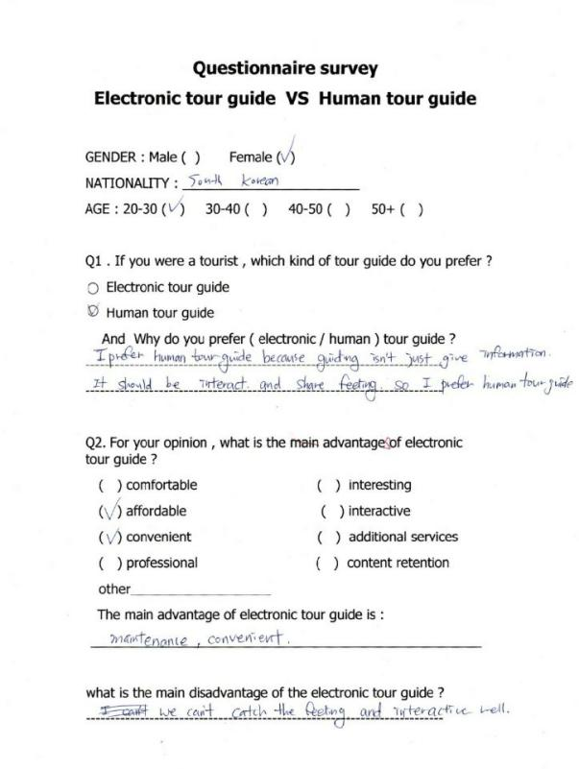

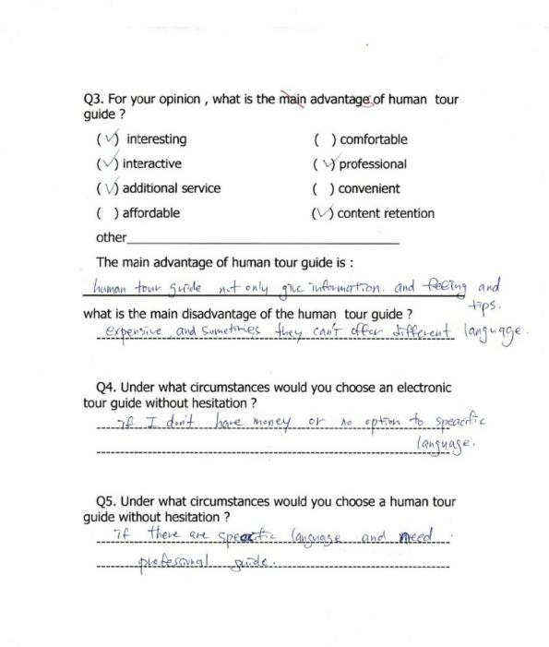

### 9.5.2 Questionnaires result 2:

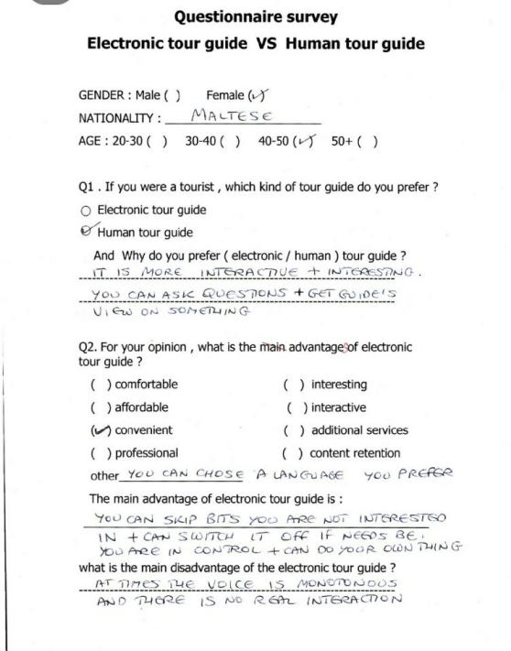

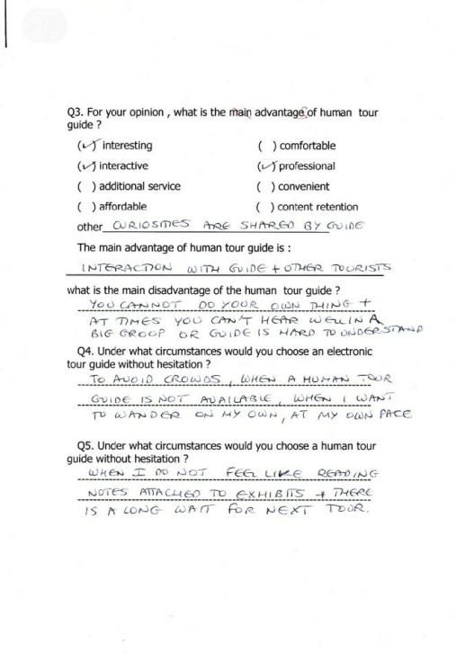

### 9.5.3 Questionnaires result 3:

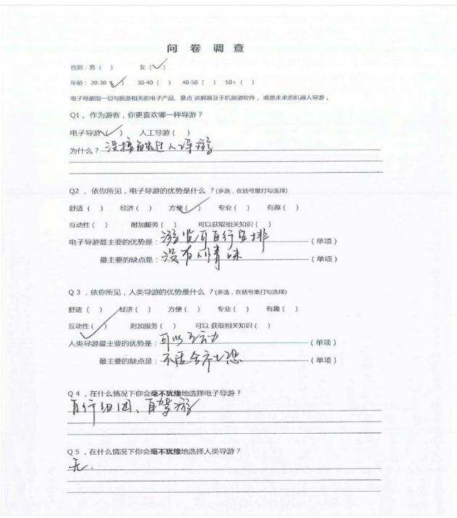

### 9.5.4 Questionnaires result 4:

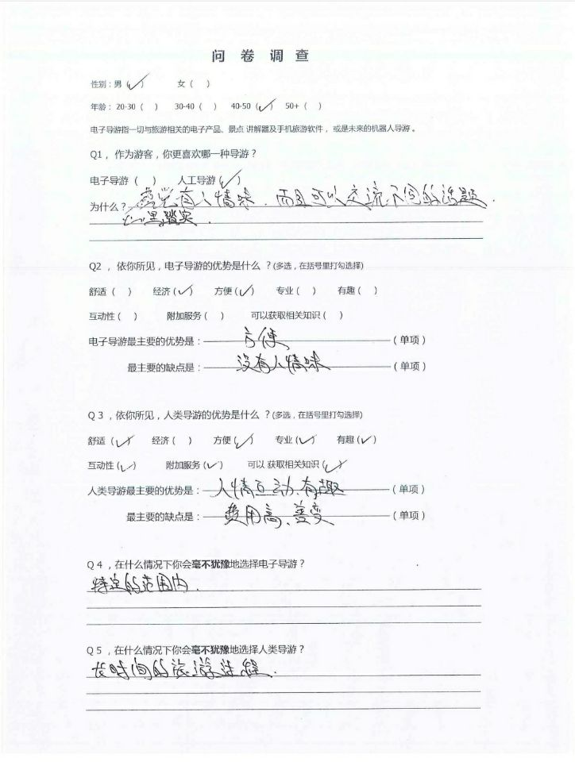

### 9.5.5 Questionnaires result 5:

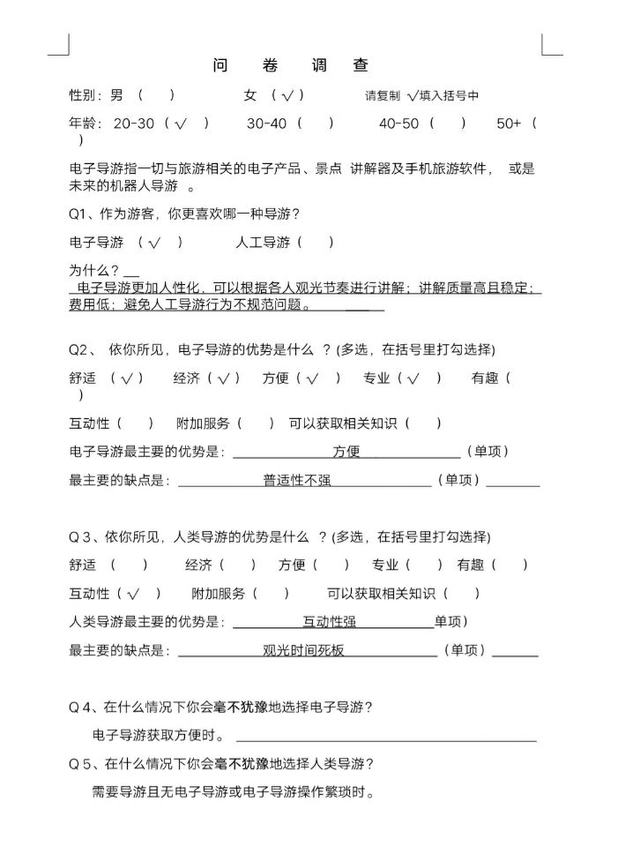

### 9.5.6 Questionnaires result 6:

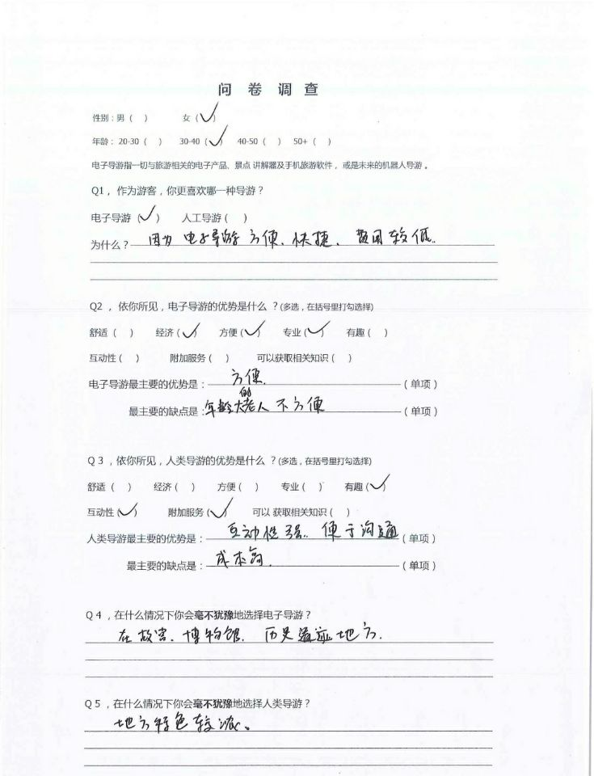

### 9.5.7 Questionnaires result 7:

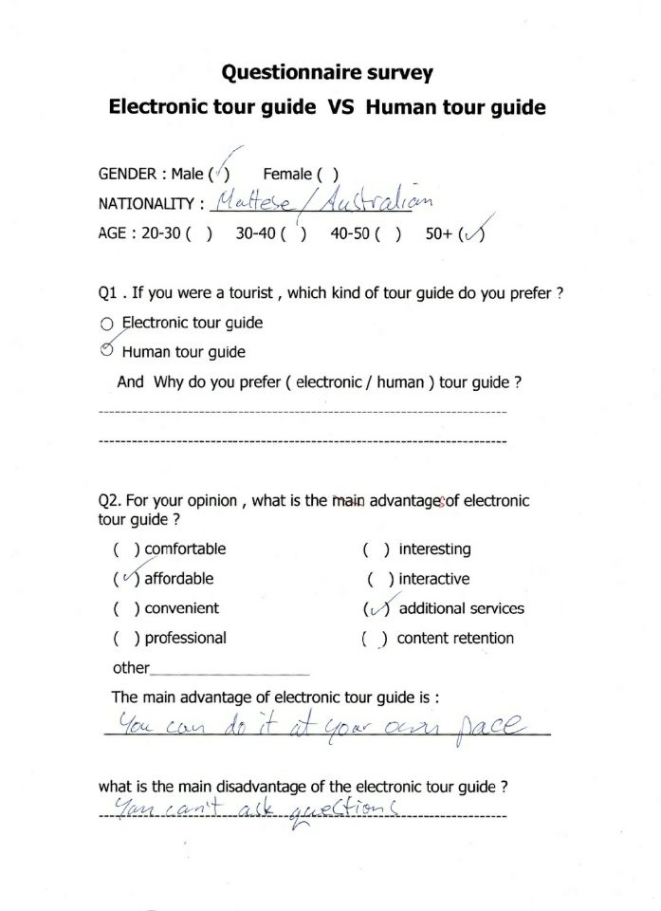

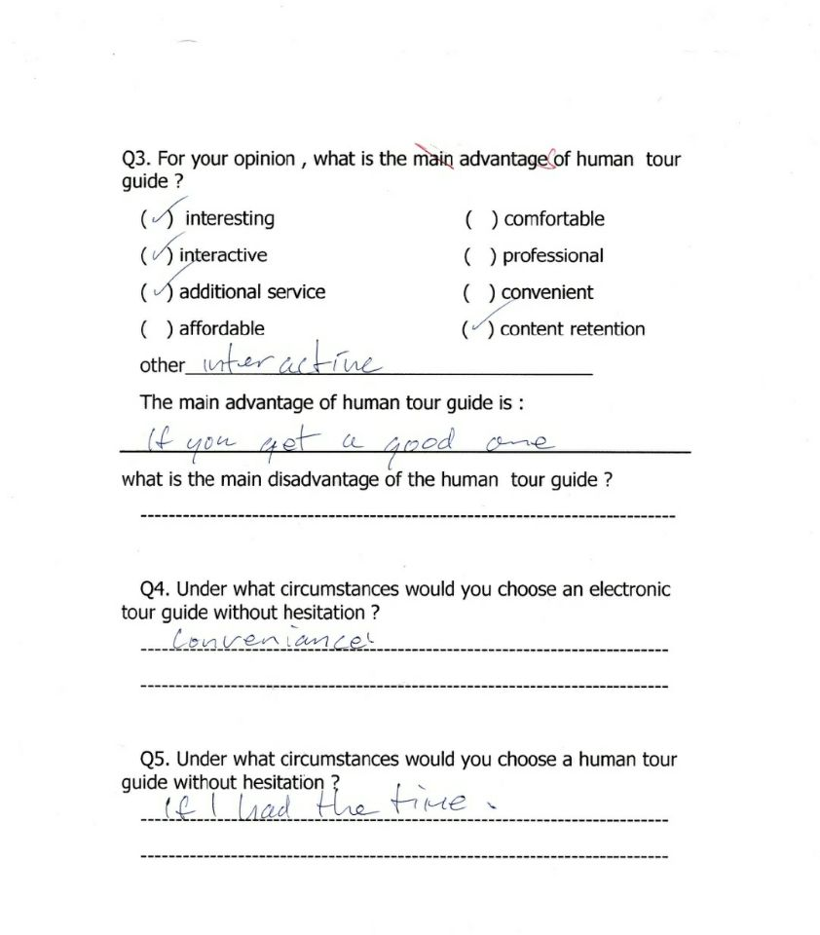

### 9.5.8 Questionnaires result 8:

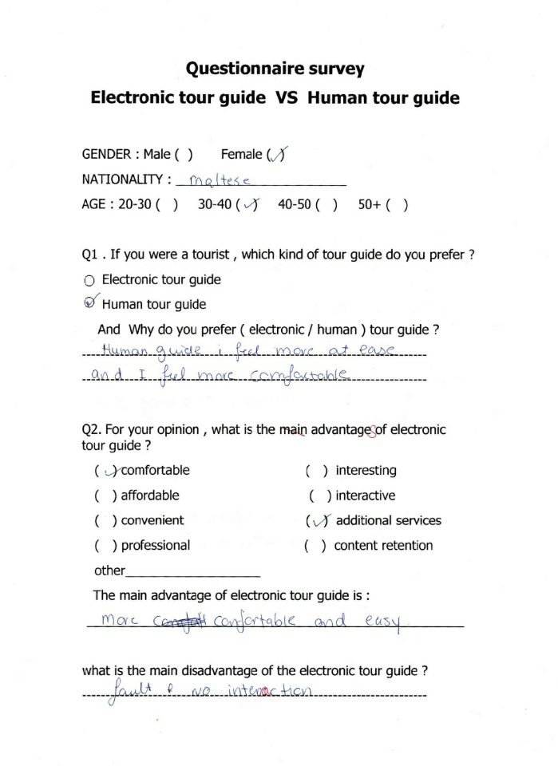

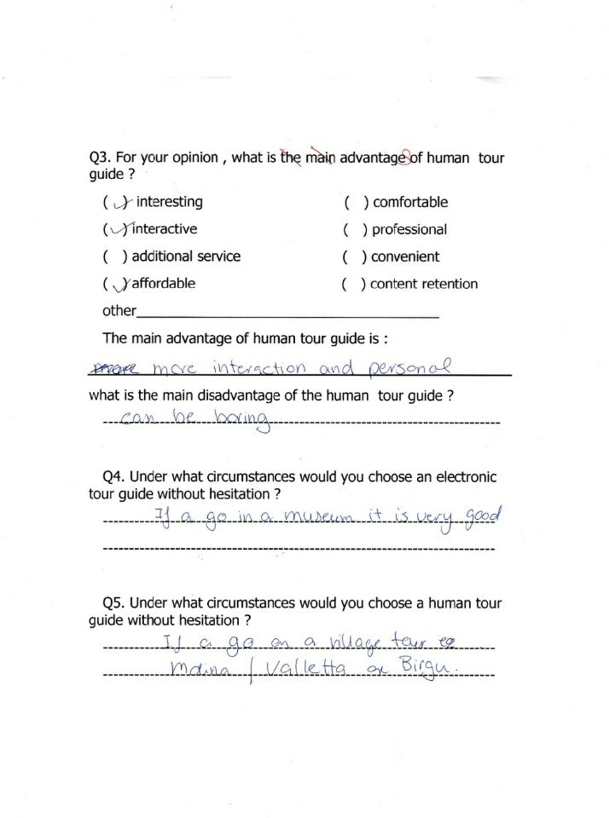

### 9.5.9 Questionnaires result 9:

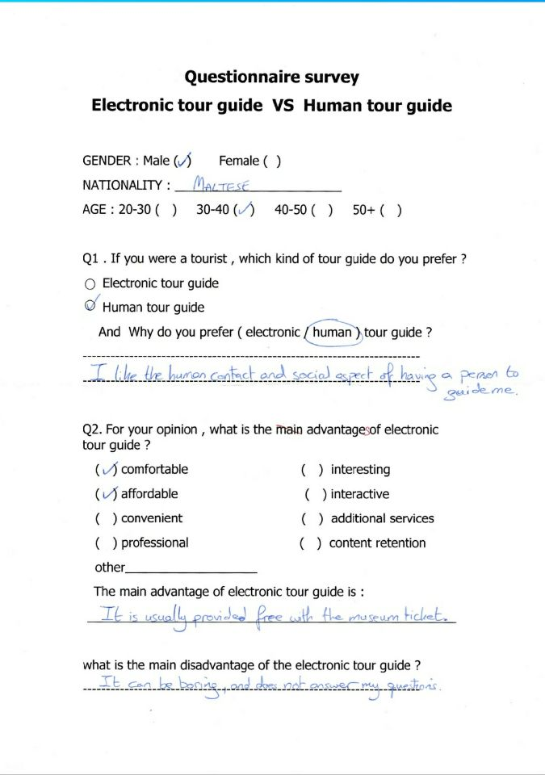

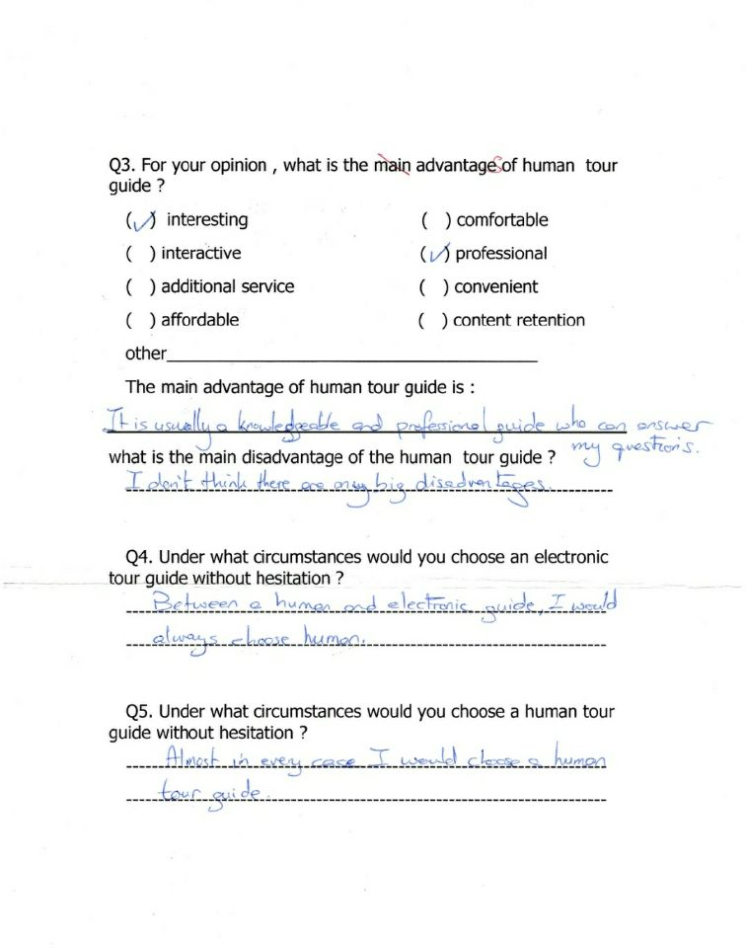

### 9.5.10 Questionnaires result 10:

