Mass Tourism affecting Malta and its inhabitants: An analysis based on reviews by repeat tourists

*Raisa Chetcuti*

September 2020

A dissertation submitted to the Institute of Tourism Studies in part fulfilment of the requirements for the Higher National Diploma (HND) in Tour Guiding.

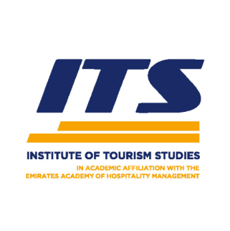

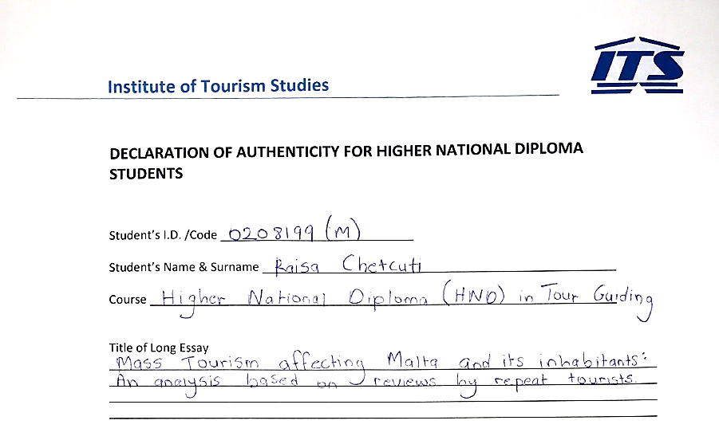

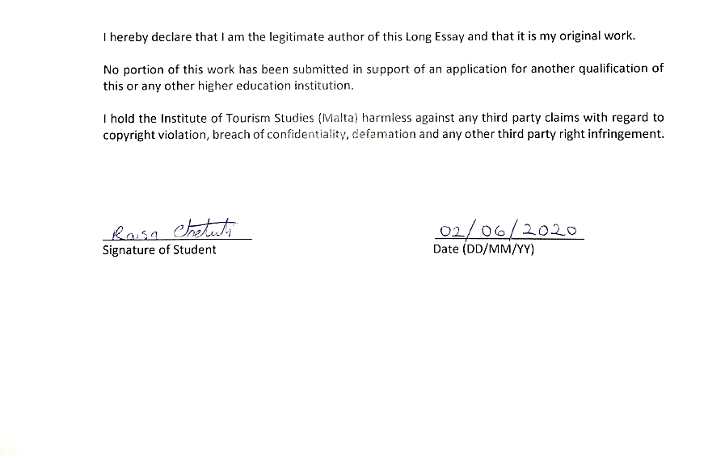

**Abstract**

This research focuses on the current impacts facing Malta and the causes leading to the increase in mass tourism from 2010 till 2019. It is a review of the development of this increase and its effect on the Maltese islands. The marked increase in incoming tourism (that will continue to increase) has given rise to a number of problems and is exasperating endemic problems related to the island’s small size and high population density. The main research question is: “Whether mass tourism can still be considered an economic asset or a problem that is actually risking Malta’s economy”.

The research will try to identify the improvements and changes needed to reconcile mass tourism with more sustainable forms of tourism and try to include the idea of carrying capacity as a tool to control rampant tourist numbers.

The research will be based on a number of questionnaires given to repeat tourists and interviews with key people in tourism to find out what are the main problems that affect repeat tourists and to see whether the problem is being studied by MTA and MHRA personnel.

The long essay will focus on several key aspects of Malta's economy, and present a broad study of a certain depth and analysis of the research in question. Tourism is a vast industry and therefore involves many different stakeholders. Some essential stakeholders for sustainable tourism development are definitely tourists. They play a major role in the tourism industry since tourists need to have a clear picture of the country and what it offers. Henceforth, repeat tourists will be the right audience to seek the desired answers as they tend to see things differently than any local individual and can spot changes which are not clearly seen by first time tourists. Additionally, repeat tourists can also identify the changes seen from their perspective through time and the development of Malta which lead to the current situation.

Keywords: Mass Tourism, Sustainable Tourism, Repeat Tourists, Carrying Capacity, MTA

**Acknowledgements**

It is with immense gratitude that I acknowledge the support and help of my tutor & lecturer Mr David Pace, for his valuable guidance. You provided me with the right guidance that I needed in order to successfully complete my dissertation.

I would like to thank every individual who contributed and participated in taking part of this research which helped me with gaining the desired analysis and conclusion in this long essay, mostly highlighting the Malta Tourism Authority and the travel agency who were of a great assistance. I want to thank you for your excellent cooperation and for all of the opportunities I was given to finalise this research into a reality.

In addition, I would like to thank my parents for their wise advice and for always being there for me. Finally, there is my boyfriend, who was of great support in deliberating over our problems and findings, as well as providing happy distraction to rest my mind outside of my research.

**Table of Contents Page**

AUTHENTICITY 2

ABSTRACT 3

ACKNOWLEDGEMENTS 4

LIST OF TABLES AND FIGURES 6

CHAPTER 1: INTRODUCTION 7

CHAPTER 2: LITERATURE REVIEW 9

2.1 Physical Impacts of Tourism Development 9

2.2 Infrastructure Development and activities 9

2.3 Deforestation 10

2.4 Physical Impacts from Tourist Activities 10

2.5 Transport 11

2.6 Solid Waste, Littering and Sewage 11

2.7 Economic Impacts 12

CHAPTER 3: METHODOLOGY 14

3.1 Choice of Research Methods 14

3.2 Sampling Method and Data Gathering 15

3.3 Data Processing 15

3.4 Testing Hypotheses 16

CHAPTER 4: ANALYSIS AND DISCUSSION OF THE RESULTS 17

CHAPTER 5: CONCLUSION AND RECOMMENDATIONS 39

REFERENCES 41

APPENDICES 44

Appendix A 44

Appendix B 54

Appendix C 71

**List of Tables:**

**Table Page**

1. Evaluation of Accommodation 28
2. Participant Demographics 31

**List of Figures:**

**Figure Page**

1. Butler’s lifecycle curve 8
2. Mass Tourism versus Alternative Tourism 40

**Chapter 1: Introduction**

The Maltese islands consist of three main islands: Malta, Gozo and Comino, situated in a strategic position, just right in the middle of the Mediterranean. In fact, this was one of the various reasons why many of the powers recognised Malta as very significant and wanted to capture Malta. In addition, it is known that Malta was ruled by various rulers, starting from the Phoenicians, the Romans to the Byzantines, the Arabs, the Normans, the Knights of St John, the French and the British. In was then in 1964 when Malta gained independence, becoming a Republic in 1974. Being an island in the middle of the Mediterranean, with such rich, colourful history, one does realise that Malta could make a fortune by promoting it for mostly tourism, and for our warm climate, which is considered to be an asset. This idea indeed was established through time. Additionally, during the late 1950’s, Malta was initially promoted for tourism purposes. Malta’s tourism industry marked the development of tourism as the Maltese authorities sought to identify new areas of economic development in view of the diminishing role of the British in Malta. The evolution of tourism in Malta can be analysed on the Butler’s (1980) tourism destination life cycle model (figure 1) (Dodds, 2007). According to it, visitors will come to an area in small numbers but they would be restricted by lack of accessibility, facilities, and limited awareness of what the country offers as well as lack of marketing. However, as facilities are provided and the awareness on the country grows, visitor numbers will start to increase. With all the points mentioned, including marketing the area’s popularity will grow rapidly. Moreover, the rate of increase in visitor numbers are supposed to decline as levels of carrying capacity are reached, although it is not the case with Malta. Over a million tourists, more than double the island's resident population at an average of 440,000 residents and is experiencing a common condition which many small islands with relatively low carrying capacity suffer: a damaging environmental impact of high-density tourism (Briguglio and Briguglio, 1996, p. 177) This is why tourism developers should try to rejuvenate the tourism destination before it completely reaches a maximum carrying capacity. These stages are depicted in Figure 1. In addition to this, that is how mass tourism is developed, especially as the authorities are money hungry so therefore they are promoting Malta way more than it should be sustainably promoted. Therefore, environmental protection and conservation is very crucial and essential in a country, especially when being a popular tourist destination, like Malta. This applies in different areas as well as in tourist destinations and only wonder ‘why this environmental degradation has become a national and global concern now’ (Ryan, 1995, p. 213). The research will be focusing on the improvements and highlighting the changes that need to be modified, in order to eliminate mass tourism and introduce more sustainable forms of tourism and try to include the idea of carrying capacity as a tool to control a massive number of tourists. The long essay will be also focusing on the environmental factors including land scarcity, water quality, and air quality. Other sectors, such physical impacts, infrastructure development will be also highlighted. Several key aspects of Malta's economy, and present a broad study of a certain depth and analysis of the research in question will be studied as well. Tourism is a vast industry and therefore involves many different stakeholders, they are very important as they play a major role in the tourism industry so therefore that is why repeat tourists will be the right audience to seek the desired answers. Thanks to their background on the island and perspective they will be more aware of the changes done which lead us to the current crisis.

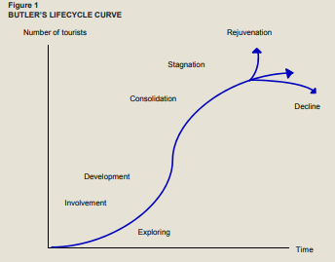

Figure 1: Butler’s Lifecycle Curve

The Butler’s Lifecycle curve theory explains how the economy of resort regions will be affected through time. It is characterised by six distinct stages:

* Exploration
* Involvement
* Development
* Consolidation
* Stagnation

Then either

* Decline

Or

* Rejuvenation

It is in an “S” – shaped life cycle curve which is used to show the number of tourists in a country. The evolution of tourism in Malta can be analysed on the Butler’s (1980) tourism destination life cycle model. One can easily distinguish that Malta faced and is still facing some of the stages. It can be noticed that Malta reached the stage of stagnation; Malta’s future will solely depend on whether tourism developers should try to rejuvenate the tourism destination before it completely reaches a maximum carrying capacity or else a decline would occur.

**Chapter 2: Literature Review**

**2.1 Physical Impacts of Tourism Development**

Wherever you see the term ‘tourism’, the first thing that comes in mind is definitely a well-balanced country with a stable income. The country that does not have a lot of flaws and is a popular destination where people take interest in, irrelevant if it is for cultural, religious or for a medical purpose, amongst other reasons. In the perspective of the leaders who are ruling over the country means doing everything possible to advance in most of the sectors, especially economical wise, that needs to be highlighted. Consequently, this is as tourism has an immediate negative and/or positive impact on the environment. Due to mass tourism in Malta, consequences emerged, especially the physical impacts. The physical Impacts which concern the island itself are quite abundant, researchers have stated that the ecosystem of Malta is resulting into a failure and is not given enough significance (Dodds, 2007). This includes the geographic areas with all the living organisms and what surrounds them, the elements Malta is mostly affected by this due to the reason that it has a lot of attractive landscape sites and sandy beaches, typical of our Mediterranean climate (Bramwell, 2004) This is very eye appealing for both tourists and developers. One of the main negative impacts is the development of tourism facilities. These are mostly the things which do most harm to an island such as Malta. Such as accommodation, restaurants, the extension of sandy beaches and the road construction which results into land degradation and less space on such a tiny island (Dodds, 2007), (NSO, 2018).

**2.2 Infrastructure Development and activities**

For instance, the expansion of natural sandy beaches, being extended by artificial sand where these changes can cause severe disturbance and erosion of the local ecosystem or worst case scenario the disturbance of the local ecosystem in the long term period. Another impact on such a small island is the evolution of marinas and breakwaters which can cause severe changes in currents and coastlines (Infrastructure Malta, 2019) (Jones, A. & Navarro, C. 2018). In addition, overbuilding and extensive paving of shorelines can result in the destruction of habitats and the disruption of the land and sea connections, like sea-turtle nesting spots. The mentioned negative impacts create several problems which need to be modified. Event based tourism promotion activities can also be initiated by the tourism department to capture the attention of tourists round the year and at the same time to avoid seasonality such as Carnival and Holy Week celebrations (MTA). Events like trekking, hikes and recreational activities like rock climbing, diving, bird watching and nature photography can be organized for adventure lovers (Jones, A. & Navarro, C. 2018). Nevertheless, a protected area might certainly be suitable as a tourist-attraction, where tourists can experience amazing nature whilst learning about the conservation and traditional uses of natural resources in the area (Jones, A. & Navarro, C. 2018).

**2.3 Deforestation**

A major problem is indeed the space on such island, as so many is based on the economy of Malta, which equals to money that they seem to forget out limited space. Last but not least, the lack of trees and vegetation spread throughout the island which is very limited. Henceforth, Malta has the EU's largest proportion of built-up land, at 33%. One can notice that most of the greenery is fairly distributed in the northern part of Malta whilst the central/southern part of Malta is bombarded with buildings. Due to all this is that companies are building hotels and boutique hotels, transforming the limited space left in Malta into buildings (Dodds, 2007). The Development Planning Act, the primary legislation that regulates land-use in Malta, is currently under reviewing this problem and so is the Planning Authority (ERA, 2018). These are currently undertaking a review of the Structure Plan, which guides land-use on the Maltese Islands and of subject plans governing main sectors involving land-use. What can be done is Eco-tourism circuits in urban areas can be created in the northern part of Malta as a solution. Recent tourism literature recommends that Malta needs to carryout institutional capacity-building so as to achieve sustainable development (Smith and Eadington, 1992; Hall and Lew, 1998; Ionnides et al., 2001; Bramwell, 2004). Aquilina (2004).

**2.4 Physical Impacts from Tourist Activities**

Another point is the negative outcome which the tourists may leave, such as trampling. Most of the time tour guides follow the same routes for popular places that lead to the use of the same trail over and over again, causing damages to the vegetation and soil. This is obviously caused by the cultural activities. These are for tourists done by tour guides and are often harmful to the environment which can cause loss of organic matter. The reaction to this problem is in process as some areas have been protected either as Nature Reserves under the Environment Protection Act or as Scheduled Property under the Development Planning Act. Both are expected to bring Malta in line with the EU legislation in terms of Nature Protection and are the right thing to do (ERA, 2018).

**2.5 Transport**

The transport by air, road and sea is rapidly increasing. Mostly air transport where even the statistics show that international worldwide passengers increased by 9.8% from the previous year to this current year (ERA, 2018). In addition, road transport is also very commonly used by the tourists and by the locals themselves. It is quite a major problem as there are 394,955 licensed motor vehicles on the roads which obviously increases traffic (NSO, 2019). Continuous traffic jams creates blockages around Malta which one can arrive late for work, school or even appointments (Foxell & de Trafford, 2010). Vehicles when in traffic will still emit harmful gases and damages the environment. New legislations are in process such as the regulation of energy done by the Malta Resources Authority Act. Another solution for the energy problem is solar power. For instance hybrid cars would consume less energy and reduce pollution. There is the need to promote environmentally friendly modes of transport and transport concepts in Malta that can reduce tourism-related traffic and adapt to less environmentally damaging modes of transport as there are only 0.9% which sums up to 3,708 electric and hybrid vehicles used (NSO, 2019). It is also beneficial to reduce and recycle waste, ensuring safe waste disposal and to develop sustainable transport policies and systems such as efficient public transport, walking as well as cycling in destinations (ERA, 2018). Infrastructure development could include measures to avoid traffic congestions for example constructing alternative routes within the area and pedestrian zones.

**2.6 Solid Waste, Littering and Sewage**

In several areas with high concentrations of tourist activities and natural attractions, the disposal of waste is a major consequence which leads to improper disposal which damages the natural environment (Foxell & de Trafford, 2010). Solid waste and littering can degrade the appearance of the sea and the coast, leading the death of marine animals such as sea-turtles who eat plastic bags thinking they are jellyfish (NSO, 2019). In addition, wastewater has polluted seas and it also damages the flora and fauna. This indeed threatens the health of all the humans, animals and biodiversity. The EU Habitats Directive and the Natura 2000 Network of Protected Areas, the National Biodiversity Strategy and Action Plan are implementing and following up EU funded projects related to biodiversity and nature protection (ERA, 2018). The elimination of plastic use and non-reusable materials will be very beneficial for the environment. Another option is to plant more trees and local councils may even start doing “clean-up days” such as coastal clean-up which would be an efficient solution. The latest Waste Management Plan for the Maltese Islands discusses legislation relevant to waste management in the Maltese Islands, with the objective of re-using, recycling and recovery.

The Waste Management Plan has a policy based on four main principles (ERA, 2017)

* To reduce waste and to prevent waste occurring, with a view to achieving a zero-waste society by 2050 (ERA, 2017).
* To manage waste in accordance with the waste hierarchy, whereby it is recognised that waste should be prevented or reduced, and that what is generated should be recovered by means of re-use, recycling or other recovery options, in order to reduce waste going to landfill, and to use the collection system to aid with achieving these goals (ERA, 2017).
* To cause the least possible environmental impacts in the management of waste (ERA, 2017).
* To ensure that the polluter-pays principle is incorporated in all waste management procedures (ERA, 2017).

**2.7 Economic Impacts**

“Many residents [in Malta] appeared to have tolerated mass tourism’s unwanted costs because of their perception of its substantial economic benefits” (Bramwell, 2003:8). Malta’s Economy is mostly based on tourism, so the Maltese government is advertising and selling Malta as a tourist destination. As the government directs the money to support hotels, restaurant chains and international companies, it is not balancing to finance the local needs and what Malta is lacking from. Seasonality should also be highlighted as the seasonal nature of tourism has led to swings in employment (ERA, 2018). This consequence can lead to the residents not liking the island at all, if the government do not plan to start the reduction of pollution, waste, amongst others that have been discussed.

On the basis of research and investigation it can be concluded that tourism has become unreasonable and illogical to some individuals where awareness on the improvement of all points mentioned should be necessarily involved. “Another factor relating to the lack of commitment to sustainability is the issue of improving quality.” (Dodds, 2007). The present study and previous research suggest that it is impossible to sustain tourism in Malta if that is not supported by the local community. Community participation can be facilitated by public hearings, advisory committees, surveys, polls, focus groups, collaboration, and written comments (Dodds, 2007). Policy makers should involve more the locals in making decisions and to understand their aspirations, in this way they can have the opportunity to contribute to a change.

Last but not least, the stakeholders for sustainable tourism development are definitely tourists. Therefore, this research aims to identify the reasons for repeating a destination as well as the socio-demographic and psychographic profile of the repeat visitor to a destination like Malta. Secondly, it aims to investigate whether this repeat visitor attaches emotionally to the community due to his/her regular visits, and see if they are more conscious about the situation in the frequently visited destination (Gitelson and Crompton 1984). Henceforth, a questionnaire will be developed and distributed to repeat visitors, as a number of empirical studies have examined first time and repeat visitors. It was concluded that repeat tourists are expected to be more likely than first-timers to choose the same destination in their future holiday and this was lead to find out what are the main problems that affect repeat tourists. In this research, interviews with key people in tourism will be carried out, to find out and to see whether the problem is being studied by MTA and MHRA personnel.

**Chapter 3: Research Methodology and Data Collection**

**3.1 Choice of Research Methods**

The main purpose of this research is to establish “whether mass tourism can still be considered an economic asset or a problem that is actually risking the Maltese economy”. The approach used in this study was both descriptive and exploratory in order to gain a broad understanding to determine the viability of mass tourism in Malta.

Questionnaires and interviews were completed in two stages, between early November 2019 and early May 2020. The first stage involved identifying the key people in the implementation process. Once that was established, the first stage also involved gathering additional information about Maltese tourism. The research was used to “find solutions to problems which arise in particular policy, planning or management situations” (Veal, 1997: 28). These were the secondary data used in order to continue writing this long essay which also included several books and websites, all cited in the reference section. Once key stakeholders were identified, they were given questionnaires and then interviewed MTA and MHRA personnel to gain in-depth knowledge on certain issues and barriers to find out if they are being studied or not. During the second stage, the interviews were completed. Interviews were undertaken to gain in-depth knowledge about respondents’ perceptions and to see if they are aware of the current issues that Malta is facing which could not be extracted from a questionnaire.

This questionnaire was done to understand the concept of tourism in Malta, and how do tourists view Malta. In addition, the questionnaires collected contained a substantial amount of feedback from a foreigner’s perspective on the island. Doing so, it resulted into getting an actual feedback and what can be improved in Malta.

The methodology used for this questionnaire was classified as deductive process. The deductive process follows a quantitative methodology starting from the initial theory mentioned leading to the development of the hypotheses. The hypotheses are the problems which were elucidated in depth in the previous chapters and they were tested in a cause-effect order. The questionnaires were purposefully done so that variables could be measured numerically and analysed in a statistical manner which determines whether repeat-tourists are able to distinguish certain issues which are currently occurring nowadays. The hypotheses in this study have been tested by means of a mail questionnaire using a Likert scale.

On the contrary, the interviews conducted were more focused on the perceptions given by expert entities and they were based on qualitative methodology. These were completely based on inductive logic as the interviews provide an in-depth analysis on the topic from entities that have been monitoring tourism in Malta for decades. In addition to this, the data collected is rich and could easily lead to further research.

**3.2 Sampling Method and Data Gathering**

Primary Data was collected through a mail questionnaire which was sent to 60 individuals from which 70% had successfully filled and sent back the survey. In total, there were 41 valid completed questionnaires and 1 invalid. The invalid questionnaire was excluded from statistical analysis.

The interviews conducted are also considered as primary data. Two interviews were completed from two different stakeholders; The Malta Tourism Authority (MTA) and The Malta Hotels and Restaurants Association (MHRA).

**3.3 Data Processing**

The questionnaire consisted of 21 questions which focused on several topics that were comprehensively discussed in the previous chapters and is reproduced in the Appendix. The duration to fill in this questionnaire is from about 5 minutes to 10 minutes. Apart from using the Likert scale questions, they also consisted of open-ended, closed-ended, rating, multiple choice and demographic questions which helped in obtaining valuable data. The data collected from the survey was then selected, analysed and then presented by numerous pie charts and graphs which are also found in the Appendix. There were 4 multiple, 4 closed-ended, 5 open-ended, 4 demographic and 4 Likert scale questions. The Likert scale questions consisted of a scale from 1 to 5; starting from poor (1) to excellent (5) and the same questions had additional topic-related questions. Question 12 had 7 additional topic-related questions, Question 13 had 8 additional topic-related questions, Question 14 had 6 additional topic-related questions and Question 15 had 18 additional topic-related questions.

The structured interviews consisted of 10 questions each and both the MTA and the MHRA personnel managed to answer all of the queries asked. The duration of both interviews lasted from about 45 minutes to 1 hour each.

**3.4 Testing Hypotheses**

The first thing after collecting all of the valuable data was to codify the data. The codified data was organised by MICROSOFT WORD 2010, Google forms and MICROSOFT EXCEL 2010 spread sheet which all served as the statistical analysis for the questionnaires. Descriptive Statistics were done as a first level of analysis. These consisted to find ranges and percentages which clearly states and organises the codified data.

Regarding the interviews, a framework was developed which helped a lot to structure and label the data obtained. The approach to analyse the data used was content analysis which is focused on interpretation and understandability. Another approach to simplify data was factor analysis which helped in reducing a numerous amount of variables into fewer, simplified factors which makes it even easier to recognise and interpret data.

Although the qualitative and quantitative data were successfully identified, there were still a few limitations. For instance, one limitation which was overcame was to get enough valuable questionnaire responses which can be a challenge especially with the current situation of Covid 19 in Malta which limits everything and everyone, especially this affected mostly the type of interviews conducted; as both interviews were done via phone. This was an inevitable limitation where one needs to adapt in certain situations, especially a situation like this.

All in all, both the interviews and questionnaires were still done and dusted which was a stepping stone that lead to the analysis and the discussion of the results.

**Chapter 4: Analysis and Discussion of the Results**

This chapter will present the findings resulting from analysis of the data. A summary is generated from data collected from questionnaires and interviews conducted. In addition, its related participant responses are presented in this chapter. Both qualitative and quantitative data were analysed and the findings are displayed as well in this chapter.

One of the analytic tools used in this chapter was Theoretical Sampling. It was used in order to gain a repeat tourist perception rather than focusing on first time tourists who are unable to spot any changes occurring on the island. On the other hand, repeat tourists can identify these variations seen from their perspective through time. Additionally, they play a potent role in the tourism industry, especially because they need to have some background knowledge on the country and its offerings. Therefore, they were the right audience to question as they could see these changes affecting Malta and also its inhabitants.

**Results**

The questionnaire was based on 21 questions which were asked to 41 respondents, all repeat tourists. The first question was asked to see why they selected Malta.

*Q1. How did you choose Malta as a destination? (More than one answer allowed)*

Question 1 was asked to see how the participants got to know about Malta, what made them choose the island instead of other countries and how did the tourists manage to decide to come to Malta. As it was a multiple choice question, there were several answers:

Out of 41 respondents, 4 of them which is equivalent to 9.8% chose to come with a travel agency. In addition, 7 out of 41 participants (17.1%) chose to book on the internet, 30 respondents (73.2%) took their families and friends’ advice, 3 of them (7.3%) chose Malta from travel brochures. Furthermore, 1 out of 41 respondents (2.4%) chose Malta from a radio advertisement and 1 (2.4%) of them stated that she/he had lived in Malta when she/he was young. Last but not least, none of the participants came to know about Malta from Newspapers/Magazines, Travel Guides TV and tourist fairs (0%).

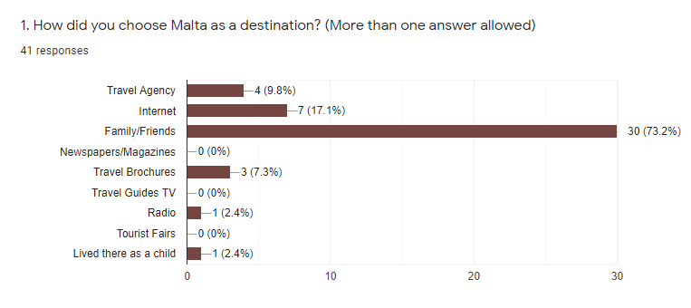

This was a very important question to ask the respondents to establish why they come to Malta and what type of tourists they are; business and professional tourists, leisure and holiday tourists or tourists travelling to visit friends or relatives.

The next question, Q2, was a very significant question asked as it determined the frequent visits of the respondents and if they were repeat tourists or not.

*Q2. How many times have you visited Malta before now?*

Out of the same 41 respondents, 7 (17.1%) of them stated that they visited Malta once before now. In addition to this, 4 (9.8%) stated that they came twice, 6 (14.6%) of them said that they came three times, 5 (12.2%) came to Malta four times and 19 (46.3%) respondents came to Malta more than five times before now.

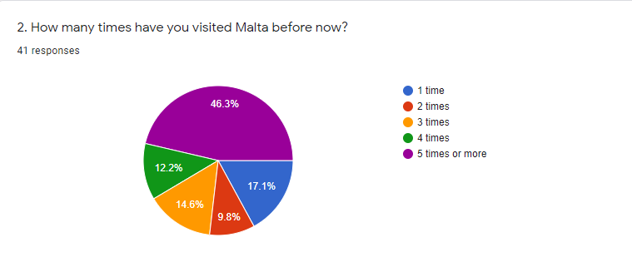

Furthermore, question 3 consisted of asking the respondents about their aim of choosing Malta as their destination.

*Q3. What was the aim of your holidays in Malta? (More than one answer allowed)*

Out of 41, 17 (45.5%) respondents chose Malta as a beach holiday, 4 (9.8%) chose Malta for its Nature and for walks, 4 (9.8%) chose Malta as their honeymoon destination, 10 (24.4%) chose Malta as their cultural holiday, 6 (14.6%) chose Malta for various festivals, 3 (7.3%) chose Malta for its nightlife, 1 (2.4%) chose Malta as a spiritual holiday, 25 61%) chose Malta for a family visit, 2 (4.9%) chose Malta for work purposes, 20 (48.8%) chose Malta for relaxing, 1 (2.4%) chose Malta to do an English language course. None of the participants chose Malta for diving purposes, as an active holiday and for eco-tourism.

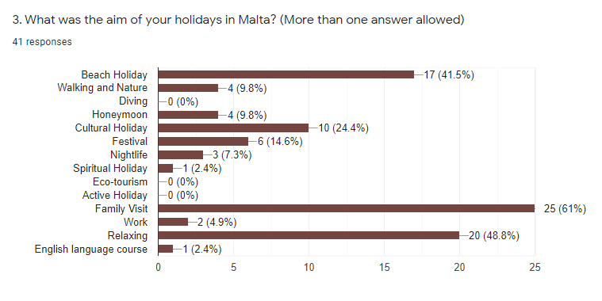

The next question asked, determined whether the respondents enjoyed coming to Malta or not.

*Q4. (A) Did your trip to Malta meet your expectations?*

From the 41 responses, 26 respondents (63.4%) chose “completely’’, 11 (26.8%) chose “for the greater part’’ and 4 (9.8%) chose “Partly”. None of the participants chose “Not really” or “Absolutely Not”.

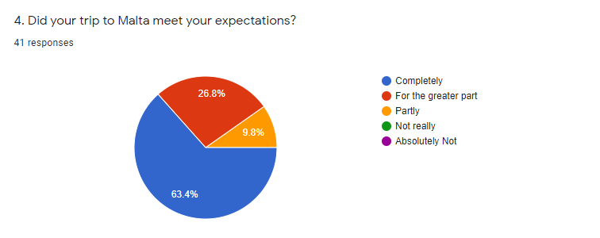

Then another question was asked in relation to *question 4:*

*Q4. (B) If not, please state why?*

4 out of 41 participants answered the question from which 3 out of 4 responses were valid whilst 1 response was invalid for the only reason that Respondent No.14 did not completely understand the question asked.

The three main answers were based on different topics;

The first response was from Respondent No.28 who stated that *“commute to beaches is too long”* and that *“Public transportation is unreliable”.* This problem is an issue which was mentioned in **Chapter 2** (section **2.5 Transport**) and was noticed by this participant during his/her stay in Malta.

The second response stated by Respondent No.32 was about how *“the island changed so much, since his/her first visit”* and *“how the new infrastructure destroyed much of Malta’s old world charm and heritage”.* In addition, this is another problem which was mentioned in **Chapter 2 (section 2.2 Infrastructure Development and Activities, section 2.3 Deforestation)** and this participant managed to notice all of these changes during his/her many stays in Malta.

The last, very similar response to the second response was from Respondent No.33 who stated that there is “too much dust and building upheavals everywhere you go”. This was explained in **Chapter 2** (section **2.3 Deforestation**) that mentions how the rampant buildings being built all over the island, results into land degradation and less space on such a tiny island (Dodds, 2007), (NSO, 2018).

Question 5 was one of the most significant questions to ask as it determined what the respondents like about Malta and what exactly led them to choose it as their destination repeatedly,

*Q5. What do you LIKE the most during your visit to Malta?*

11 out of 41 respondents (17%) liked the Maltese beaches, 9 respondents (14%) enjoyed the culture, 8 (12%) respondents liked the Maltese people, 8 (12%) respondents liked to visit their family and friends. In addition, 5 out of 41 respondents (8%) came for the weather. Another 5 respondents (8%) liked the Maltese food, 4 respondents (6%) enjoyed the nightlife, 3 respondents (5%) enjoyed the scenery and another 3 respondents (5%) liked the historical background that Malta has. Furthermore, 4 respondents (6%) liked the lifestyle, 2 respondents (3%) loved the nature, 1 respondent (2%) liked Carnival and another 1 respondent (2%) enjoyed learning the Maltese language.

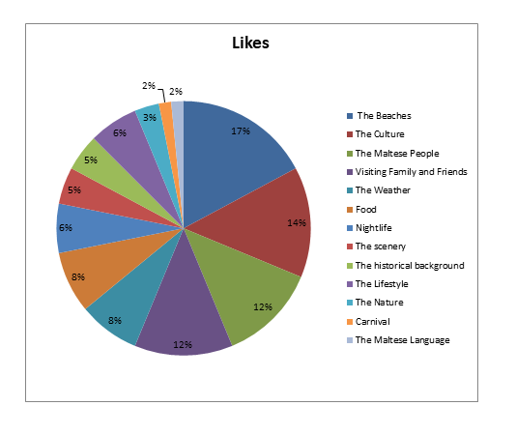

11

9

8

8

5

5

4

3

3

4

2

1

1

*Q6. What did you DISLIKE the most during your visit to Malta?*

8 (17%) out of 41 respondents said that they disliked the traffic in Malta, 12 (25%) respondents stated that they did not like the Public Transportation, 6 (13%) participants said that they disliked nothing, 3 (6%) participants said that they did not like the building construction sites, 9 (19%) respondents commented on the islands cleanliness and 1 (2%) respondent said that there are a lot of tourists on the island. In addition, 1 (2%) participant stated that Malta is not as advanced as other countries, 2 (4%) respondents said they disliked the pollution in Malta, another 1 (2%) respondent disliked the heat, 1 (2%) other participant did not like the heat, 1 participant (2%) said that Malta has become too commercialised and another 1 (2%) said that he disliked Maltese politics. In addition, 1 participant (2%) said that the Maltese people lacked “common manners”, another 1 participant (2%) did not like Malta in winter and 1 respondent (2%) did not like the karozzin drivers which occupied the streets.

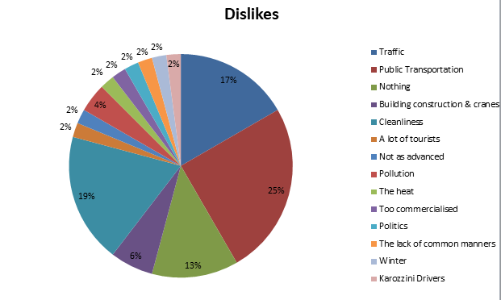

8

12

6

3

9

1

1

2

1

1

1

1

1

1

*Q7. (A) Would you visit Malta again within the coming 5 years?*

36 (87.7%) out of 41 participants stated Yes, 5 (12.2%) said that they do not know and none (0%) of the respondents said No.

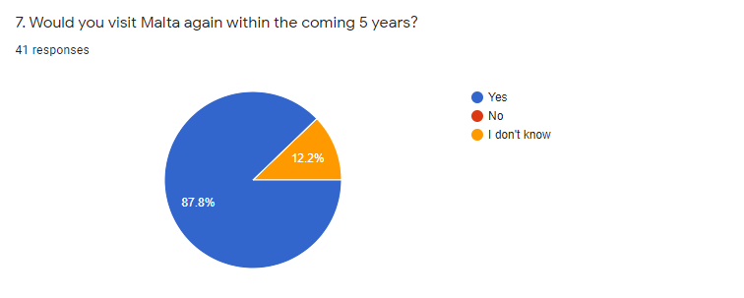

An additional question was asked in relation with question No. 7 to try to understand why they would visit the island again:

*Q7. (B) Please state why?*

37 out of 41 participants answered positively and 4 out of 41 participants answered negatively about visiting the island again. Many of the respondents described Malta as “the most beloved island in the Mediterranean” and how “*Malta deserves to be visited again as it is rich of heritage sites and natural landscapes.”* There were others who said that they will visit the island again to see their families and friends again and there were several responses on coming back here to Malta for the Sun, Sea and Sand. On the other hand, there were four negative comments; the first respondent answered *“I do not know”* and the reason being was as he/she *“has financial issues”,* another respondent who also answered the same question expressed how *“the flights are too expensive to travel from Australia.”* The third respondent does not want to visit Malta as he/she *“would like to go somewhere else”* and the last participant answered the following:

*“Because of nature, sea, and cultural heritage. I hope that the construction sector consider the nature of the typical Maltese houses before building those horrible block apartments! Malta is very beautiful, and it's a pity seeing that nature has been replaced by apartments, and buildings everywhere.”*

This respondent expresses exactly how Malta is losing its identity and its typical characteristics due to the Maltese carrying capacity. Furthermore, this shows how Malta has become full of buildings which are an eyesore for many. This topic was discussed in detail (**Chapter 2** - section **2.3 Deforestation**) and is now a real issue that even repeat tourists are slowly becoming aware of the rampant changes done to the island.

*Q8. What would you do during your next holiday to Malta? (More than one answer allowed)*

19 out of 41 respondents (46.3%) said that they will visit it as a beach holiday, 9 respondents (22%) will visit it for walks and nature, 4 participants (9.8%) will visit Malta for diving, 2 respondents (4.9%) will visit it as a honeymoon destination, 12 respondents (29.3%) prefer to visit it as a cultural holiday, 15 participants (36.6%) said that they will visit Malta for festivals, 10 respondents (24.4%) prefer to visit it for the nightlife, 2 participants (4.9%) will visit it as a spiritual holiday and another 2 (4.9%) will visit it for Eco-tourism. 3 participants (7.3%) prefer to visit it as an active holiday whilst 23 participants (56.1%) will visit Malta to see their families. 3 respondents (7.3%) will chose it for work purposes whilst 24 (58.5%) would rather visit Malta for relaxation purposes. In addition, 1 particular respondent (2.4%) said that he/she would visit it as an experience to learn more about agriculture and another 1 (2.4%) said that he/she will purposefully come to Malta to visit his/her friends.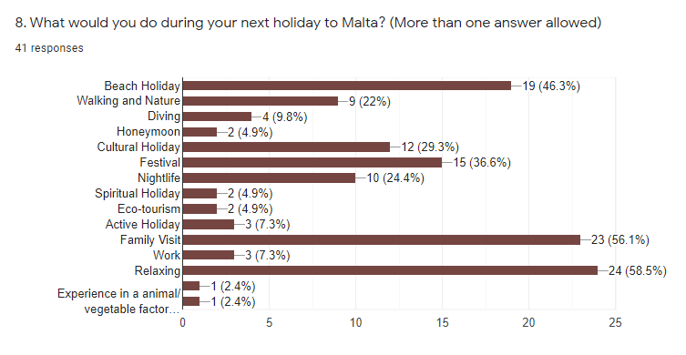

Viewing these results, one can understand that Malta is still aggressively promoted for the sun, sea and sand. It is also promoted for other motives such as culture, heritage and meetings but there is the need to start advertising Malta for other purposes to attract more tourists for different purposes. Henceforth, one can recognise how most of the repeat tourists would rather come back again for the same reasons they came for the first time rather than trying something new. This is due to always promoting Malta for the same things, which always include our Mediterranean climate. One can also view how few respondents prefer to visit Malta for Eco-tourism or as an active holiday; this is indeed due to the lack of advertisements promoting Malta for such reasons. This diminishes the variety of things that one can do in a country and it can result in tourists preferring other countries rather than Malta. In fact, this is also evidenced by the MTA 2018 -2019 statistics; first-time tourists have increased by 7.5% while repeat tourists were only increased by 1.6% which is quite low compared to first-time tourists.

*Q9. What changes would you like to see during your next visit to Malta?*

6 out of 41 respondents (15%) said that they would not like to see any changes to the island, however there were a lot of the participants who want to see several changes:

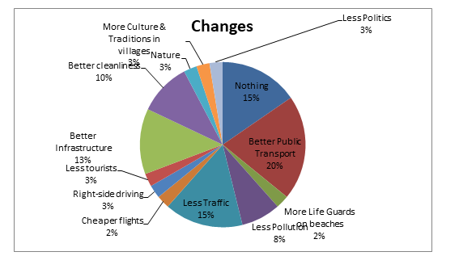

8 out of 41 participants (20%) want to see better public transport, 1 respondent (2%) would like to see more lifeguards on beaches and 3 participants (8%) wrote that they wanted less pollution. Furthermore, 6 respondents (15%) would like to experience less traffic, 1 particular respondent (2%) would like to have cheaper flights whilst another particular participant (3%) would like to see right-side driving in Malta. In addition to these, another participant (3%) want to see fewer tourists when visiting the island, 5 out of 41 respondents (13%) would like to see better infrastructure and 4 participants (10%) said that they would like to see better cleanliness. Last but not least, 1 respondent (3%) would like to see more nature, another 1 (3%) wants less politics and the last respondent (3%) wants to see more culture and traditions, especially in rural areas and villages.

After analysing these results, most of the issues are about better infrastructure, better cleanliness, better public transport, less traffic and less pollution. These problems were all mentioned in **Chapter 2 (sections 2.1 Physical Impacts of Tourism Development, 2.2 Infrastructure Development and activities, 2.3 Deforestation, 2.5 Transport and 2.6 Solid Waste, Littering and Sewage)** and they are all issues that should be adequately tackled.

*Q10. How long did you stay in Malta?*

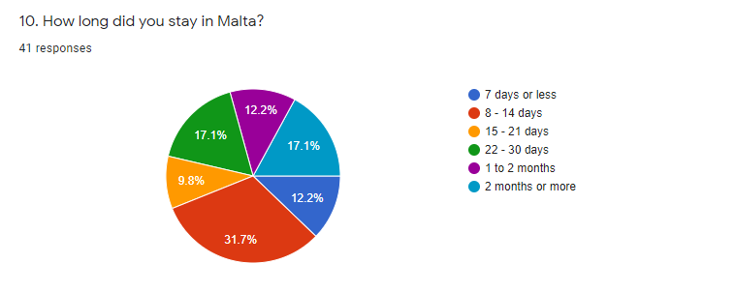

5 (12.2%)

13 (31.7%)

4 (9.8%)

7 (17.1%)

5 (12.2%)

7 (17.1%)

*Q11. What means of transportation did you use in Malta? (More than one answer allowed)*

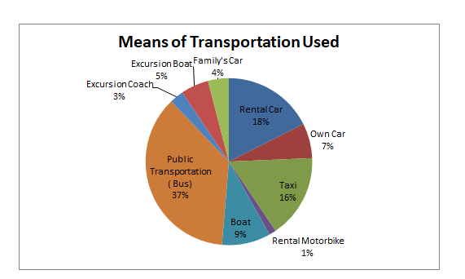

Surprisingly, although many people noticed the improvements needed on public transport, it is still the most popular option selected by tourists while to rent cars or to hire taxis are not the most popular options.

The next five questions were extremely important as they determined the respondents’ perceptions on Malta from a scale from 1 to 5 using the Likert Scale method.

**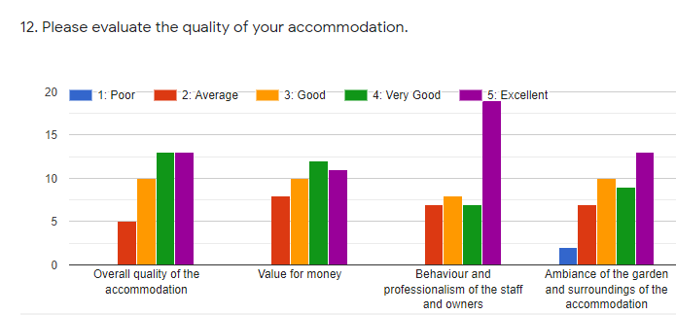***Q12. Please evaluate the quality of your accommodation.*

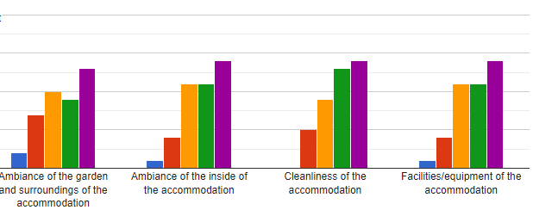

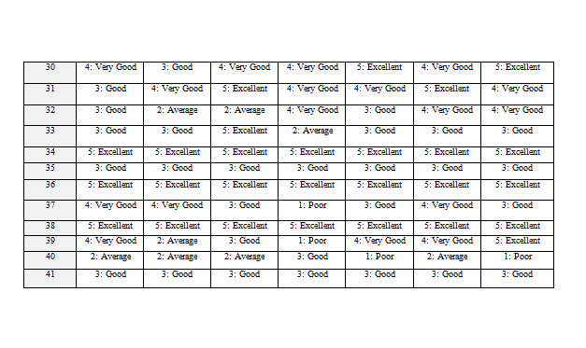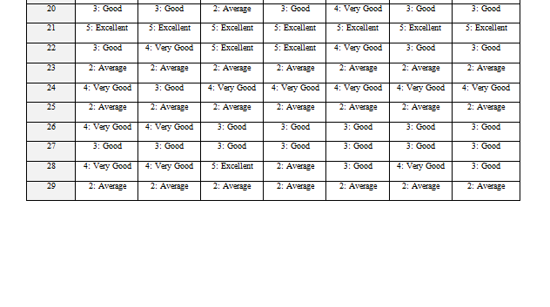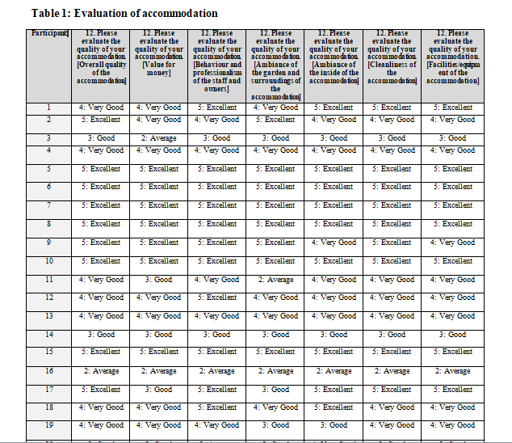

*Q13. Please evaluate the quality of restaurants, cafes and bars of Malta.*

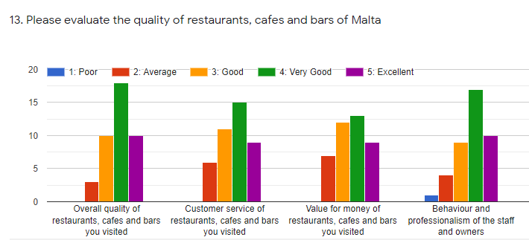

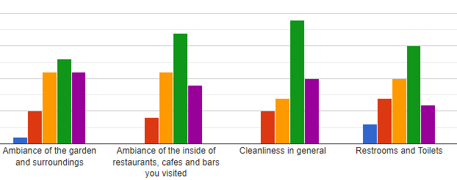

The next question asked was about the quality of the Maltese beaches:

*Q14. Please evaluate the quality of our beaches.*

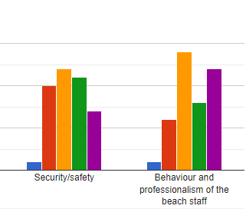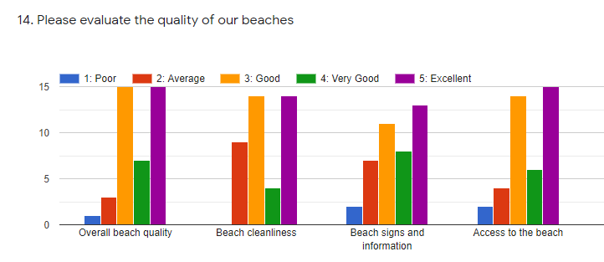

*Q15. Please evaluate the different aspects of our area.*

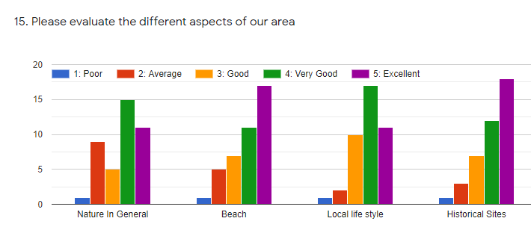

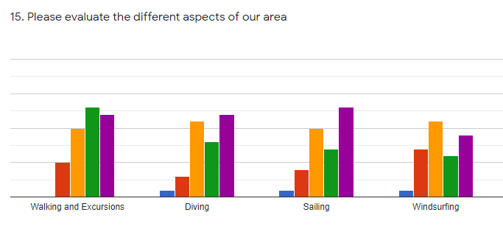

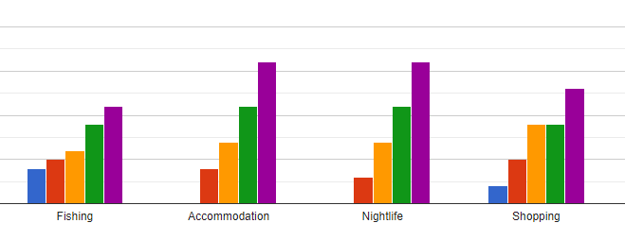

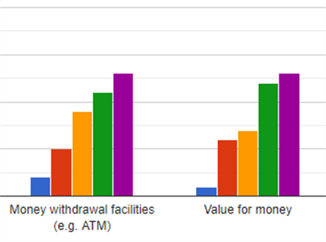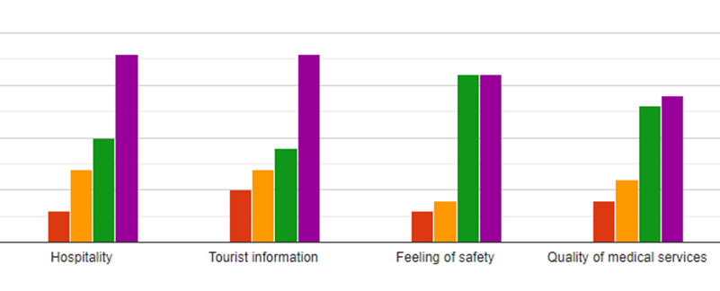

**Table 2: Participant Demographics**

The results showed a variety of responses from the participants based on the demographic questions. Starting with question number 16, the most popular answer from the visitors who participated was their age; ranging from 18 up to 24 years, totalling 22%.

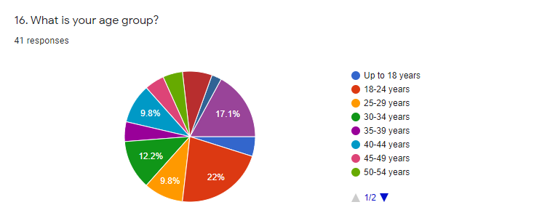

In addition, question number 17 examined their current status, in this case the most selected answer was Employed Full-time, totalling 29.3%

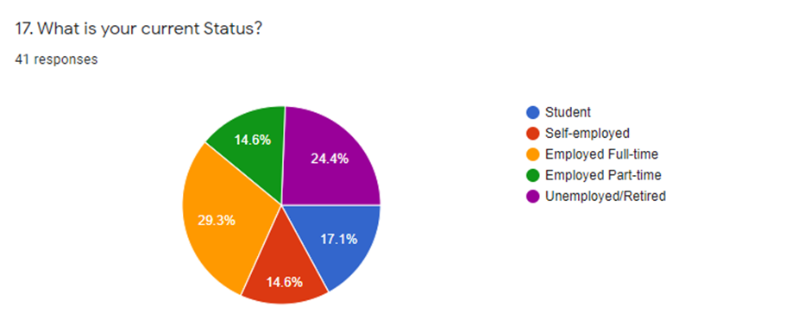

Question number 18 was asked to know their nationality; 46% of the respondents are from Australia, this determines that there is a large amount of people travelling from Australia to visit Malta.

Last question, question number 19 was asked to get to know with whom they travelled to visit the island of Malta, 46.3% said that they travelled with their partner which was the most commonly used answer.

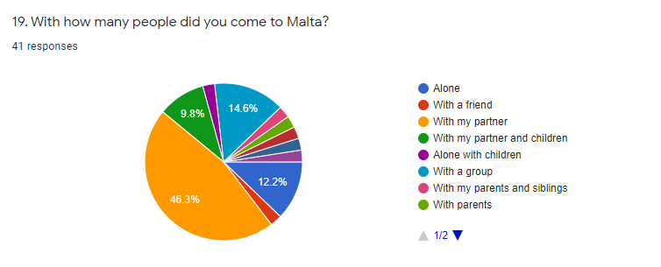

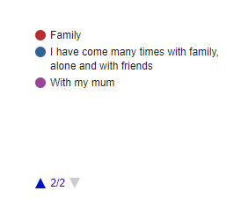

**Summary**

More detailed information on the demographics of the participants can be seen above in Table 2. After analysing the data, it was concluded that overall, repeat tourists are aware of the rampant changes on our island. This is as they are seeing the infrastructure developments and the physical impacts that are currently affecting Malta. The study identified that repeat tourists can actually see the differences from their previous visit to their next. This is especially because many of them must have encountered some of the problems mentioned in **Chapter 2 - Literature Review** during their visits in Malta, although despite these consequences, the problems did not limit them from visiting Malta again. This is a sign that Malta has still great things to offer but these things should be promoted and tackled the right way in order to improve the tourists’ satisfaction. Furthermore, this will attract more tourists and it will bring more income as the visitors would book more days to spend in Malta, rather than choosing a new destination.

After analysing the questionnaires, the interviews were next;

Once the interviews were finished and recorded, the results were transcribed verbatim into a Microsoft Word document. After writing down every word, the data was analysed. The first interview was done with the Malta Tourism Authority (MTA). MTA was chosen as one of the stakeholders in this study for several reasons, mostly because it is *“the tourism industry's regulator and motivator, its business partner, the country's brand promoter, and is here to form, maintain and manage meaningful partnerships with all tourism stakeholders. Primarily, this means attracting visitors to the Islands, but also working closely alongside the private sector partners.”* (Quoted from the Malta Tourism Authority Website)

MTA was the perfect choice as they monitor, maintain and promote tourism. Therefore, an interview was arranged to get to know if they are aware of the current situation in Malta and to see if something is being done to maintain tourism in a sustainable way. They also agreed that they felt comfortable being recorded during the interview.

Another interview was conducted with the Malta Hotels and Restaurants Association (MHRA) which was also a great stakeholder as *“the Association maintains close contact with government departments and ministries, keeping them aware of the problems facing this industry from time to time.”* Furthermore, they proved to be an excellent choice for an interview as they work with a lot of important, influential stakeholders.

In addition, the central questions guiding this study were the following:

1. To see if they are aware of the rampant changes & constraints and also to identify if they know about the current situation in Malta. (Awareness)
2. To identify what measures they are taking and to understand which implementations they are doing in order to improve the situation in Malta. (Implementations)

The full transcriptions of both interviews can be found in the Appendix.

**Summary**

On the basis of study and investigation it can be concluded that Malta is suffering from over-tourism and awareness on the improvement of many of the points mentioned in **Chapter 2 – Literature Review** should be necessarily involved.

The present study and previous research suggest that it is impossible to sustain tourism in Malta if that is not supported by the local community, tourists and the authorities themselves. Community participation can be facilitated by public hearings, advisory committees, surveys, polls, focus groups, collaboration, and written comments. Policy makers should involve more the locals in making decisions and to understand their aspirations but they should also take note of the tourists’ demands. Henceforth, in this way the authorities can have the opportunity to contribute to a change which can be successful in achieving more quality tourism. In addition, MTA has come up with a support scheme to boost the economy. This is known as The Major Tourism Events Support Scheme (MTESS) and this scheme provides assistive funding for the development of massive events. Furthermore, this scheme was initiated to boost Malta’s attractiveness, to generate the economy as well as the international marketing and to prolong the tourist season which is a good initiative to advertise Malta for other purposes.

Apart from the positive impacts of the tourist development, what is currently occurring is due that the tourism developers are supporting mass tourism because it generates a lot of income for local areas, despite the fact that it is completely ruining the physical impacts of tourism development mentioned in **Chapter 2 (section 2.1).** This was proven after conducting both interviews with MTA and MHRA; MTA stated that Malta’s economy is more of a “*volume intense destination”,* rather than Mass Tourism but Malta is clearly a mass tourism destination. Especially as mass tourism is usually when there are a huge amount of people visiting popular destinations. In addition, mass tourism is a phenomenon which is necessarily identified where there is seasonality in a country. According to the research found Malta does suffer from mass tourism which is an active problem that needs to be solved. For the case of Malta, mass tourism is often present in the summer months; this was confirmed with the MTA representative who clearly said: *“In July/August/September, we reach the highest levels”* and how *“volumes are intense and are big as last year we have reached the 2.7 million figure”* which is a huge amount of tourists travelling to Malta. On the other hand, MHRA are evidently aware on Malta suffering from mass tourism. In addition, this was precisely confirmed when the MHRA representative said how *“mass tourism brings a lot of problems with it although it contributes well to the economy and to the country”.*

Seasonality is another impact which should be improved. According to both MTA and MHRA, they both said that seasonality is something that they are working on. MTA said that they negotiate a lot with airlines and the opening of new routes during low seasons which will give a boost in more tourists coming over in the winter months but this do not affect nor will improve the quality of tourism. In addition, MTA organises events such as the Baroque Festival held in January whilst MHRA is introducing Dark Tourism in winter months which is a great initiative which if promoted the right way, it would easily attract a lot of new tourists whilst making sure that the economy is well balanced in the low seasons as well. In addition, this will definitely help Malta to focus more on promoting other seasons in order to have tourism all year round not only during peak seasons.

Many trees are being chopped off in order to enhance Malta’s road works and infrastructure. A third of Malta is covered with built-up and other artificial areas whereas vegetation and greenery is lacking. Both MTA and MHRA are aware of this; MHRA stated that the tourists’ demand is high, but the tourism quality is decreasing as Malta does not have the quality environment and this is a grievous evidence that Malta will end up losing its quality due to the authorities always looking at numbers. Furthermore, MTA seems to be lacking awareness when it comes to dealing with the tourists demands as they are more focused on attracting more and more tourists with new airlines routes which is where they are lacking as they should see the bigger picture where Malta has a carrying capacity which they need to be aware of as the island cannot sustain more tourists.

Henceforth, there are a lot of residential areas where people use certain commodities such as cars and public transport which according to this analysis; are two of the most popular type of transport used by tourists. These two, including all other types of transport result in a lot of pollution and traffic congestions in Malta. According to these results, tourists do not only complain on the traffic congestions, but also on the service of the public transport which both MTA and MHRA mentioned that when referring to their annual tourists’ survey analysis, many of the negative answers would be on the service itself, over crowdedness on buses and on bus stops. These are the impacts which are degrading and severely damaging the country and this is where the quality should be improved.

Tourism is a rapidly growing industry and the impacts of tourism are extremely varied. On one hand, it plays an important and certainly positive role in the political development and others, many job opportunities are generated by tourism, providing more construction of the resort, in travel, in food provision and in other service related industries but this was proven wrong when viewed from the perspective of a local commonly average person, as many foreigners are taking most of the jobs. This is as foreigners are more determined to work for low wages and that is why they get employed unlike the locals who are very selective when it comes to the type of work and wages. Both MTA and MHRA said that in tourism, the only way is to start from the bottom and go up the ladder by promotions rather than having a high wage. This is unfair to the locals as tourism related jobs are paid low considering the fact that there is quite a huge need for local staff.

In addition to this dissertation’s analysis, it was concluded that the authorities are only focusing on how to attract tourists to Malta, but not preserving the island. Neither MTA nor MHRA have on-going projects about sustainability which is something that lacks and something definitely has to be done. It was proven that both MTA and MHRA are finding it challenging to shift the economy from mass tourism to a more sustainable alternative which in reality they should come up with new incentives as there are ways of promoting Malta in a more sustainable way. In fact, MTA said how they are finding the environmental impacts the most challenging which is a bit worrying as they should start on planning a way to start improving Malta on the negative impacts to improve the tourism quality.

Doing these two interviews with the MTA and MHRA were very beneficial as a lot of valuable information was gained. After analysing all of the data, this led to the next chapter. During chapter 5 conclusions and recommendations will be discussed in detail.

**Chapter 5: Conclusions and Recommendations**

After analysing all the data obtained from the research, questionnaires and interviews, it was concluded that tourists seem to have a different perspective on tourism than the MTA and MHRA officials. Both MTA and MHRA seem to be pre-occupied with rampant tourism and mass tourism but were unable to present any workable alternative In addition, this is mostly due to Malta being an island that has invested in mass tourism for so long, that now they are finding it very difficult to change direction. Furthermore, there are no plans to introduce sustainable forms of tourism neither from the government nor from the MHRA which is something that needs to be introduced. Henceforth, another consequence is that the country is not investing enough in the natural environment, as there is not enough environmental protection and conservation. Last but not least, there are several liabilities such as the difficulty to access the countryside and also there is too much conflict between different groups such as hunters and tourists which both do not know how to compromise with each other.

Although there were attempts to try to mitigate the island’s over-dependence on mass tourism by focusing on business, cultural and historical tourism, it is quite evident that the interviewees do not have any concrete solutions.

In addition, there must be a decent investment into promoting alternative tourism which there isn’t any from the MTA. Also, there needs to be a plan particularly after the COVID scare and a decent attempt to diversify the tourism product. In addition, both interviewees mentioned no current plans to diversify the tourism product. This process will scatter tourists to different areas which is also very beneficial for repeat tourists and for first-time tourists as well, especially to see Malta being promoted for other factors, not only for the sun, sea and sand as usually depicted. The type of niche tourism chosen is dark tourism, as it is one of the most recent growing types of tourism in Malta’s tourism industry. Dark tourism definitely proves to be sustainable when contemplated carefully, especially in the case of Malta as it can serve as an alternative tourism but also to avoid seasonality and have tourism all year round.

In conclusion, there is the need to promote environmentally friendly modes of transport and transport concepts in Malta that can reduce tourism-related traffic and adapt to less environmentally damaging modes of transport. It is also beneficial to reduce and recycle waste, ensuring safe waste disposal and to develop sustainable transport policies and systems such as efficient public transport, walking as well as cycling in destinations. Infrastructure development could include measures to avoid traffic congestions for example constructing alternative routes within the area and pedestrian zones.

Last but not least, if contemplated carefully, all recommendations given will definitely make a huge difference to drastically improve the situation in Malta.

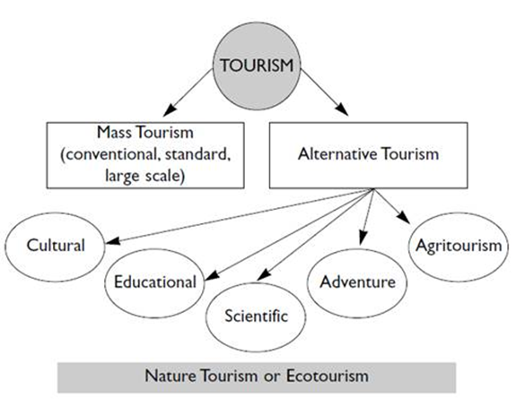

*Figure 2: Mass Tourism versus Alternative Tourism*

**References**

Briguglio, L. and Briguglio, M. (1996), ‘‘Sustainable tourism in the Maltese Islands’’, in Briguglio, L., Butler, R., Harrison, D. and Leal Filho, W. (Eds), Sustainable Tourism in Islands and Small States: Case Studies, Pinter, London, pp. 162-79.

Foxell, E. & de Trafford, A. 2010, "Repositioning Malta as a cultural heritage destination", International Journal of Culture, Tourism and Hospitality Research, vol. 4, no. 2, pp. 156-168.

Bramwell, B. (2003), "Maltese responses to tourism", Annals of Tourism Research, Vol. 30 No. 3, pp. 581-605.

Markwick, M. 1999, "Malta's tourism industry since 1985: diversification, cultural tourism and sustainability", Scottish Geographical Journal, Vol. 115 No. 3, pp. 227-47.

Jones, A. & Navarro, C. 2018, "Events and the blue economy", International Journal of Event and Festival Management, vol. 9, no. 2, pp. 204-222.

Ayres, R. 2000, "Tourism as a passport to development in small states: reflections on Cyprus", International Journal of Social Economics, vol. 27, no. 2, pp. 114-133.

Hitchcock, M. 1997, "Sustainable Tourism in Islands and Small States: Issues and Policies / Sustainable Tourism in Islands and Small States: Case Studies", The Journal of Development Studies, vol. 33, no. 5, pp. 737-738.

Pavlic, I., Portolan, A. & Puh, B. 2019, "Does Tourism Cut the Branch it is Sitting On? – Local Residents' Perspective", Montenegrin Journal of Economics, vol. 15, no. 2, pp. 153-164.

Dodds, R. 2007, "Malta's Tourism Policy: Standing Still or Advancing towards Sustainability?", Island Studies Journal, vol. 2, no. 1, pp. 47-66.

Fakeye, P.; Crompton, J.L. (1992). “Importance of socialisation to repeat visitation”, Annals of Tourism Research, 19 (2), 364-367.

Gitelson, R. J.; Crompton, J.L. (1984). “Insights into the repeat vacation phenomenon”. Annals of tourism Research, 11 (2), 199-217.

Ryan, C. (1995). Researching Tourist Satisfaction, London: Routledge.

Malta Tourism Authority (2006), Tourism Policy for the Maltese Islands (2007-2011), Government of Malta, Valletta.

NSO. (2018, January). NSO. Retrieved 05 03, 2019, from NSO: https://nso.gov.mt/en/News_Releases/View_by_Unit/Unit_C3/Tourism_Statistics/Documents/2018/News2018_005.pdf

Office, N. S. (2014). NSO. Retrieved 05 03, 2019, from NSO: https://nso.gov.mt/en/News_Releases/View_by_Unit/Unit_C3/Tourism_Statistics/Documents/2018/News2018_005.pdf

(ERA), E. a. (2018, November). State of the Environment Report 2018 - Summary Report. Environment and Resources Authority (ERA) & National Statisitics Office (NSO).

Infrastructure Malta. (2019, July 31). Retrieved June 02, 2020, from Maritime Infrastructure: https://www.infrastructuremalta.com/projects/maritime-infrastructure

ERA. (2017). 12. Delimara Decommissioning WMP_post ERA comments 26 May 2017. Environment & Resources Authority.

Office, N. S. (2019). News Release. October.

Wasteserv. (n.d.). Retrieved 05 25, 2020, from Wasteserv: https://www.wasteservmalta.com/statistics

Wasteserv. (n.d.). Retrieved 05 3, 2020, from Wasteserv: https://www.wasteservmalta.com/sortitout

Vella, M. 2018, Population growth killing Maltese tourism is an actual financial risk, San Gwann, Malta.

Costa, M. 2018, Even in Malta, the fight against mass tourism starts gathering steam, San Gwann, Malta.

Dark Tourism

**Appendices - Appendix A**

The Dark side of Southern Malta – A Half-day tour with a difference

This tour runs for a spooky four hours in which you will go to Malta’s Southern area and get a peculiar and mysterious view of the mentioned area. You will get the opportunity to pass through the dark and creepy streets of several towns and be told some of the most terrifying stories in the south of Malta while stopping off at some really dark and infamous places. You will get to see another side of Malta, an obscure, different perspective from the lovely beaches that the island is known for…make sure to bring your torches for an effective experience!

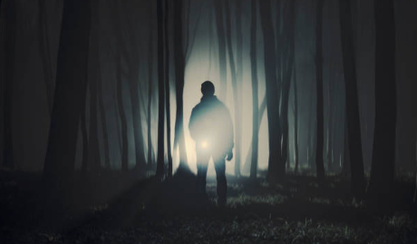

Introduction:

Tourism is an important factor in most of the developed countries, which these countries get a decent amount of income yearly. It is very evident that tourism plays an important role in Malta, having the GDP as high as 63.9%. Furthermore, it is also known that tourism is becoming rampant with all of these huge amounts of tourists visiting the Maltese islands. The marked increase in incoming tourism (that will continue to increase) has given rise to a number of problems, mostly regarding endemic problems related to the island’s small size and high population density. In addition, this process is known as mass tourism, which is not only affecting the locals living in the highly visited areas, but it affects everyone which emerges consequences. By promoting the same type of tourism for repetitive times will only result into risking Malta’s economy, as it is clear that Malta mostly depends on tourism which causes a major imbalance on the other sectors. Henceforth, by not giving enough importance to the other sectors, Malta’s economy will become solely based on tourism which can be mostly interpreted as wrong for various reasons. One of them being that many tourists visit the most popular tourist attractions found on the island, which is a major consequence of mass tourism. Therefore, to eliminate or at least reduce the amount of tourists from the usual areas, one should focus on promoting an alternative tourism. By promoting an alternative tourism, you are not only generating income with the help of another type of tourism, but one will also reduce the amount of tourists from the most populated areas to less populated areas, especially in rural villages which are not that popular with tourists. This process will definitely scatter tourists to different areas which is also very beneficial for repeat tourists and for first-time tourists as well, especially to see Malta being promoted for other factors, not only for the sun, sea and sand as usually depicted. The type of niche tourism chosen is dark tourism, as it is one of the most recent growing types of tourism in Malta’s tourism industry. Dark tourism definitely proves to be sustainable when contemplated carefully, especially in the case of Malta as it can serve as an alternative tourism but also to avoid seasonality and have tourism all year round. Dark Tourism started to become extremely popular in the early 90s, but it only recently has sparked the interest of many individuals worldwide. Somehow, many countries are involved with dark tourism and even unknowingly promote dark sites, such as Auschwitz in Poland, or to Pompeii in Naples. Dark tourism varies upon many dark activities; this can be shown on a dark tourism spectrum, which can range from the lightest type to the darkest type of dark tourism. In addition, dark tourism can take many forms; such as grief tourism, disaster tourism and supernatural tourism, amongst others. The tour prepared is mostly based on supernatural tourism, although it is mixed with educational tourism where tourists can learn about Malta’s history with a paranormal twist. Although this tour is based to promote the southern part of Malta, it can be still done with other areas as it can also serve as a bespoke tour depending on your client’s preferences. A map is provided below to show a chronological description of the tour:

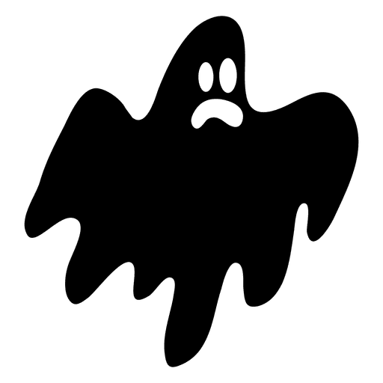

Tour Map:

Żejtun

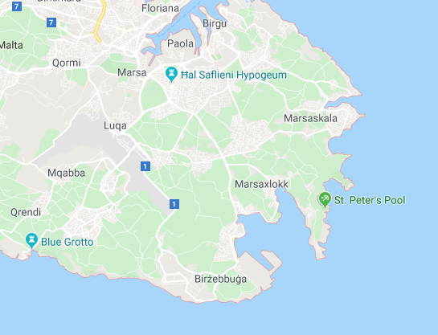

The tour would kick off in front of the Addolorata Cemetery’s main gate. Guests will be welcomed and given all of the safety instructions. Each guest will be given a bottle of water, a map and ensure that everyone has a torch, as most of the places will be very dark. After taking all of these measures, tourists would be furnished with some background information before actually going inside.

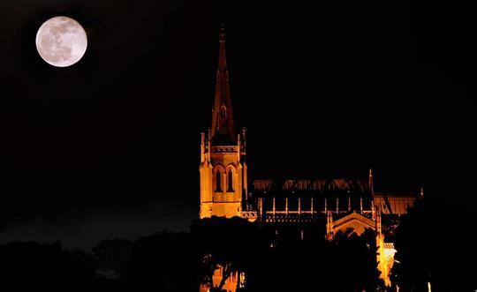The Dark side of Marsa – The Addolorata Cemetery

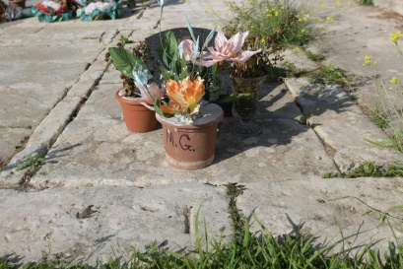The Santa Maria Addolorata Cemetery was built and inaugurated in 1869. It was designed by architect Emmanuele Luigi Galizia in a neo-gothic style, as we can presently see. In the 19th century, it served as a cemetery, reserved only for Roman Catholics coming from the Cottonera area, Valletta and its suburb, Floriana. It was then in the 1960s that the cemetery was then opened for everyone, regardless of their Religion. At the time it was built the deceased were buried in churches and who ever had contagious illnesses like the plague were buried in outdoor burial grounds although many people did not like to bury their deceased outside a church, especially as they were very keen on religious beliefs. The first burial occurred in 1872, three years after the inauguration of the cemetery. It was Anna Magro, who was buried in common grave 1. She was originally from Naxxar so technically she could not be buried there, but she died in the Floriana hospital so there was a special permit which was authorised by the government. The second burial took place the following day, a six-month old baby boy was also buried there.

When walking through the cemetery, one can see the amazing architecture of the chapel and might also reveal some interesting monuments, statues and graves. There one can find several graves belonging to famous or well-known people, such as the one of Giuseppe Gouder, he was just eighteen years old when he died in a tram accident in 1905. Then we find the statue depicting a weeping angel that tells the story of Giulio Mifsud, who will be forever known for his bravery. He died at the young age of 19 years old during the Second World War in 1942, to save the life of his friends.

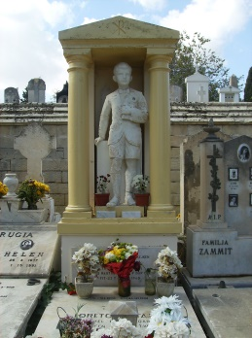

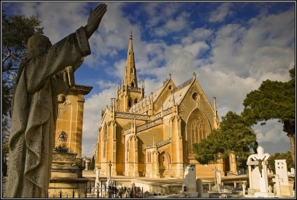Famous among visitors is the grave of Twanny Aquilina, an eight-year-old boy who was killed with a bread knife in 1960. The murderer is still unknown to this day, although some say that his mother Giga was responsible for her son’s murder but always denied it. In the provided picture, one can see the commemorating monument of the boy in his Holy Communion outfit.

Now we can go deeper inside the cemetery, make sure to stay within the group as this cemetery is considered to be one of the largest cemeteries that we find onto our island and if explored alone it can easily turn into a labyrinth!

The guests will have some time to explore the cemetery along with the tour guide before heading to the next stop, Birżebbuġa.

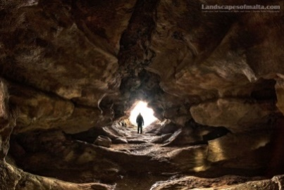Birżebbuġa with a paranormal twist – The Legend of the Haunted Cave, Għar Ħasan

Birżebbuġa is a seaside town, very close to Marsaxlokk. The town is very popular and it is known for its sandy beach, Pretty Bay. The village is also important for its archaeological sites Għar Dalam, Ta' Kaċċatura and Borġ in-Nadur, and another cave known as Għar Ħasan. The cave of Ħasan was once known as a secret hide-out in the 12th century by a Saracen, which lies within the coastline cliffs of Birżebbuġa. The views from this cave are breath-taking, one can actually see panoramic view of the sea horizon, and it is definitely worth a visit. Although one does not only go for its beauty, but also as it is very famously known for a particular legend.

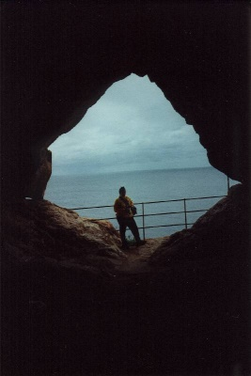The legend tells us that the Saracen used a knotted rope tight at the entrance to enter the cave, as it was very different from what we find nowadays at the main entrance. Once arrived to the main entrance, make sure to switch on the torch. Unfortunately an iron-gate bar blocks the access to proceed to the inner parts, although one can still enter the man-made chamber present which is thought to be Ħasan’s living quarters.

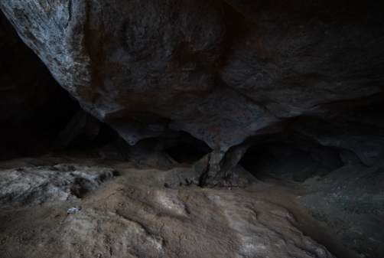There are numerous versions of the legend, but the most popular of these tells the story of the Saracen whose name is Ħasan. It is said that he abducted a beautiful girl and held her captive in the cave where he took refuge. This angered the girl’s family who started to investigate what happened to the girl and after sometime they found the cave. They went in to attack him but the terrorised Ħasan flung the girl into the sea below, and then jumped after her and committed suicide.

One can actually feel the energy surrounding the cave, the energy it transmits is ancient although one actually feel a hint of sadness, maybe Ħasan and the girl want us to feel this way!

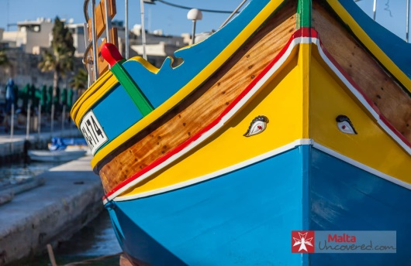The ‘evil eye’ of Marsaxlokk – Villa Sans Souci

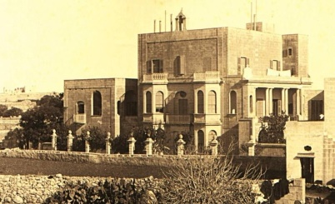Marsaxlokk is a fishing village which is equipped with a harbour. It is a tourist attraction known for its views, fishermen and history. Marsaxlokk is well known for the colourful lively luzzus, cafeterias, bars and restaurants, among others. Although one would think the contrary of lively when seeing the abandoned villa just in the outskirts of this village known as Villa Sans Souci. This villa was built by Professor Salvatore Luigi Pisani in the 1870s. Originally, it was used as his private residence but after his passing, it was later used as a hotel in the 1910s.

Villa Sans Souci is said to be haunted by a sense of dread, perhaps it has something to do with Pisani dying inside the house. In 1940, the villa was eventually sold to the Royal Air Force to serve as a base, but was abandoned. Once the villa was abandoned, it became a target for vandals and thieves due to its valuable items and architecture. The reason this house is haunted remains unknown but it is said to be one of Malta’s most haunted locations. Noises were repetitively heard coming from the inside of the building. In addition, anyone who enters the house claims a sense of paranoia following them everywhere. This happens as soon as one enters the building.

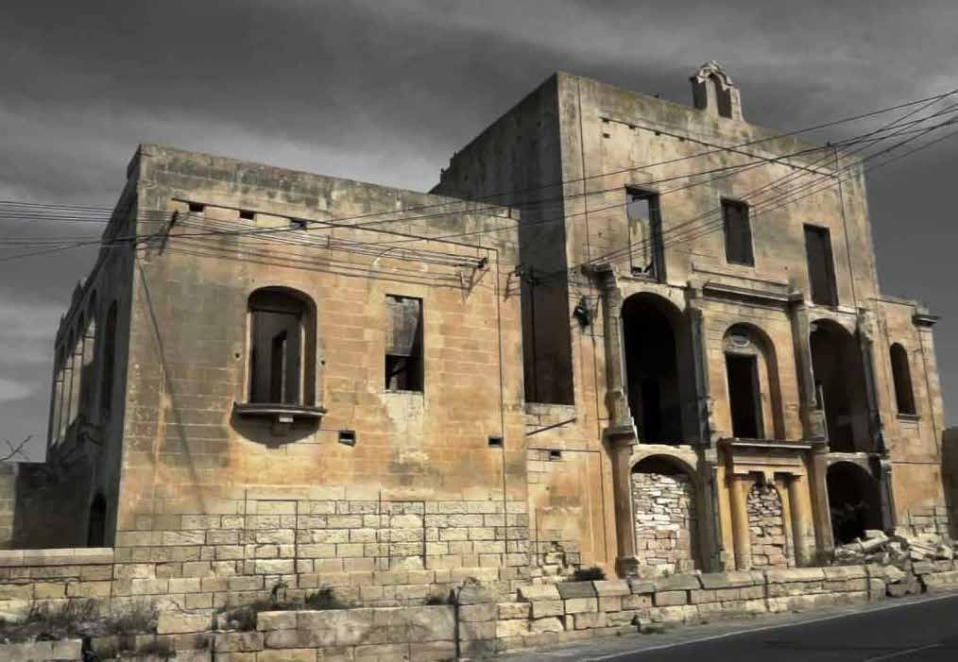

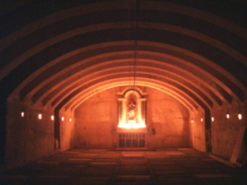The Deadly side of Żejtun – The crypts inside the parish church of Saint Catherine

Żejtun is traditionally known as Città Beland, a title given by the grandmaster of the Order of the Knights of Malta, Hompesch in 1797. Before this time, the village was named after its patron saint and parish titular, known as Casale Santa Caterina. In fact our patron saint is indeed Saint Catherine which even the local Parish Church is dedicated to this saint. Inside the parish church, one can find these large crypts that have been dug in the rocks.

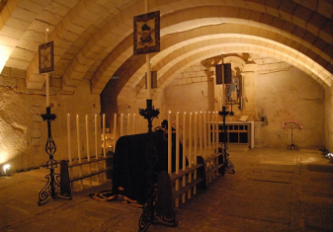The grave in front of the altar inside the crypt had been reserved for the Testaferrata family, the heirs of Girgor Bonici, who was the benefactor. It was in 1709 that the first burial took place in this crypt. It remained in use until 1975. Under the Parish Church of St Catherine one finds two crypts, the main crypt known as Il-Mudlama. Along the north side of the main crypt, there are three narrow passages which lead to the side facade of the church. These passages were done to facilitate air circulation.

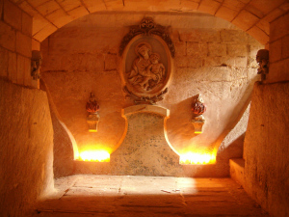

On the southern side, one finds the second crypt which was built in the 18th century. At the end of this crypt there is a medallion of Our Lady of the Rosary flanked on each side by soul sculptured figures, the burial area in front is reserved for members of the clergy. On the side walls of both crypts one can still identify the tombs from the marks onto the walls.

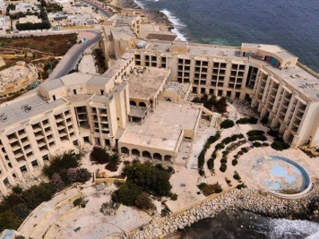The supernatural side of Marsascala – Jerma Hotel

Marsascala is a very well-known fishing village in Malta, with an astonishing bay that attracts many swimmers. It was also home to a 5 star hotel back in the days known as the Jerma Palace. The Jerma Palace Hotel was a 5 star hotel and it was built in 1982 by a Libyan investment fund. It was recognised to be the largest hotel ever built in the south of Malta. The Jerma presence meant that the village of Marsascala will no longer be known as a fishing village but will become a village dedicated to tourism.

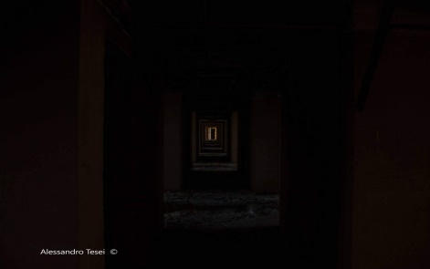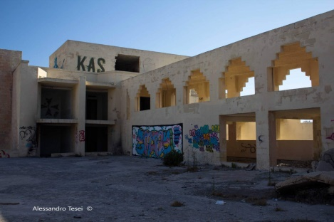Unfortunately, the Hotel closed its doors in 2007, and in a very short time it became abandoned. Over the years it served as a refuge for drug addicts and is recently a suicide spot. Nowadays, the hotel is now in a derelict state, with parts of it having collapsed and its interior having been stripped of everything of value. The walls are covered in graffiti. The area surrounding the abandoned Jerma Palace Hotel is one of the South’s favourite swimming spots. Although creepy, this hotel is surrounded by colourful graffiti.

The tour would end in Marsascala, after a walk near the beach where guests will have the opportunity to have a chat about their personal paranormal experiences or stories over a complimentary drink offered after the tour next to the beach.

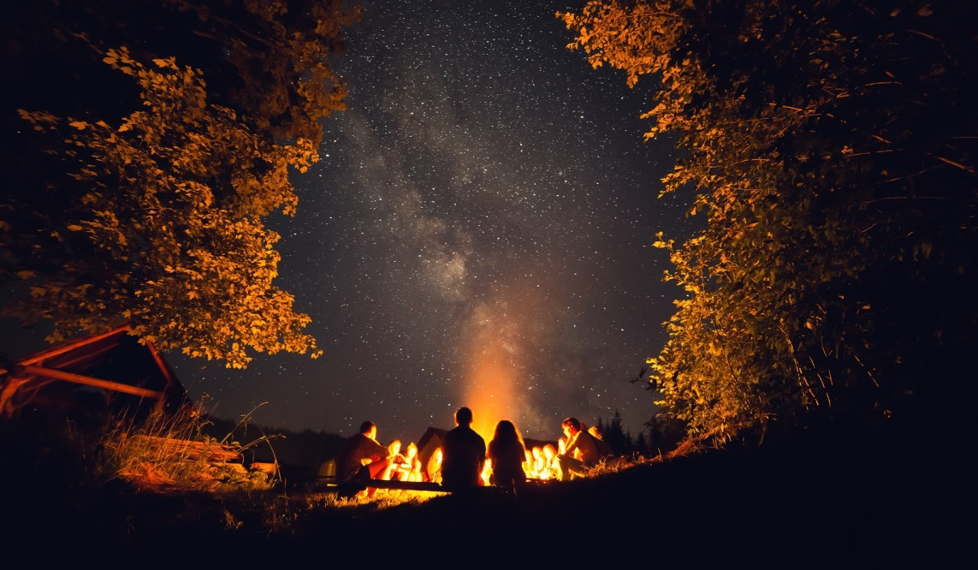

**Bibliography**

Calleja, C. (2019, November 2). *TimesofMalta*. Retrieved January 2, 2020, from TimesofMalta: https://timesofmalta.com/articles/view/seven-secrets-from-the-addolorata-cemetery.745440

Calleja, L. (2017, June 26). *Shootingmalta.* Retrieved January 1, 2020, from Shootingmalta.: https://www.shootingmalta.com/blog/2017/6/19/villa-sans-souci-marsaxlokk-malta

Dowling, K. C. (2019, October 28). *GuideMeMalta.com*. Retrieved January 1, 2020, from GuideMeMalta.com Web Page: https://www.guidememalta.com/en/7-parties-kiddie-events-ghost-tours-events-to-hit-in-malta-this-halloween

Dowling, K. C. (2019, March 31). *GuideMeMalta.com*. Retrieved January 1, 2020, from GuideMeMalta.com Web Site: https://www.guidememalta.com/en/an-abandoned-graffiti-jungle-does-the-jerma-palace-hotel-have-a-bright-future

MireilleMichael. (2017, May 9). *Wattpad*. Retrieved January 02, 2020, from Wattpad - The Ghosts of Malta: https://www.wattpad.com/story/108657531-the-ghosts-of-malta

Office, N. S. (2014). *NSO*. Retrieved 05 03, 2019, from NSO: https://nso.gov.mt/en/News_Releases/View_by_Unit/Unit_C3/Tourism_Statistics/Documents/2018/News2018_005.pdf

Teodor. (2016, October 29). *Lovin Malta*. Retrieved 1 1, 2020, from Lovin Malta Web Site: https://lovinmalta.com/lifestyle/history/6-haunting-stories-of-maltese-murders/

TimesofMalta. (2016, February 15). *TimesofMalta*. Retrieved January 1, 2020, from timesofmalta - Spirits in the city: https://cms.timesofmalta.com/articles/view/Spirits-in-the-city.602503

Wirt iż-Żejtun. (2013, March 26). *Wirt iż-Żejtun*. Retrieved January 1, 2020, from Wirt iż-Żejtun Web Site: https://wirtizzejtun.com/2013/03/26/architecture-the-parish-church-crypt/

**Questionnaire Analysis:**

**Appendix B**



7 (17.1%)

4 (9.8%)

6 (14.6%)

5 (12.2%)

19 (46.3%)





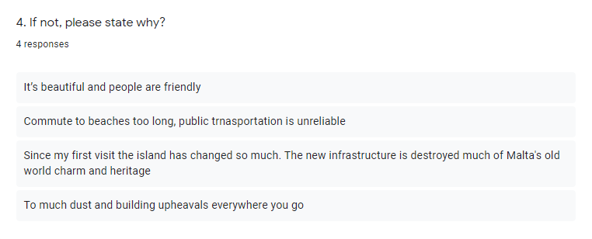

26 (63.4%)

11 (26.8%)

4 (9.8%)

0 (0%)

0 (0%)

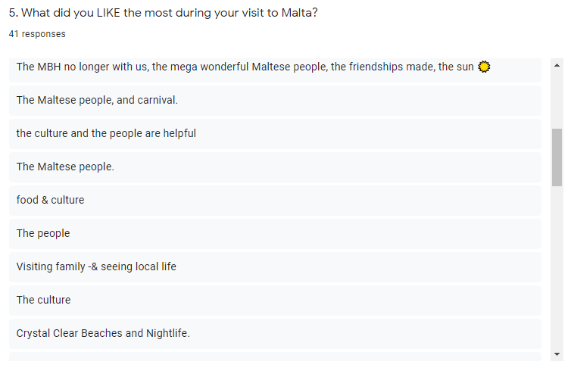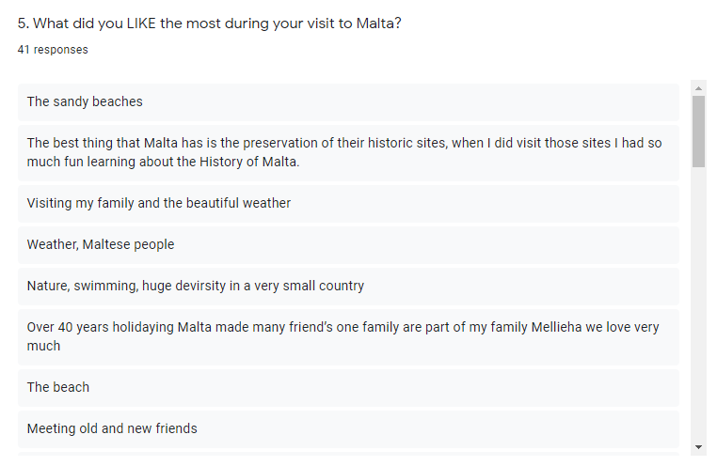

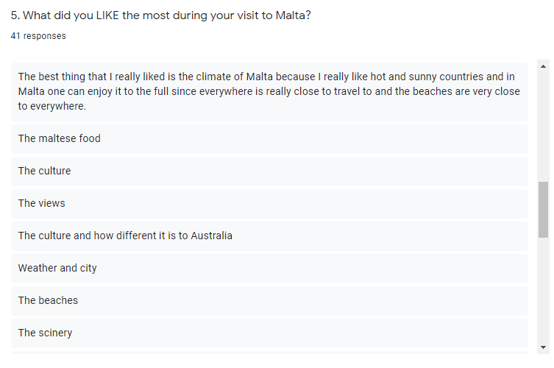

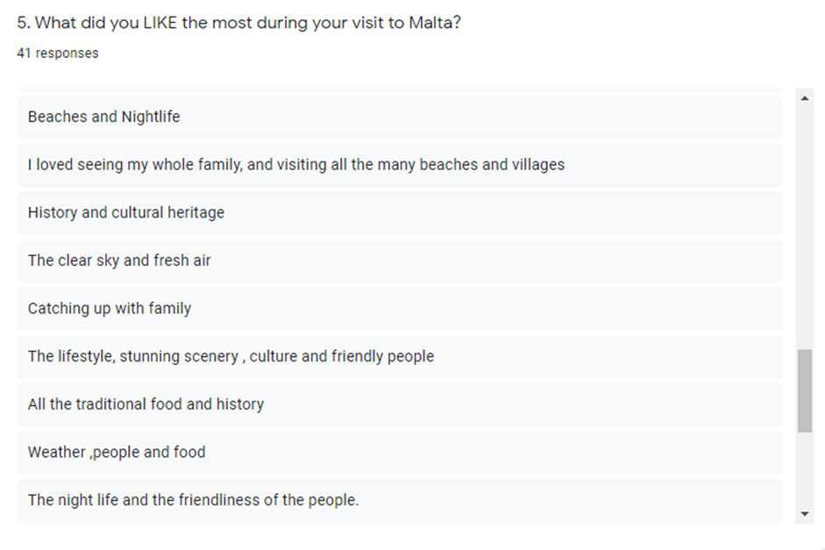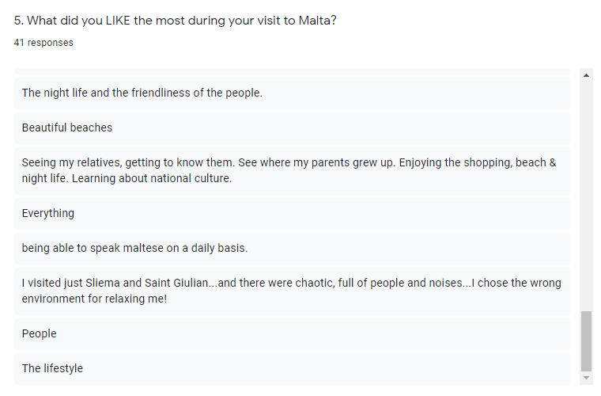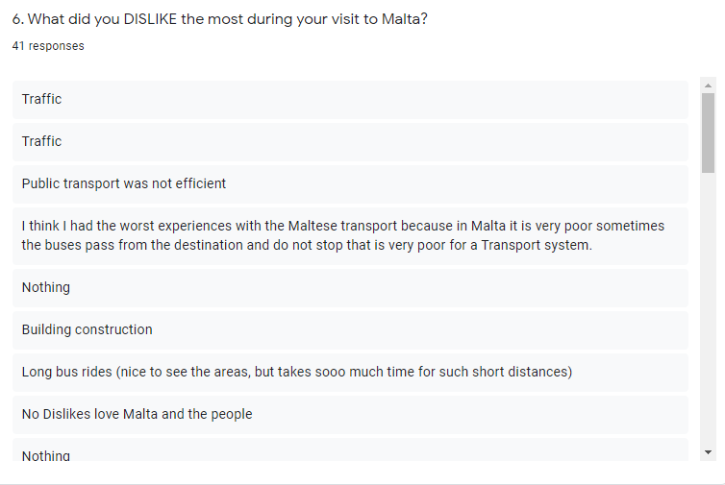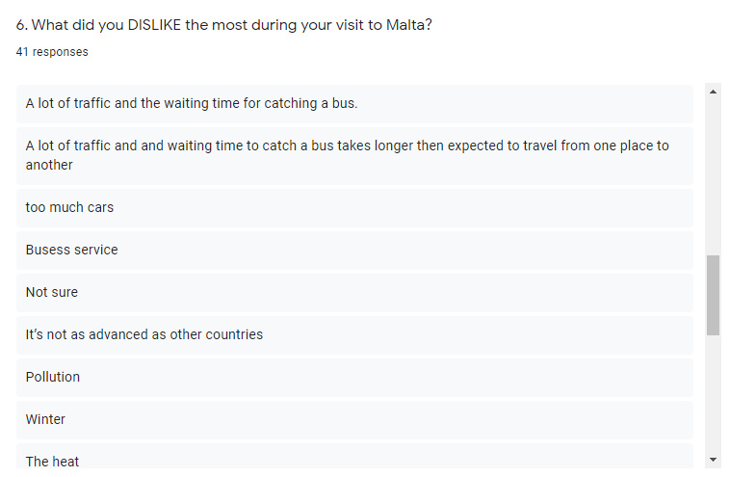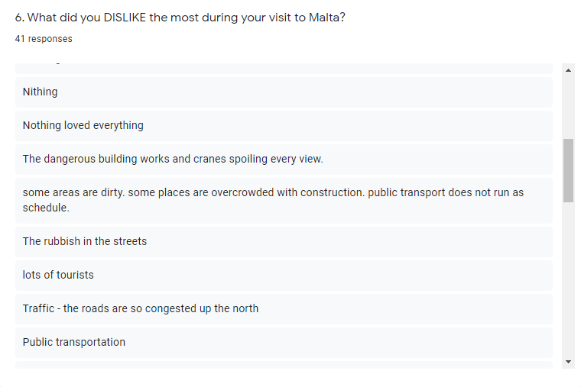

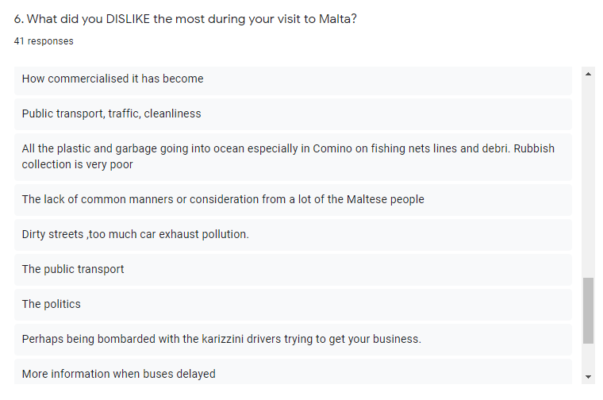

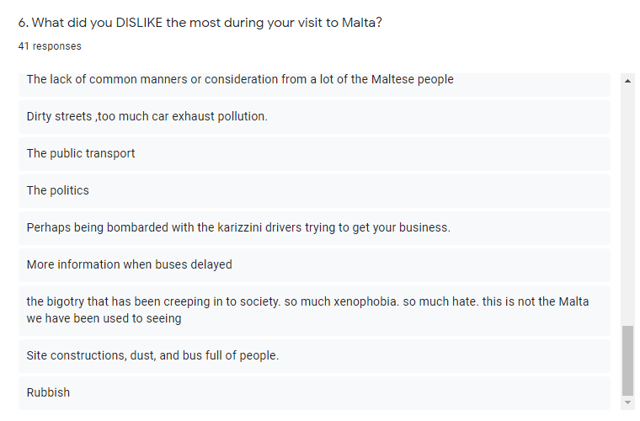

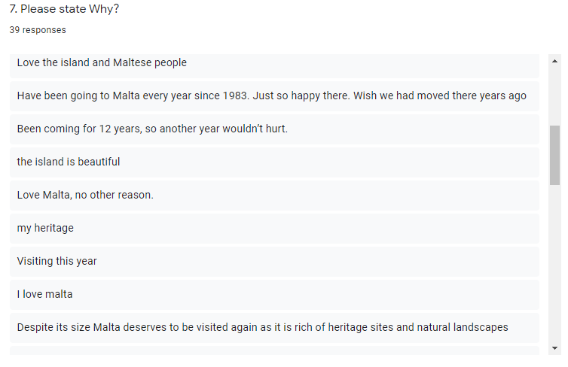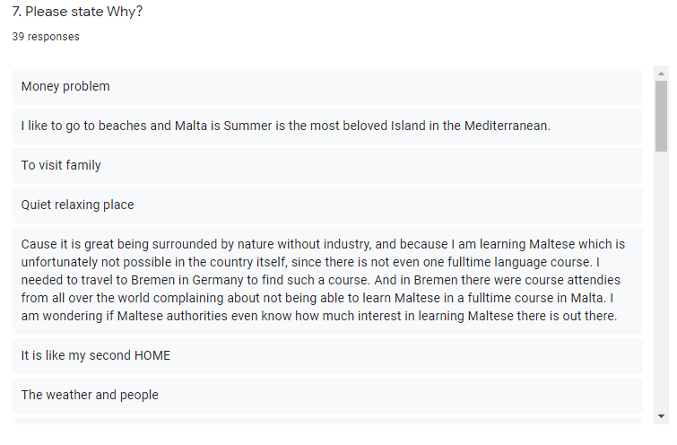

36 (87.8%)

0 (0%)

5 (12.2%)

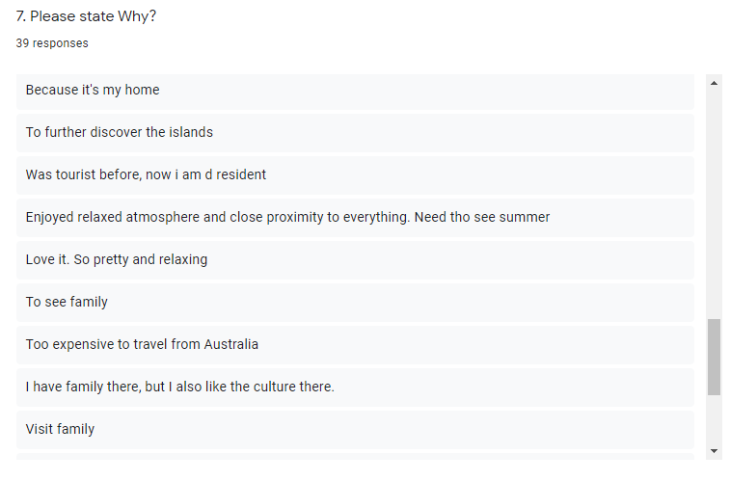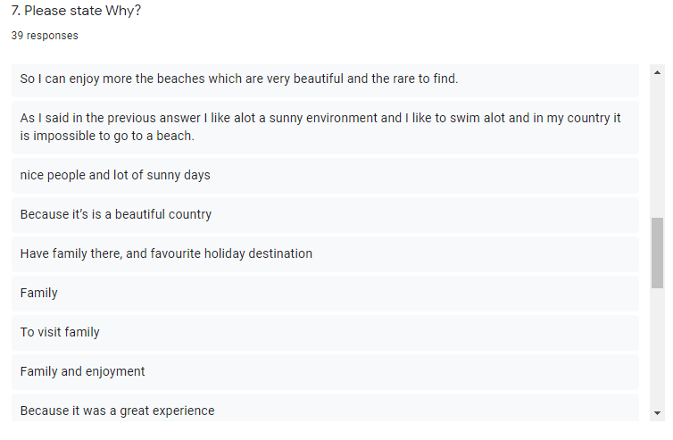

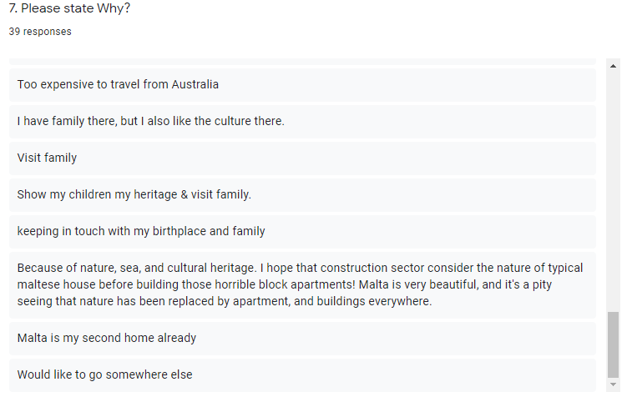



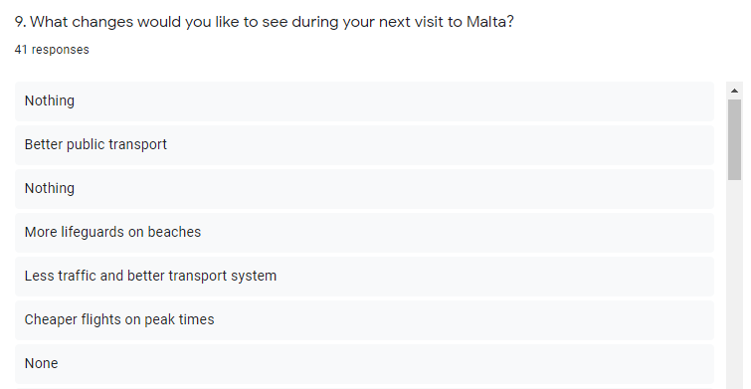

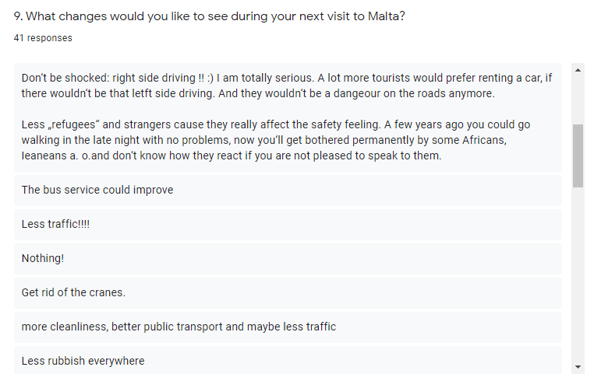

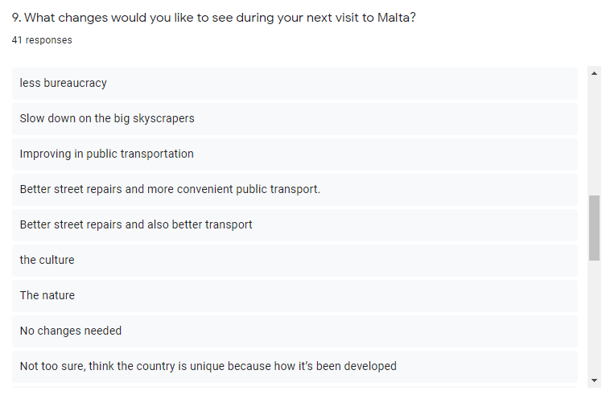

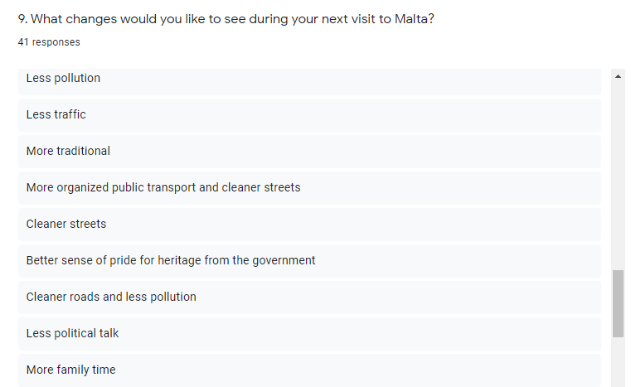

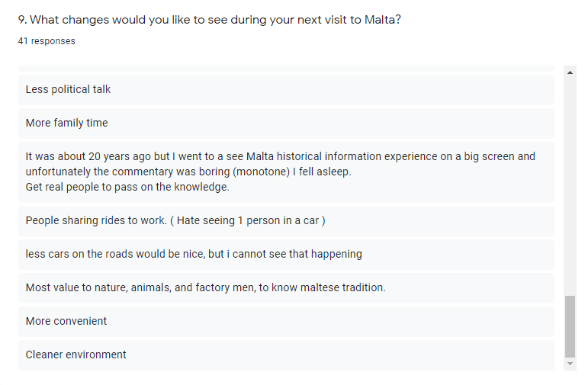



5 (12.2%)

13 (31.7%)

4 (9.8%)

7 (17.1%)

5 (12.2%)

7 (17.1%)



3

7

10

15

6

0

5

7

19

10

0

4

11

17

9

1

5

11

13

11

1

4

9

17

10

0

7

12

13

9

0

6

11

15

9

1: Poor 0

2: Average 3

3: Good 10

4: Very Good 18

5: Excellent 10

0

7

8

7

19

1

4

11

11

14

0

5

9

13

14

1

4

11

11

14

2

7

10

9

13

0

8

10

12

11

1: Poor 0

2: Average 5

3: Good 10

4: Very Good 13

5: Excellent 13



1: Poor 1

2: Average 3

3: Good 15

4: Very Good 7

5: Excellent 15

0

9

14

4

14

2

7

11

8

13

2

4

14

6

15

1

6

14

8

12

1

5

7

11

17

1

3

7

12

18

1: Poor 0

2: Average 5

3: Good 10

4: Very Good 13

5: Excellent 12

1

3

11

8

12

1

4

10

7

13

1

7

11

6

9

4

5

6

9

11

0

4

7

11

16

0

3

7

11

16

2

5

9

9

13

1

2

10

17

11

1: Poor 1

2: Average 9

3: Good 5

4: Very Good 15

5: Excellent 11

1

10

12

11

7

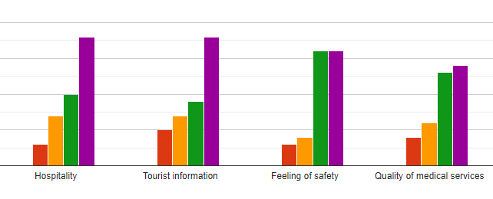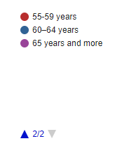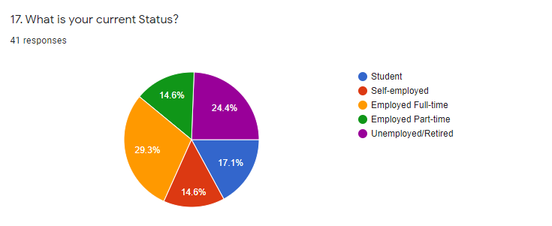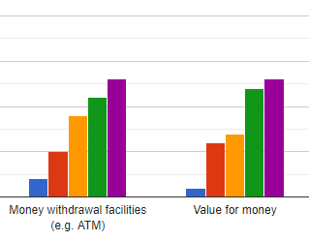

1: Poor 0

2: Average 3

3: Good 7

4: Very Good 10

5: Excellent 18

0

5

7

9

18

0

3

4

16

16

2 (4.9%)

9 (22%)

4 (9.8%)

5 (12.2%)

2 (4.9%)

4 (9.8%)

2 (4.9%)

2 (4.9%)

3 (7.3%)

1 (2.4%)

7 (17.1%)

7 (17.1%)

6 (14.6%)

12 (29.3%)

6 (14.6%)

10 (24.4%)

0

4

6

13

14

2

5

9

11

13

1

6

7

12

13



1 (2.4%)

1 (2.4%)

1 (2.4%)

5 (12.2%)

1 (2.4%)

19 (46.3%)

4 (9.8%)

1 (2.4%)

6 (14.6%)

1 (2.4%)

1 (2.4%)

**Appendix C**

**MTA - Transcription**

*Q1: The first question that I'm going to ask you is about tourism in Malta. The question goes a substantial amount of the gross domestic product comes from tourism. Do you think that Malta’s economy has become solely based on mass tourism.*

A1: Basically, I agree that tourism is very important to the economy. However, according to the recent studies it's not the biggest sector if I'm correct. I think gaming has exceeded. I mean number one to analyse the economic impact tourism you need the tourism satellite account which we do not have for Malta. There was an attempt to do a sort of a pilot study, it was a dissertation but it takes back to 2010. So you need input and output methodology basically from national accounts and we don't have as such developed for Malta. However, from the recent information that I have from NSO, that's GDP tourism as a share of GDP is in the region of 13% but that would include direct and indirect impacts. Tourism Satellite accounts stops at direct impact, the difference between the direct and indirect; like for example, if you go to a restaurant or let’s say you go to a hotel and you spend money that’s the direct impact. So a direct impact in the national accounts, when you add it up you get to one hundred. However when money flows into the economy, a multiply affect happens – so let’s say you went to a hotel and you have paid. The hotel of course has employees and this pays its employees. When the employees, with their wages they spend money, you know buying household, still here comes the indirect and then the induced effects, this is not an economics lecture but to get you aware of that. It is mostly in the region of 13% but your question was – I don’t like that the concept because Mass tourism is one of those sort of jargon which is used very loosely. Malta is a volume intense destination, I would define it. Yes, we do have high volumes, but high volumes do not necessarily mean mass tourism. We have a very sophisticated segmentation policy so if you have a look at the different segments that Why chose visit Malta, there’s a variety of reasons and of course that is the result of the strategy and of the type of marketing we carry out. Of course in the peak months of summer; July / August /September we reach the highest levels which is part of the curve of how people travel. But the concept of mass tourism – I mean – Mass tourism usually is referred to destinations for example, like Benidorm which people go to drink and for the sun only, sort of. There are various definitions, whilst I wouldn’t define it – the destination is a complex destination, referring to Malta and as I said, of course, volumes are intense and are big as last year we’ve reached the 2.7 billion figure but I would be very careful on how to use the term Mass Tourism even for your dissertation. I hope that this answered your question.

*Q2: Yes, it did in fact, thank you for answering and I will take your advice into consideration. I have another question which is related to the one that I have previously asked, it is as Malta’s GDP is mostly dependant on tourism, how do you deal with all of the tourists’ demands during peak seasons?*

A1: I wouldn’t say that most of the GDP as I said is tourism because other sectors could be bigger, the tourism in Malta is a tertiary which is based on services so that there would be the banking and financing sector, artificial - all areas which the government was sort of investing in and gaming also in particular. In terms of the peak, how do we handle the volumes. During the past years, it was a phenomenon whereby I'm sure you're aware of the sharing economy. So basically many people identified that said they would actually earn money if they rent out their properties. Looking at it from an accommodation perspective, we saw an increase in beds and in non-collective accommodation. So when we say collective accommodation, we refer to hotels, guest houses, hostels, basically that’s it and the tourism village and the non - collective would be apartments and farmhouses. So we have stir an increase in that latter. If you have a look at where people stay, the most of the increase in demand for the peak was absorbed in the non-collective, in the other type of accommodation sort of so the demand was absorbed from that end. Then of course we have the airport which so far it was able to help the passengers in flows at the airport and the airlines basically there is the strategy whereby we carry out negotiations with airlines and we do joint activities in order to attract basically the opening of new routes. Nowadays we managed to open new routes in a way to help in a substantial manner. And also like with the airlines, Turkish Airlines and also Qatar for example, and you have also Emirates; it's good connections also to the long hauls, Of course you have more traditional airports as well and they fly with airlines like British Airways, Lufthansa and also Air Malta but Turkish Airlines, Qatar have a lot of potential to target long haul tourists. So the demand was very much absorbed from that end and we managed to deal with the numbers so far. Primarily, there was the policy as well from the government so far to encourage hotels to extend a floor on their current structures. So that there would be more beds in the hotel (collective) but of course it takes time because to build – there is a time lap but of course you can accommodate the tourists. With regards for example to restaurants, we have seen the phenomenon of tables and chairs, so, tables and chairs outside. Of course it is a trend that people like to eat out and let’s say in the restaurant outside, but that was also the result of increased demand because they would extend the capacity of restaurants was basically to encroach on the pavement and many people got permit to sort of have more tables and chairs outside. So in a way sort of; of course, I'm not saying that there isn't a strain on the infrastructure in the peak month of summer, especially with regards to public transportation, for example, you have overcrowding and buses are not punctual for example, we have waste, we have also - for example for my thesis I studied the social impact of tourism and I had a sample size of 500 residents so it was quite a good size. It represents the population of Malta as well. So basically, it was carried out in 2018 and the feedback – because a lot of work has been done on the economic impacts however the social impacts were a bit neglected and I was interested to have a look at that for my studies. Although let's say the local residents are aware of the negative impacts of Tourism mainly little overcrowding and over-development mostly. The four main negative impacts are Traffic, Litter, over development and Over-crowding to a certain extent. Frankly, I was expecting that people were more conscious on the environmental impact which was not the case but the results were that they were so aware of the economic impacts. The positive impacts still outweigh the negative impacts. Vestments, economic impacts, social, psychological impacts because it investigated sort of the psychological impacts of tourism and the sense of pride, your nation is a tourist destination is and as a popular destination. Then there are the social impacts, interaction and you have the positive, negative impacts and also the political impacts, how much they are involved in the stream making positive, negative and their support of Tourism Source. Basically, an actual support was still very high back in 2018 which was quite a recent study.

*Q3: Malta has numerous amounts of tourists yearly especially during summer and peak times as Malta is mostly promoted for the Sun, Sea and Sand. Are you taking any measures to attract tourists during low seasons as well? (If yes, how? if not, why not consider it?)*

A1: As I said before, I do not agree that tourists come to Malta for the sun, sea and sand and for mass tourism. This is a wrong perception my opinion, if you have a look at the segmentation, I have sent you the statistical report for that simple reason because if you have a look at it you see that most tourists visit Malta for sun and culture. So when you travel basically, you don't just have one single motivation sometimes but you have multiple motivations. So, we have the majority of persons who come for the sun and culture then you have a share of tourists who come for sun only but it could also be as winter sun I think it was about 15% but I’m not sure. Then you have the ones who prefer only culture and as Malta is very strong on culture, and we do emphasise a lot on culture, then you have incentives and is mainly off peak which is a higher capita expenditure when compared to leisure. We have language travel, activity holidays, breaks. We have invested in a strategy whereby we organise a number of events both in summer and winter and if you have a look at the statistics, Malta is an all-year round destination. It’s true that the highest rates are in summer but this year the highest growth rates over the past year happened in the winter months, not over the summer months. For the simple reason that when we negotiated with air lines, of course you cannot get an airline which flies only in winter and stops in summer because the profit departure of course is higher in summer. So basically what we did, when we deal with airlines we try to maintain as much as possible extend the operation into the winter months. It may not be a twelve month operation for example but most of them are a twelve month operation – the routes. But it could be also nine months or a bit less. What we do is we negotiate that we have frequency throughout the year, it may not be as frequent as in summer – let me give you an example. For example in summer you have a daily flight to some destination than in winter it goes down to three times a week, but it doesn't stop. So since most of the routes are introduced let's say summer which for the airline jargon summer April to October. So let’s say they start in April, when we extended them into the winter months, they had an impact on seasonality. In fact recently we saw that there was a hit in seasonality , in winter months and you have particular months in winter which the peak months of a couple of years ago. So it’s quite well spread. I mean be careful on how – I do not know who gives you the impression that tourism is only sun and sea because even lecturers themselves need to educate themselves with what’s happening in the industry. Even the way the questions are worded, it's not exactly correct. So I would ask rather than making a sweeping statement, I would ask, just a recommendation. I would check before asking a question, the situation is this, how do you see it because it might not be in that way – anyway.

*Q4: Would you consider doing new forms of tourism during the low season or helping specific niches such as religious (Xmas & Lent, Feasts, etc) or Spring tourism based on nature, walks etc.*

A1: That is all being done as I have mentioned before we have again a very sophisticated segmentation strategy the example in the low season of January we have a baroque festival which is two weeks long and over the past years we have studied the profile of tourists so we have a significant share of tours, even from countries coming specifically for that event. So the strategy is there so you have of course which into specific segments because it's into culture and a bit in sports. Over the years if we have a look at the calendar of events, it’s very rich. So we do promote carnival for example for winter Christmas, all this is happening. Activities like diving and other sports activities walking and climbing especially for Gozo, very important because Gozo is sort of more linked back compared to Malta and you have more greenery as well and it northern part of Malta. Religious tourism, yes, they have also set up a committee which bring together all religions including different religions in Malta including like the Jewish church and other churches. However apart from the fact that we are Christian and we have a lot of churches and that type of thing, there are also the temples which goes into spiritual let's say theme. We do have a lot of segments and that is why I basically we are active in the winter very active and basically you have few or no establishments which close down in the winter months. City breaks are very important for the winter months as well. Short breaks because tourists were travelling frequently – now the situation is completely different with the current crises. Now this can change the travelling patterns and there is also a lot of uncertainty. But as I said from our end we have several segments which basically make tourism active throughout the whole year. The sun and sea are important but its more the climate and the warmth because if you compare our beaches to other Mediterranean countries, they have much bigger beaches and resorts than Malta. We have to focus on other segments.

*Q5: Okay. Now I'm going to ask you something a little bit different. This one is about public transport. I know that you have mentioned something but it was concluded that in my research. I had different responses on how should Malta time prove especially the touristic product, about half of the answers were on public transport. It seems that tourists prefer to rent a car or get a taxi rather than you know getting on the public transport. Are you aware of such case? And is there something planned to improve the situation maybe?*

A1: Basically, from our research, we distribute a questionnaire at the Malta International Airport so you have around 70 % to 80% of tourists actually use public transportation compared to the 30% of tourists who rent a car. Public transportation usage in terms of total is higher than renting a car I do not know the sample size of tourists but we have a sampling of around seven thousand a year, so in terms of public transportation usage is higher than car rental. Having said that yes, when we do the rating that we receive it’s like 70% public transportation would be Very Good or Good but you have a considerable 30% who rated it as Average, Poor or Very Poor. Most of that is Average, but you had also poor and Very poor. We wrote down tourists’ comments, especially the negative ones. Most of the comments we receive – it is coded as transport not Public Transportation. We have a particular comment “Foreign bus drivers are rude and uncooperative”, “Traffic Congestion and overcrowded buses”, “Irresponsible Driving”, “Overcrowding of buses”, “more buses frequently needed”, “Traffic”, more comments on traffic. Our comments match, the problem is – when we had a meeting with the Public Transport providers, the most recent feedback that we had was if you increase frequency because of the heavy traffic in Malta, the buses would still be stuck in traffic so nothing - not saying the problem is a bit complex - now as we had the meeting rules are being appointed sort of, a lot of projects are being carried out and but yes, we are in touch with the public transport providers and when we have like negative comments and complaints, we sort of, we do forward them to the public transport providers. I'm not aware of any projects. It was good that now the buses have fewer emissions, with the new buses introduced. They are accessible for the disabled as well, so a lot of improvement has been done in the public sector fields. What I noticed as well, I was not aware of it but the ministry towards the end of the year introduced a scheme to attract green mobility from hotels, I don’t have that much information about this scheme but hotels can apply to this scheme and they would have to introduce some sort of green mobility from the Airport to the Hotel and they can get an accreditation for that. But if you need one information on that subject, I can give you the link. Maybe have a look at it maybe in a position to sort of help you more because I haven't been involved in the project before. It’s not just public transportation or taxi but you have like pool option, these golf carts, but it’s more like an excursion. You have ecabs – taxis, it’s not just renting a car so the transportation options, have widened a lot so you have a lot of options nowadays which were not available a couple of years ago as well.

*Q6: Yes. I have another question as well. Do you think about the long-term effect of Tourism decisions to generate the economy on a long-term basis?*

A1: Yes, the tourism policy which was issued in 2020 and we were actually beginning to work on the coming policy depending on the high goal rates that we had and object of this policy was to manage the growth in the coming years. So, in tourism we do look in long term but mostly plans are usually are for a five year period. Most of the plans so far are based on five years. January and February were good before the crisis, now as most of the new airports - airlines which operate to Malta if you have a look at the map we are linked to most of the destinations; it is a matter of either finding new airports or to increase frequency on current airports. But if you increase current airports which are serviced by more than one airline, let’s say I am going to Milan for example, no let’s take Rome, there are Alitalia and Air Malta for example, if you increase another airline, let’s say airline X does fly to Rome as well, the risk is for the price to go down at one of the islands to draw. So technically you would lose rather than gain. The way we have grown was quite substantial because if you compare to 2010 tourism sort of has doubled in less than ten years, the strategy was to manage that growth and sort of ease down and manage the volumes for the coming year depending on the trend, but now the crisis has put everything on hold, because we don’t know if tourism – this is of receded proportions and we don’t – so far tourism has been resilient so under terrorist attacks but now but a pandemic of this nature which has and know there is a lot of fear, which is health-related because it's a contagious disease. Depends very much on how people react, people of course are going to be short of money – nothing is certain but I mean many people are losing jobs. So they won't have saved - the middle class would be very much affected and also most volumes are generated by them. So there is an impact on the issue of the economy which is going to have a very negative crisis and a bad impact on the economy. Also on vacation leave, because to travel you need vacation leave, apart from that, depending on the policy government lie for Malta – domestic tourism is a small phenomenon but for bigger countries like Germany, domestic tourism is much bigger than international tourism – the number of Germans who travel within Germany to other regions, is much higher than Germans who actually travel abroad so since the economy hit in a bad manner, I do not know if you have seen any posts, but this post even in Malta which was saying when the crisis is over, spend the money in Malta so if that strategy in other countries as well, there would be a shift from international - domestic is already substantial in France and in Germany, but not in Malta as we mostly go to Gozo or the Gotizans come to Malta or there is also this trend of Maltese spending the nights in hotels as a break. Mostly in Winter and in Summer they may go to Gozo, but if countries embarks such a strategy – I am not really in a position to say, I mean if we had this interview the last month I would have given you a completely different answer but it’s very tough at this moment as we don’t know if the tourism works, I mean many businesses would go as well some airlines, which are not able to deal with loses sort of, so this scenario may be the difference and we don't know how long it's going to last and whatever the number is. Every year you start from zero, so you cannot take for granted, last year for example I had ten clients so this year I surely have twelve so every year starts from zero, of course you have plans with tour operators and then as which go from year to year. I mean it's a very tough situation. It's like you know reading the future which unfortunately I’m not able.

*Q7: I was going to ask you something which you have already mentioned. It's about on-going projects. Are there any on-going projects in fact at the moment to increase tourism in a sustainable way or maybe plans?*

A1: The ones that I am aware of, sort of. At MTA we have an eco-scheme, which is an eco-certification scheme for hotels, and basically this is an accreditation so they have to invest in infrastructure, whereby the infrastructure would have a good economic impact the way the energy is used in the hotel and waste is dealt with and generated. So there is this scheme and I think so far we have in the region of hotels which are accredited. There is also a project which was communicated by the minister at Viast which is to carry out investments where by cruise ships operating at the ports would generate sort of less pollution the way it's then when I'm not and I don't know exactly but there is also this project at the cruise port to decrease the pollution of cruise liners. There is this green Mobility project which I have mentioned. With regarding to sustainability, It is also an accreditation scheme, then I mean from the product development side within MTA, they do carry projects, beach cleaning mostly and each managements, blue flag certification beaches which all of course, you have to monitor the quality of the water. So you have a number of projects from the product development as well to safeguard the environment.

You can also do certain things like a clean-up day for example as well. In fact, I'm I've mentioned that numerous times in my dissertation

Yes. These initiatives sometimes are taken up by the industry themselves and diving sectors, going underwater to collect waste and this makes people aware of the waste generation. I mean the campaigns we do and we educate kids we have a – we go in schools, our quality assurance directory they go in schools to basically make children aware of the importance of Tourism, how important it is for the environment clean and the type of it as well.

*Q8: I was going to ask you something about the introduction of new types of Tourism in Malta. Do you plan to introduce new types of Tourism such as alternative tourism to eliminate or reduce over tourism?*

A1: Alternative tourism, as I mentioned we have this sort of rural tourism. There are like initiatives on a small scale that generate that type of activity. In terms of alternative we have – don’t know if it falls under that category, we target luxury tourism. So we have LGBT but I don’t think it’s a form of alternative tourism, segments I would say I mean as I said before, I mean, I don't want to repeat myself too much. We do have quite an expensive segmentation strategy and you have even a lot of different initiatives even from the private sector to target specific segments as well. But some maybe small and they are not captured for example in our survey. so I wouldn't be able to say listen, this segment is big or the size of the segment would be for example questionable. We wouldn't know how big it is. But in terms of alternative tourism, as I’ve mentioned you have the phenomenon which is accommodation which is the investment in boutique hotels for example to attract city based holidays sort of whereby many tourists are staying in – more tourists are staying in Valletta because of the investment which has being carried out in boutique hotels and also you have the phenomenon as B&B which is a type of alternative tourism as well but let’s say it is another option in terms of accommodation. People prefer B&B not because of the money and because it is cheaper but as it offers flexibility; it offers space so it very much depends on the preferences of people travelling as well. So you have different platforms online which you can, you know, make use when you are planning your holiday and where to stay, what to do and this type of thing. You also have guides that are specialising in a specific tour, for example ghosts tours like the Colours of Malta.. so this is, you know different interests which can be catered for by being innovative and creative, you can encourage tourists to engage in new activities. Even if they have an interest and you can provide options you can get them to spend more money than they actually would have wanted to spend. To increase expenditure you need to have the appropriate offers. Maltese tend to spend a lot of money on shopping because maybe because our shopping malls are small so they get a little bit excited you know when they travel but I mean tourists wouldn’t be excited to buy clothes in Malta I would presume and now they are looking more on authenticity. There are a lot of interesting things like souvenirs or selling something which is locally made and that is another point which is in the alternative tourism – it’s the creative industry so the artist out there – artisan market. You have also the foreign people who live in Malta, I am a fan of these artisan markets in Malta and I like to buy artisan products and handmade goods myself, so I do visits in markets and I do notice that many of these artisan markets are actually from foreigners living in Malta, British, Spanish, Italian, etc. The creative industry is also very important for – I don’t know if its alternative tourism the appropriate term, but to get tourist, you know, to do activities which are traditional and are more authentic, and reflect the authenticity to the traditional of the Maltese/ Gozitan products.

*Q9: So, I have another question, how can tourism and Malta be described as healthy and sustainable considering we may be suffering from over tourism.*

A1: In any type of tourism you have a sword which cuts from both ends, I would say. Of course, it has the positive impacts, we have an open mentality and it’s good for the economy. It’s good for social, to keep your mind open, having a level of education and intelligence. It has a lot of positive impacts, but of course we have seen that in this crisis just to give you an example by staying inside the pollution in the environment, you know is better and it brings a lack of pollution but staying inside 24hrs every day, is not I think a sustainable option either. The environmental impacts are the most challenging. Sometimes, you know, it's mentioned but you know it is the actual statistics and figures to know how big the impact is. Even for tourism, when studies are on economic, social and environmental impacts is you know quite right above to decipher. But you know, it can be done by you know we have the hypogeum, they could measure the damage being done such as the oxygen and when people breathe. So they have a carrying capacity so it can be managed, of course, you focus the environmental impact much easier than were you need to measure a whole destination. I am sure there are methods but the methods are more challenging. There are a lot of good impacts resulting from tourism as I mentioned, many investments being done the offer improves, there’s investment in culture, both the culture offer and the entertainment offer, this improves for the tourist and also for the residents. Let’s take for example the project in Valletta. Valletta nowadays is very much active in the evening, which is something that we had been trying for many years but there is a price to pay as it consisted of a lot of gentrification for example, where people to a certain extent were pushed out of their residence because whereby were used to rent, the owner was more profitable for him/ her to sell the property rather than rent and sort of some residents may have been pushed outside of Valletta. Of course prices have gone up so that’s another cause, so in everything there is the positive and the negative so that's why in our next policy we will be mostly focusing on managing the tourism because it was clear that substantial amounts were being reached and of course, the pace could not be maintained because it was too big. So it's quite a challenge because it is an activity which generates a lot of positive but also negative effects. Hopefully, I mean the perception of the Maltese residents is correct because the positive effects still outweigh the negative ones.

*Q10: How can tourism in Malta be described as Equitable considering many of the lower jobs and tourism are low-paid?*

Interesting question. Number 1, if you look at the employment rate in the industry, you had a lot of situations in shortages. So people were choosing not to work, like the construction industry for example, there was a situation where by Maltese people were not interested in the construction it was sort of a declining group of who were actually invested – Maltese builders let’s say and of course construction was increasing at a higher rate and we brought people from abroad for a construction project. The same thing happened with - the tourism industry. I've worked. I mean I worked at the MTA for 22 years now, but when I was young I used to work in hotels as well. And even in restaurants and what is interesting is that even though you may start low, opportunities for promotions do exist and if you do a good job, you can go up the ladder quite fast, maybe faster than others. So we start slow but if you’re good – there are various factors – a study by MHRA a couple of years ago. You have the issue that yes, maybe at the Frontline, the tourism industry they don't really pay high wages so the people were not interested in anything to do waitering job and other from even receptions nowadays you go in hotels they are mainly foreigners. The young people of today when we did the study they are reluctant to work in the evenings and in weekends for example and the tourism industry. Basically it has to do with the job that you have to work in the evenings and during the weekends. So it could be a social thing where the parent have pampered the kids so much - it’s not a matter of sacrifice, I mean I worked also part-time as I needed the money and to pursue my studies and whatever but nowadays I think many young people are relatively easy. I mean the employment in tourism - let's not forget there is part time and full time. So by time it may not be a job for a lifetime, you can engage in it, but let's say people of my generation we used to work more. We used to have a job and study. I'm not saying that the students of today don’t have jobs but this phenomenon yes, but people are less reluctant and more reluctant sort of in working in tourism, but it's a combination of things. It's not just the wage but also the fact that they do not want to work – I mean this was a study by MHRA but I don’t think it was ever made official. Equality is very different, life in general, I guess. Even the females in the work, we haven’t reached a stage, whereby you know, we are treated at the same level, unfortunately. I mean I come from the management sector but sometimes I personally do feel it so the quality is based on a utopia. There is an issue on the quality as well because when you go in a restaurant, the Maltese have to speak foreign languages and sometimes it's not understood because first we have let’s say people who could speak proper English, but there are even a few people who could not speak proper English and you have the problem of communication just to order, imagine they may have an authentic experience in an establishment. So equality is an issue – as I said, the positive side of it as that people who are interested in working in tourism may climb the ladder maybe faster than they actually think but yes then there is the fact that the front liners - its effect that the wages are also not that attractive, you know, I think that there is that perception.

*Q11: Okay, one last question before we can before we conclude which difficulties limit you from reaching your goals. And how do you plan to overcome them?*

A1: I mean the biggest difficulty is that tourism is so interrelated with other Industries. That I mean - to have the perfect experience through everything - you have transportation, food, retail, so we have so many different suppliers falling under different Ministries. So let's say cleanliness, for example, you have the ministry for public works or I don't know, I'm not really sure which one is used responsible for cleaning. I think it used to be public. Those responsibilities, which fall under the different ministries because of the interrelationship of tourism, ideally you have to communicate with all the Ministries to get the perfect experience from A to Z from, you know, when the tourists lend at the airport until the time they go back. At any point if they have a negative experience with public transportation, for example. Which falls under the Transportation Minister that is bad for tourism, but that’s not the direct responsibility of MTA, so we have to work with - because you don't have- you don't control, you know, things that we have to go through which makes it more challenging. Of course, we do working with other entities as much as possible but I think that is the most difficult task in tourism because as I said it’s so diverse and every ministry and every economic sector has a lot of impact on tourism. That is the biggest challenge, I think, to get everyone on board and have the same objective. I mean sometimes it's challenging for the same organization for people, you know to pull the same – or imagine working with, I mean even to achieve sustainability not just on its own but you have other ministries and sometimes the politicians themselves, they are in competition with each other and this something is good and bad so it’s quite complicated let’s say but I think that’s the biggest challenge because tourism affects more or less most sectors in the country.

Okay, thank you for all that valuable information is there anything else you'd like to add before we end?

Nothing comes to mind at this stage but if you have any more questions, feel free to email me.

**MHRA - Transcription**

*Q1: A substantial amount of the GDP comes from tourism, do you think that Malta’s economy has become solely based on Mass tourism? Why?*

A2: Mass Tourism started in 1980, first via restaurants then later on via brand. It was from since I was 16, about 45 years ago, as I have 60 years – that tourism started. Nowadays we still call it as Mass Tourism, but how did it come about? It came about as travel was made more available. Bugibba for example evolved from Mass tourism, a lot of buildings and hotels were being built and that’s how mass tourism came about. We have a very different situation as the economy developed so much and we need to sustain those 2.6 million tourists that came last year, in reality, we need to sustain them by hiring more foreign staff , as we do not have enough local staff as Maltese do not like low wages. But we have foreigners paying rent, they have to live, they have expenses plus they pay because their main aim is to come to Malta for 1 – 3 years, even shorter, and basically they don’t have enough wages to live in Malta. They come to Malta to make money, but there is the cost of living obviously. So the demand for workers increased as we had a lot of restaurants, establishments, hotels, etc. There was a time where we redirected tourists to Sicily because we didn’t have enough capacity in hotels which in the future the hotels were building two extra floors to their establishments, on the condition that they upgrade their product so a lot of upgrades have been happening. They had to upgrade their product as by time they become old although they had maintenance. Mass tourism come very concentrated in summer, so we have a huge amount of tourists in summer but we still have an element of seasonality. We still have the element of seasonality due to the carrying capacity of Malta which was the topic that I wanted to discuss in my dissertation back when I was studying at the university. Mass tourism brings a lot of problems with it although it contributes well to the economy and to the country; it also brings employment and other things. Mass tourism brings a lot of problems with regards to infrastructure and as well to the carrying capacity which is something that we are focusing on at the moment and to go for more quality tourism.

*Q2: As Malta’s GDP is mostly dependant on tourism, how do you deal with all of the tourists’ demands during peak seasons?*

A2: Now with Covid it’s a different situation but a few months ago we were saying other things but right now it’s not applicable as now with Covid, it literally changed the whole scenario. Cause now we are with zero tourists arrivals, although MHRA is pushing very strongly to have the airport opening because all other countries are opening although from July they have to do 14 days in quarantine. Other countries have even announced that we were on their routes but obviously there is no official detail from government. The country cannot survive if the economy is not healthy. If the country’s economy is not healthy you’ll have mass unemployment in Malta and in hotels don’t have some sort of summer, tourism is not going to work as these are massive buildings which need a lot of expenses to run, plus they have to promote and advertise so if they can’t promote if they are not going to open from July till September. Even if it’s a few rooms it would still make a difference, if they are not going to be part of the marketing out there, they will forget about Malta. 2.6 million tourists are quite a lot especially for Malta’s capacity and the infrastructure can’t take it which is why we are not going for quality tourism, if quality tourism does not have the quality environment. There is also a lot of construction going about, a lot of accidents, a lot of bad road works, so then you have a 5* , 4*, 3* or a boutique hotel , I am staying in one of these hotels, we have high expectations and standards but then as soon as they go out of the hotel it is a disaster. So, I think the demand for the peak seasons, for example if you want to go to the Blue Lagoon, there are a lot of countries which have a Blue Lagoon, they limit the amount of boats to go there and you have to have a special permit to go there, not just that you go by boat and that’s it. There are a lot of boat trips on the Captain Morgan or the other boat trips to go to Comino. There should be a limit and people would actually have to pay to get there, to maintain the upkeep in Comino and the area. For examplehow many toilets are there? Cause the toilets are on the boat. Covid made us think how we are going to keep up in the future because we have to have a rise in quality vs. quantity; for example, I am at a restaurant and the restaurant has 100 people for 10eur each but you can have 10 people for a 100eur each, but this will affect the quality of staff and the quality of service. We always pushed for the carrying capacity on the island. Every room and apartment that’s added which a lot of them are illegal, not like hotels which have more control so they should be on the same page. It’s all about control for example St John’s co- Cathedral, they can limit the amount of tourists who can enter and they can do a different strata of payment, for example if I want to do an exclusive tour, with just a small group of people, or what they can do is that they can stagger the time of the opening hours. Every aspect is important because not all restaurants are silver service, not all restaurants are high class, not all hotels are five stars, there are four star, three star, boutique hotels, etc. To attract tourists, it is not only on accommodation, but on the whole experience, how their stay, the taxi, the restaurants, shopping, was tour guide etc. They have to enjoy their experience from A to Z. MHRA is focusing on quality rather than a lot of numbers, you have a mixture of tourists ranging from families to the younger generation who would prefer clubbing so the island should offer different possibilities of entertainment. It is all about the story telling when they go home and they talk about the experience. So it is trying to find the right balance with numbers within the different strata. We used to be known as the Pensioner’s Island as we had a lot of people coming from the British colony, the soldiers who came here and made friends and families. Even with regards to Religious tourism nowadays which have a lot of impact as well, so you need the right balance. With the current situation you have to try and take out the negative from the positive although October will be another nightmare. Right now is the right time to make marketing with MTA.

*Q3: Malta has numerous amounts of tourists yearly especially during summer and peak times as Malta is mostly promoted for the Sun, Sea and Sand. Are you taking any measures to attract tourists during low seasons as well? (If yes, how? if not, why not consider it?)*

A2: This is the Seasonality – So the seasonality, during the low seasons, mainly we get light groups and conference groups. All the big conferences that come to Malta and actually give a huge injection of revenues to hotels, jobs and to the economists but with today’s situation everything’s changing. Will there be these types of groups? No. Will they be the years after? When you think about all that is happening and about everything that is going on- they used to attend conferences, afterwards they would go out to dinner but with the fear of the virus. We cannot foresee if we are going to be like the year we had in 2019, for the following 3 years but now everyone is other on wage supplement in other countries and unemployed because we’re all on lockdown or partial lockdown. So even in the future, the companies who used to organise these groups – you have events in winter, for example like Dark Tourism. Dark Tourism means that there are actual people who travel for dark tourism. What is Dark Tourism? It is visiting cemeteries, or visiting for example the bastions of Valletta and going to the shelters... This is dark tourism. So you have a lot of different – you have the ramblers, who go walking, you have sport related events, so that is the seasonality element where we would be pushing more because in Winter you get the quality tourist anyway, why, because these are the tourists that are not burdened with family pressures, like not having children, a lot of them would be retired people or can actually can afford to. These are people who can travel which normally come in September / October where they say, kids are at school. Even in restaurants – they came to your table, they spent more time and more money because you don’t have the added cost for a family of four – they are two.

*Q4: Would you consider doing new forms of tourism during the low season or helping specific niches such as religious (Xmas & Lent, Feasts, etc) or Spring tourism based on nature, walks etc.*

A2: One of our strong niches is carnival for example, they do celebrate Easter in St Paul’s Bay because it’s a touristic area, this is not like the Parish church where you have the Parish feast and where we have Easter procession and all this and we don’t have it in St Paul’s Bay. You have also a lot of Easter Monday parades for example in Scotland, they would get millions of people visiting on Public Holidays. Even our banks in Malta, on Easter Monday we don’t open. We organise for example Jet Ski races, power boat races, we organise quite a lot because of the sea. We looked at the element of the sea – cultural events and the different niches even in St Paul’s Bay to try to do activities to gain more money. We also did a wine festival, a local wine festival in St Paul’s Bay and the square, quite a lot of work but it’s very rewarding. I think these nature walks are actually interesting.

*Q5: In my research, I had different responses on how should Malta improve the touristic product. But about half of the answers were on public transport. It was concluded that tourists prefer to rent a car or hire a taxi, are you aware of such case and is there something planned to improve the situation?*

A2: So, in reality if you take a look at Rome or other countries in the world, many people like to have their own car, but to rent a car or a taxi, I tend to disagree. I think public transport should be very drastically improved and from our experience, people tend to use more public transport. Even in St Paul’s Bay and in the northern part of Malta, as it is my area – 45% of tourism comes from the north. So basically, one of our constant complaints used to be about the service, especially as you had a lot of massive queues of people waiting on the bus stop but it was because there were not a lot of frequent buses. Nowadays it did improve a lot, but tourists do rent cars and hire a taxi but the majority out of 2.6 million uses public transport, that is why they increased the routes.

*Q6: Do you think about the long-term effect of tourism decisions to generate the economy on a long-term basis?*

A2: These questions were obviously thought to be answered before the covid situation. Even the decisions on the airport opening, to generate the economy. We have now confirmation that – we always knew about it - tourism is the wheel to the bigger chain around a mechanism that turns around and then the inner wheel chain work, the bigger chain is the economy is the airport and that is what makes the wheel go round. If you look at suppliers, at the moment they are doing very well with the selling of super markets and mini markets but if you think about all the suppliers in Malta, they have lost a lot. Why? Because all the local and foreign workers were always there and will remain there but added to that, we have 2.6 million tourists as they still had to work over the three months partial lockdown. But if you take out those three months out of the whole year of what they used to sell to the restaurants and hotel industries – all the people that are buying from super markets are the actual people that still need to buy, but now are buying more because if they used to go out 4 times a month to go out to the dinner or twice a week to go out for lunch and a dinner, if you think about it they are still the same amount of people. So the money that these businesses used to sell as a supplier, regardless if its food, they actually lost because the lost the amount of the food and drinks consumed within the hotel. The economy generated is within the local community as the airports are not opened. The tourism decision to generate the economy is the right decision to be made now – how to go for the different niches and try to get a balance. The airport will be probably open by end of June but I’m saying this as we are seeing what is happening with this airlines and the option to change the flight if it doesn’t happen because that is how the airlines are currently working. To see long term affect, we see that this drastic affect that happened with a total of no tours at all, which is as the airport is closed. Now, we have about two year to get back to where we were, because to get 2.6 million we have about 2 or 3 years so we have to be more selective as a country.

*Q7: Are there any on-going projects at the moment to increase tourism in a sustainable way?*

A2: There are on-going discussions with proposals of different niches. What has happened was that the demand was so huge that the demand overcame the quality. We were looking at the country as a number which is why more hotel services have been issued but now obviously to remain sustainable, a huge emphasise has to be done, even more permits should be done on hotels because so that hotels have permits already issued, we can withdraw them because that is the planning authority decision and for example, I have a permit and it was issued now so I have five years to do this hotel. I cannot do it now, I would probably do it in 3 years maybe, and it is something that I have to put aside my project for example. I am not going to rush in investing because you have to see the whole tourism with our locations and I am saying this not to give you my example but I am portraying what others are doing, cause a lot of places don’t have just one place but they have more than one but they would be more concentrated on cuisine or on others.

*Q8: Do you plan to introduce new types of tourism such as alternative tourism to eliminate/reduce Mass tourism?*

A2: We are trying to move away from the Mass Tourism and we all wish to get away from it as it destroys a lot of things. Every politician from whichever political party are always after the number. It was always about numbers and if you are interested you can take a look at the model of Ayia Napa, it was a typical fishing village and obviously you have Ibiza as well, they have now started restructuring and it was over 60 years ago that they’ve started the progress. They are looking to develop the whole areas because the locals were actually pushed out of their area. Imagine for example Marsaxlokk and the investors came in, started buying up. This is what happened for example in Sliema, all the old buildings went and they started investing. If you take a look at Paceville, it is a very typical Mass tourism entertainment area where it’s an all go area, even for the Maltese. But the Maltese were kind of pushed out, even the younger generation, they don’t want to go to Today’s Paceville.

*Q9: How can tourism in Malta be described as healthy and sustainable considering we may be suffering from over-tourism?*

A2: MHRA did not answer this question.

*Q10: How can tourism in Malta be described as equitable considering many of the lower jobs in tourism are low paid?*

A2: So, the lower jobs – we don’t have enough staff, so we actually outscore. Companies do not charge us the minimum wage but in fact it is a lot of money so if the standard wage is €4.75 an hour, we are charged about €7.50 per hour but obviously the company has to cover the bonus, leave, sick leave and they want to make a mark-up. In tourism, everyone starts from the bottom up, so you can start as a job of a waiter/ waitress but you can end up to be a general manager, it all depends on the capability of the individual, and how you want to make it as a career. It’s not all about wages, it’s about the satisfaction, as a country, we became selective at what we do. Even with Covid now, it will be a filter to all of these as people now will realise that the lower jobs – you do not always stay on a minimum wage but they give you an increase because you cannot stay on a minimum wage. We don’t find a lot of Maltese that want to do the job anymore, if they offer them a minimum wage, we don’t. We all invest our time, money and energy on our employees for example we spend about €200 course just to train our staff for Covid. So we constantly invest in our staff and send them to training, it’s all about the perception in what you want to do in tourism. You have to love it and you have to have a passion.

*Q11: Which difficulties limit you from reaching your goals and how do you plan to overcome them?*

A2: Difficulties per se, it is more the challenges that we are facing right now - we have been 40 years in business so we have our own assets, investments, we have loans, we needed to take a loan just to save us for these six months to pay our suppliers and our wages. We even have a wage supplement which is not eternal as we have to pay the government back as the government would cover them from taxes so we will all end up paying more and to pay more in taxes in future. We are looking that we have a year for sure because we are all going to struggle and I am very positive. That’s why we are trying to get more help from the government to help us in paying rent – we have electricity, panellings, buildings, etc to pay. This is a good example in what will happen to other business on the island such as the restaurants, hotels and the tour guides are struggling as there is no work whatsoever for them because there’s no tourists – everywhere else is struggling, if you take a look at retail shops. I think it’s the way forward with tourism, basically just to conclude we have niche markets, we need more quality and we don’t have proper English-speaking staff. There are as well a good number from the 2.6 million who have had a positive experience. We always survived what we had come, as a country we will even survive this situation and again the hotels, if they don’t have enough tourists during the summer this will cause problems and they would just have to close the hotel. We have to keep in mind our identity as well.

*Thank you for all that valuable information, is there anything else you’d like to add before we end?*

*\*Please note that the original questionnaire forms, the questionnaire tables and the interview recordings will be sent via email.*

© Reproduced with permission of copyright owner. Further reproduction prohibited without permission.