Jacqueline Richard

Higher National diploma in travel & tourism Management  2019/2020

Investigating the factors responsible for drawing Maltese athletes away from the Island in order to better their sporting performance.

Investigating the factors responsible for drawing Maltese athletes away from the Island in order to better their sporting performance.

“A Dissertation to the Institute of Tourism in Part Fulfilment of the requirements for the Degree of Bachelor in Tourism Management. “

Authenticity form

The Abstract

This study aimed to understand the reason behind Maltese athlete’s decision to leave the island in order to train and compete overseas. It also aimed to identify factors attracting these athletes which may not be available locally. The research question was: Why do Maltese athletes travel overseas to train and compete?

What is Sports Tourism?

“Broad in its scope, [sports tourism](https://sportadvisory.com/sports-tourism/) is defined as an individual’s travel to a location for the specific purpose of either participating in or viewing a sporting event.”

SFA and SFM. (2020). *Defining Sports Tourism | Sports Facilities Advisory*.

“Sports Tourism is defined as a specific travel outside of the usual environment for either passive or active involvement in competitive sport where sport is the prime motivational reason for travel and the touristic or leisure element may act to reinforce the overall experience. Another definition worth noting explains sport tourism as a combination of sports activities and travel.”

web@tourism-review.org, T. (2020). *Sports Tourism: Worldwide Phenomenon | .TR*.

“Sports tourism refers to travel to play sports, watch sports, or to visit a sport attraction including both competitive and non-competitive activities.”

*(Delpy, 1998).*

Acknowledgements

I would like to express my special thanks for gratitude to my Tutor Ms. Carmen Rita Bugeja, as well as ITS for giving us HND students the opportunity to carry do this study.

Secondly I would like to thank my sister Janet Richard, and also a very good friend of mine and team mate, Claire Casha, for their help in this research and for allowing me to interview them.

Also, a special thanks goes out to all my participants from both sports for their help and support in conducting this research, which thanks to them I could have an interesting topic to work on.

Table of contents

Title …………………………………………………………………………………………1

Authenticity form……………………………………………………………………..2

The Abstract……………………………………………………………………………..3

Acknowledgments……………………………………………………………………5

Table of contents…………………………………………….……………………….6

Introduction…………………………………………………………..…………………7

Literature review………………………………………………………..……………..8

Methodology……………………………………………………………….………….11

Analysis and Discussion of the Results……………………………………14

Conclusions and Recommendations……………………………….………24

References…………………………………………………………………………….…25

Appendices……………………………………………………………………………..27

Introduction

Sports Tourism is characterized as a particular journey outside the normal environment for either passive or active participation in competitive sport where sport is the primary motivating factor for travel and where the tourist or leisure aspect may serve to reinforce the overall experience. Another description worthy of mention describes sport tourism as a combination of sport and travel activities (Gammon and Robinson, 2003)

This research was based on why Maltese athletes are drawn away from the Island in order to better their sporting performance.

With the aim of this study, the researcher wanted to have a better understanding on why Maltese athletes decide to travel in order to participate in many different international competitions.

This study is relevant because the explanation why athletes travel and what makes them leave the country can be better understood through this. Hopefully this study will allow Malta to have the facilities required to keep its athletes competing locally, and to enjoy doing so.

The researcher has conducted 2 interviews and a set of questionnaires on the topic. The interviews and questionnaires were carried out with 2 individuals that have been in the sporting scene for a number of years. The questionnaires were given out to several athletes from both sports respectively.

**Literature review**

The past few years have seen a significant growth in the sports tourism industry (Pigeassou, 2004). This has been defined as the planning of an international trip outside an individual’s home country for the purpose of engaging in athletic, sports related activities or events for a minimum duration of one night (Mokras-Grabowska, 2016).

Due to an increase in awareness and education pertaining to leading a healthy and balanced lifestyle, vacations prioritising physical activity, health and wellbeing have become more common among individuals who wish to remain healthy and active while also visiting foreign countries and cultures. Consequently, such trips can be said to hit two birds with one stone and is responsible for the boost in the sports tourism industry. People prioritising an active lifestyle, has provided tourism with the opportunity to include destinations and trips focusing mainly on sports and physical activity or even as an added value (Cavill and Bauman, 2004). Being a small state, Malta is unable to cater to and host a high volume of tourists due to issues such as having a lower carrying capacity which is a factor which needs to be heavily considered (Briguglio, 2008). Maltese tourism however, promotes Malta as the ‘place to be’ when planning trips revolving around sports tourism, short breaks and other specialist holidays. The targeting of such segments ensures social inclusion, economic delivery and the preservation of the environment (Higham, 2005)

Sports tourism does not only refer to athletes or individuals participating in a sports event, but also includes individuals travelling for the purpose of spectating at these activities (Mapjabil, 2017). Tourists travelling in order to participate in a sporting event may be divided into two main classifications; recreational tourists and competitive tourists. The first category being recreational sports tourists refers to individuals whose main reason for travel is in fact to participate in sporting activity for enjoyment and in order to have fun. Alternatively, competitive sports tourists choose to travel in order to either train for their specific sporting discipline or to take part in high level competitions. Having these classifications in place is paramount for any country attempting to diversify the tourism sector since it provides clear guidelines as to what standards the sporting facilities must meet depending on the clientele (Deery, Jago, and Fredline, 2004)

In Malta, diving contributes greatly to the tourism sector since it is responsible for 4% of the total tourist flow (Sultana, 2019). In addition to this, training camps organised by sports such as football and athletics as well as a number of other events attract numerous tourists to Malta. In fact, a key factor attracting sports tourists to any particular destination is the organisation of events. The Maltese islands annually host a variety of sports events, inviting athletes from around the globe to participate. Such events include the ‘Middle Sea Race’, 'Le Baillie de Suffren' boat race, la 'Bordée Maltaise' boat race and the well-known Malta Marathon. The ability for countries such as Malta to host and organise such events heavily depends on whether or not the host has an adequate infrastructure. This refers to the availability of high standard sports facilities, accommodation as well as means of transportation including both road and air networks. When analysing the available facilities in Malta, adopting a strategic approach to the development of Maltese sports tourism would be beneficial in order to explore and identify both the competitive sports as well as the recreational sports which prove to have the most potential for growth and success. When attempting to attract funding and investments for the development of facilities, cost- effectiveness is another key factor which must be considered. With regards to investing in facilities, it is of utmost importance that both sporting entities as well as tourism groups collaborate effectively since a single facility is rarely ever exclusive to sports tourism or the community. Without effective communication between both organisations, opportunities and benefits in sports tourism are unfortunately lost or do not reach their full potential.

With particular reference to the situation in Malta, a national sport strategy has been set in place which emphasises the integration of physical activity into the lives of the Maltese public and support the upcoming generation of local athletes in order to help them elevate their sporting standards and achievements in order to achieve satisfactory results when competing internationally. This 10 year project boasts 30 million euros to be invested in the development of local sporting infrastructure and an addition 6 million to be spent on the training of Malta’s talented athletes. The prime minister at the time, Joseph Muscat, claimed the funds for this project would come from the citizenship scheme fund in order to advance this sector. The aim of this strategy is ultimately to promote a healthy and active lifestyle among Maltese citizens and develop Malta into a “centre of sporting excellence”. With Malta hosting the Small Nation Games in 2023, a major sporting event for small European countries, this scheme aims to prepare both Maltese athletes in order to ensure the best performances at the games, as well as developing local sporting facilities. Sports tourism has great potential for growth which may be achieved through a good sporting culture and adequate sporting infrastructure. These factors, together with target marketing are important for growth to be achieved which leads to a number of social and economic benefits.

The Impact of the global COVID-19 Pandemic on Sport

The global COVID-19 pandemic disrupted life and society as we know it. Malta was also affected, namely the sporting industry. Moreover, the research process of this study was also impacted by the global pandemic since as the researcher, I had to gather my data all while abiding by the imposed social distancing regulations which provided a challenge when it came to conducting the face to face interviews. Apart from this, the pandemic brought sports events and activities to a halt since competitions and events were cancelled with the main devastation coming from the postponement of the Tokyo 2020 Olympic Games which were meant to take place over the summer months and has been postponed to 2021 (Weed, 2020.) Such cancellations and disruptions in the sporting season caused major distress and anxiety among athletes whose lives revolve around their sporting careers. Maltese athletes also had to endure the closing down of the regular training venues and gyms for several months and had to adapt their training schedule accordingly all while trying to remain positive and motivated.

**Methodology**

Introduction

This chapter illustrated how this research study was carried out and discussed the rationales which supported several decisions throughout the research process such as the choice of methodology, data collection tools and data analysis techniques.

Aim and Research Question

This study aimed to understand the reason behind Maltese athlete’s decision to leave the island in order to train and compete overseas. It also aimed to identify factors attracting these athletes which may not be available locally. The research question was: Why do Maltese athletes travel overseas to train and compete?

Review of Data Collection Methods

The methodology adopted for this research was in fact both qualitative and quantitative in nature. According to Davies (2003), mixed methods or triangulation of data with regards to the study of tourism allows for a better understanding of the phenomenon under study since while gathering the required statistics, the data also uncovers the meanings that individuals give to the phenomenon. For this reason, the data collection tools used for this research were online questionnaires as well as face to face interviews.

Primary Data

As previously discussed, this research made use of both qualitative and quantitative research methods. Qualitative semi structured interviews were conducted with two participants, a sprinter and a rugby player. Such interviews granted the researcher with a greater degree of flexibility by probing for more information where necessary while still making use of the interview guide (Refer to Appendix A) for reference (Choak, 2012 as cited in Evans & Lewis, 2018). Due to the Covid-19 pandemic which hit Malta in the midst of the research process, conducting the interviews presented a number of challenges due to the implemented social distancing regulations. For this reason, the researcher was forced to adapt and send the questions to the participant via email. The sprinter however, was interviewed face to face since she resided in the same household as the researcher. The interview was recorded and later transcribed. Prior to the interview the participants were presented with a consent form (See Appendix B) detailing the aims of the research as well as their rights as participants. Online questionnaires through the use of ‘Google Forms’ were also used in order to gather data. The questionnaire consisted of 13 questions including Likert scales, open ended questions and multiple-choice questions (See Appendix C). The link to the form was distributed by the researcher to several rugby and athletics teams and 28 responses were obtained.

Criteria for Sample Collection

The target population for this particular research was athletes practicing athletics and rugby. The reason the researcher chose these 2 disciplines in particular was because it would have been impossible to include all the types of sport in the study. For this reason, the researcher opted for an individual sport (athletics) and a team sport (rugby). In order to distribute the online questionnaires, the researcher made use of 2 gatekeepers, one which distributed the questionnaire to rugby players and the other to the athletics community and so in this case, the researcher adopted snowball sampling.

Methods of Analysis

Thematic analysis was used in order to analyse the transcriptions obtained from the interviews conducted. The researcher extracted themes from the data by identifying commonalities in the answers from the participants. The themes were later discussed in relation to previous research. With regards to the questionnaires, graphs were constructed for each recorded answer displaying the type of response. The researcher analysed the different responses obtained and discussed them while referring to previous research.

Limitations

Covid-19 created a number of challenges during the research process, especially data collection. The researcher initially planned to conduct 2 face to face semi structured interviews however, in order to follow social distancing guidelines alternative methods were adopted such as via email. This may be considered as a limitation since the researcher was unable to take note of non-verbal communication.

With regards to the questionnaires, the number of responses did not live up to the researcher’s expectations since 28 responses were recorded while the researcher was aiming for a minimum of 40 responses.

Another limitation faced was the fact that the study focused mainly on athletics and rugby, and so results were not representative of the entire Maltese athlete population practicing alternative sports. Similarly, the decision to choose one participant from each sport to take part in an interview also contributed to this since such a low volume sample is not representative of neither the rugby nor the athletics community and so the data obtained cannot be generalised to the entire population.

**Analysis and Discussion of Results**

This chapter outlined the results which emerged from the interviews conducted with the participants as well as the results obtained from the questionnaires.

**Analysis of Interviews**

Participant Characteristics

|  |  |  |  |
| --- | --- | --- | --- |
| Name | Sport | Experience | Achievements |
| Janet Richard | Athletics | 10 years | Janet took part in many international competitions and is the national record holder of the 400m. |
| Claire Casha | Rugby | 12 years | Claire forms part of the Maltese women’s national rugby team and has taken part in many European championships. |

Themes

* + 1. The Importance of Travel
    2. The Lack of Promotion in the Media
    3. The Need for Better Facilities
    4. The Impact of COVID-19 on Maltese Athletes

The Importance of Travel

Both athletes interviewed mentioned how traveling is extremely important in order to gain more experience and play or compete against different athletes who are on a higher level than they are. In fact, Janet explained how:

*“in Malta the athletics community is very small, so we are constantly competing against the same people. So if you want to mix it up and compete with people at a higher level then you are […] it is very important to go abroad and compete in competitions that are at a higher level.”*

In fact, both athletes admitted to travelling to many countries to participate in various championships and competitions. They both mentioned the importance of travel, whether it was just to compete or for the different training camps organized. It was interesting to notice however, that although both participants were strong advocates of travelling overseas in order to better their performances, they still mentioned the advantages of competing locally. The weather in Malta was the main advantage according to both Janet and Claire. They mentioned that Malta's hot weather was a bonus to them as athletes since their bodies would be used to the heat. Therefore, when traveling to warm countries to compete, they automatically felt at home and their bodies adapted to the hot weather immediately.

*“Since it is very hot we have the advance of training in the heat and we usually play and compete in the heat so our bodies are acclimatised to it, whilst other countries usually train in the cold.”* (Claire-Rugby player)

Maltese athletes, on the contrary, tend to struggle when visiting extremely cold countries, as their bodies are not used to that type of weather. This finding correlates with previous literature stating that the weather plays a big role in sports and how athletes constantly seek optimum environmental conditions in order to produce good performances (Thornes,1977).

In addition to this, the sprinter also mentioned how she has no choice but to go abroad if she wishes to compete during the indoor season since Malta does not have an indoor athletics track:

*“in winter the athletics season consists of the indoor season, and unfortunately we don’t an indoor track in Malta, so its important for us to go abroad and to compete in such a facility.”* (Janet, sprinter).

She also mentioned how certain athletes must travel abroad to train because it is impossible to carry out certain competitions in Malta such as mountain running and high altitude training:

*“Apart from that, there is also mountain running which is part of athletics, obviously in Malta we don’t have mountains, so the athletes would need to go abroad to places where there is high altitude.”* (Janet, sprinter).

The Lack of Promotion in the Media

Both athletes believed their respective sport has the potential to grow in Malta, but both stressed that the promotion in the Maltese media is severely lacking. In fact, Janet mentioned that sports media in Malta places a great deal of attention on sports such as football and water polo and gives little to no coverage on sports such as Maltese athletics.

*“We haven’t been given much of a priority, I mean, if you just watch Maltese news, the sports section, all you see is football or water polo. So unfortunately, our sport is not being promoted as much.”* (Janet, sprinter).

The Need for Better Facilities

Both participants expressed how the local facilities where they train and compete need desperate attention. They described how when compared to the facilities they train on when overseas, the ones in Malta are not up to same standard.

*“in Malta we have a track, we have a gym, we don’t have like ice baths or recovery rooms or physio therapy rooms on sight, which is what were usually used to when we go abroad, we have the bare minimum actually”* (Janet, sprinter)

*“At the moment we don't even have changing rooms and the pitch is usually hard and uneven which causes a lot of injuries to a lot of us players […] we definitely need more organisation and better facilities”* (Claire, Rugby player).

Moreover, the athletes explained how Malta lacks certain facilities such as an indoor track and this forces the athletes to weather the cold winter elements during training:

*“our indoor season is done outdoors anyway and so we’ve got the winter elements, its cold, its raining, its windy, so we need an indoor track”* (Janet, sprinter)

The Impact of COVID-19 on Maltese Athletes

Both participants were terribly upset at how their ability to train and travel for their respective sport was taken over by the pandemic. Both athletes had their own planned international competitions but had to be cancelled unfortunately. During this period, both athletes had to find alternative ways to keep fit and both had to adapt to the new circumstances until new measures for both individual and team sports were announced by health authorities.

*“We had lots of international competitions scheduled and that they were all cancelled, so there were no international races this year […] the track closed, gyms closed, so it changed a lot. We had to adapt to the circumstances so it was a lot of running on the road, running in the hills, beach training, doing whatever we can to try and keep a level of fitness for whenever we do eventually get back on the track.”* (Janet, sprinter).

*“The league had to finish in the middle of it this year, the IRB rugby European championship were cancelled and training up to this date is cancelled”* (Claire, Rugby player).

**Analysis of Questionnaires**

Participants were given 3 weeks to fill in the questionnaire and a total of 28 responses were obtained.

Section 1:

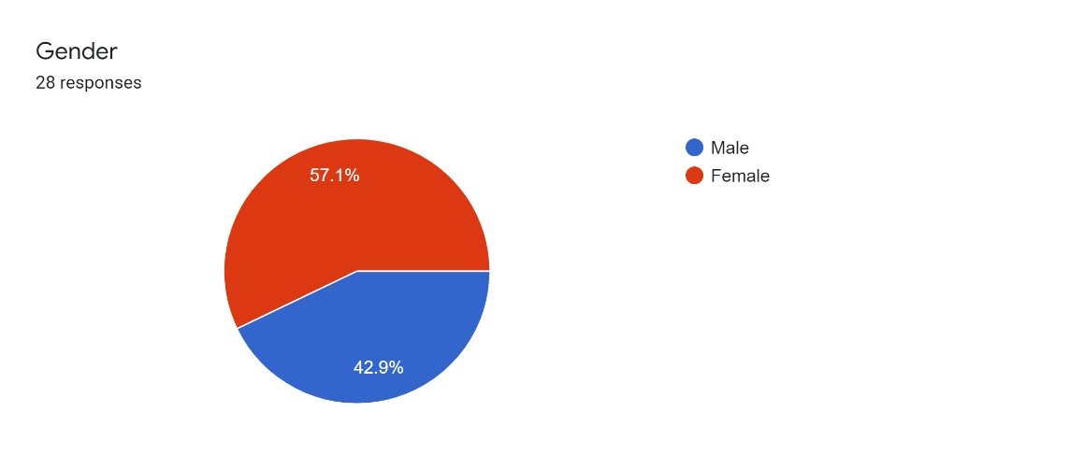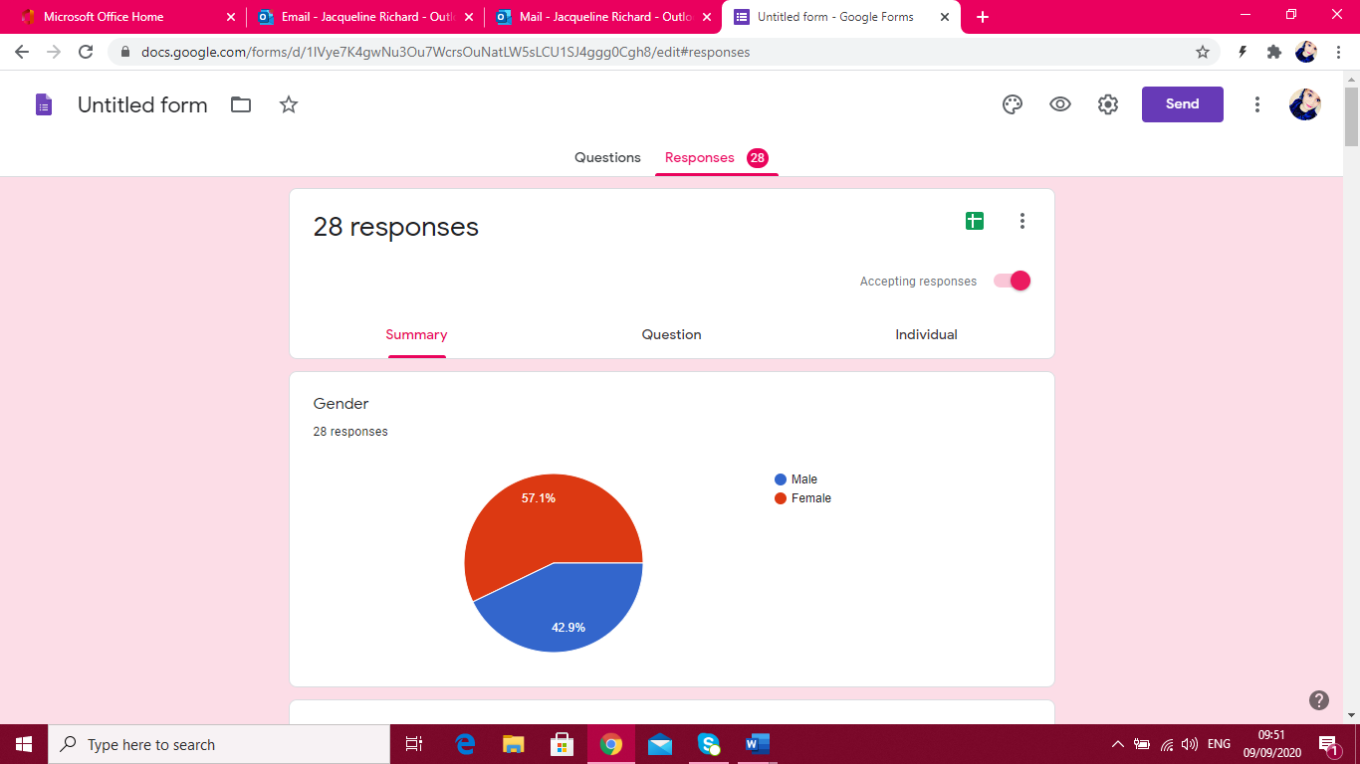

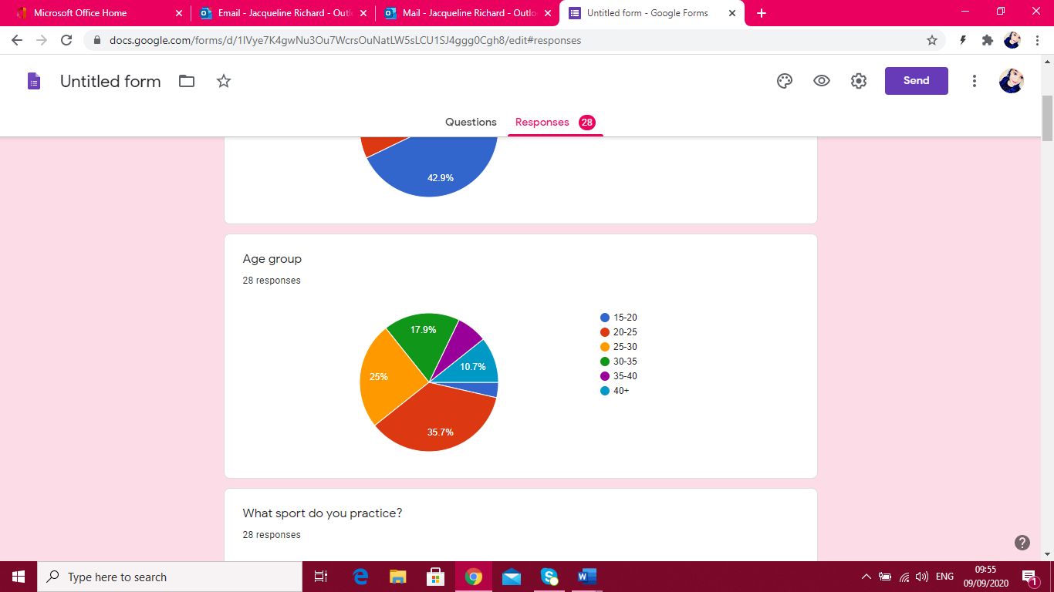

This first question was just a starter question to get to know the audience. This questionnaire was sent out to both athletes practicing rugby and athletics. The results show that 57.1% of the respondents were male and 42.9% were female.

This question shows the age group of the participants.

15-20: 1 participant (3.6%)

20-25: 10 participants (35.7%)

25-30: 7 participants (25 %)

30-35: 5 participants (17.9%)

35-40: 2 participants (7.1%)

40+: 3 participants (10.7%)

It shows that the most common age group is the 20-25 year olds.

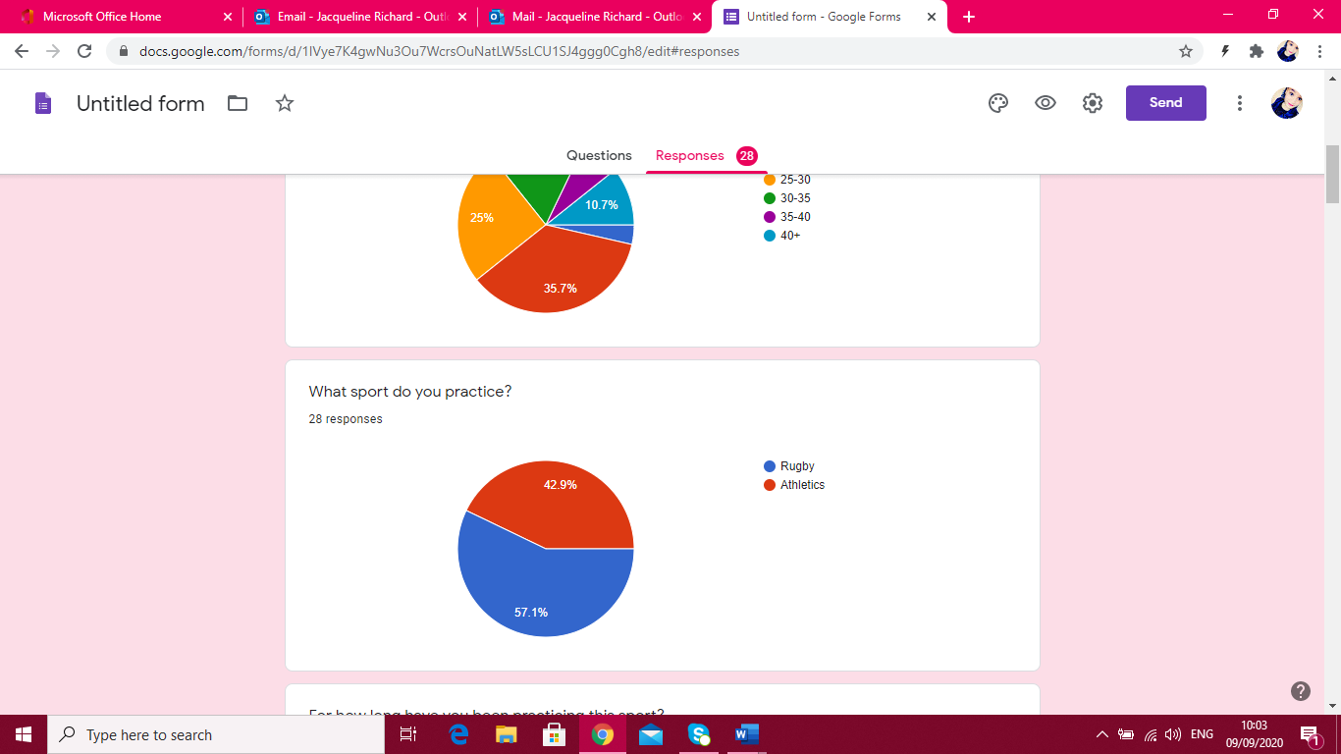

This question aimed to see which sport the participants practiced. The results show that most responses came from ruby, with an amount of 16 participants (57.1%) and 12 athletes (42.9%).

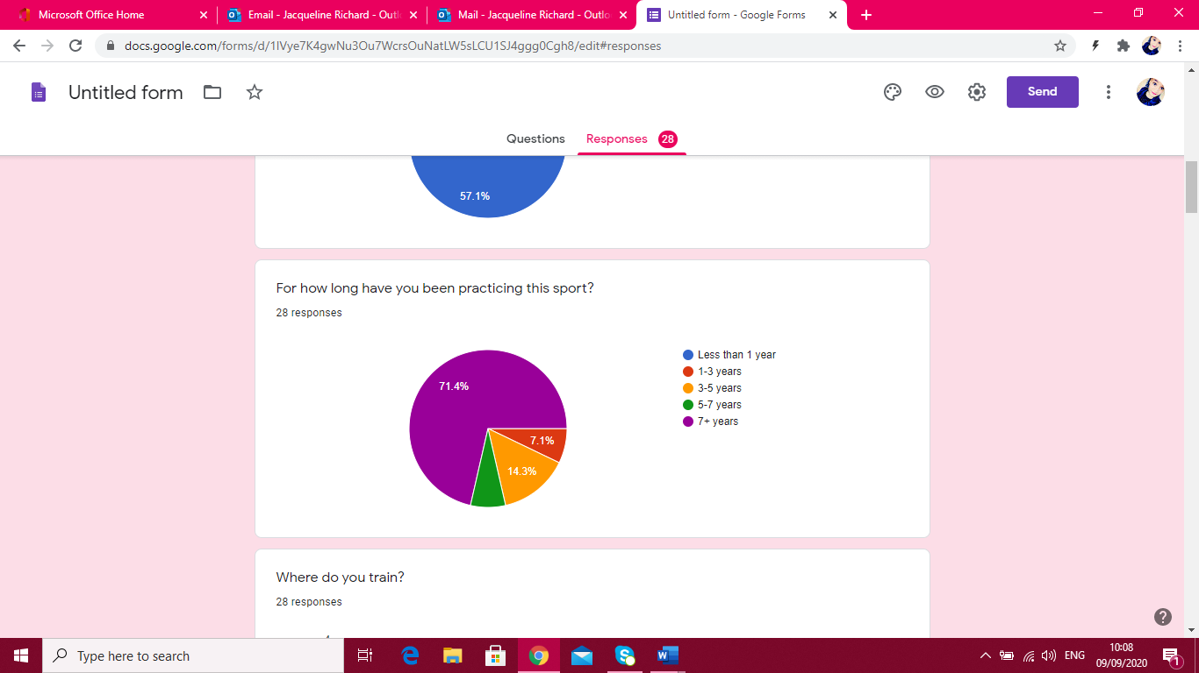

This question aimed to see how long these athletes had been practicing their respective sport.

<1 year: 0 participants (0%)

1-3 years: 2 participants (7.1%)

3-5 years: 4 participants (14.3%)

5-7 years: 2 participants (7.1%)

>7 years: 20 participants (71.4%)

It showed that most of the participants had been practicing their sport for 7 or more years.

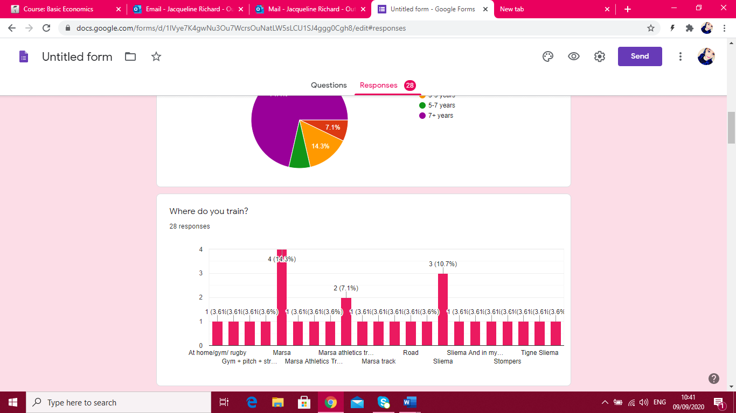

The purpose of this questions was to find out where the participants usually train. The majority answered with Marsa pitch as their training location. Some answered with Marsa track, Sliema wanderers pitch, gyms and road training and home training (especially with the Covid spike).

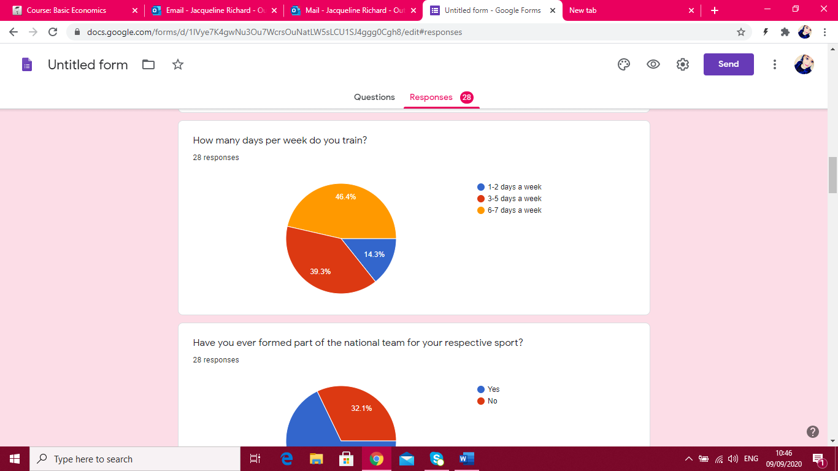

This questioned showed how many times the participants train per week

1-2 days a week: 4 participants (14.3%)

3-5 days a week: 11 participants (39.3%)

6-7 days a week: 13 participants (46.4%)

It showed that most participants trained 6-7 days a week

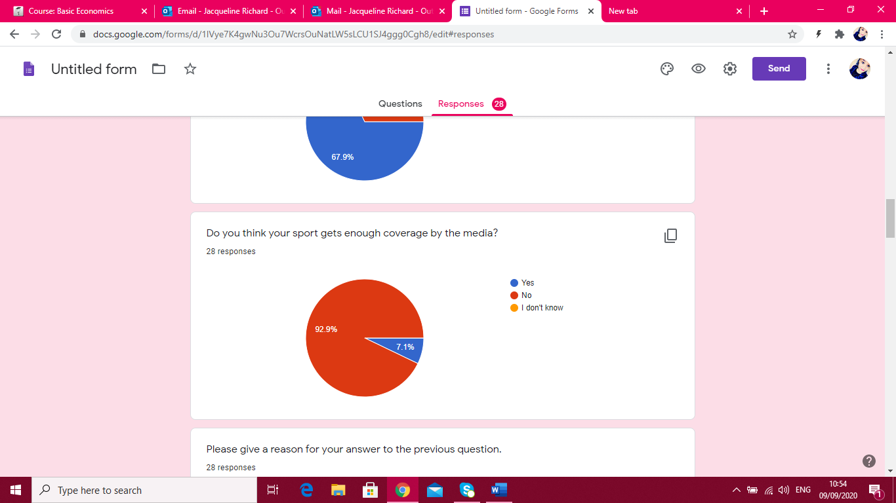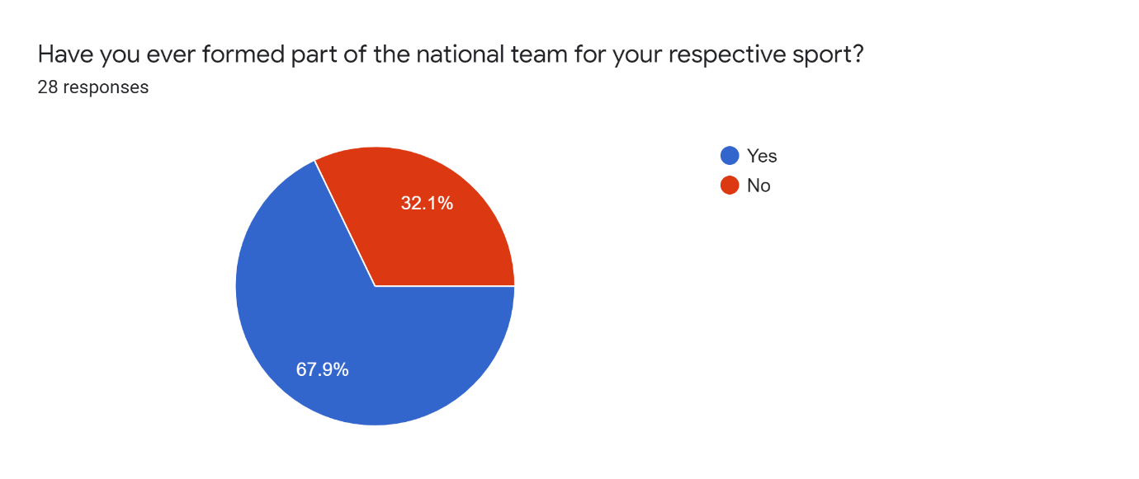

In this question it is very clear that athletes from both sports agree that both of their sport is not given the right amount of promotion and coverage by the media as it should. 26 participants (92.9%) answered with a “NO”, and only 2 participants (7.1%) think that their sport is given good promotion by the media and answered with a “YES”. No one answered with an “I DON’T KNOW”.

The next question for the participants was to give a reason for their answer. I have included the answers in the appendix section, however many athletes are upset that no promotion is being given and the media only covers what they wish to cover, leaving the success of many of these athletes unseen and unheard of.

In this question I wanted to see if my participants had ever formed part of the national team for their respective sport. The results show that 19 participants (67.9%) have formed part of the national team, whereas 9 participants (32.1%) still have not made it on the team yet.

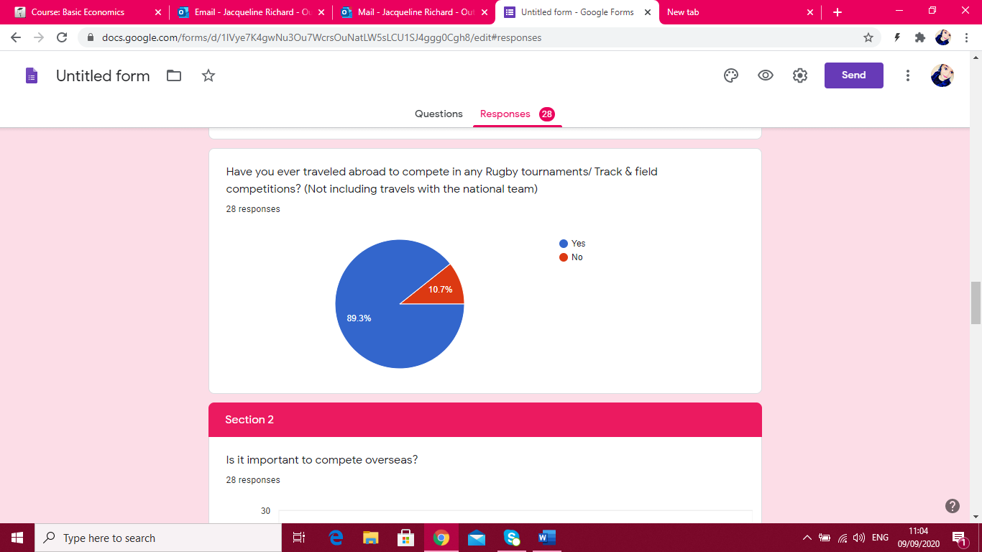

This question aimed to see if the participants ever had the opportunity to compete in any rugby tournaments/ track and field competitions abroad. The majority (25 participants: 89.3%) answered with a YES, whereas 3 participants (10.7%) answered with a NO.

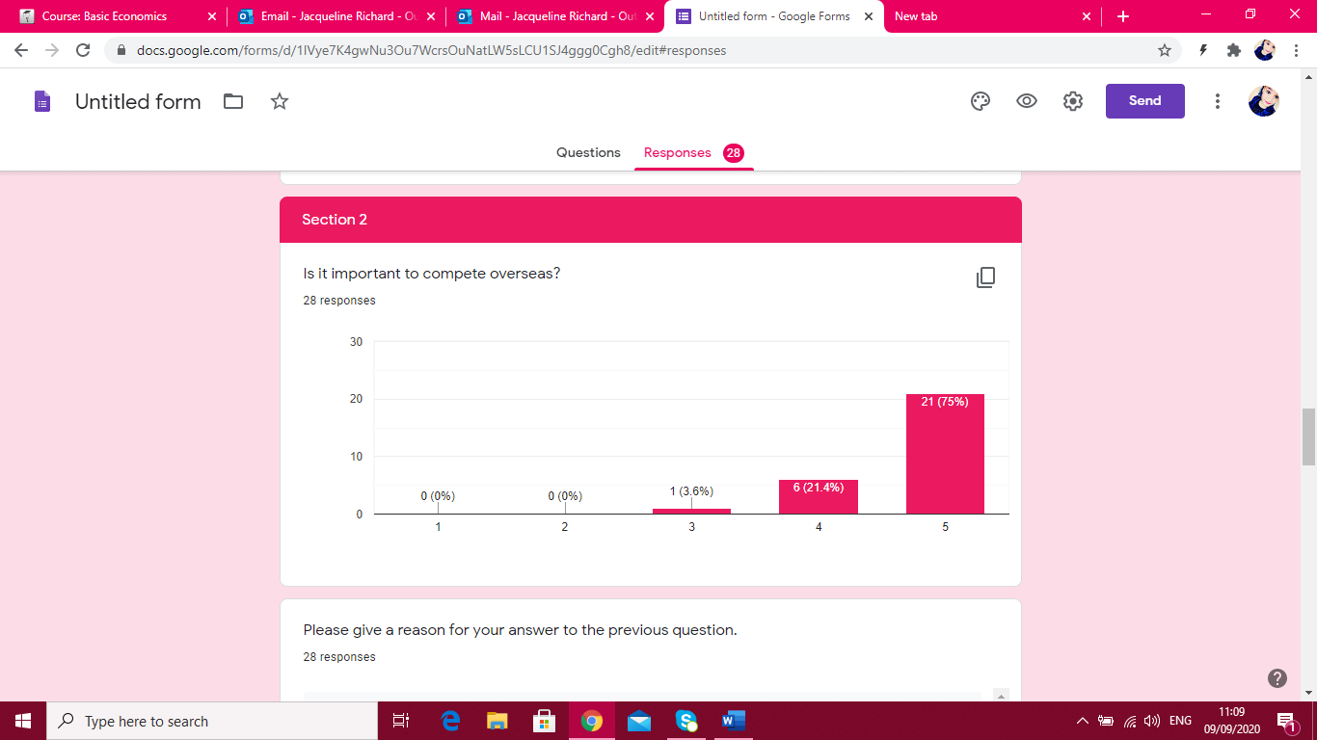

For this section, I have added a Likert scale for my participants to use. In this question, the majority of the participants (21) answered with a 5 meaning that they strongly with the importance to compete overseas.

I have then asked to give their reason for their answer (added in appendix)

However, the main reason I got was for the experience of playing against different levelled teams and higher levelled athletes.

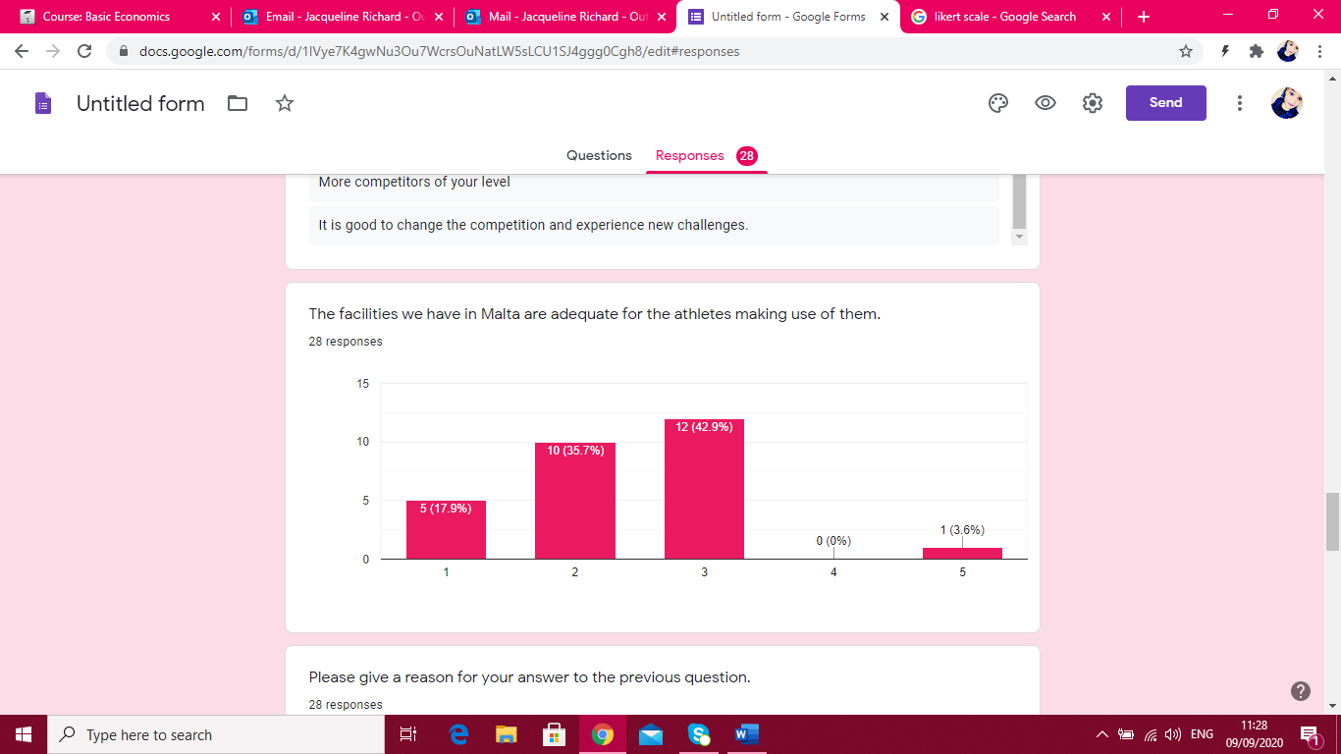

With another Likert scale added for this statement, I could see that the participants now are not too happy with the facilities that they have here in Malta. Most of the participants answered with a 3, 2 and 1. Only 1 participant answered with a 5.

I have then asked to give their reason for their answer (added in appendix)

There were many reason, but the ones that struck me the most was:

“The equipment is run down, most hurdles are broken and only 10 are usable whilst the others fall at the slightest touch. The gym equipment is old and only 2 sand pits out 4 can be used at one time when training and the blocks we are allowed to use for training have no spikes to hold down the blocks.”- Track and Field athlete

“Rugby pitches in Marsa are in very poor conditions most of the year either due to social events ending up heavily littered including nails lying in the grass, harsh Summers drying the turf to the very core making it dangerous to play or train given that Rugby is a contact sport.”- Rugby Player

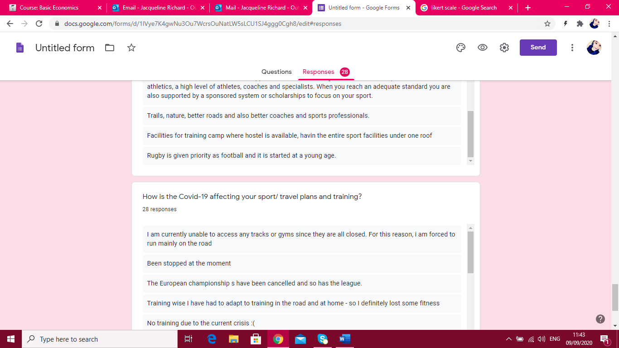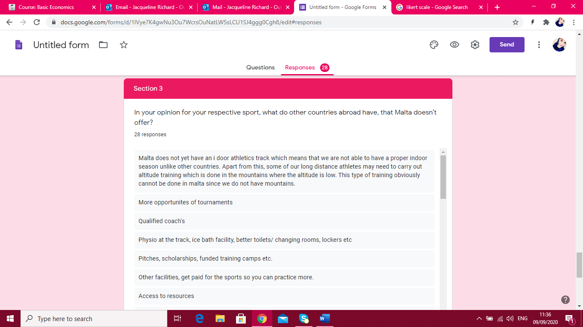Section 3:

For the last question, I have decided to ask the participants something in regards to the Covid-19 pandemic which is currently happening at the moment.

All 28 participants gave their input and concerns on the issue, the following are a few of them:

* “Sport is cancelled, training is done individually so it limited to what can be done in terms of skill work, and as a team sport we cannot practice as a team”
* “Training is not specific to my event. Back to general preparation due to lack of facilities and lack of gym. I had over 5 competitions abroad over all summer (extending the Maltese season longer). Everything is cancelled or even worse unsure.”
* “Although we cannot have the appropriate training, personal training is being done.”

All the other 25 results can be found in the Appendix section.

For this section, I have decided to ask the participants for their own personal opinion.

This question gave the opportunity for the participants to give their own opinion on what they think other countries have which Malta does not seem of have and offer. All 28 participants gave very good reasons, but the ones that struck me the most were the following:

* “Physio at the track, ice bath facility, better toilets/ changing rooms, lockers etc”
* “Pitches, scholarships, funded training camps etc.”
* “Media coverage, government support, sports being an important part of the educational system. Sports is still thought of as hobby doesn't matter at which level you're playing.”

All the other 25 results can be found in the Appendix section.

***Conclusions and Recommendations***

This research was based on why Maltese athletes are being drawn away from the Island to improve their performance in sport.

During this research, the researcher wanted to dig deeper behind all the reasons behind why Maltese athletes travel abroad to compete. The researcher wanted to learn and know what challenges the Maltese athlete faces on a day-to-day basis, so that they can continue to practice the sport they love and maintain a good reputation for the country.

The participants sample was all Maltese and selected from Malta to represent the Maltese population. Different athletes from 2 specific sports practiced in Malta were the targets. The research methodology the researcher used were qualitative and quantitative methodologies, in the form of online surveys and face-to - face interviews.

The researchers aims were met at the end of the research because the researcher wanted to have a better understanding on why Maltese athletes decide to travel in order to participate in many different international competitions. With all the research found and results obtained the aims have been therefore met.

The implications that arose from the researchers findings were that when it came to the sporting industry, Malta has much potential. The researcher learnt that the athletes were mostly struggling with the training facilities they have here in Malta, and also when it came to promoting their sport. They found sponsorships terribly difficult to find because of the lack of media coverage that their respective sports face on a daily basis. The athletes travel to gain more international experience, train in incredibly good facilities and then train with higher levels to improve their performance.

The researcher strongly agrees with the responses and opinions of the athletes regarding this research. Being an athlete, the researcher feels that traveling and exploring different competitions, levels, different sporting facilities, whether indoor or outdoor tracks, pitches, and gyms, is very important. With these experiences, athletes can grow so much and the researcher hopes that in the future, Malta will be able to offer the best for Malta’s current athletes and future athletes.

***References***

MaltaToday.com.mt. 2020. *[WATCH] New National Sports Strategy Aims To Raise The Bar, Trigger Culture Change In Malta*. [online] Available at: <https://www.maltatoday.com.mt/news/national/95163/watch_new_national_sports_strategy_aims_to_raise_the_bar_trigger_culture_change_in_malta#.XhW40MhKjIU> [Accessed 9 September 2020].

Independent.com.mt. 2020. *Sports Tourism And Its Benefits - The Malta Independent*. [online] Available at: <https://www.independent.com.mt/articles/2005-11-01/others/sports-tourism-and-its-benefits-83284/> [Accessed 9 September 2020].

En.wikipedia.org. 2020. *Impact Of The COVID-19 Pandemic On Sports*. [online] Available at: <https://en.wikipedia.org/wiki/Impact_of_the_COVID-19_pandemic_on_sports> [Accessed 9 September 2020].

Davies, B. (2003). The role of quantitative and qualitative research in industrial studies of tourism. International Journal of Tourism Research, 5(2), 97-111.

Pigeassou, C., 2004. Contribution to the definition of sport tourism. Journal of Sport & Tourism, 9(3), pp.287-289.

Mokras-Grabowska, J. (2016). Sports tourism: terminological discussion. Turyzm, 26(1), 13-18.

Mapjabil, J., Marzuki, M., Kumalah, M.J., Tangavello, L. and Abidin, M.K.Z., 2017. Sport as a tourism attraction in Malaysia: Potential and prospects. Geografia-Malaysian Journal of Society and Space, 11(12).

Cavill, N. and Bauman, A., 2004. Changing the way people think about health-enhancing physical activity: do mass media campaigns have a role?. *Journal of sports sciences*, *22*(8), pp.771-790.

Briguglio, L., 2008. Sustainable tourism in small island jurisdictions with special reference to Malta.

Higham, J.E. ed., 2005. *Sport tourism destinations: Issues, opportunities and analysis*. Routledge.

Deery, M., Jago, L. and Fredline, L., 2004. Sport tourism or event tourism: are they one and the same?. *Journal of Sport & Tourism*, *9*(3), pp.235-245.

Sultana, T., 2019. *Exploring scuba diving tourism sector in Malta and its sustainable impact on the island* (Bachelor's thesis, University of Malta).

Weed, M., 2020. The role of the interface of sport and tourism in the response to the COVID-19 pandemic. *Journal of Sport & Tourism*, pp.1-14.

Gammon, S. and Robinson, T., 2003. Sport and tourism: A conceptual framework.

***Appendices***

***Transcription***

***Interview Transcripts- Athletics- Janet Richard***

**How long have you been playing/doing the sport and what got you started?**

So, I have been training athletics for 10 years now. I started because the secondary school that I used to go to gave a lot of importance to sport and especially athletics, so, and we actually competed a lot between schools, we took part in the interschools where I saw that I did well, so I decided to take it up as an extracurricular activity after school, and that’s when I met my coach, Zeljko Aras, and I’ve been with him ever since.

**Ok.**

**Can anybody practice this sport? What are the qualities that a person needs to start athletics?**

So athletics is not just running as a lot of people may believe. There are a lot of elements to athletics, we have jumps, we have throws, and yes I believe that everyone can practice athletics. It is for people of all ages. The qualities that you need, I mean, you don’t need to go into athletics thinking that you have to take it very seriously or that you want to go pro, you can just have fun with it. So what you need is, I mean, a good work ethic, discipline and to be committed.

**What are your biggest achievements up to date?**

So I have had the honour of representing Malta in a number of international competitions. I am actually the national record holder of the 400m, the senior, junior and indoor record, and also the 4 by 100m relay. Till now I have represented Malta at the world championships in Doha, and I believe that that is by biggest achievement to date.

**Ok**

**Janet** **why is it important to travel? And what makes athletes leave Malta to compete abroad?**

So in Malta the athletics community is very small, so we are constantly competing against the same people. So if you want to mix it up and compete with people at a higher level then you are, which for us is very very important, so that we don’t get stuck and so that we can improve our performances, it is very important to go abroad and compete in competitions that are at a higher level.

And what was the rest of the question?

**What makes athletes leave Malta to compete abroad?**

So, like I said, to compete with people who are better then us and even maybe to compete in facilities that are better than the ones we have in Malta. Also for example, in winter the athletics season consists of the indoor season, and unfortunately we don’t an indoor track in Malta, so its important for us to go abroad and to compete in such a facility. Apart from that, there is also mountain running which is part of athletics, obviously in Malta we don’t have mountains, so the athletes would need to go abroad to places where there is high altitude.

**So,** **Have you ever left the country to train or compete abroad? If yes, why, and to where?**

Yes I have, I’ve gone for training camps abroad and I’ve competed quite abit abroad as well. Training camp, I actually went for an indoor training camp in February, like I said, in Malta we don’t have indoor facilities so it was important for us to get an idea of the indoor track since it is very very different to the outdoor, and since we had indoor competitions scheduled later on in the year, we thought it was important for us to be able to train on such a track. So I went to Berlin where they have indoor facilities and I spent a week there. Competitions abroad I’ve done also. I’ve competed with the national team where we go abroad all the time, and I’ve also gone by myself just to, like I said to compete against people better then me.

**So what are the ideal/ optimal facilities needed to carry out the sport?**

Well, I believe that the ideal facility would be….. one would be accessible. It doesn’t need to be very fancy or whatever but just the basics, the essentials, I think its ideal, like in Malta we have a track, we have a gym, we don’t have like ice baths or recovery rooms or physio therapy rooms on sight, which is what were usually used to when we go abroad, we have the bare minimum actually, but its enough, it’s what works for us and, like there is room for improvement obviously but for athletics you don’t much, you just need the implements and you need a track where you can run.

**What changes do you think can be done here in Malta in order to live up to international standards?**

I think the inclusion of a recovery room and including ice baths and physiotherapy rooms, even an indoor facility, so that we can compete at the same level as abroad, because for example our indoor season is done outdoors anyway and so we’ve got the winter elements, its cold, its raining, its windy, so we need an indoor track so ideally we would have that, and like I said places where the athletes can recover also.

**So** **do you think there are any benefits of training or competing here in Malta? Do you think that sometimes we have an advantage over athletes overseas?**

I think our main advantage is the weather, because were fortunate enough to have sunny weather most of the time, yes we have winter just like everyone else but I don’t think it’s that bad. It’s not as cold, it’s not as rainy, so for competitions and even for training, I think we are at an advantage. So weather wise I think it’s good in Malta.

**So do you think that athletics in Malta has a potential to grow? And do you think we are promoting the sport in the best possible ways to attract new faces to the sport?**

I think there is always potential for growth obviously but it always depends on how much money people are willing to put into the sport, which unfortunately, to date, hasn’t been much. We haven’t been given much of a priority, I mean, if you just watch Maltese news, the sports section, all you see is football or water polo. So unfortunately our sport is not being promoted as much. Latterly there has been some improvements since we have changed the president and he has all these ideas but, there is nothing concrete yet so as far as promotion I don’t think were there yet, but hopefully someday we will be.

**Ok, and the last question I had to include something in regard to the pandemic.**

**So how is the Covid-19 affecting your sport/ travels and training?**

Obviously it affected us a lot. We had lots of international competitions scheduled and that they were all cancelled, so there were no international races this year. Training wise, also, everything went out of the window, every programme we had, the track closed, gyms closed, so it changed a lot. We had to adapt to the circumstances so it was a lot of running on the road, running in the hills, beach training, doing whatever we can to try and keep a level of fitness for whenever we do eventually get back on the track.

**Ok, would you like to add anything else?**

No from my end I’m good, thank you

**From my end we are fine as well. I wish you all the very best.**

Thank you very much

**And all the success in your athletics career.**

Thank you, good luck to you too

**Thank you very much.**

***Interview Transcripts- Rugby- Claire Casha***

**How long have you been playing/doing the sport and what got you started?**

I have been into rugby for 12 years. My sister was already playing rugby at the time and asked me if I wanted to join a session, and I thought it would be a great way to get fit.

**Can anybody practice this sport? What are the qualities that a person needs to start rugby?**

Yes, anybody can give rugby a shot, there are different positions within the game, so any body type will find a place within the team. Basic fundamentals such as running and ball handling skills will surely be beneficial for a person to start.

**What are your biggest achievements up to date?**

Playing for the Malta national team will always be my biggest achievement. Nothing beats the feeling of wearing the jersey and playing for your country.

**Why is it important to travel? And what makes athletes leave Malta to compete abroad?**

Travelling is important to participate in different tournaments and training camps, also for fun and team building with the local clubs. And it is also really good to play against different teams of different levels and experience.

The IRB (International Rugby Board) rugby European championships happens once a year and it is always held overseas. This year unfortunately, it had to get cancelled due to the pandemic.

**Have you ever left the country to train or compete abroad? If yes, why, and to where?**

Yes I have on a number of occasions done so.

I have been to Greece, Holland, Denmark, Belgium to train and to compete I have been to Belgium twice, to Croatia three times and Romania.

**How often per year do you travel abroad to take part in any sporting events?**

Usually once to compete with the national team and once for a fun tournament or game with the club.

**What are the ideal/ optimal facilities needed to carry out the sport?**

Good soft rugby ground and a good gym with basic equipment is enough.

**What changes do you think can be done here in Malta in order to live up to international standards?**

Better stadium, better pitches, changing rooms. At the moment we don't even have changing rooms and the pitch is usually hard and uneven which causes a lot of injuries to a lot of us players.

**Do you think there are any benefits of training or competing here in Malta? Do you think that sometimes we have an advantage over athletes overseas?**

Since it is very hot we have the advance of training in the heat and we usually play and compete in the heat so our bodies are acclimatised to it, whilst other countries usually train in the cold.

**Do you think that rugby in Malta has a potential to grow? And do you think we are promoting the sport in the best possible ways to attract new faces to the sport?**

We have potential to grow, but we definitely need more organisation and better facilities. I don't think any promotion is being made, or if it is being made it certainly is not enough. We barely see any new faces in women's rugby. There is also no youth women's section, so that makes it even harder.

**How is the Covid-19 affecting your sport/ travels and training?**

The league had to finish in the middle of it this year, the IRB rugby European championship were cancelled and training up to this date is cancelled. We started a bit but had to stop again due to the increase of Covid cases. Individual fitness had to be done since team training was not being done.

***Questionnaire***

Do you think your sport gets enough coverage by the media?

(Please give a reason for your answer to the previous question.)

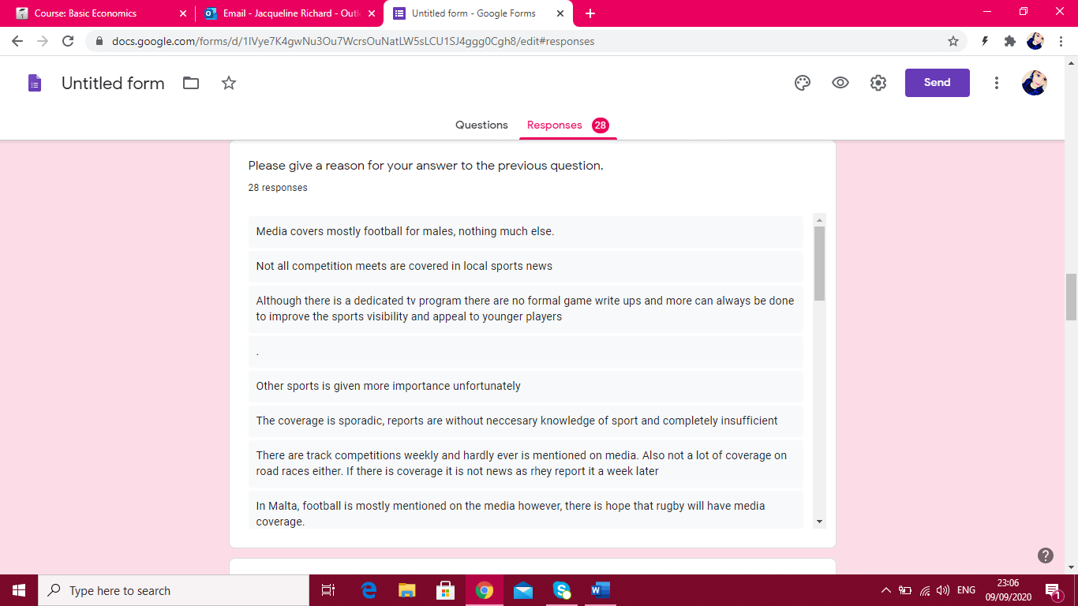

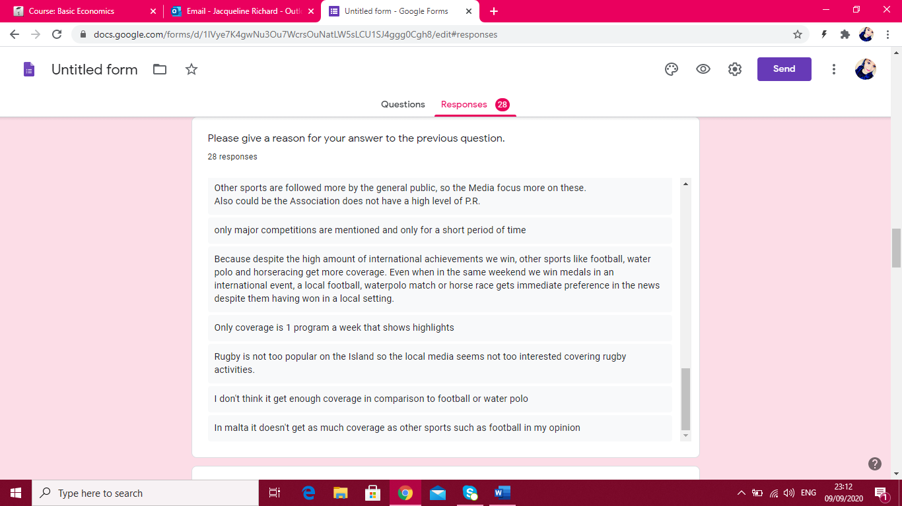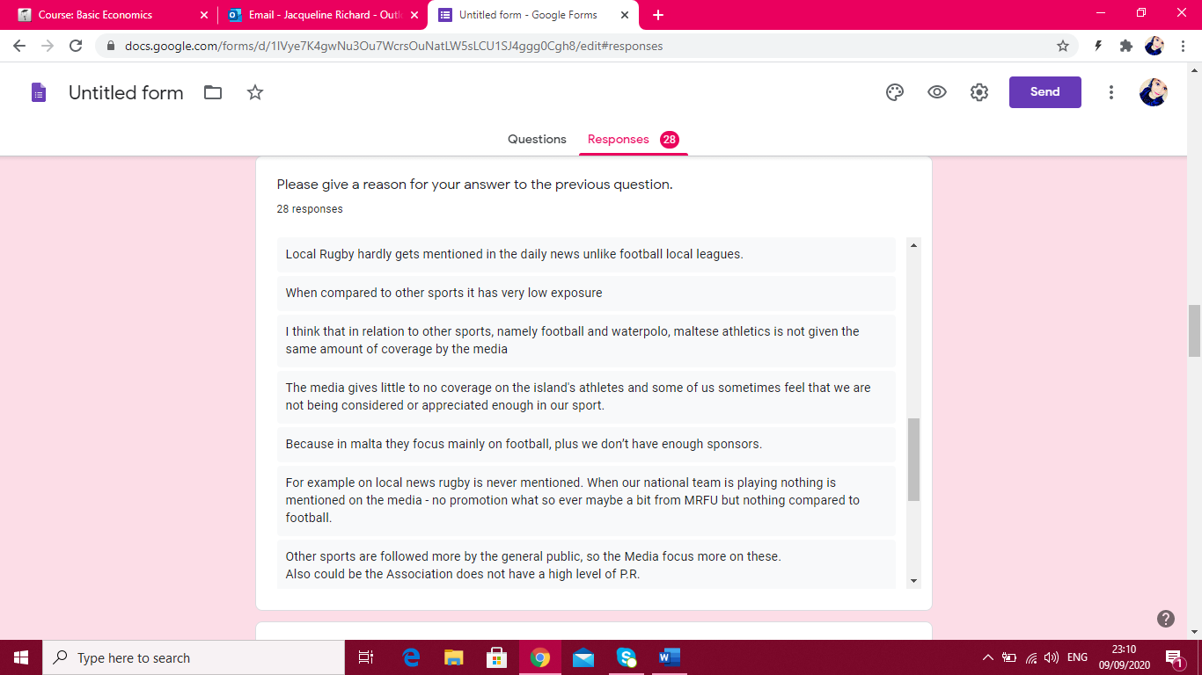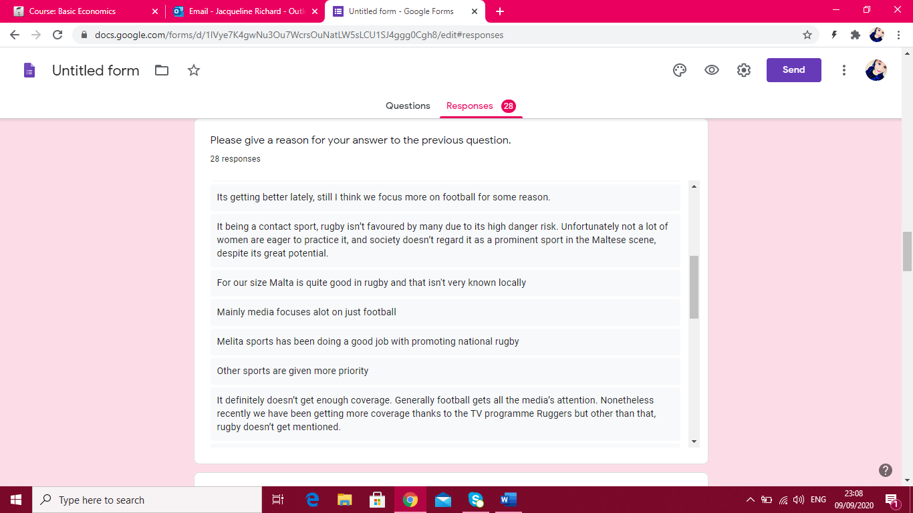

Is it important to compete overseas?

Please give a reason for your answer to the previous question.

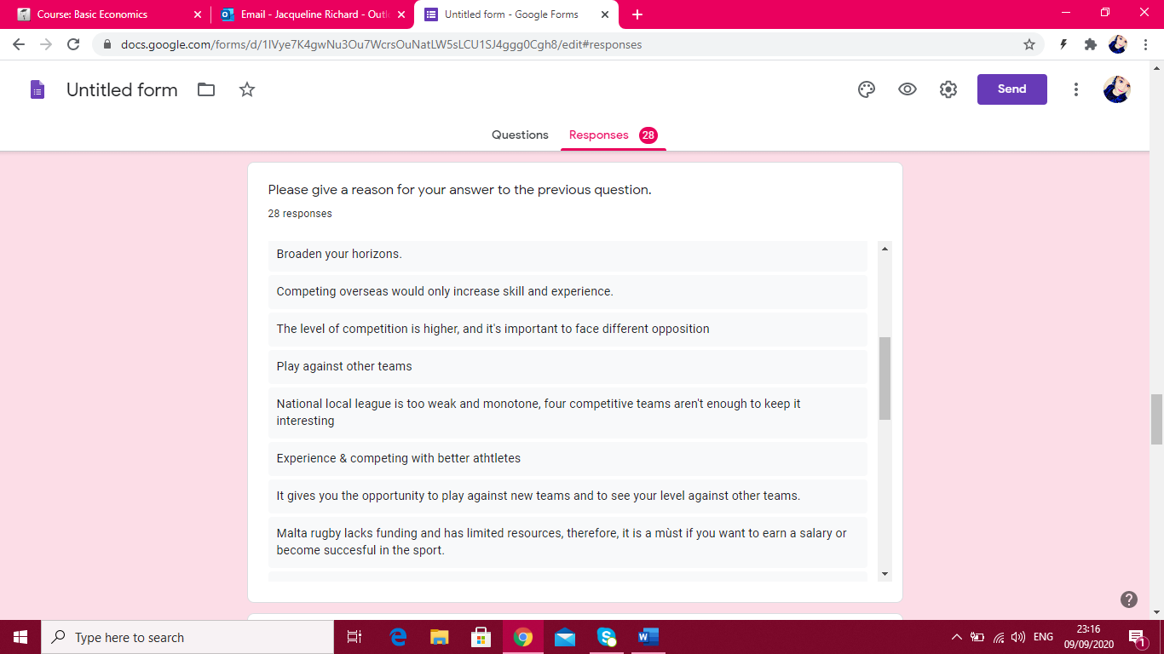

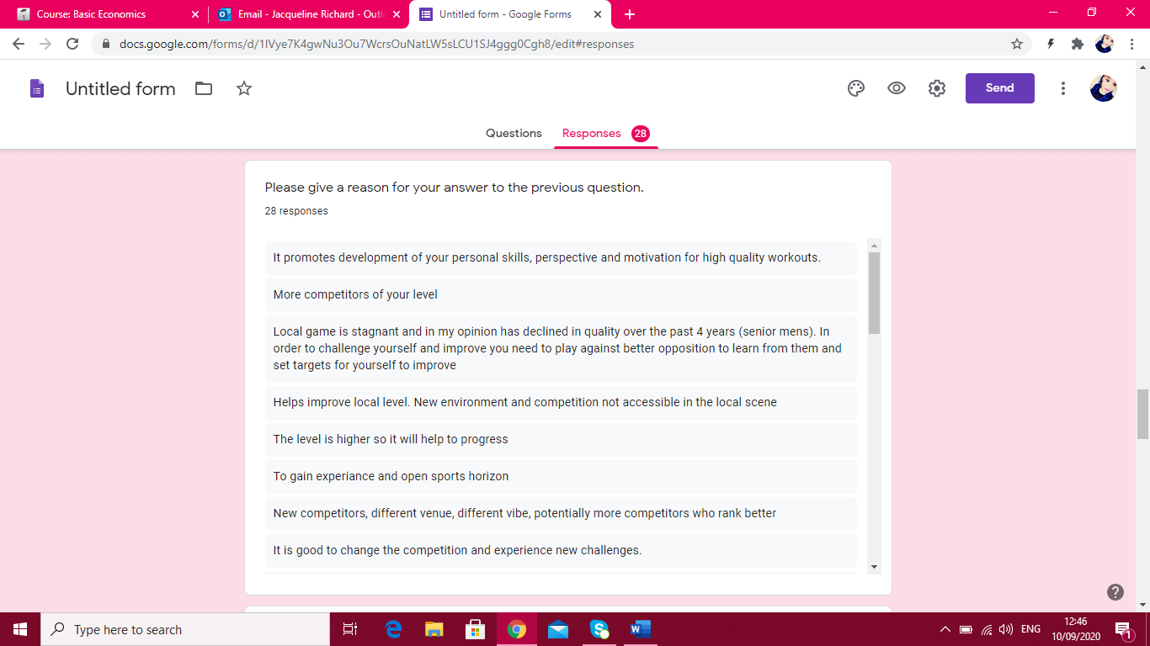

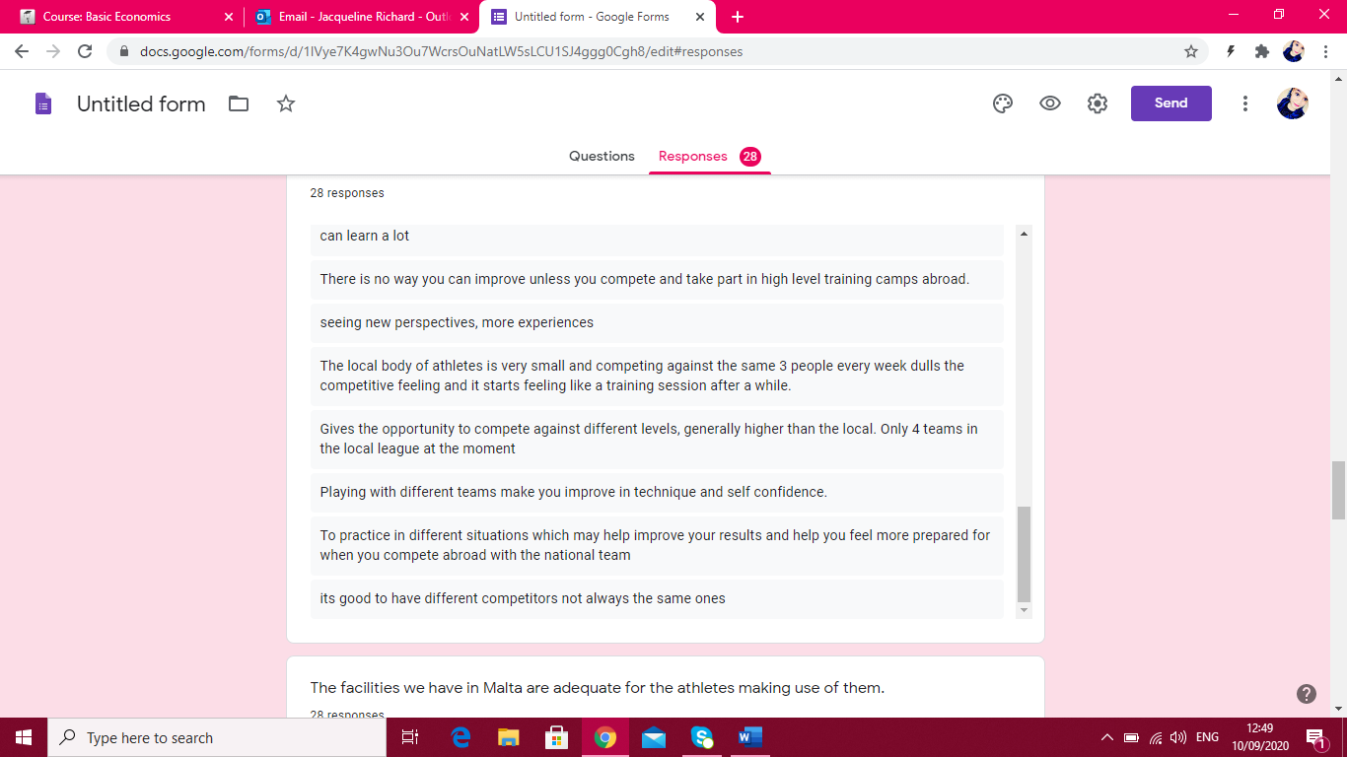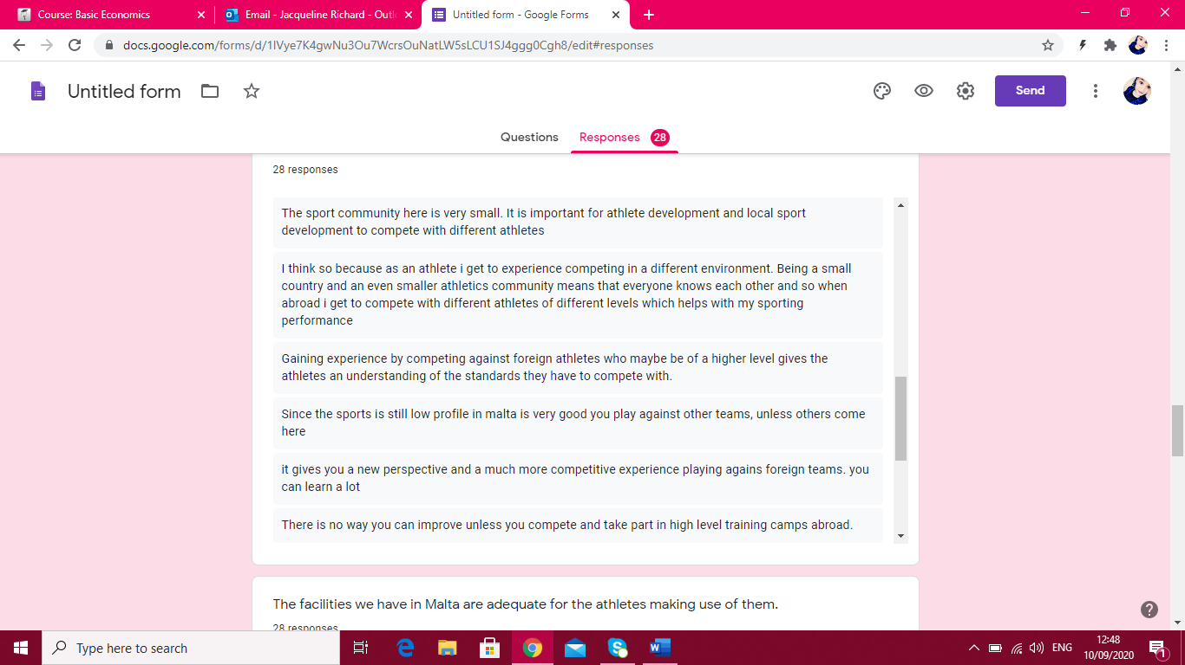

The facilities we have in Malta are adequate for the athletes making use of them.

Please give a reason for your answer to the previous question.

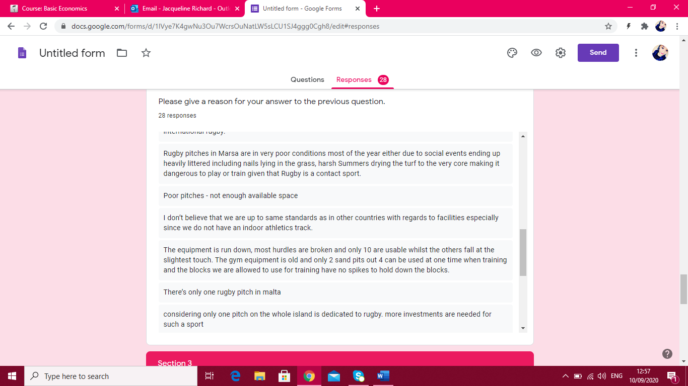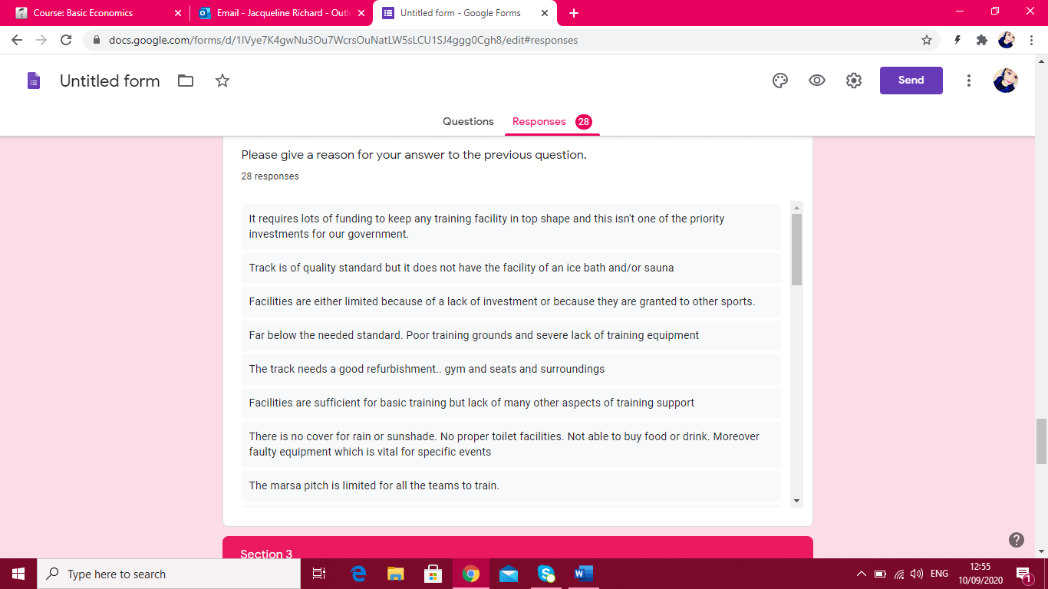

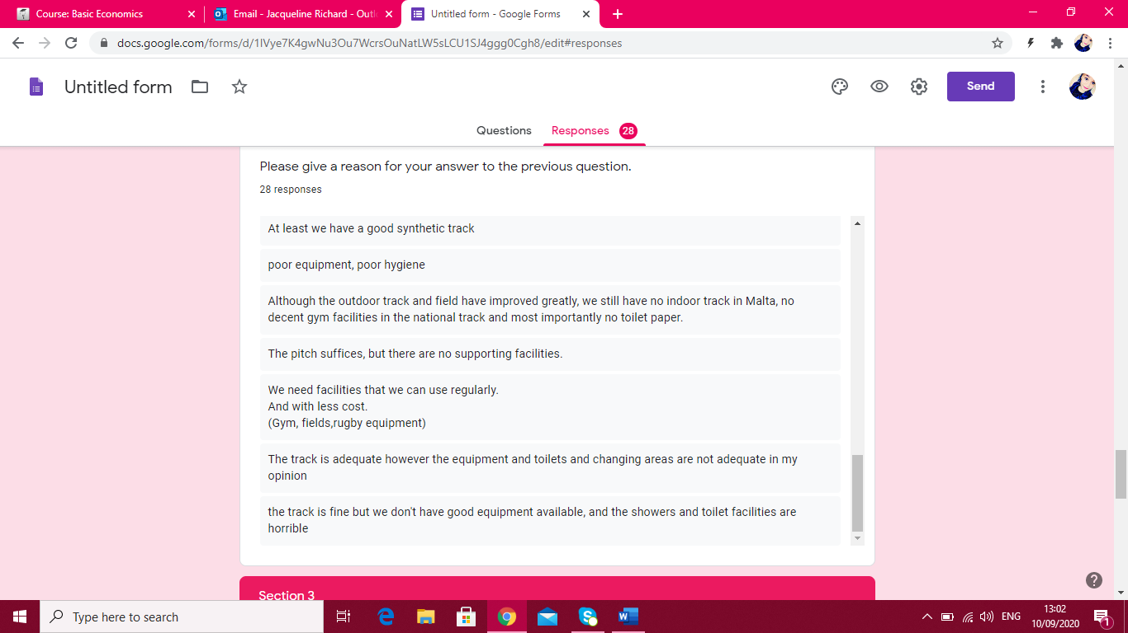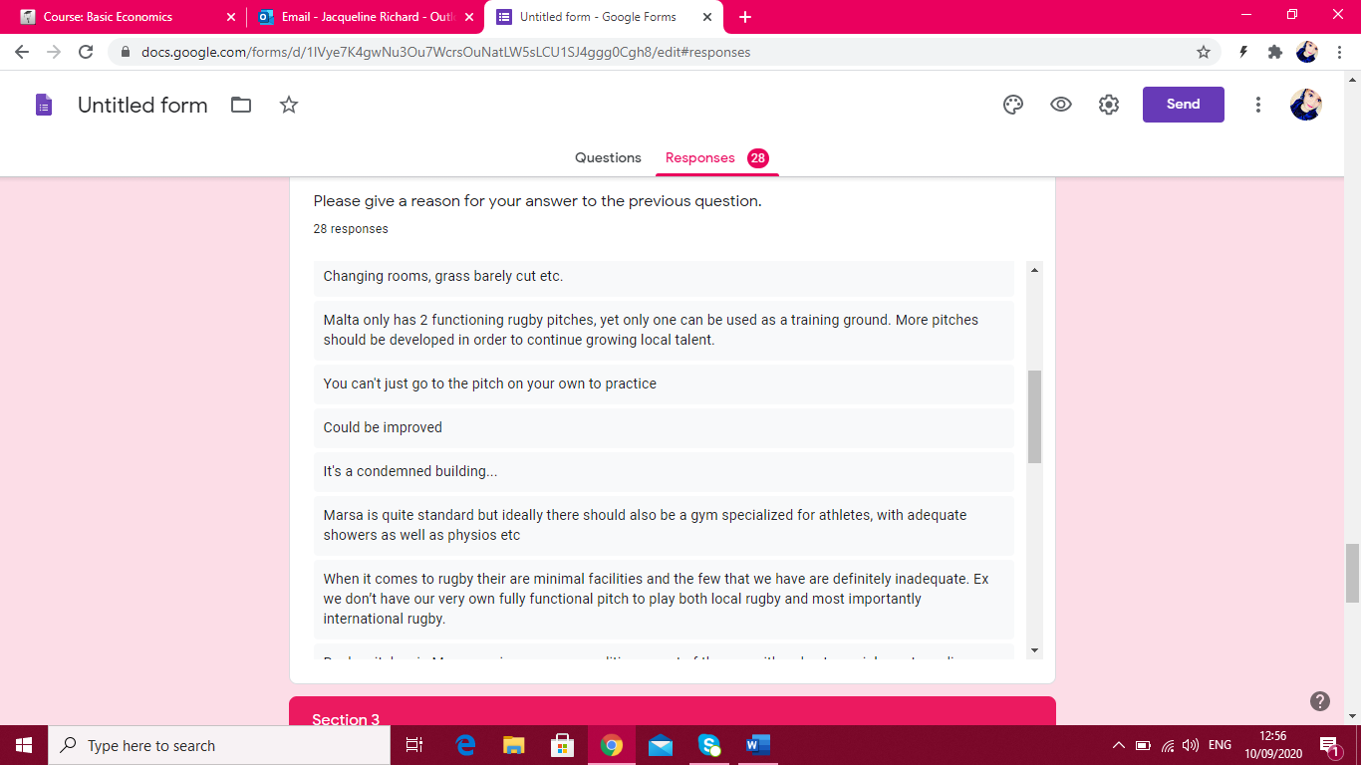

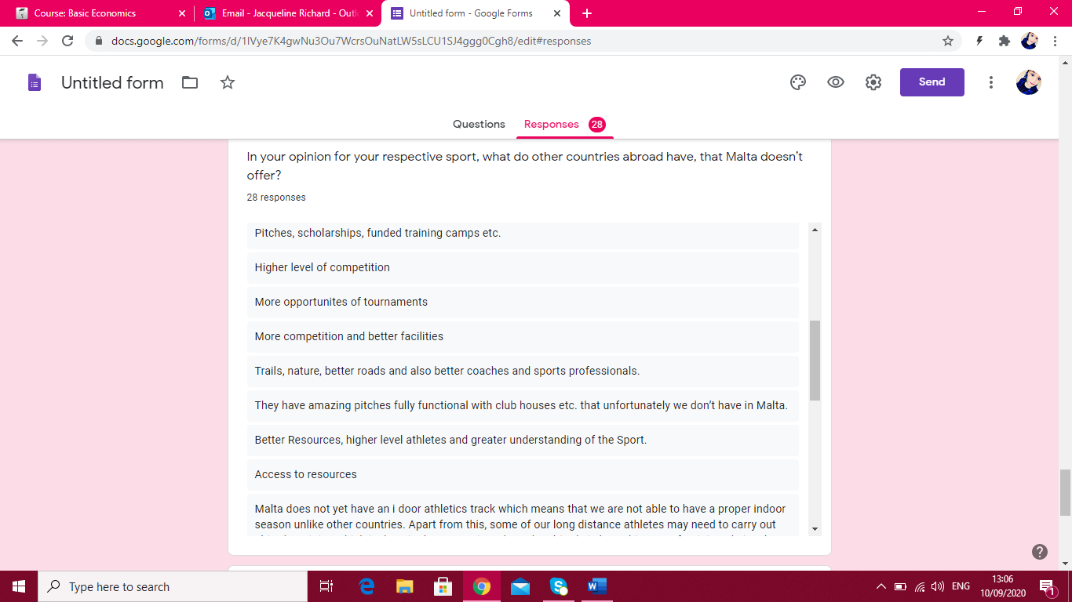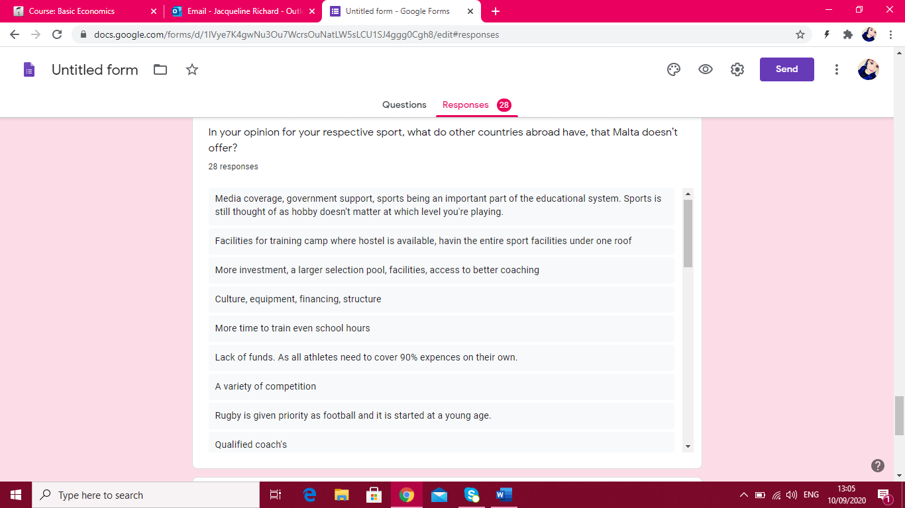In your opinion for your respective sport, what do other countries abroad have, that Malta doesn’t offer?

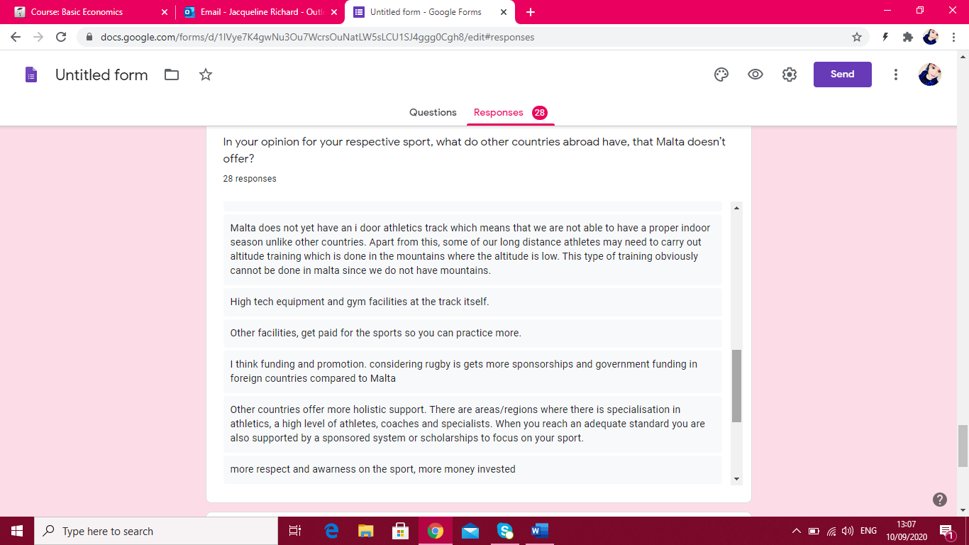

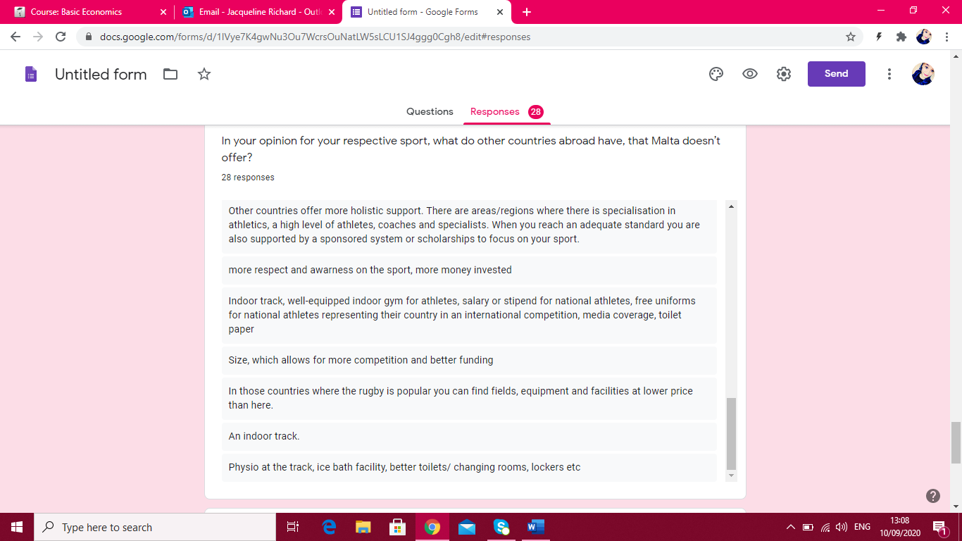

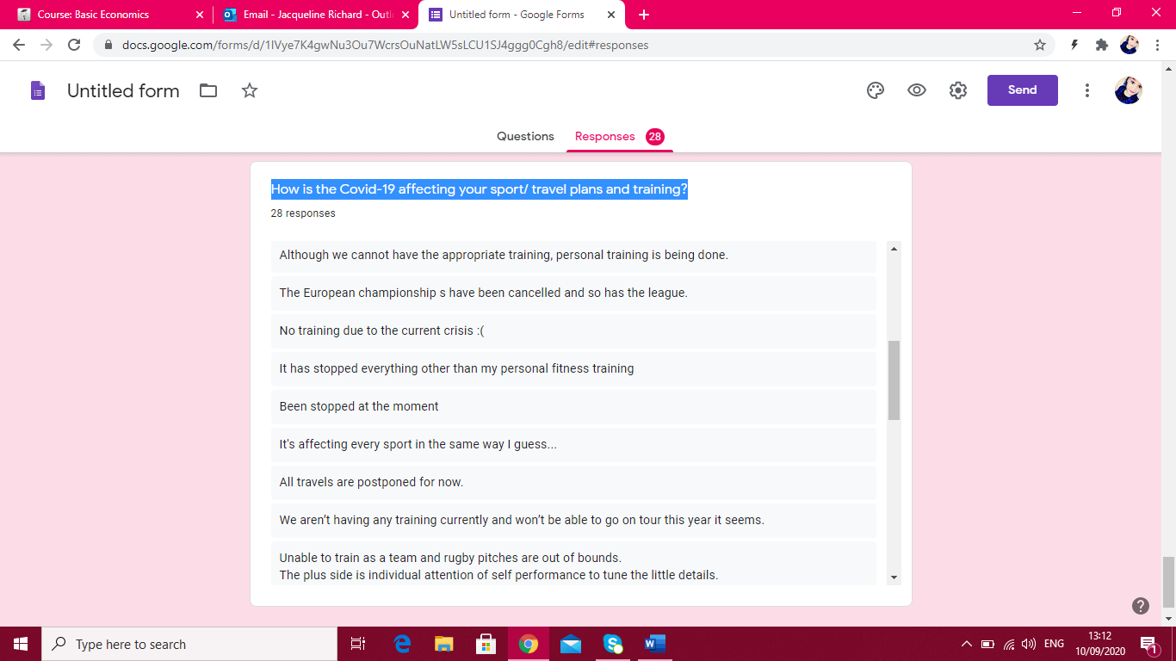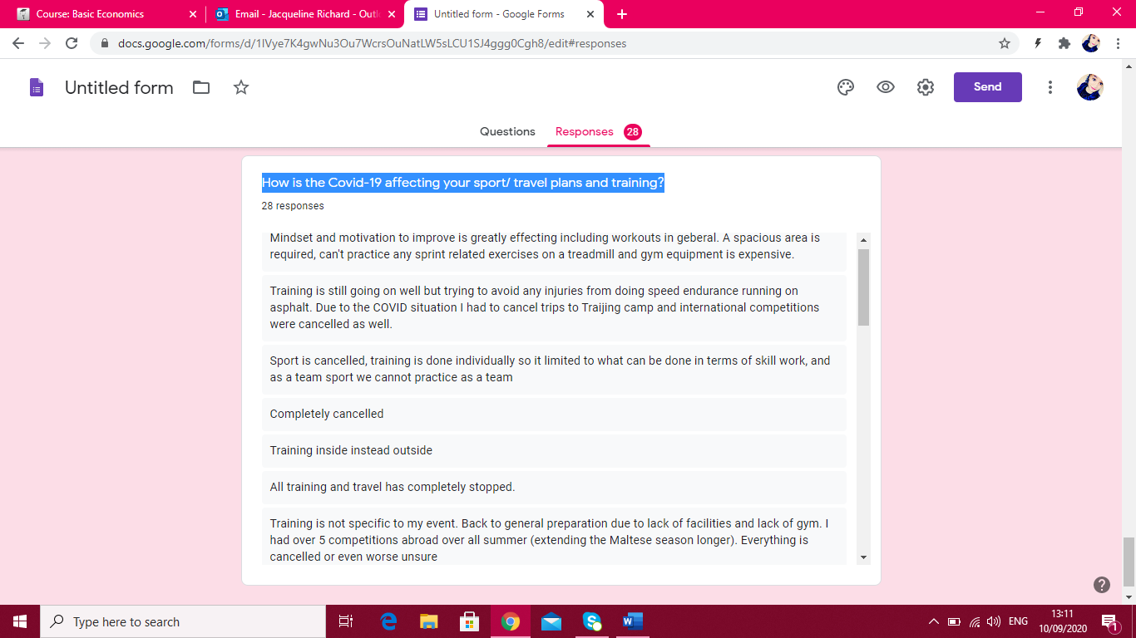How is the Covid-19 affecting your sport/ travel plans and training?

