Personalities and their role in establishing
the Maltese-Russian relations.

Dissertation submitted for the Higher
National Diploma in Tour Guiding

2020

Denis Galea Vella Maslennikov

Contents:

Declaration of authenticity ………………………………………………...………………….. 1

Contents ……………………………………………………………………………..………………..… 2

Acknowledgments …….………………………………………………………..………………….. 3

Introduction ………...……………………………………………………………..………………….. 4

Literature review ………………………………………………………………..………………….. 6

Research methodology …………………………………………………………..………………. 8

Data Analysis …………………………………………………………………………………………… 10

Peter the Great and Grand Master Perellos ………………………………………….… 12

Catherine the Great and Grand Master Pinto da Fonseca …………………….… 14

Paul the I and Grand Master Homepesch ………………………………………………. 16
Maltese, Russian and British connections ………………………………………………. 19

The last Princess and the first President ……………………………….………………… 20

Conclusion …………………………………………………………………..……………….……….. 22

References ……………………………………………………………………………………………… 23

Appendix …………………………………………..…………………………………………………….. 26

Acknowledgments.

The author would like to thank his tutor Caroline Muscat for her support and patience.
Chev. Saviour Garcia - the secretary of the Russian Priory of the Order of St John for providing precious information about the history of the Order of St. John and its connections with Russia.
Mr Andrey Muraviev - the director of the Russian Cultural Centre for getting acquainted with the works of the Russian artists who stayed in Malta during the Russian revolution of 1917.
Mr Robert Cassar and Mr. Emmanuel Magro-Conti - the curators of the Grand Master’s Palace, for sharing their knowledge and recommending important sources of information for studying.
Professor Antonio Espinosa Rodriguez - lecturer at University of Malta and Institute of Maltese Studies and former Senior Curator at Heritage Malta for revealing new names of personalities who had contributed to the establishment of cooperation between Malta and Russia, which are not mentioned in most sources.
Natalya Voverits – the curator of the Russian Museum in Saint-Petersburg for sharing her knowledge of the Maltese-Russian connections.

Introduction

The author of the dissertation is intended to work not only with the English speaking tourists but also with Russian speaking visitors. This is why it is important to focus on the historical connections between Malta and Russia.

Presenting the history of Malta can become more attractive for the tourists when they discover the connections with their native country. It makes them feel proud to be involved and become more attentive to the provided information. Discovering the facts that some of the well-known Russian personalities and prominent Maltese figures had initiated and supported the diplomatic, military and cultural cooperation between two countries during three centuries can make the guiding tour an exciting experience. Such perspective of a guiding tour can help to promote Malta as a more attractive destination for the potential Russian speaking tourists.

When the tourists arrive in Malta for the first time their knowledge of the Maltese history is usually limited to few facts from the history of the prehistoric temples to the heritage of knights of the Order of St John. Most of them are surprised to discover that the history of Malta is much more rich than they expected and it is impossible to discover it in one visit.

Another unexpected fact for the tourist is the discovery of connections between the Maltese prominent figures and famous personalities of their native country. Revealing these connections arouses stronger interest and motivation for further exploration of the Maltese historical heritage.

One of the stereotypes which exist nowadays is that the comprehensive cooperation of Malta and Russia is a recent phenomenon. However, a deeper research reveals that the Russian-Maltese relationship has been initiated more than 300 years ago.

When we analyse the convergence between the countries, we should consider it not just as a number of related events, but to look deeper and find the reasons of those events and the motives of personalities who were capable to initiate them and change the history.
In reality many of the events bringing together Russia and Malta were initiated by people, who were motivated by their personal interests and intentions. It could be a governor looking for the allies against common enemy, a historian who intended to reveal a story of common life in Malta to his compatriots or a noble ballerina, looking for a safe place for her family and not giving up on supporting art and culture even in hard times.

The interviews with the experts in history and the analysis of primary and secondary sources helped the author to reveal deeper connections between two countries and to understand the significance of specific Russian and Maltese personalities and their role in establishing diplomatic, military, commercial and cultural connections.

The objective of this thesis is to highlight the most important elements of the historical timeline, describing the process of the comprehensive rapprochement between Malta and Russia.

The information collected in this research forms the base of the guided tour, revealing the history of Malta and its connections with Russia. ^{i}

Literature review

Even though the history of the relationship between Malta and Russia had started in the 16th -17th centuries, the proper study of this subject is a recent phenomenon. This is happening due to the increasing amount of Russian people coming to the island for various reasons, which itself is contributing to the growing interest in the subject. This explains the limited number of printed resources. Most of those resources share the same vision and sometimes even stereotypes, which misinterpret the facts.

One of the books, which had inspired the author to choose this topic for the research was the book of Princess Nathalie Poutiatine - “Princess Olga, my mother”, 1982, Valletta, Malta. It showed that one person is able to create a strong cultural connection between two far apart countries, bring the traditions from one country and influence the appearance of new tendencies in another.

Even though it is the story of one family, not revealing the history of the relations between Malta and Russia in general, it had provided important information for understanding what lies behind the events which establish cultural connections between different countries. This book had also inspired the author to study the personalities who had contributed to the establishment of the Russo-Maltese relations at various levels.

One of the most important sources for the author was the book of Guzeppi Schembri – “The Malta and Russia Connection”, Malta, 1990. This book helped the author to create the draft structure of the thesis and to identify the field of the further research.

The importance of this book was in revealing the historical events, which are not mentioned in most of the books and articles dedicated to the topic of the dissertation.
In his book Guzeppi Schembri mentions various personalities, who are associated with the contacts between Malta and Russia, but he focuses more on the events themselves and not on the role of those people. This is why the author had to find new sources, dedicated to the most important figures, to study their role in the establishment of the Russian-Maltese relations.

Thanks to the work of Guzeppi Schembri, the author had a chance to explore such important documents as a letter of the Pope Pius VI showing his support in re-establishing of the Order of St. John in St. Petersburg after the expulsion by the French. This document was vital for shading light on a true role of Paul I, as many other sources show him only in bad light.

For example, in the article of Sarah Wilkinson Paul I is depicted as a person whose initiative to establish a Grand Priory was an usurpation, without mentioning the reaction of the Pope Pius VI. At the same time Sarah Wilkinson mentions that Paul I had received the support of such European leaders as King Louis XVIII, kings of Naples and Portugal, and Kaiser in Vienna.

This article clearly demonstrates a controversial approach in depicting an important historical figure, showing more of the personal attitude then the real documents, related to the subject.

This dissertation gave the author a chance to explore rare sources of information, revealing new perspective for the Russian-Maltese history. These sources include a book of Grigory Kraevsky, Russian topographer and historian who visited Malta in 1786 and had left a unique description of Malta and life on the island at that time. It was one of the first sources of printed information in Russia, which started to promote Malta as an attractive destination to Russian people.

Grigory Kraevsky is hardly mentioned in the researches, dedicated to the history of the Maltese-Russian relations. It proves the argument of the author that some key personalities, who played an important role in rapprochement of two countries, are not studied enough and not many mentioned enough to present a comprehensive vision of the convergence process.

The sources mentioned above, allowed the author to shed the light on personalities who are unfairly not mentioned in most researches dedicated to the subject and to find more facts regarding the contradictory interpretations of some personalities.

Other books listed in the “References”, including Anisimov Evgeny, Maroma Camilleri, Saul Norman and Andrew Vella are focused on the same names of Peter the Great, Catherine the Great, Grand Master Perellos and Pinto da Fonseca, which are known to the common public. Those books allowed the author to collect more facts regarding each of the mentioned personalities and to understand their role in the historical convergence of Malta and Russia.

Researching available sources of information, the author came to a conclusion that there is a need for a more detailed publication, presenting all available artefacts of cooperation and contacts between Russia and Malta through the last three centuries. This publication should reveal the role of Grigory Kraevsky, Nathalie Poutiatine and Paul I, apart other well known personalities, to present the comprehensive vision of the history of relations between two countries.

Research Methodology

The history course at the Institute of Tourism Studies has revealed to the author that Malta had multiple connections with other countries including Russia. Being a Russian citizen, the author got interested in exploring those connections.

While working at the museums of Heritage Malta, the author had a chance to discuss the events connecting Malta and Russia with the curators of the Grand Master’s Palace Robert Cassar and Emmanuel Magro Conti. The curators shared their knowledge and recommended some useful sources of information for further study.

One of those sources was the book by Guzeppi Schembri – “The Malta and Russia Connection”. Thanks to this book the author has realised that the connections between Malta and Russia are deeper than he expected and contain events, unknow to the common public. The book by Guzeppi Schembri reveals new names of the personalities who contributed to the establishment of the relationship between Malta and Russia.
This book mentioned the name of Grigory Kraevsky – the Russian topographer, who had visited Malta in 1786 and wrote a book about the island, revealing valuable information.
This rare book, found in the National Library has motivated the author to continue the research. [Kraevsky Grigory]

The new information received from the curators and new books helped the author to realize that the history of cooperation between Malta and Russia contains many events and names, which are not known to common public. This idea helped to formulate the purpose of this dissertation - to explore the history of the Maltese-Russian relations from the perspective of the personalities who had contributed to its establishment and to analyse the role they played.

Starting the research, the author intended to find more correlations between two countries.

The author had to go through books which are not biased which he will mention in the bibliography. To assure himself and also confirm the facts, he made contact with the Director of the Russian Cultural Centre Andrey Muraviev who provided him with some further references regarding Russian artists who stayed in Malta during the Russian Revolution of 1917.

Interviews with curators, historians, secretary of the Grand Priory of St John and Russian cultural representatives in Malta have become vital for creating the structure of the thesis and for forming the list of resources for further analysis. Interviews made by the author became of a great importance as they helped to find the sources of information, which are not usually mentioned in most books and articles dedicated to the topic of the thesis.

Finding reliable sources of information fully revealing the subject of research has become a challenge itself. The number of books revealing the comprehensive analysis of cooperation between Malta and Russia is limited. Most of the resources are dedicated only to certain events and don’t provide the general picture of the relationship between the countries through the last three centuries.

During the research, every new source of information helped to find new facts, which were used by the author to construct a historical time line of diplomatic, military and cultural interactions of Malta and Russia. This new information helped the author to prove the hypothesis that the real history of Maltese-Russian relations is deeper than commonly known and that the role of some figures like Peter I, Catherine the Great and Paul I is underestimated by the general public and local historians.

The information collected through the researched was also used by the author to create the guiding tour dedicated to the historical events and personalities who established and supported the rapprochement of Malta and Russia from the 17th century up to the modern time.

Current research has revealed the directions for further analysis, which the author is intended to continue to update the guiding tour with new facts.

Data Analysis

As already mentioned above, finding reliable sources of information dedicated to the subject has become a challenge. This is why the author is thankful for the chance of discussing the topic of his thesis with such experts in history as the Curators of the Grand Master’s Palace, a Professor of the University of Malta and Institute of Maltese Studies, Secretary of the Grand Priory of the Order of St John and the Curator of the Russian museum in St. Petersburg.

The interviews included the following questions:

- Who were the main personalities (Russian or Maltese), who contributed to the diplomatic, political or cultural rapprochement between Malta and Russia?

- Why Paul I is considered to be a controversial figure in the history of the Russian-Maltese relations and what was his actual role in the rapprochement of two countries?

- What sources would you recommend as reliable for further research?

It was not a surprise that all interviewees have mentioned the same names of Peter the Great, Grand Master Perellos, Catherine the Great and Paul I. This reaffirms my argument about the lack of information present, regarding the Russo-Maltese connections.

Senior Curator of the Grand Master’s Palace Emmanuel Magro Conti has pointed out that in most books the Russian Czars are mentioned as individuals who initiated the contacts with Malta, but in fact the Grand Masters were looking forward to build up a friendly relationship with Russia as well. This had started even before the first official diplomatic contacts. The reason, according to Emmanuel Magro Conti, was that Malta was considering Russia as a strong ally, who could help fighting against the Ottomans. However, some French knights were against this official union. This is why Grand Master Perellos could offer only a friendly neutrality on the first diplomatic contact, but also had started unofficial military cooperation with Russia.

Professor Antonio Espinosa Rodriguez, apart of personalities mentioned above, underlined the name of a Russian Princess Natalya Poutiatine. According to Professor, she was the one who made a significant cultural contribution when she had established a ballet school which is still popular in Malta till nowadays. Antonio Espinosa Rodriguez also recommended the author to find the book of Princess Nathalie Poutiatine - “Princess Olga, my mother”. The author has managed to find this very rare book and it made a significant contribution to the research.
This book contains the memoirs of the Russian Princess who had to leave her motherland to escape the execution by the communist regime and eventually stayed in Malta.

Mr Andrey Muraviev - the director of the Russian Cultural Centre has mentioned the names of the Russian artists who had connections with Malta: Boris Edwards (monument of “Sette Giugno” at the Addolorata cemetery and “Reverie” statue in MUZA), Nikolay Krasnoff (paintings of Maltese landscapes in MUZA) and Grigory Maltsev (icons in the Greek Catholic Church in Valletta). Thanks to Andrey Muraviev the author had a chance to see the paintings of Nikolay Krasnoff, which were exhibited in the Russian Cultural Centre. Some of them were brought from MUZA and some belong to the private collectors and are not usually accessible for the public.

The reason why the author asked the experts about Paul I was because there is a lot of controversial information regarding this personality.
Some sources say that Paul the first was planning to occupy Malta after he became the Grand Master, but according to Emmanuel Magro Conti, even if Paul I has not been assassinated, most probably, Malta would still be under the rule of the British as the Maltese were looking for the protection and support from Britain at that time.

Natalya Voverits – the curator of the Russian Museum in Saint-Petersburg and Chev. Saviour Garcia - the secretary of the Russian Priory of the Order of St John helped the author to find important documents regarding Paul I. They included the letter of Pope Pius VI in which he supported the establishment of the Grand Priory in St Petersburg and expressed his hope that Paul I would be able to re-establish the Order of St John in the time of decline.^{v} This important document shows the real position of the Catholic Church regarding the Russian Grand Master. Unfortunately many sources depict Paul I as a person who accepted the title of Grand Master against the will of the Pope, this is why it was important to find documents revealing the real facts.

The personality of Paul I and his assassination are associated with various contradicting stories and interpretations and deserve an individual research.

The interviews and discussions regarding the history of the relationship of Malta and Russia with the mentioned above experts helped the author to find valuable sources of information for further details. Thanks to the interviewees the author could make a list of personalities who played the most important role in building the cooperation between two countries and focus on finding more information regarding those personalities; hence such information is provided in this thesis.

Peter the Great and Grand Master Perellos

The first official contact between Malta and Russia is associated with the Russian Czar Peter the Great and Grand Master Perellos.

Peter the Great (1672-1725) is considered to be one of the most prominent rulers in the Russian history. The tallest of the Russian Czars in Russia - 2.03 cm high, is known for significantly enlarging the territory of the Russian Empire, starting economical and educational reforms, increasing the Naval power of the Russian Empire and establishing Saint-Petersburg in 1703 - the new capital of Russia. [Anisimov Evgeny]
The main reason which motivated Peter the Great to establish diplomatic contacts with Malta included the search for the allies against common enemy, strengthening positions in the Mediterranean and acquiring the knowledge which could support the educational reforms and the development of the shipbuilding industry.

During the reign of Peter I the main enemy of Russia was the Ottoman Empire. This is why Czar Peter was looking for the allies who were fighting against the Ottomans and this is how Malta had appeared in the diplomatic agenda. In a case of a successful contact, Malta could help Peter the Great to secure a footing in the Mediterranean.
In 1697 the Russian Czar started his Grand Embassy tour across Europe. ^{ii} The Czar was travelling incognito as he preferred not to waste time for social and diplomatic events.
In Netherlands he was studying shipbuilding with his crew and was building the ships himself. He also dedicated himself to studying science and in new trends in medicine. ^{iii}
In 1967 Peter the Great visited Austria, Netherlands, France, England and he was planning to visit Malta as well, but because of the local riot he had to return to Russia. Prince Boris Sheremetev was the one who continued this diplomatic mission in Europe.
Boris Sheremetev in his youth was a page to Czar Alexis – father of Peter the Great. He started a successful diplomatic and military career. Eventually he became a renowned diplomat and a field marshal who played an important role for the Russian history.
In May 1698 Peter the Great sent a letter to Grand Master Ramon Perellos y Roccaful in attempt to establish formal relations with the Knights.
According to the interview with Emmanuel Magro-Conti, in the 16th-17th Malta had been looking forward to make contacts with Russia for the same reason – common enemy. But it was complicated to propose an official diplomatic and military cooperation, as the Order of St. John was formed by various European powers, which sometimes represented controversial vision of the political situation.

Before visiting Malta Boris Sheremetev went to Italy where he met Pope Innocent XII (Antonio Pignatelli) who was famous as the Inquisitor in Malta in 1646-1649.
In May 1698 the Throne Room of the Grand Maters Palace witnessed the first official contact of Malta and Russia - Grand Master Perellos and Boris Petrovich Sheremetev.^{iv} The audience had been granted by Grand Master Perellos. As a sign of respect and honour Grand Master himself placed a chain with a diamond-studded Maltese cross round the neck of the first Russian diplomat who visited the Maltese Island. [Camilleri Maroma]
The main reason, which motivated both parts to start negotiations was a common enemy – the Ottoman Empire. [Schembri Guzeppi]
Peter the Great was looking for new allies and Russia could be a strong ally for Malta. Grand Master Perellos met the Russian diplomat with respect, but he couldn’t come to any official agreement as he was under the pressure of political interests of other countries presented in the Order of St John. Such official agreement could have changed the balance of power in unpredictable way. The main obstacle for the development of the official military cooperation at that moment was the position of France, which was looking forward to establish commercial connections with the Ottoman Sultan.
Boris Sheremetev had delivered the letter from Peter the Great to the Grand Master Ramon Perellos, which is considered to be the first official letter from a Russian sovereign to the Order of St. John. This letter had been informing that a treaty had been concluded between Russia and Venice against the Turks and requesting the Order to join the alliance.^{v}
Even though Perellos could officially offer Russia only a friendly neutrality at that moment, this meeting had started a gradual rapprochement between Malta and Russia.
As the result, few Russian volunteers had been sent to serve on the ships of the Order in Malta and few knights came to serve in the Russian navy. A military educational program between two countries had been started. [Anisimov Evgeny]

Catherine the Great and Grand Master Manuel Pinto da Fonseca

The next phase of the diplomatic relations between Malta and Russia, initiated by Peter the Great, has been continued by Catherine the Great and Grand Master Pinto da Fonseca in the second half of the 18th century.
Catherine had initiated the correspondence with the Grand Master Pinto da Fonseca and these letters are stored in the National Library of Malta.
In those letters Catherine had acknowledged that Russia needed the help of Grand Master for improving the situation of the Russian Navy.^{vi}
Grand Master replied that he could send two of his knight Chevalier the Marquis Sagramoso and Chevalier Count Giulio Renato de Litta to help at the Russian navy. In 1789 Giulio de Litta arrived to St Petersburg to help the Russian fleet to sail around the continent of Europe and into the Mediterranean. Giulio de Litta had received the title of a Russian General from Catherine the Great, when he was just 26 years old and he became the youngest General in Russian history. This fact demonstrated how important was for the Czarina to build friendly relations with Malta.

The next year few Russian officers went to train in the Order’s navy. Among them were Admiral Sergius Babinkoff, Lieutanant Timotheus Koslaninoff and the officers Ivan Selifontoff, Nikolai Skuratoff, Fedor Mossoloff, Matthaus Kokowzoff, and Nikolai Ragosin from St. Petersburg Naval Academy. In his letter Grand Master Pinto had demonstrated his “joy” for the Catherine’s high respect for the Order’s navy. Grand Master had assured that the Russian officers would be most welcome and would be treated on equal terms as the Knights. [Bonanno Joseph-Stephen]
During the rule of Catherine the Great, Russia still had been fighting with Turks, culminating in the Russian-Turkish was from 1768 to 1774.

One of the most important battles was the sea battle of Chesma in 24-26 June 1770. It is important to notice that some of the Maltese knights took part in this battle. Among them was the Commander of the Order of Malta Massimi. He left the detailed description of that event. There were other Maltese knights who had joined the Russian fleet including Joseph de Maisonneuve who became the officer in the Army of General Rumanzoff and Guglielmo Lorenzi, who was in command of few Russian vessels and his own ship called “La Fama”.
The battle of Chesma became the biggest lost for Turks since the Battle of Lepanto in 1571. It was one of the events showing the decline of the Turkish naval power.
Though Grand Master Pinto still could not give an official support to the Russian navy, he found a way to helpe. Russian officers were invited for training in Malta and few of the Maltese knights took part in the Russo-Turkish war including the battle of Chesma.
As a symbol of a victory over Turks, Czarina has sent her glorious portrait by Dimitri Levitzky to the Grand Master. This portrait is still exhibited in the Ambassador’s Room of the Grand Master’s Palace among the portraits of various European rulers.

During the restoration of this prominent portrait the curator of the Grand Master Palace Emanuel Magro Conti had asked the author of this thesis to confirm the translation of the signature made in old Russian style, signed on the shield lying at the ground. It was a unique opportunity to explore the messages shared by the Czarina with the Grand Master Pinto. The sign which the author received from the curator Emanuel Magro Conti said: “И мечъ твой лаврами обвитъ. Необнаженъ воин пресѢкъ ”. In the interpretation of the author it said: ”And sword of yours with laurel leaves enlaced. The sheathed blade succeeded.” This immodest phrases were designed to underline the successful experience of Catherine the Great as a commander in chief of the Russian Army and Navy. The laurel leaves symbolised victory and the “sheathed sword” meant that Czarina could succeed even without taking a sword out of the sheath.
The message of this portrait was to show the Maltese Grand Master that Russia represented by Czarina is a powerful ally, fighting against the same enemy.

Summarizing the efforts of Catherine the Great we can suggest that she effectively continued the policy of Peter the Great, managed to enhance the military cooperation between two countries and wisely used the victory in the war with Turks to improve the diplomatic relations with Malta.

As a matter of fact, the Russo-Turkish war resulted in closer relations between Russia and Malta and the establishment of permanent Russian diplomatic representatives in Malta. [Bonanno Joseph-Stephen] Marquis Cavalcabo, Admiral Spiritoff and Chevalier Psaro became the first official Russian ambassadors in Malta.

As not everyone was supporting this idea and the French specially did not like Russian presence in Malta, various rumours about Russian ambassadors were spread from time to time, creating some tension in the diplomatic relations. [Schembri Guzeppi]
As we see the diplomatic relations have been growing stronger and from 1772 to 1773, Grand Master Pinto sent Baillif Sagramoso as an ambassador to Russia, with the purpose of maintaining the Order's cordial relationship with the northern giant.

Apart of improving of the diplomatic and military cooperation, the victory of Catherine the Great over Turks allowed Russia to use new territories in Crimea for increasing agricultural production. The access to the Black sea encouraged commercial shipping from Russia to Malta and supported the development of Russo-Maltese maritime trade.^{vii}

Paul I and Grand Master Homepesch

During the reign of Catherine’s son Paul the first, the Order of Saint John was highly popularised in Russia.
One of the reasons for that was the romantic nature of a new Czar who was dreaming to become a noble knight since his childhood.

Unfortunately, it was the time decline for the Maltese Order as it was a time of the French Revolution, fighting against clergy and nobility.^{viii} The Order’s treasury was almost empty and the military power was not strong enough. This situation was wisely used by Napoleon to seize Malta without a fight.

During the period of the Order’s decline Czar Paul had been continuing diplomatic relations with Malta. In 1782, Empress Catherine sent him to visit Grand Master De Rohan as a gesture of respect and admiration. [Schembri Guzeppi]
When Paul I become the Emperor, he continued supporting the Maltese Order and compensated the loss of income from the former Polish Grand Priory to the Order. As a sign of gratitude on 7 August 1797 the Agreement has been signed between Hompesch and Paul I approving the Establish of the Grand Priory of Russia incorporating the Polish Priory and above all the Paul I received the official title of the Protector of the Order. It happened just a year before the arrival of the Napoleon to Malta. [Wilkinson Sarah] Besides the title of Protector Paul I had received various items of honour from Homepesch including La Vallette’s silver cross and another cross possibly belonging to L’Isle Adam. [Schembri Guzeppi – p. 35]

After the expulsion of the knights from Malta by Napoleon, some of the French knights had followed Napoleon to Egypt, some went around Europe and some went to Saint-Petersburg seeking help from the Protector of the Order Paul I. They supported Paul I and proclaimed him the Grand Master of the Order of St John on 27th October 1798. [Schembri Guzeppi - p.90] Homepesch had accepted the ruling of the Russian Czar and abdicated. [Wilkinson Sarah]

One of the stereotypes repeated in many sources depicts Paul I as an illegitimate Grand Master who took this title illegally.
Even though Paul I was not like all previous Grand Masters - as he was an Orthodox Christian, not a knight of the Order and married, he did get support from some leaders of Europe including King Louis XVIII of France, kings of Naples and Portugal and Kaiser of Austria. [Wilkinson Sarah]
Thanks to the information provided by Chev. Saviour Garcia during the interview, the author had a chance to study rare sources revealing true facts. One of those sources included the letter of Pope Pius VI to Bailli de Litta – the knight of the Order of St. John who performed his diplomatic mission in St. Petersburg, Russia. In this letter Pope had approved the establishment of the Grand Priory in Russia and expressed his hope that Paul I could “restore the Order to its ancient splendour”. ^{ix}
The Russian Emperor solemnly excepted the title of the Grand Master after receiving the letter from the Pope Pius VI.
The support of the knights was proved by presenting the relics of the Order to the Russian Emperor: “… the part of the Holy Cross, the icon made by St. Luke’s hand and St. John’s relic were presented to Emperor Paul I on the 12th of October 1799”. [Schembri Guzeppi – p. 33]
The memoirs of the knight Charles Joseph Meyer de Knonau of 1792, show that under the circumstances of that period, knights and the European nobles had considered Russia as the protector of the Order and the conservative values.^{x}

The reason why the Pope had supported the reestablishment of the Catholic Order in an Orthodox country was clarified during the interviews with Chev. Saviour Garcia ( secretary of the Russian Priory of the Order of St John) and Emmanuel Magro-Conti (curator of the Grand Master’s Palace). At the end of the 18th century the clergy and nobility in Europe were threatened by the supporters of the French Revolution. It was the time when the Catholic and Orthodox Christianity had to unite to support such institutions as the Order of St. John.
Any person who would accept the title of the Grand Master at that time should be ready to pay the price for it. And the price could be worth of his own life. This is the price Paul I had payed after accepting the title of the Grand Master.

One of the Paul’s main intentions was to reclaim the island of Malta for the Order, but the British didn’t want these plans to come true and took fast actions to take control of Malta themselves, violating the agreement made between Russia and Britain and eventually refusing to return the island to the Order of St John. This situation had created tension between Britain and Russia and inspired the British side to send the assassins to Russia in 1801 who tried to force Paul I to abdicate and killed him as he refused.

The story of the Russian Grand Master has inspired various controversial interpretations and deserves a separate research analysing various opinions and facts. The interesting fact is that the future of the Order could be completely different if the Russian Grand Master had not been brutally killed. We can see the intentions of the Russian Czar to protect the Order in the time of French expulsion and to return Malta to the Order of Saint-John. These plans which are sometimes called “romantic”, probably were the reason for the assassination of the Russian Czar.

The legacy of Paul I – the “Russian Grand Priory” is still functioning until today. Even though some historians say that the official foundation of the Priory is debatable, it was officially recognized by the European Courts. ^{xi}

Nowadays the Russian Grand Priory is situated in Valletta in St Paul’s street. It gave birth to various branches in different countries performing charity functions.
The Russian Grand Priory is guided by the ecumenical and democratic principles. The Order is open to members of all Christian faiths and its leaders are democratically elected. [The Grand Priory of Russia in Malta]

The sources analysed by the author revealed the significance of the role that Paul I played performing as a Protector of the Order and accepting the title of the Grand Master. Apart of that Russian Emperor was the one who promoted Malta in Russia. The Russian Grand Priory of the Order of St. John, established in St. Petersburg attracted many noble families.
In 1796 Paul I sent a Russian topographer Grigory Kraevsky to explore Malta. His research was published in 1800 - “A short description of the island of Malta and of the Order of St John”. This book is of a particular interest as it contains unique description of Malta of that time. It includes the history of Malta, its traditions, language and even everyday life details. This book motivated initiated Russian people to explore the “Mysterious Island of the Knights”.
The book of Grigory Kraevsky is an important source to study for those who are interested in the history of the relations between Malta and Russia. It could be also valuable for the researchers of the Maltese language as it contains the records of that time including the “Holy Father” prayer in Maltese and Russian, recorded by Kraevsky in 1786. ^{xii}

Analysing the sources dedicated to the Russian Emperor, author came to conclusion that Paul I was the one who contributed most to the rapprochement of Malta and Russia. He was eager to support the Maltese knights in the time of decline and he was the only Russian personality who had received the title of the Protector of the Order.
Paul I had received the support of various European rulers and the Pope when he attempted to re-establish the Order and planed to return Malta to the knights.
Apart of diplomatic cooperation, Russian Emperor promoted Maltese culture and traditions in Russia and attracted noble families to join the Grand Priory of the Order of St. John.
Paul I did a significant effort to bring two far apart countries closer to each other, to support the Order and Maltese knights and payed a price of his life, proving his authenticity of his intentions.

Maltese, Russian and British connections

The nineteenth century had started a new page of Russian – Maltese connections thanks to new links between British and Russian royal families.

In 1874 the only daughter of Czar Alexander II Grand Duchess of Russia Maria Alexandrovna of Russia (later Duchess of Edinburgh) married the second son of Queen Victoria Prince Alfred, Duke of Edinburgh. This couple spent their happiest years in Malta together with their children, one of whom – Victoria Melita, was born at San Anton Palace in Malta. Technically, Victoria Melita became the “Russian Tsarina in exile” after her second marriage to Grand Duke Kirill Vladimirovich, when the latter assumed the title of head of the Romanov family after the assasination of his cousins Tzar Nicolas Nicolas and his brother.
However, there is little and unknown information about their stay on the islands. I would be grateful to look further into this topic maybe in future research.

The couple had five children: a son, Alfred, and four daughters: Marie, Victoria Melita, Alexandra, and Beatrice. Maria Alexandrovna accompanied her husband on his postings as an Admiral of the Royal Navy at Malta (1886–1889) and Devonport (1890–1893). The Duchess of Edinburgh travelled extensively through Europe. She visited her family in Russia frequently and has always been mentioning Malta as “amazing place” promoting the Island as a travelling destination for the Russian noble families.
Maria Alexandrovna was the aunt of Nicholas the II – the last Emperor of Russia.

The last Princess and the first President

During the twentieth century there were two important figures who left a significant impact on the relations between Malta and Russia. They were the last Princess of the Monarchial Russia Natalie Poutiatine and the first president of modern Russia Mikhail Gorbachev.

The Revolution of 1917 has started the aggression against the royal family, their relatives and all noble families of Russia. They had to leave their country not to get killed. Noble families had to find their new home all around Europe and some of them came to Malta as this destination became popular thanks to the recommendations of Grand Duchess of Russia Maria Alexandrovna. Among the Russian refugees were the dowager Empress Maria Feodorovna, mother of the last Czar Nicholas II and her daughter Grand Duchess Xenia together with her children. There were many other famous names connected with the Russian history: Prince Yussupov, Count Orlov, Prince Putyatin, Count Dolgoruky. Most of them arrived on the last ships from Crimea which managed to escape the Bolshevik’s regime. Some of those noble refugees moved further to other countries, many of them went to Paris but some preferred to stay in Malta. One of them was Princess Putyatina. She got famous for opening the Ballet school, presenting the traditions of the Russian ballet in Malta. Her students and the the Princess herself had presented often on the stage of the Manuel Theatre and the Royal Opera House in Valletta.
Princess Poutiatine organised annual concerts, charity performances and various ballet performances at different prominent locations around the island. She not only taught her students the ballet, she inspired them for exploring and deeper understanding of the art of dance.

The students of the Russian ballerina recall their experience with gratitude and nostalgia. “It was not just the steps or the posture or the choreography that she taught us, but a way of life; a whole way of being and seeing the world” – recalled Tanya Bayona, former student of Princess Poutiatine and eventually the director of the “Tanya Bayona – Poutiatine Academy of Ballet. [Privitelli Giulia]

In her book “Princess Olga, my mother”, 1982, Valletta, Malta, Natalie describes the life story of her family including witnessing of the abdication of Grand Duke Michael, brother of the assassinated Czar Nicholas II, migrating to Malta and establishing the ballet school. Malta has become her destiny as she fell in love and married Edgar Tabone.
Natalie Poutiatine died in 1984 and left a significant positive impact on the cultural traditions of Malta. The legacy of the Russian Princess is not only in establishing a professional education of dance, but also in footing the presence of women in the Maltese cultural scene.

Russian revolution resulted in bringing various cultural resources from Russia to Malta and Russian Ballet was not the only one. Some of the Russian artists left their mark in Malta too. Russian sculptor Boris Edwards arrived in Malta, along with some other 800 Russian refugees, in 1919. There are his two famous works presented in Malta - monument of Sette Giugno at the Addolorata cemetery and a statue called “Reverie” at the National Museum of Fine Arts. [Zolina Elizaveta]

Another Russian artist Nikolay Krasnoff has created beautiful landscapes of Malta during his stay in 1919-1922. They were exhibited in the Russian Cultural Centre in December 2019. Some of them form the part of the collection of the National Art Gallery – MUZA the rest belong to private collectors.

More Russian names are connected with Maltese culture – the Russian council Roudanovsky who wrote a book, explaining Maltese grammar for Russian students; the painter Grigory Maltsev whose icons now decorate the Greek Catholic Church in Valletta and Russian painters N. Mukhin and V. Serikov, who painted the dome of the Russian chapel in San Anton Palace. [Zolina Elizaveta]

The second part of the 20th century was marked with the “Cold War” between USSR and USA, which also resulted in neutral distance between Malta and Russia (USSR at that time). However, Malta became associated with breaking that ice.
Starting from 1967 diplomatic contacts between Malta and Russia became more frequent. In 1967 Mikhail Smirnovsky, USSR ambassador to London presented his credentials as ambassador to Malta. In 1968, the Maltese ambassador in Washington, Dr Arvid Pardo, presented his credentials as ambassador of Malta to USSR. Since then the official relations between Malta and Russia have significantly increased and resulted in signing of many agreements during the following years.^{xiii}

On December 3, 1989 a peaceful agreement has been signed between president Bush and president Gorbachev, symbolising the end of the “Cold War”. During the summit in Malta President Gorbachev mentioned the important role of Malta in achieving the agreement between USSR and USA: “Malta is reminding the World of its role as a crossroads of languages and culture, a point of contact for nations and civilisations… with the help of Malta give an impetus to forward movement in the direction of peace”. [Naudi Paul]

Malta has been chosen as a place for signing that agreement as a symbolic spot connecting various cultures. This even has created another positive symbol connecting Russia and Malta.

Conclusion

Discovering so many connections between Russia and Malta, initiated by various personalities is really astonishing. Two countries separated by significant distance, language and cultural differences are not expected to have so much in common from the first sight, but as new facts are revealed, we can see that some of the traces of those interactions are still alive, like the popularity of the ballet school in Malta and artefacts of the Russian artists forming a part of the Maltese cultural heritage.

This research helped the author to reveal that with the pace of time various events had created a very special and intriguing image of Malta for the Russian people. This image contains a significant potential for promoting Malta as an attractive destination at the Russian touristic market, destination, which can reveal astonishing facts from the history of both countries.

Looking back at more than 300 years history of relations between Malta and Russia we can assume that they had been formed by the personalities who had various motives but all contributed to building a positive and productive cooperation between the countries.
Czars and Grand Masters looking for an ally against a common enemy, Emperor trying to make his romantic dream come true, Princess trying to save her family and devote her life to the art of dance and the head of the states finishing destructing “Cold War” – all of them had contributed to the history of Russo-Maltese connections mostly in a positive way. They formed a strong base, which can be used for the further collaboration in various fields.
Researching available sources of information concerning the cooperation between Malta and Russia, the author came to conclusion that most of them don’t have a comprehensive approach and reveal only small part of this historical process.
Some of the sources, mostly electronic ones, contain and repeat stereotypes, which most probably have been created during the time of the “Cold War”, when the attitude in Europe towards USSR became “less positive”.
This is why the author suggests a more detailed publication, presenting all available facts of cooperation and contacts between Russia and Malta through the last three centuries. Such comprehensive research could reveal the genuine historical time line without misinterpretations or stereotypes. Presenting the “full story” of how the relationship between Malta and Russia has been evolving through the centuries will definitely motivate both sides for further cooperation and will make Malta more attractive as a touristic destination for the Russian speaking tourists.

References
Books
Anisimov Evgeny – “Peter the Great – personality and the reforms”, St. Petersburg, 2009.

Borg Tonio – “Series of Talks on Malta’s Relations with States”, Ministry of Foreign
Affairs, Valletta, 2011.

Camilleri Maroma, and Zolina, Elizaveta – “Three Centuries of Russo-Maltese Historical Connections”, Russian Centre for Science and Culture, Malta and the National Library of Malta, Malta, 1998.
Freller Thomas – “Malta. The Order of St John”, Malta, 2010.

Gregory D. – “Malta, Britain and the European Powers, 1793-1815”, London, 1996.
Iosias Jody – “Grand Embassy of Peter the Great”, Cred Press, 2011.

Krayevsky Grigory – “A short description of the island of Malta and of the Order of St John”, St Peterburg, 1800.

“Malta: Order of Malta Handbook: Strategic Information and Contacts”, USA, 2016.

Naudi Paul - “The Bush-Gorbachev Summit”, “Malta and Russia. Journey through the Centuries”, 1989.

Princess Nathalie Poutiatine - “Princess Olga, my mother”, Valletta, Malta, 1982.

Ryan F.W. – “The House of the Temple: A Study of Malta and its Knights in the French Revolution, London, 1930.

Saul Norman – “Russia and the Mediterranean, 1797-1807”, Chicago, 1970.

Schembri Guzeppi – “The Malta and Russia Connection”, Malta, 1990.

Sherbowitz-Witzor Olga and Cyril Toumanoff - “The Order of Malta and the Russian Empire”, 1969.

Vella Andrew – “Malta and the Czars Diplomatic Relations Between the Order of
St. John and Russia 1697-1802”, Royal University of Malta, Malta, 1965.

Zolina Elizaveta – “A Journey Through the Centuries Historical Discoveries in Russo-Maltese Relations”, Malta, 2002.

Electronic Sources

Bonanno Joseph-Stephen - “The battle of Chesma and the Russo-Maltese relations”, 2014
https://u-boat.com.mt/the-battle-of-chesma-and-the-russo-maltese-relations/

Frendo Henry – “Czars, Knights, Republicans: the Malta question in Paul I’s time”,
University of Malta, 2003.
https://www.um.edu.mt/library/oar//handle/123456789/24829

Palmieri Pamela – “Exploiting the tourism potential of Russian visitors to Malta”,
University of Malta, 2012
https://www.um.edu.mt/library/oar//handle/123456789/10663

Smith Harrison – “Relations between the court at St. Petersburg and the court of the “Grand Masters at Malta”, University of Malta, 1961. https://www.um.edu.mt/library/oar//handle/123456789/17765

The Grand Priory of Russia in Malta – the official site.
https://russiangrandpriory.wordpress.com/

Wilkinson Sarah – “Tsar Paul I: The Unlikely Grand Master”, Museum of the Order of St John, 2019, http://museumstjohn.org.uk/tsar-paul-i-unlikely-grand-master/

Press

Micallef Keith – “History of Ta’ Braxia Cemetery”, Times of Malta, Malta, 2017.
https://www.timesofmalta.com/articles/view/20171127/books/the-cemetery-which-opened-the-gates-to-extramural-burials.664184

Privitelli Giulia - “A leap Towarsd Beauty”, “Il-Bizzilla” magazine, Issue #85, January 2020,
p. 44-45

Personal Interviews

Andrey Muraviev - the director of the Russian Cultural Centre, Valletta, Malta
Chev. Saviour Garcia - the secretary of the Russian Priory of the Order of St John, Valletta, Malta
Emanuel Magro Conti - the curator of the Grand Master’s Palace, Valletta, Malta
Professor Antonio Espinosa Rodriguez - lecturer at University of Malta and Institute of Maltese Studies and former Senior Curator at Heritage Malta
Natalya Voverits – curator of the Russian Museum, St. Petersburg, Russia

Appendix

- The plan of a guided tour, revealing the historical connections between Russia and Malta:
The tour starts at the Grand Master’s Palace in the Throne Room (Grand Council Chamber). It was the place of the first official contact between two countries. Here in May 1698 Grand Master Perellos met the Russian diplomat Boris Sheremetev, sent on his mission by Czar Peter the Great.
The Throne Room is used by the author for the introduction part of the tour, explaining the situation in Russia and Malta at that time and the reasons that motivated both countries to initiate the diplomatic relations between two countries.
The next spot of the tour is the Ambassador’s Room. This is where the portrait of Catherine the Great is exhibited. In this room the author continues the story of development of the diplomatic and military connections initiated by Catherine the Great and supported by the Grand Master Pinto da Fonseca. The important point of this part of the tour is the mentioning of the Russo-Turkish war and the role of the Maltese knights.
The tour continues in the National Library where the letters of Peter I and Catherine the Great are stored. There you can also find the portrait of Paul the first and explain the role of the next Emperor of Russia in supporting the Order of St. John during the time of decline of the Order.
The next place of the visit is the office of the Grand Priory of Russia in St Paul street where the group can see various artefacts from the period of Paul I and explore the history of the Grand Priory from the date of establishment in 1797 until the present days.
At the Russian Cultural centre at Merchant street the author is intended to reveal the facts from the modern period of the history including the Summit between USA and USSR which ended the “Cold War” and also the cultural activities which are being organised between Russia and Malta until the present time.
If the time allows the tour can be extended for visiting the Russian Chapel in San Anton Palace and the Tabraxia cemetery where some of the Russian noble personalities are buried.

- Iosias Jody – “Grand Embassy of Peter the Great”, Cred Press, 2011

- Peter the Great had been attending lectures of anatomy in Holland and practiced new techniques in surgery and dental care. He is famous for pulling out the sick teeth himself. In the museum of anthropology and ethnography in Saint-Petersburg you can see the collection of 70 teeth pulled out by the Czar.
Anisimov Evgeny – “Peter the Great – personality and the reforms”, St. Petersburg, 2009

- It was the first official diplomatic contact between two countries. However there is much earlier record, showing a respectful attitude between Malta and Russia. In 1543 Grand Master Juan de Homedes issued a safe-conduct for the repatriation to his native land of a Russian John of Russia who was rescued from Turkish slavery. But it was not until 1698 when both countries had become eager to meet and discuss the future cooperation.
Camilleri Maroma, and Zolina, Elizaveta – “Three Centuries of Russo-Maltese Historical Connections”, Russian Centre for Science and Culture, Malta and the National Library of Malta, Malta, 1998

- “We had made war against the enemies of the Holy Cross, against the Turkish Sultan and the Khan of Crimea and we hope, valiant knights that you are, that you would profit this happy circumstances to resume your glorious actions and join us against this enemy”. [Borg Tonio]

- In her letters to Grand Master Pinto Catherine had acknowledged that Russia needed the help of the Order: “We have ships, and men on them to abundance, but we have neither fleet nor sailors …. It must be confessed that they look like a herring-fleet which sets out every year from Holland, and not at all like a fleet of war.” [Bonanno Joseph-Stephen]

- “The production of grain boomed, became the mainstay of the economy and this area remained the granary of Europe practically to the First World War. There were a number of Maltese merchant families (like Tagliaferro, Scicluna, Andrea Cassar, Rosario Messina and Sir Agostino Portelli) who conducted a brisk trade, especially in grain, between Malta and Black Sea ports like Odessa, Berdyansk and Taganrog.” [Borg Tonio]

- “Internationally the tiny principality of Malta found itself embroiled in the upheavals which shook Europe after 1789. The French Revolution and its aftermath would bring the end of the European system of the Ancien Regime and in the long run also the end for the Order as the sovereign of Malta… In fact the Order lost more than two-thirds of its income”. [Thomas Freller – “Malta. The Order of St John”, p. 203-204]

- Published in the book of Schembri Guzeppi – “The Malta and Russia Connection”, Malta, 1990, p. 92-93:
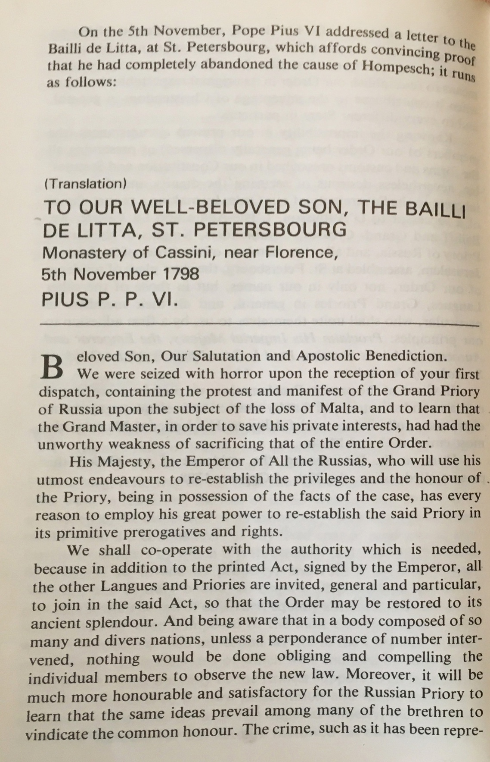

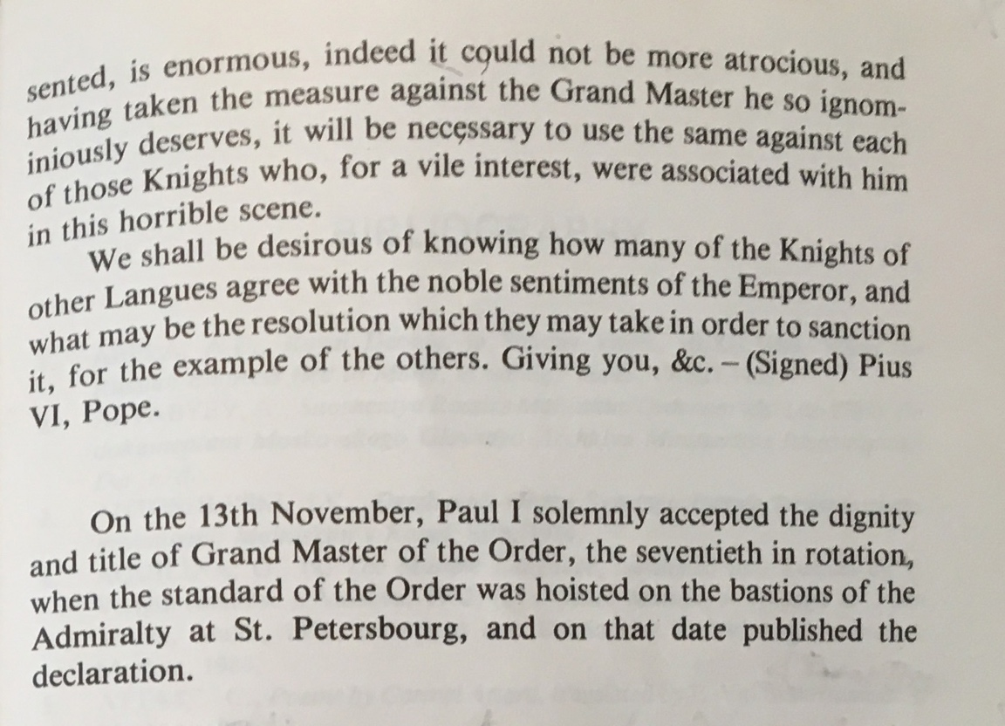

- “The Order and many conservatives and refugees of the Ancien Regime in Europe looked towards Russia as the protector of the old system, traditions, and conservative values.” [Thomas Freller – “Malta. The Order of St John”, p. 203]

- “For more than thirty years after the surrender of Malta, the only Order of Malta ever accepted or recognised at the Courts of Europe and by the famous British authority, “The Debrett Peerage,” (acting as a guide for the Court of St James), was the Russian Grand Priory founded and protected internationally by the Treaty of 1797, a treaty always respected and fully supported by all of the Imperial Families of Russia down to the last Czar.” [Schembri Guzeppi – p.83]

- From the book of Krayevsky Grigory – “A short description of the island of Malta and of the Order of St John”, St Peterburg, 1800:

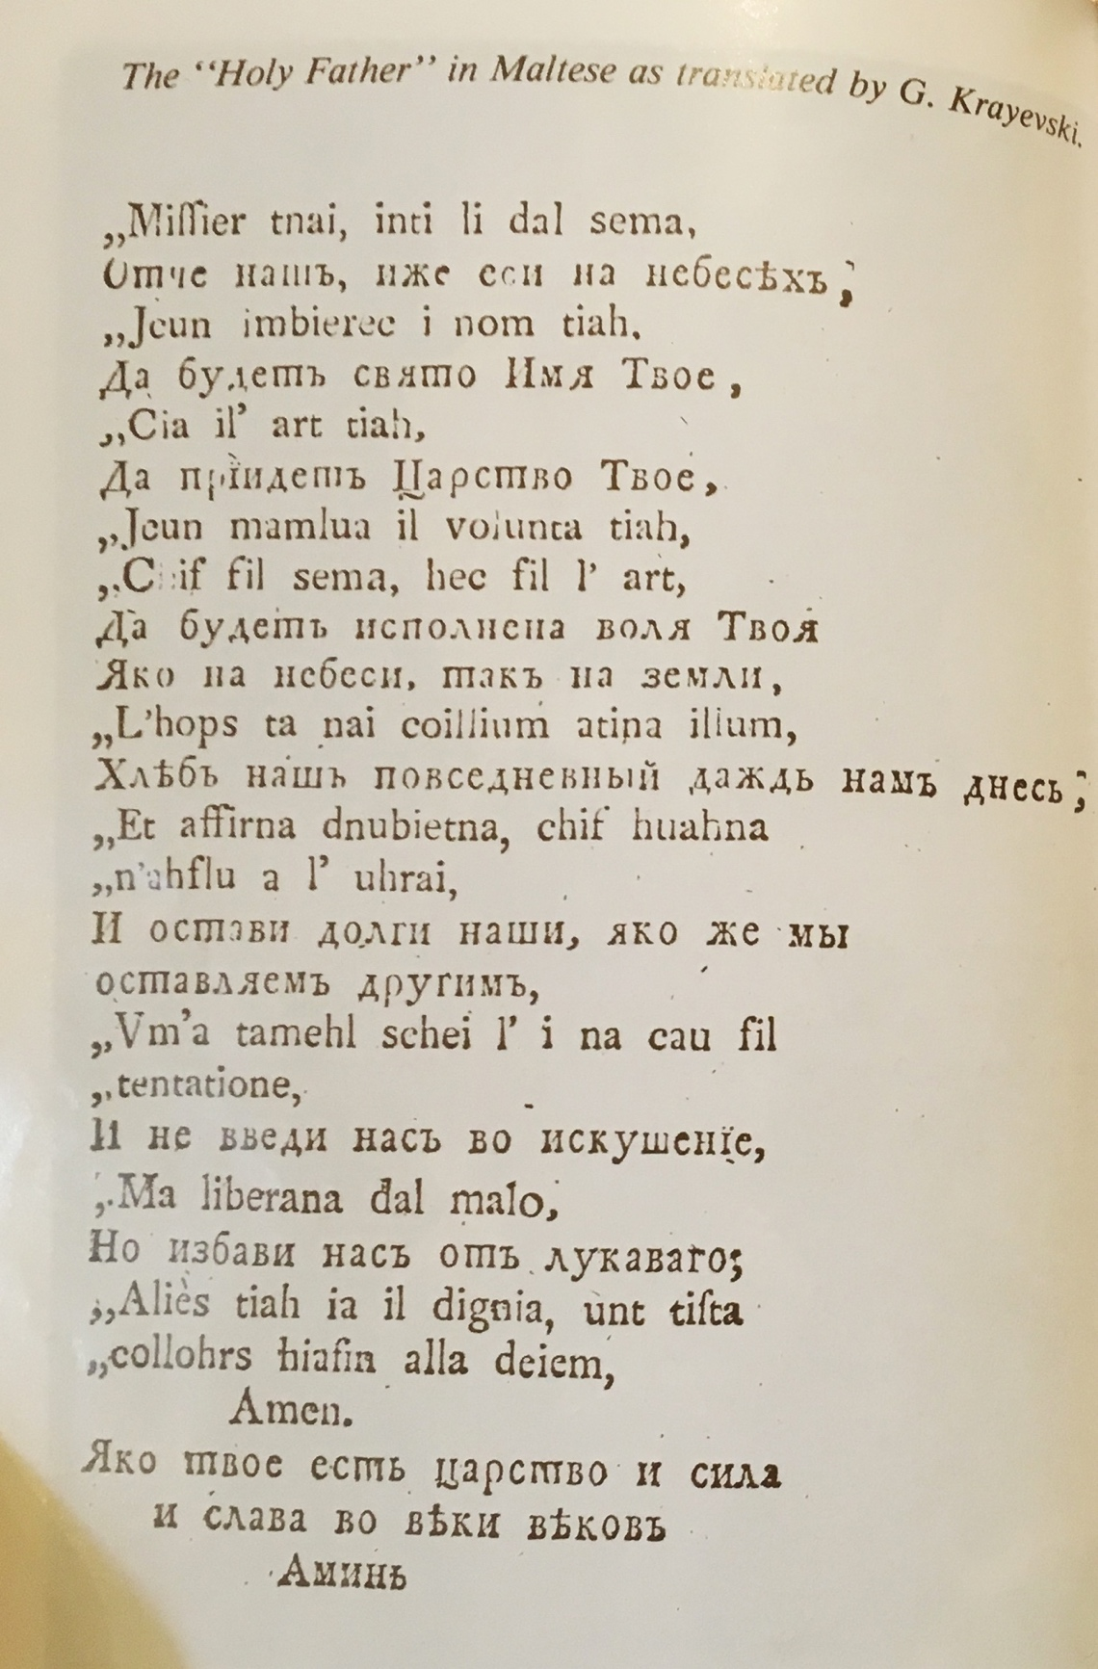

- “… a number of agreements to illustrate the scope: agreements on: Bunkering (1981); Merchant Shipping (1981); Protocol on the exchange of diplomatic missions (1981); Air Services (1981); Recognition, Respect and Support for Malta’s status as a neutral State (1981)” health and Medical services (1984); combating illicit trafficking and abuse of Narcotic drugs (1993); tourism (1995); Cooperation between the Ministry of Justice of Malta and the Ministry of Justice of the Russian Federation (2001); Programme of Cultural and Youth Exchanges and others. [Borg Tonio]

