|  |
| --- |
|  |
| Casal Fornaro: |
| The Importance of Bread in Qormi |

|  |
| --- |
| Higher National Diploma in Tour Guiding  2020  Leeann Davis |

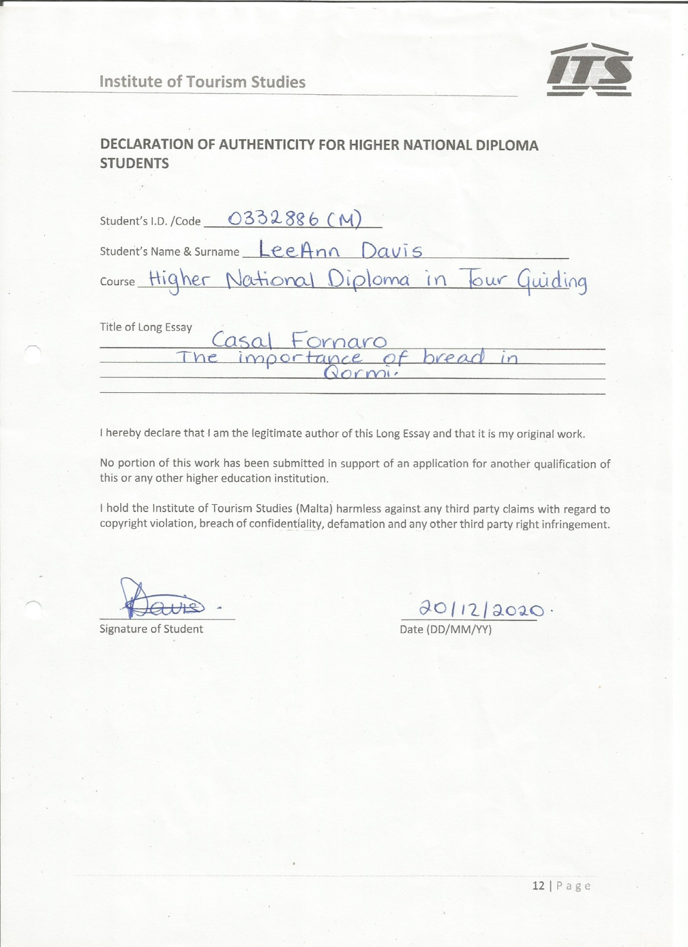

Abstract

In this dissertation I have decided to focus on two family run-bakeries in Qormi. Having few studies on recent history of bread, this might help contribute to literature. This long-essay is meant to answer the research questions, to promote family-run bakeries in Qormi and also for a Tour being organised for this dissertation.

This study intends to transmit knowledge about bread to future generations because as time goes by, the practice of bread-making is being considered a dying art. The primary and secondary data for this study were collected through interviews with members of family-run bakeries and from books, journals, academic studies, and the World Wide Web, respectively.

The general findings were that the main ingredients and procedures to make bread remain the same, but new technologies have been introduced to facilitate the baker’s work. Other types of bread, like the Low Glycemic bread, were introduced to keep up with people’s dietary requirements. Events are organised in order to promote the work of these artisans and the history of bread-making in Malta, and social media are also used to support family-run bakeries throughout the island in order to keep the traditions alive. Moreover, it was discovered that it is necessary to keep a record of the changes that bakeries endured throughout the years so as to analyse the recent history of bread.

Published or unpublished work focused on past centuries on bakeries and bread-making in the 21st century. Thus, other researchers are encouraged to conduct further studies on bread-making and the modern history of bread.

Acknowledgements

I would like to express my gratitude to my tutor Tara Portelli, who guided me throughout this dissertation, Ruth Azzopardi, and my lecturers from the Institute of Tourism Studies.

My thanks also go to Mr Paul Vella of Ta’ Kalċ Bakery and Mr Carmelo Debono of Maypole for the interviews conducted for this long essay.

Table of contents

Page

Abstract 3

Acknowledgements 4

Chapter 1: Introduction 6

Chapter 2: Literature Review 7

Chapter 3: Research Methodology 11

Chapter 4: Analysis and Results 14

Chapter 5: Conclusions and Recommendations 20

References 22

Appendices 24

Chapter 1

IntroductionOver the centuries, bread was fundamental in Maltese culinary history. It became part of the culture, generated political and social conflicts, distinguished between different classes, and even influenced the Maltese language (Zammit, 2018, 1). Since Malta is an island in the middle of the Mediterranean Sea and thus, is located in a strategic position, it was dominated by different rulers with different cultures. Consequently, Malta inherited a variety of traditions from other countries, the influences of which are reflected in our language, religion, habits, customs, and craftsmanship (Culture Directorate,2017).

The culinary art and culture of the flattened sourdough bread, known as the *ftira* in Malta, was submitted to the UNESCO Intangible Cultural Heritage of Humanity list in March 2019. (Culture Directorate,2017)). Nowadays, it is recognised by UNESCO, and Malta has its first element inscribed in UNESCO’s Representative List of the Intangible Cultural Heritage of Humanity. The Minister for National Heritage, the Arts and Local Government José Herrera welcomed the inscription of the ftira by stating that the Ministry will be promoting and safeguarding its culinary art and culture, while bringing international recognition to the Maltese ftira (Gov,Press Rel, 2020). Safeguarding the ftira will ensure that the quality remains up to standard when being produced, and in doing so, the quality of other Maltese bread and food will also improve. Consequently, there would be a bigger push for good quality local products.Family-run bakeries were chosen to be interviewed for this study due to their knowledge, and the fact that their skills, which have been instilled within Maltese culture, history, and tradition, were brought down from previous generations.

The research questions are the following:

1. How are family-run bakeries in Qormi a testament to the culture, history of bread and tradition of bread-making in Malta?

2. How have the Qormi bakeries run by family business, change throughout the years to keep up with the demands of the current society? Bakers are important people because they contribute to the health, tradition, and history ofindividuals. They mantain old traditions by baking the Appostle’s ring bread during Lent, they promote bread,organise events to keep the culture of bread alive in the society and although they work with simple ingredients, their profession is one of the most difficult jobs because typical Maltese bread has to be made manually and so, it takes longer to produce it.Seeing that certain traditions are slowly being lost, intangible heritage can be consolidated by, for instance, using displays in museums, taking the initiative to document valuable ethnographic data, and organising thematic events and educational programmes (Zammit, 2018, 1).

Chapter 2

Literature Review

Sec 2.1: Introduction

Bread-making in Malta takes us back to the prehistoric times as emmer wheat and barley dating from around 5000 BC were discovered in Skorba, confirming crop production from the time of the first settlement. (Trump, 2002, 253). Another site investigated by David Trump in 1960 was Ta’ Ġawhar Tower in Żurrieq. Some artefacts were recovered, one of them being part of a carbonised quoit-shaped bread roll, which had been burnt in the fire that destroyed the tower (2019 exhibition). It is unique in Malta, as it is one of the few organic artefacts found on the island. Carbon dating was carried out, accurately dating the fire to around the third century AD (Bonanno, 2005, 294).

Sec 2.2: Bread in Malta

In the late medieval period, people from Qormi were very religious. Most of them were farmers owning or renting lands (Grima, 2001, 36). For those who worked in agriculture, the seasons were their calendar, and the feasts of particular saints marked the payment days (Lanfranco, 2001, 165). Villagers had a basic lifestyle, they went to work in the morning and back home in the evening, so feasts were part of the calendar of events, during which families gathered in a community in which various devotions and traditions evolved. During these events, charity was given to the poor. This mostly involved Maltese bread, which symbolised divine prosperity (Buttigieg & Cassar, 2019, 1).

On 23rd April 1623, Grand Master Antoine de Paule visited Qormi. Rev. Salvatore Imbroll (1598–1650), a prelate who later became a prior of the Conventual Church of St John in Valletta, refers to Qormi using another name, this being Casal Fornaro or Raħal tal-Furnara, the Town of Bakers (Grima, 2001, 84–85). Meanwhile, in the book Della Descrittione di Malta Isola Nel Mare Siciliano: Con le Sue Antichita’, ed Alter Notizie, Gian Franġisk Abela, the father of Maltese history, referred to Qormi as Casal Curmi. (Camilleri, 2014, 18). On 25th May 1743, Grand Master Manoel Pinto de Fonseca issued a decree saying: ‘Habita relatione, Terram Curmi erigimus in Civitatem, Imponentes el nomen Pinto’, meaning that the land of Qormi was given the status of a city bearing his name (Grima, 113).

One of the many traditions that the Order of the Knights of St John brought with them from Rhodes was the distribution of bread on the feast of St Blas. The sacristan of the conventual church in Valletta gave *ħobż ta’ San Blas* to those who came to kiss the reliquary of the saint on his feast day (Cassar-Pullicino, 2005, 43). Bread was also blessed and distributed to those present at the Mdina Cathedral and the Jesuits’ Church in Valletta. Bread was given to heal throat disease and help women give birth. St Blas’s feast day is on 3rd February (Lanfranco, 2001, 171).

Meanwhile, on 11th November, which marks the feast of St Martin, children are given a bag full of walnuts, almonds, chestnuts, figs, an orange, and St Martin’s bread. The latter is a small bread roll with a piece of liquorice in the middle (Lanranco, 2001, 192).

In Malta, during Lent, Lenten bread called *ftajjar tar-Randan* are consumed. It is also known by another name, *fixhija*. These are thinner than the basic ftira, and they are fried and topped with something sweet like honey or salty like anchovies (Lanfranco, 212,2001).

In Qormi, on the days of Our Lady of Sorrows, Maundy Thursday and Good Friday there would be stalls in front of St George’s church selling the Apostles’ ring bread, a large, round type of bread with seeds and almonds on the surface (Lan, 2001, 219–222).

Sec 2.3: The importance of bread in Maltese history

Until the second half of the 14th century, Malta seemed to be self-sufficient when it came to food necessities for its inhabitants. On the other hand, from the 15th century onwards, wheat importation from Sicily started to increase, and the more the population grew, the more Malta imported this product (Gambin & Buttigieg, 2003, 75). Bread was so important that it became a staple product, especially for the lower class citizens who had to spend half their pay on bread only. Since bread had so much importance, the miller and the baker were valued for their profession. The wheat imported from Sicily cost almost double the local product because it was considered to be of better quality; thus, such wheat was sought by the higher classes to distinguish them from the rest of the society (Gambin & Buttigieg, 2003,76).

In the 16th century, the Order of St John came to Malta, fought the Great Siege, and built a new city on the land pertaining to Qormi. The bakeries of Qormi used to provide bread to the Knights and the inhabitants of Valletta until they built their own bakeries in Bakery Street, Valletta. By the end of the 18th century, domestic bread-making remained a female prerogative in rural areas; urban citizens would gradually start to abandon this traditional practice in favour of ready-made bread prepared by professional bakers (Buttigieg, 2019, 36). The British built a massive bakery in Vittoriosa, which opened in 1845. The Naval Bakery worked with steam engines, and the total production amounted to 30, 000 lbs of bread and biscuits every day to supply the Royal Navy’s Mediterranean Fleet.(Thake, 2011, 41) These engines were the first engines found on the island and were used for bread making. If the ovens were used at a higher temperature than the Traditional oven, the Maltese bread would have been more brownish and crustier from the outside.

Since Malta was a British colony, the island saw itself drawn into the theatre of war. Malta was doing well economically, it was a perfect base ideal for refuelling and nursing the wounded soldiers but after the War, many Maltese were even migrating because of the lack of employment. The prices of commodities remained the same as they were during the War, but the wages were low. (Briffa, 2020). In March 1919, the price of wheat increased and the local milling industry had to either buy it at a high price and bread would rise up to 9½d.per rotolo or decline the importation of wheat. Cassar Torreggiani , one of the leading millers tried to negotiate with the British Governor to suspend tax over bread.(Vassallo,2013) The high price of bread made the Maltese angry, so they went to Valletta, where the National Assembly was being held for the self-government issue, and attacked the grain mills and their owners. The Sette Giugnio event took place on 7th June 1919. (Blouet, 2017, 186). Shortly after the Second World War the price of bread was subsided all over Europe .In the 20th century, most people didn’t have an oven at home, so they used to make the dough themselves and then take it to the baker to bake it. Others used to prepare it at the baker’s from scratch. They often used to bring some branches with them to feed the fire as a means of paying the baker. In other cases, the baker used to send an employee once a week to knock on people’s doors and ask them to prepare the dough. Then, later on, they would be told to turn the dough. Afterwards, the employee would return with a wooden tray to collect the dough. These would be taken to the bakery and then brought back when ready. Each individual would make a sign on them to recognise their own bread (Lanfranco, 2002, 27, 28). In the late 20th century in Qormi both churches were surrounded by bakeries and late at night they would open up and bake to have bread for those people who went for the early mass.(Calleja Portelli,2017,12) On a humorous note, people from Qormi are teased for being ‘*nies sa nofsinhar’*, meaning that since they would have been working all night, by noon they would be tired, and they would go to rest at that time (Zammit Munro, 2015, 43 “ At the time, some bakers were selling sliced loaves and buns using the traditional *hobza* recipe”. (Calleja Portelli,2017,50,51) Sliced loaves, fancy bread buns and rolls were not very much found in bakeries but since Qormi had a large number of bakeries, bakers had to find other solutions to attract more customers. In the 21st century the so called ‘fancy bread’ are a demand from customers.

In the 21st century, the Maltese ftira is going to be added to the UNESCO Intangible Cultural Heritage of Humanity list; thus, it is a part of both the Maltese and worldwide heritage. Buttigieg explains that the main aims of this inscription to UNESCO’s Representative List are to raise awareness and educate and encourage stakeholders to rediscover the artisanal practices of the ftira production (Buttigieg, Cassar, 2019, 64, 65).

In the Maltese language, the word *ftira* is found in various idioms and metaphors. The word derives from the verb *fattar, meaning to flatten (the dough*), as described by the linguist Giovann Francesco De Soldanis in his Damma, a 1766 dictionary. Reference to *pane sciacciata* (the Italian word for flatbread) is recorded in the deposition of a slave informing a civil court of justice about grain trafficking from the bakeries of the Order in 1742 (Buttigieg, Cassar, 2019, 58). The ftira is also referred to by Soldanis as *xawwata*, meaning baked at a higher temperature so that the top becomes dark brown in colour. Indeed, ‘in bakeries using wood-burning ovens, the ftira loaves are baked first every morning to avoid wasting the high temperatures of the oven while it cools enough for the lower temperature baking’ (Buttigieg, Cassar, 2019, 59). Right after the ftira, the traditional Maltese ‘ħobża’ bread is put in the oven for at least 90 minutes.

Sec 2.4: Conclusion

In this review of literature some short historic information was gathered from pre-history up till the 21st century. From a discovery in 1960 were a carbonised bread was recovered to the 2019 when the *ftira* was recognised in the UNESCO list of the Intangible Cultural Heritage of Humanity. It is mentioned that bread used to be associated with Saints and feasts with traditions that are alive till today, the profession of the baker, the quality of bread which distinguished classes in society and the reasons why of the *Sette Giugno* riots which today is a National day in the Maltese islands. In the next chapter there are the methods used to conduct this literature.

Chapter 3

Methodology

Sec 3.1: Introduction

This chapter presents the methods used to conduct this study. Primary research methodology was used for carrying out in-depth analyses, while secondary research methodology was conducted to increase the overall effectiveness of the study. Two family-run bakeries in Qormi were chosen to analyse how they changed throughout the years. The city of Qormi was chosen because from all of Malta it has a largest number of bakeries to choose from, together with a long history of bread-making.

Sec 3.2: Research Gap

All the consulted literature focused on past centuries. There are few documents on bakeries and bread-making in the 21st century. This study intended to fill this gap by analysing the history of bread-making and discovering how family-run bakeries have evolved over the past century.

Sec 3.3: Objectives behind the Research

This long essay sought to answer the following research questions:

How are family-run bakeries in Qormi a testament to the culture, history of bread and tradition of bread-making in Malta?

How have the Qormi bakeries run by family business, change throughout the years to keep up with the demands of the current society?

The two bakeries that participated in this study are the Maypole and Ta’ Kalċ bakeries. Maypole was chosen because it is a huge industry that started off very simply as a bakery. Nowadays, Maypole has a huge factory and distributes all types of bread to their own shops, which are found all over Malta. Their future ambitions include selling their products internationally. Ta’ Kalċ is a smaller industry compared to Maypole and they still use the traditional wood-fired oven. Another objective behind this research is to promote family run bakers to keep up the bread culture alive.

Sec 3.4: Research Methods

The primary research methodology takes a qualitative approach rather than a quantitative approach, where observation, participation, and direct face-to-face interactions are needed to learn about the participants’ history (Neuman, 2017, 276). Two open-ended interviews were conducted with two members of family-run bakeries. The purpose of these interviews was to see how bread has evolved throughout the years. Open-ended interviews allow researchers to obtain a considerable amount of information that is sufficient for fulfiling a specific aim, rather than simple ‘Yes’ or ‘No’ answers. The following questions were asked:

1. How have family-run bakeries in Qormi changed throughout the years to keep up with the demands of the current societies?
2. Who started the industry?
3. How did you get interested in becoming a baker?
4. Can you give me a brief history of your family-run business?
5. How long have you been in this industry?
6. Were any new types of bread introduced to keep up with the current society? How were they introduced?
7. How did you keep up with Malta’s traditions regarding bread?
8. How did you sustain the business?

Secondary research was also conducted to support this study. As shown through the literature review, historical research was carried out using books, journals, academic studies, and the World Wide Web.

Sec 3.5: Tour

This study is intended for a tour around the city of Qormi. The tour should take around two hours, and the itinerary will involve visiting St.George’s Bakery and Ta’ Kalc Bakery. These bakeries are situated in the core of Qormi, where the visitor can observe the everyday life of the locals. Both bakeries will give a demonstration on how the bread is made and baked. St.George’s Bakery bakery owns a traditional Maltese oven and makes Maltese bread and ftajjar, while Ta’ Kalc Bakery has both a traditional and electric oven. Here, the visitor can compare and contrast the bakeries and the quality of their bread by tasting the bread. A visit to the Maypole factory to see the modern technologies involved in bread-making can also be part of the Tour, transport is needed to take us to Handaq. Handaq is very close to Qormi.

Sec 3.6: Research Ethics

Prior to the interviews, the interviewees were asked to sign a paper for an interview which was obtained from my tutor. Participants were aware of their rights and gave me permission to record them.The interviews were recorded for responsible publication, and the answers were answered in full, carefully, but with openness.

Sec 3.7: Research Limitations

The first limitation was the selection of bakeries because bakeries are closing down due to bakers going to pension and do not have any family members to continue this practice or others due to unsufficient budget to mantain the business. In Qormi are found a lot of confectioneries or some of the bakers did not want to do the interviews because they were too tired or busy. In the afternoon they had to go and sell the bread they did in the morning so it was very complicated to find someone who had some extra time to spend with me explaining everything I need to know.

The second limitation was the limited access to data were I had to go to the University of Malta just to get previous studies. It would have been easier if the Institute provided acess to the University of Malta Library, other Institutes and the University Library needs to be connected together for everyone. There was not much books to look up to and studies or articles were found mostly online. The National Library of Malta did not have any archives written specifically on bread, one has to go through other subjects like Culture or what the knights ate during the 16th century and this takes a long time to get some information. There was only two books by Chiron and book sponsored by Maypole.

The third limitation was that there was studies with a gap of period between one study and another. A century is a bit long to distinguish how the bread used to be made,where and by who, there needs to be a book about the history of bread in Malta from Pre-History till today. Few was found of the 20th and 21st centuries regarding breadSec 3.8: ConclusionThe Methodology chapter introduces methods used that was conducted during this study. Objectives behind this research was to answer the research questions, to use the information for a tour which is going to be conducted for my Tour Guiding course and to promote family run bakeries in Qormi. The research methods were primary and secondary research. Primary research using a qualitative approach by giving interviews to the two chosen families that run bakeries by using open-ended questions. Secondary research was used for a deeper understanding of literature,analysis and results which most literature was focused on past centuries. Research ethics and limitations were also part of the method introduced in this essay.

Chapter 4

Analysis and Results

Sec 4.1: Introduction

Qormi is recognised as the town of bread, bearing the historical name of Casal Fornaro. Nowadays, it is considered to have the most bakers and bakeries in Malta, although their number has diminished over time. Some of them are still open to this day shows that the Culture is still alive. The family-run bakeries in Qormi are a testament to the culture, tradition, and history of bread and bread-making in Malta because some of their resipes and methods that came from previous generations are still in use today. The Ta’ Kalċ and Maypole bakeries changed considerably throughout the years, for instance, by investing in or switching to electric ovens, among other changes.

Sec 4.2: The Promotion of bread in Malta

An event named *Lejl f’Casal Fornaro* is usually organised in October. This event is designed to promote Qormi’s culture, traditions, and folklore, including the town’s traditional bakeries and its longstanding association with Maltese bread. It is organised by the Kummissjoni Żgħażagħ Bastjaniżi and Maypole with the cooperation of the Qormi Local Council, the Ministry for Tourism, and the Parliamentary Secretariat for Agriculture and Fisheries and Animal Rights. Ryan Mark Mifsud, one of the event coordinators, stated to a journalist from Television Malta that ‘Lejl f’Casal Fornaro is an event to attract young people to volunteering, enabling them to enhance their capabilities with new volunteers and provide fresh ideas how they may continue to build on their talent’. Sarah Camilleri, the secretary of the organisation, added that ‘Lejl f’Casal Fornaro simply embraces the past and wants to instil in future generations the beauty around the cultural and folkloristic aspects of our old towns’.(TVM,2017) Maypole also contributes to the event in order to highlight the importance of bread in Qormi, where culture, traditions, history, food, and entertainment attract both locals and foreigners alike. On this occasion, the people from Qormi expose their artisanal and traditional products. In 2016, the traditional 18th-century wedding of Bastjan and Katarin was re-enacted during this event. This is a type of wedding that it is not organised anymore; the bride and groom used to be accompanied to the church by three men carrying baskets full of delicate bread, nuts, and incense. Bread was also threaded through a sash that the bearer used to wear across his chest. The *qarċilla* also used to be included; this was a figure of a man and a woman shaped out of pastry representing the couple. It symbolised fertility, regeneration, and the bond of marriage.(Taste History). Such stories could attract the younger generation and encourage them to learn about past traditions involving bread. Furthermore, during this event, the horse cart, which was used by vendors to sell bread in the streets during the early 20th century, would be on display. Vendors stopped using the horse cart during the late 20thcentury as they started using vans instead. These vendors can still be found in the streets of Qormi to this day.

Meanwhile, in 1900, according to Carmenu, my interviewee, Maypole was a grocery shop in Pietà, not yet owned by Nenu Debono. In the 1930s, Maypole started delivering bread to Sliema using horse-drawn carriages. During the Second World War, rules and regulations for the bakers were the same as the police so there would always be someone distributing bread. The horse-cart drivers sometimes returned without their horses because of the bombs landing during the war. The vending in the streets ended when more women started to go to work, and they were not at home in the morning. Consequently, it was much easier for him to open up a shop. Moreover, with a shop, the clients could find bread at any time. Similarly, according to Paul, the owner of Paul ta’ Kalċ Bakery, used to distribute bread to shops and sell bread inside a van in Żabbar. However, this was before he opened up the bakery in Qormi. In the literature review, it was mentioned how the baker used to collect the dough from their customers, bake it, and later on, brought back when ready. Over time, the baker started going through the whole process in the bakery while also distributing the bread to their buyers. While this is still done, nowadays, most people buy their bread from the local bakery, shops, or supermarkets.

During the Lejl f’Casal Fornaro event, the *pudina tal-ħobż*, the Maltese bread pudding, is also made available. In the 18th century, this treat was a delicacy because due to poverty, not a crumb of bread was wasted. One can create this dessert by soaking leftover bread in water or milk and adding some sultanas, candied peel, and chocolate. During the interview Paul ta’ Kalċ mentions that he has a lot of leftover bread, but unfortunately, he does not make the pudina because the ingredients would take up space in his bakery and not many people would buy it on a daily basis. When making other products, he prefers following recipes that require ingredients that are already found in the bakery, like the *qagħaq tal-ħmira* (yeast rings) instead. He also has a machine for making these rings. In Malta, during Lent, the Apostles’ ring bread is sold during the month of April. Both Paul ta’ Kalċ and Maypole sell this type of bread, especially on Good Friday. This suggests that bakeries still follow certain recipes for specific feasts, indicating that such recipes are still a part of Maltese culture.  Indeed, by keeping such traditions alive, bread and bread culture can be promoted.

Initiatives to promote bread-making can include organising educational activities in schools. Ftira Day is one such activity, during which students can learn how to make a healthy sandwich filled with wholesome ingredients like tuna, olives, capers, and olive oil. Training facilities can also encourage young people to enter the profession. Courses for bread-making have also been introduced. Indeed, the Institute of Tourism Studies has a Bread and Pizza course where one can learn how to bake Maltese bread, fancy bread, brown bread, and Pizza in a single session (Bread and Pizza 1 session course,2014). The Cultural Directorate expressed interest to offer their help by restoring wood-burning ovens. Furthermore, in order to raise awareness, the authorities have allocated a budget to create an online platform and a guide to promote bakers and ftira-making on their social media pages, radio, and television (Buttigieg & Cassar, 2019, 61-62). Additionally, the Malta Enterprise has a service called ’Family Business’, which offers incentives to help family businesses grow by means of training and support.(Family Business Support Service,2017)

Sec 4.3: Recent History

There are similarities in people’s attitude towards bread during these different time periods. During the rule of the Order of the Knights of St John,in ‘1609, following allegations of a supposed conspiracy, the same bakery slaves were planning against the government of the Hospitaller Knights’ (Buttigieg, 2011, 6).                                                                                                There always seemed to be a problem surrounding bread. In 1919, when Malta was still a British colony, the Maltese turned against the British due to the rising unemployment and the increasing costs of daily necessities, like bread. During the interview with Carmenu, he gave me a book named Nenu for the love of Maltese bread by Sandy Calleja Portelli and told me that if I need to get more details about his life I can find it in this book. Furthermore, in 1977, the Government announced that rationing and the subsidy received for the price of flour was going to be stopped in early February, so on the 7th of February 1977, the bakers went on strike, and the Armed Forces of Malta had to distribute bread instead. When the bakers saw that there wasn’t going to be an agreement on increasing the price of bread, they went on a second strike on 8th March. Those bakers who refused to operate their bakeries were arraigned in court, and Nenu was one of them. Malta was an independent country, but the British forces were present up until 1979, with the British Navy, Army, and Air Force supplying bread during the strike period only. The strike ended on 4th April, when the Government subsidised the flour for Maltese bread to 12c (€0.28) per sack of flour; it would remain this way until January 2009 (Calleja Portelli, 2017).   Nevertheless, there were no recent arguments against the Government; even when during the COVID-19 pandemic, there was a lack of flour in the shops, the Maltese didn’t rebel. This suggest a change in attitude towards bread. In fact, one positive outcome of being stuck inside was that people baked all sorts of food, and bread was a daily image on the social media where everyone showed their final result. Consequently, they were also preventing certain traditions from being lost in time.

The most recent contribution to Maltese bread history is the inscription of the *ftira*, a flattened sourdough bread, on the Representative List of the Intangible Cultural Heritage of Humanity in 2020. Both Maypole and Paul ta’ Kalċ, as well as many other bakers, produce the ftira, thus confirming that such family-run bakeries are a testimony to the history of bread in Malta. The element ‘Il-Ftira: The Culinary Art and Culture of Flattened Sourdough in Malta’ was inscribed on the Intangible Cultural Heritage National Inventory on 1stst June 2018 by the Culture Directorate of the Ministry for Justice, Culture and Local Government on behalf of the Minister Hon. Dr Owen Bonnici. Indeed, the ftira is now recognised as part of humanity’s cultural heritage.

 Sec 4.4: Bread-making in Malta

Maltese traditional bread consists of the ingredients, time and the method used. The ingredients for bread-making are wheat flour, mother dough,instant yeast, salt and water. The Maltese loaf takes 5 to 5.5 hours to make, from mixing, moulding and fermentation of the dough until it comes out of the oven. On the other hand, the fancy bread takes only 1.5 hours using modern equipment, thus the traditional varieties of bread can diminish.(E.Agius,1994,9,10).The mother dough is an essential ingredient for making Maltese bread. It is a dough that is left for 24 hours in a fridge so that it would be used the following day with the rest of the ingredients. The traditional Maltese wood-fired ovens are a cultural and traditional aspect that is still found all over Malta, including in Qormi. Indeed, in Qormi, there is a lady named Connie Agius, who owns a traditional Maltese oven in her own house. She bakes anything in it, from fruit cakes to traditional biscuits and bread.(fb.com) In Qormi, there are also several bakeries that own wood-fired ovens, namely St George’s Bakery, the Old Bakery, St Paul’s Bakery, and Paul ta’ Kalċ Bakery. Maypole has such an oven in their restaurant, which is situated in the city of Valletta; however, in the Mrieħel establishment, they have industrial ovens rather than wood-fired ones. Maypole keeps a wood-fired oven in order to preserve the tradition of baking bread in it and maintain it as part of the Maltese heritage.

Indeed, the Maypole Bakery started off using wood-fired ovens; the electric ones were added later on. Over time, they even bought the industrial machines that today are found in the Maypole bakery or factory in Handaq in order to keep up with the demands of the current society. Other different types of bread were added as well because economically selling just the Maltese bread and the ftira was not sufficient. Such additions were made to keep up with business and modernisation of bread-making. Nenu emphasised that industrial ovens do not change the taste or quality of the Maltese bread because it is the process and procedure that makes the bread. The recipe for the traditional Maltese bread is considered to be a refined one, meaning it has remained very faithful to the old recipes. The amount of fat, sugar, and powdered milk not found in this type of bread gives it a good taste and the recipe of the Maltese bread gives out typical pure wheat aromas (Chiron, 1994, 29). Nenu could not work with the traditional Maltese oven because the process took a lot of time. First, they had to get the appropriate temperatures, and then, the loaves had to be placed in the oven one at a time. When the baking process was ready, the loaves were taken out of the oven one by one, but in the meantime, since the oven door would have been left open, the temperature would go down. Therefore, before the next batch of loaves was put in, the oven had to be fired up again (Calleja Portelli, 2017, 69). Nenu remarked that Maltese bread would still require one hour of baking time regardless of whether the traditional or the electric oven is used; however, with the electric oven, one could produce 150 kg of bread instead of 50 kg. Furthermore, the machines are bigger so they can hold more bread inside. Nevertheless, the recipe remains unchanged. The machines help the baker use their time more productively while reducing any work-related stress and strain.

‘Wood-fired ovens cause air pollution and scarcity of wood, however bakeries have shifted to using electric ovens, more so since the Authorities now regulate the height of the chimneys and they also prohibited the burning of lead-based fuel’ (Buttigieg, Cassar, 2019, 61-63). Maypole’s modern machines work with electricity so it had generated less pollution than the traditional oven with more production of bread. In my opinion, if traditional bakeries are still found in Qormi or anywhere else in Malta is enough to satisfy the clients demand, only one factory distributing bread wont make any harm in terms of quality to the traditional Maltese bread. In a journal article,MELITA HISTORICA, Buttigieg also mentions how

‘in the past century, Maltese bread confection witnessed a series of changes, not only due to mechanization, but also because of the introduction of additives intended to shorten the leavening process. It is scientifically proven that industrial milling processes have generated several benefits but also modified the nature of flour and it’s qualities. We also know today how agricultural products enjoy distinct qualities due to the regional environmental conditions and cultivation practices’.(2014,28)

During the British period, grain imports came from various markets, while during the rule of the Order of the Knights of St John, Malta depended mainly on Sicilian grain. Buttigieg said that the Italian and French ways should be followed because they aim to safeguard bread culture and artisan characteristics. Hubert Chiron from the *Institut National de la Recherche Agronomique*, Nantes,France says that bakers need to learn from previous mistakes of other foreign bakers to maintain the quality of Maltese bread when it comes to modernisation of equipment.(1994,45). When it comes to quality of the traditional Maltese bread, grain is the main ingredient and the Kordin grain terminal is authorised to handle grain and store in nearby cement silos. In 2014 there was an issue of a potential health risk because the silos were close to the terminal(Schembri Orlando,2014). For the baker to have good quality bread, he needs good quality grain. Back in 1902, the ship HMS Hibernia was sold for skrap, some of the heavy lead painted wooden timbers were purchased by Maltese bakers,this had contaminated the bread by lead. The figurehead of the ship is found in the maritime Museum in Vittoriosa.

Sec 4.5: Qormi Bakeries

Like most other bakers in Qormi, Paul Vella, the owner of Paul ta’ Kalċ Bakery in Qormi, gained his experience by watching his parents and grandparents bake bread throughout the week. They had a confectionery in Żabbar that was combined with a bakery. The confectionery attracted more clients, and thus, business increased. Paul’s father started as a baker in 1972 but stopped in 1995. Paul continued to work with his uncles and aunties until 2000. Then from 2000 up till 2005, he worked with one of his uncles until he decided to open a bakery for himself in Qormi. In the place where he chose to open up his own bakery, there used to be another baker until he decided to close up. Paul upgraded it, and at 18 years of age, he already had his own business. In 2010, he bought the electric ovens; thus increasing production. From his past experiences, he knew that by having a grocery, he would be able to attract more clients. Moreover, this would keep him in a more competitive position than other bakeries that sold only Maltese bread and *ftajjar* (flat sourdough bread)(P. Vella, 2019,personal communication,29th,June).

One thing that changed over the years in Paul’s bakery is the process of making the Apostles’ ring bread. Back when his grandparents were bakers, they used to make this type of bread by hand. Nowadays, the dough is made and cut through using a machine. It is then shaped manually, some almonds are added to it, and in order to keep up the tradition, it is baked in a stone oven. The demand for the Apostles’ bread ring increases during the Lent period. Its production does not stop from the feast day of the Lady of Sorrows until Good Friday. The traditional Maltese bread is still sold during this period because the Maltese follow the tradition of fasting on bread and water on Good Friday (Deguara, 2019). Apart from selling bread in his bakery, Paul’s small crew distributes bread to 35 shops around Malta and also gives bread to a door-to-door vendor in Żejtun. In this bakery, work is carried out all day unlike the usual bakers from Qormi who work until 12 o’clock and then go to rest or distribute the products made in the morning to sell them around the streets. At five or six o’clock in the morning, fresh bread is produced in Paul’s bakery and again in the afternoon. When the evening comes, any unsold bread would be thrown away; a new batch would have to be prepared for the morning. The losses from the leftover bread would be made up by the grocery shop, keeping the business stable. In 2013 and 2014, Paul participated in the Malta Records where he made a braid and a cart out of bread as another way to promote bread.(P.Vella,2020,personal communication,29th,June)

Meanwhile, Nenu remembers how back in the 1950s, horses were used to turn the mixers that turned the raw ingredients into a dough. The mixer would turn according to the horse’s speed. When the horse got tired, the baker would have a hard time persuading the animal to continue its never-ending circuit (Calleja Portelli, 2017). Indeed, electric mixers were another saviour for bakers because they considerably facilitated their work. In the 1960s, very often, the baker did not have a bakery, so they used to make agreements with the owner of a bakery. According to Nenu, he had to work after the owner’s working hours and the rent would be paid based on the number of sacks of flour used on the same day. In 1986, Maypole moved to St Joseph Street, Qormi, where they had a bakery and a shop. The first machine was bought in 1988 from Denmark. In the 1980s, technology was not as advanced in Malta so Nenu had to go abroad to learn about the subject and get new ideas. During this period, there were many more bakeries in Qormi, and Nenu had to compete with them.(C.Debono,2020,personal communication,8th,June) In the end, Nenu was successful because, from a bakery in Qormi, Maypole became a large bakery in Tal-Ħandaq, from where, to this day, the bakery still distributes bread to its own grocery shops, which are found all over Malta.

Meanwhile, Maypole takes on a different approach when it comes to bread-making because industrial machines are involved instead of the traditional Maltese stone oven. The traditional Maltese bread and the ftira are made by hand, and the same ingredients as required by the traditional recipes are used; however, they are placed in large ovens for quicker and increased production instead. Meanwhile, the fancy bread is made from scratch by machines. Maypole produces a variety of bread, including buns, hotdog buns, sliced bread, pita bread, pizzini, rye bread, sunflower square rolls, ciabattas, rolls, and even sweet bread. The bakery in Tal-Ħandaq uses a room as big as the original bakery in Qormi as a refrigerator solely for the mother dough. One advantage of this industry is that it generates a lot of jobs because of the increased production due to the demands of current society and the growing population. Maintaining a healthy diet can be quiet stressful when there are so many varieties to choose from; however, there is no need to eliminate bread from one’s diet. Indeed, bread with grains is a good source of carbohydrates, vitamins, and minerals. Whole grains are also particularly high in fibre. Meanwhile, low-Glycemic bread is intended for people who have diabetes and heart disease.

Nenu explains how, in the older times, everything was done manually, and this required great skill. Nowadays, the skill lies in understanding how to use modern technologies in the best way possible to retain the genuineness of the Maltese bread. He also explained that the Maypole use a long fermentation process and that they bring the wheat over from America so that the flour would be high in gluten to make it rise. The recipe is simple and not expensive, but it requires time. It is also similar to that of the French baguette, as specified by Hubert Chiron in his work ‘Il-Ħobż Malti-Is-sengħa tal-Furnar’, where he brings up certain similarities with the French bread recipe, including the reaction of the dough, as well as the crumbs and the composition of the crust (1994, 29).

Sec 4.6: Conclusion

In this Analysis promotion of bread was essential to keep the bread culture alive. *Lejl F’Casal Fornaro* sponsored by Maypole was and still is an event in the Maltese Islands. Some recent history was mentioned, the recognition of the *Ftira* was the most recent. At the end bread-making remained the same when it comes to recipe and ingredients but electrical ovens and industrial ovens were introduced together with new types of bread. The next chapter will introduce the conclusion of this analysis and recommendations.

Chapter 5

Conclusions and Recommendations

Sec 5.1: Conclusions

The analysis confirms that family-run bakeries are a testament to the culture, tradition, and history of bread and bread-making in Malta. As discussed in the previous chapter, these families promote bread by organising and participating in events to keep the culture alive, and in doing so, the past contributes to the making of modern history. One such contribution is the inscription of the ftira as an intangible cultural heritage, which also helps safeguard bread-making in Malta. Nevertheless, it is worth noting the importance of family-run bakers in bread-making and how although throughout the years they have introduced some changes, it is concluded that traditional Maltese bread is still the same as it was for the previous generations.

Sec 5.2: Recommendations

Further studies on the quality of bread need to be held since family-run bakeries are decreasing in number, especially in the city of Qormi, due to modern technologies and the methods being introduced, which may change what is meant by traditional bread.  A new survey on bread-making in Malta is also needed since the last survey was conducted by Medigrain Limited during July and August 1994. Furthermore, the memories and experiences of individuals should be considered as historical information and used as secondary data indeed, some of the information obtained for this thesis came from interviews with regular bakers who don’t feature in any literature. It would be good if more people conduct research on the making of the Maltese *hobza and ftira* and their recent history. Now that Maltese bread is recognised by UNESCO as part of humanity’s cultural heritage, it is even more appropriate that more studies about bread-making and what makes it unique are carried out. Such studies should also consider the various people working in this sector because every individual endorses different bread-making methods, thus obtaining different results.Heritage management for the ftira led to an increased national awareness of the linkagesbetween tangible and intangible heritage. In bread culture, tangible heritage includes traditional ovens, bakeries, and old windmills, while intangible heritage means bread-making and consumption. The culture of the ftira is going to remain present now that it is part of UNESCO’s Representative List of Intangible Heritage, and consequently, it is going to be safeguarded. Intangible heritage can be preserved by looking after one’s tangible heritage. In Qormi, for instance, there is an old windmill, *Ta’ Pamplaw* Windmill dating back to the 17th century, which had been built during Caraffa’s magistracy. This windmill is currently in a bad state. Heritage Malta or other similar entities can transform this place into a museum similar to that in Ta’ Kola Windmill in Gozo. Traditions that are no longer used can be displayed in this windmill on panels or screens. Some information about bakers in Qormi can also be included in this windmill so that tourists could learn about the bakeries before visiting them. This windmill can also be used to promote sustainable tourism. Tourists could be offered the choice of experiencing something local other than the capital city, thus promoting niche tourism. Additionally, more books need to be published about bread history in Malta. Nenu has already published a book about his life journey as a baker. Such initiatives could highlight the importance of bread-making in Malta while simultaneously safeguarding Qormi’s tangible and intangible heritage.

The researcher remembers bakeries and bread with nostalgia as well as her grandmother’s various dishes, which were made to impress the family. If it wasn’t for the baker, who had to bake all the extra dishes, there would have been no family gatherings on Sundays at midday, during which everyone would enjoy each other’s company. Needless to say, bread always used to be included before or during dinner. Like Buttigieg says, ‘the kitchen table is more than a piece of furniture, it is a meeting space of dishes, traditions and meanings’.(2014,29)

References

Agius, J.E. *Survey on bread making in Malta*. Medigrain Ltd.

Azzopardi, M. (2019). *National Inventory of Intangible heritage*. Retrieved from ich.unesco.org. access date -  26/12/2020

Blouet, B. (2017). *The story of Malta* (8th ed.). Malta: Allied Publications.

Bonanno.A, 2005, Malta, Pheonician, Punic and Roman, Midsea Books,St. Venera,Malta.

Briffa, H. (2020. *Repression, Riots and Revolution-Imperial & Global Forum*. Retrieved from imperialglobalexeter.com.

Buttigieg, N. (2011). The Administration of the Order’s Bakery: some preliminary observations. *Sacra Militia*, *(10)*. Retrieved from https://www.um.edu.mt/profile/noelbuttigieg. access date - 12/11/2020

Buttigieg, N. (2014). Towards A Maltese Culinary Identity: some considerations. *Melita Historica*, *Vol.16(3)*. 69-80

Buttigieg, N. & Cassar, K. (2019). Il-Ftira. The Maltese flattened sourdough bread, an Intangible Cultural Heritage. *Tesserae,issue8, 56-65.* Retrieved from https://issuu.com/tesserae/docs/tesserea_8_book_-_final_low_res visited this page 4 times. Last visit: 30/01/2021

Calleja Portelli, S. (2017). *Nenu for the love of Maltese bread*. Tarxien, Malta: Gutenberg press.

Camilleri, D. (2014). A study in Local History since 1800: Qormi Casal Fornaro: The bread Makers, pg 18.  Retrieved from <https://www.um.edu.mt/library/oar/bitstream/123456789/9204/1/14BAHST006.pdf> visited this page 3 times. Last visit: 19/12/2020

Chiron, H. (1994). *Il-Ħobż Malti, Is-Sengħa tal-Furnar*. Medigrain Limited, Mill Sreet, Marsa

Cultural Directorate, Zammit 2018, Intangible Cultural Heritage malta,retrieved from:https://www.ichmalta.org

Deguara, C. (2019)JIZDIED IX-XOGHOL TAL-FUFNARA FI ZMIEN IL-GIMGHA MQADDSA. Retrieved from one.com.mt/news.2019/paultakalċ.

Gambin.K & Buttigieg N,2003, Storja tal- Kultura ta’ L-ikel f’Malta, Kullana Kulturali, Publikazzjonijiet Indipendenza, Pieta’ Malta.

Grima.F.J,2001, Mill-Istorja ta’ Hal Qormi, L-ewwel volum, min zmien il qedem sal-1800 W.K,Hal Qormi,Malta:Union Print Co.Ltd.

Lanfranco,G (2002). *Xogħol, Ġaħġiħ u Snajja’ li spiċċaw*.Wise Owl Publication, triq il- kbira,Rabat

Lanfranco.G,2001,Drawwiet u Tradizzjonijiet Maltin, Kullana Kulturali, Publikazzjonijiet Indipendenza, Pieta,Malta.

Malta Enterprise. *Family Business Support Services Transfer of Ownership, IncentiveGuidelines Support Measures and other Services*. Retrieved from www.maltaenterprise.com.

Registrar.2020, Bread and Pizza 1 session course, Retrieved from https://its.edu.mt/47-courses-admission/part-time-courses/423-bread-and-pizza-1-session-course.html

Malta girlguides, an association for girls & young women, Bread Making, Maypole. Media Centre Limited, Blata l-Bajda

Maypole site: [www.maypole.com.mt](http://www.maypole.com.mt).

Neuman, W. L. (2007). *Basics of Social Research, qualitative and Quantitative Approaches* (2nd ed). Design and Production Services, Inc.

Press Release by Ministry for the national Heritage, the Arts and Local Government: UNESCO recognises the Culinary art and culture of ‘Il-Ftira Maltija’,2020. Last visit:24/01/2021

Schembri Orland.K.2014,Grain terminal CEO argues that ‘one must assume the grain has already been contaminated,retrieved from:https://www.independent.com.mt/articles/2014-11-26/local-news/grain-terminal-ceo-says-contamination-might-already-be-present-no-way-of-detecting-metal-traces-6736126433

THake.C,2011, William scamp (1801-1872), An Architect of the British Admiralty in Malta, Midsea books,St.Venera,Malta.

Trump.D.H, 2002, Malta Prehistory and Temples, Midsea books, St,Venera,Malta.

TVM. (2017). *Lejl F’Casal Fornaro*. Retrieved from www.tvm.com.mt>djarju247>Lejl-fcasal –fornaro-> visited this page 2 times. Last visit: 28/11/2020

Vassallomalta,2013,MalteseHistory & Heritage/windmills. Retrieved from: <https://vassallohistory.wordpress.com/windmills/>

Vassallo.R, 2008, maltatoday,unpublished letter sheds new light on Sette Giugnio. Retrieved from:archive.maltatoday.com.mt/2008/06/08/t3.html

Zammit Munro, L. (2015). Our Daily Bread. *Il-Bizzilla,issue (26)40-43*. Retrieved from <https://issuu.com/bizzilla/docs/bizzilla_feb_low>. visit 29/11/2020

Appendices

Page 1 : Concent Form for Interview with Nenu Debono

Page 2 : Concent Form for Interview with Paul Vella

Page 3 : Interview Questions

Page 4 : Tour : Casal Fornaro : The importance of bread in Qormi

Page 5 : Recordings of Interviews

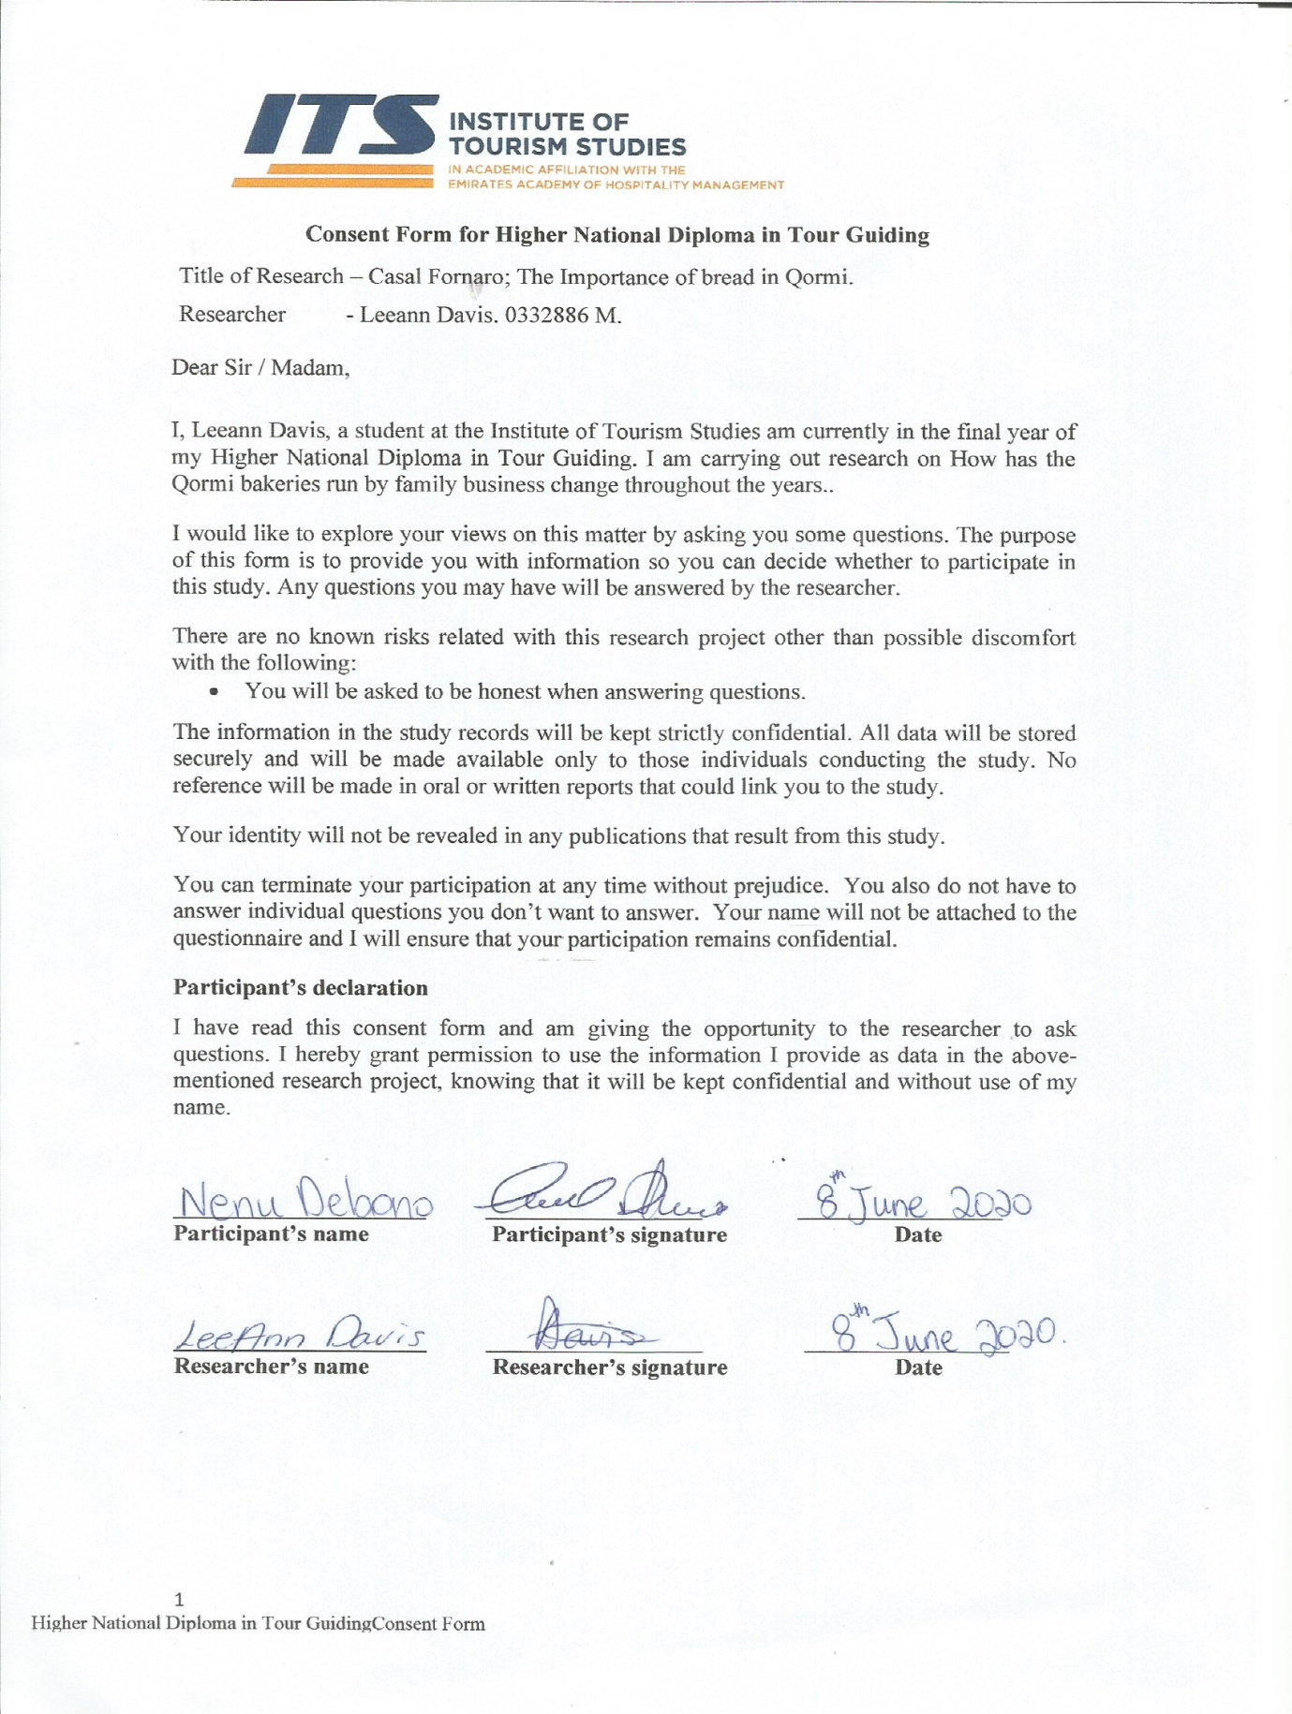

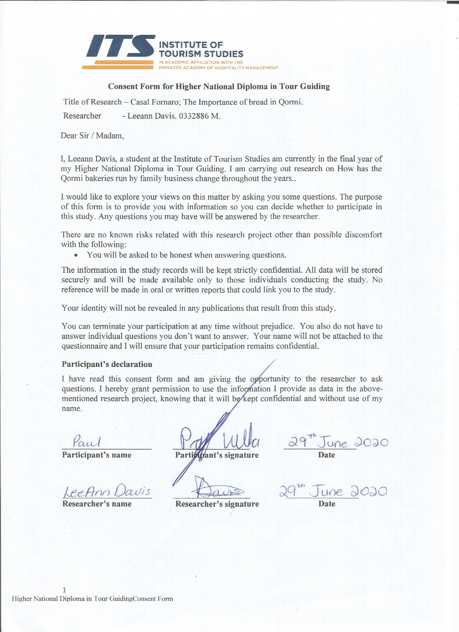

Interview Questions

How have family-run bakeries in Qormi changed throughout the years to keep up with the demands of the current societies?

Who started the industry?

How did you get interested in becoming a baker?

Can you give me a brief history of your family-run business?

How long have you been in this industry?

Were any new types of bread introduced to keep up with the current society? How were they introduced?

How did you keep up with Malta’s traditions regarding bread?

How did you sustain the business?

Tour: Casal Fornaro: The Importance of bread in Qormi

9:30 am – Meet in front of St George’s church, Qormi.

Introduction: Information about the city of Qormi, the church and its surroundings, and the bakers.

9:40 am – Visit St George’s Bakery.

Demonstration by the baker: Information about traditional Maltese bread-making and the tools and machinery used. Bread is then placed in a professional manner inside a traditional Maltese oven, and afterwards, the final result is shown.

Photos are allowed, and tasting is available.

10:10 am – Visit Paul ta’ Kalċ Bakery.

Demonstration: Comparison is drawn between the two bakers. The first bakery solely uses the traditional Maltese oven, while the second bakery has both traditional and electric ovens. Other types of bread are also included.

10:40 am – Pjazza Federico Mempel; visit the Qormi Scout Group and an exhibition of cribs made out of bread during the Christmas period.

10:45 am – Visit a horse-cart maker. Bread used to be distributed in carts.

10:50 am – Transport pick-up; visit Tal-Ħandaq.

11:00 am – Visit Maypole Bakery/Factory. Modern technologies of bread-making.

11:30 am – End of tour.

Voice Recording 1 includes the interview with Mr Debono, while Voice Recording 2 consists of Mr Vella’s interview.