The Potential of Producing More Quality Sparkling Wines in The Maltese Wine Industry

Higher National Diploma in Food and Beverage Service

18th of August 2021

Sammut Stevie

Authenticity Form
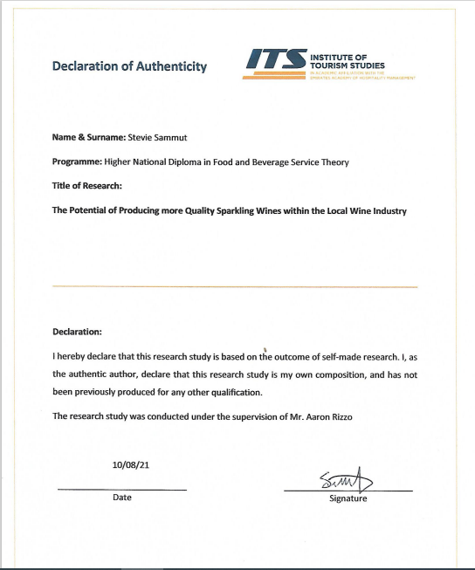

The Abstract

This study sought to identify the potential of producing more quality sparkling wines within the Maltese wine industry. Two sub-research questions in cohesion with the central research question are:
- Which are the styles of sparkling wines consumers prefer to drink in Malta?
- Which are the feasible and most practical methods to produce a sparkling wine in Malta?
Following the identification of the two sub research questions, a literature review was compiled to identify what affects consumers preferences when choosing a sparkling wine. Furthermore, the Charmat method and the Encapsulated yeast method were chosen as the two main fermentation methods which will be investigated during this study. A survey was sent to 102 potential respondents where a total of 68 individuals have responded to the survey. The aim of the survey was to identify whether there is a need to produce more quality sparkling wines and what styles of sparkling wine the consumers are demanding. Since the respondents opted for a fruit-driven sparkling wine, the tank method shall meet the respondent’s likings as it is known for retaining and preserving the freshness and fruity aromas of the grape. Also, a total of N = 41 have opted for a medium price range of €8-€15 when buying a sparkling wine from a retail shop, which should be the price range of this sparkling wine since it is produced by the Charmat method. Question 10 in particular was a crucial question to determine if there is the need to produce a quality sparkling wine in the local industry. A total majority have agreed that if a sparkling wine with similar characteristics as their favourite sparkling wine from other countries was to be produced locally, N = 60 would buy the local product.
From the results of the survey the author had concluded that the respondents are seeking for a dry sparkling wine produced by the Chenin Blanc grape variety where fermentation is conducted in tanks

Acknowledgements

I would genuinely like to thank my tutor and supervisor Mr. Aaron Rizzo for his constant guidance and support given throughout the whole process of the long essay. I would also like to thank all the respondents who filled in the survey. Their contributions are sincerely appreciated and acknowledged.

Contents

Authenticity Form 1
The Abstract 2
Acknowledgements 3
Contents 4
1. Introduction 1
2. The Production of Sparkling Wines 2
2.1 What is Sparkling wine? 2
2.2. Feasible and practical methods of producing sparkling wine 2
2.3. The Charmat Method 3
2.4. Encapsulated Yeast Method 4
2.5. Consumer preference on styles of sparkling wine 6
2.5.1. Price 6
2.5.2. Country of origin 6
2.5.2.1. Grape varieties suitable to produce local sparkling wine 7
3. Methodology 8
4. Analysis and discussion of the results 9
4.1 Pilot Study 9
5. Conclusions and Recommendations 16
5.1. Conclusions 16
5.2. Recommendations 18
5.3. Ethics 19
6. References 20
7. Appendices 22

Introduction

In compliance with international legislation, sparkling wines are produced using Vitis Vinifera grape varieties (Stefenon, et al., 2010). The key feature of producing a sparkle in wine is Carbon dioxide (Caliari, et al., 2014), which is exclusively created during the secondary alcoholic fermentation stage in sealed containers (Bordiga, et al., 2013). This research will be conducted to review the potential of producing more quality sparkling wines in the Maltese wine industry. Analysing the consumers’ needs and preferences is crucial before a new product is being produced to identify its potential success. Therefore, this title was chosen to identify the potential of producing more quality sparkling wines within the local wine industry. Studies state that a cool climate is the ideal environment for producing sparkling wine, due to certain acidity levels needed to enhance the wine's refreshing characteristics. This study shall ascertain that in the Maltese hot climate, a good quality sparkling wine can still be produced. Research shall be conducted following the central research question:
- Objective 1(O1) - Is there a need to produce more quality sparkling wines for the local wine industry?
Two sub-objectives in cohesion with the central research question:
- Objective 2(O2) - Which are the styles of sparkling wine consumers prefer to drink in Malta?
- Objective 3(O3) - What are the feasible and most practical methods that can be used to create a sparkle in wine in Malta?
While conducting this research, the primary target audience will be personnel working in the hospitality industry and wine enthusiasts who dine in restaurants regularly and are familiar with the subject. This study shall be useful for wineries to acknowledge which grape varieties and styles of sparkling wine meets consumer preferences, if a new quality sparkling wine was to be produced.

The Production of Sparkling Wines

2.1 What is Sparkling wine?

There are many variations in how sparkling wine can be produced. Different production methods have specific time frames, which is often reflected in the selling price of the sparkling wine (Rossier, et al., 2016). The winemaking technology has evolved throughout the years, leading to higher quality products (Torresi, et al., 2011). Studies show that the demand for sparkling wines in the last decade has increased by 40% (Torresi, et al., 2011), resulting in a significant economic impact due to sparkling wine's high added value (Garofalo, et al., 2016).

As mentioned earlier in the introduction, the dominant characteristic in sparkling wine is carbon dioxide which is included by various methods during a second alcoholic-fermentation (Bordiga, et al., 2013). Following Bordiga's findings, Conde et al (2017) state that the collar dynamics and the bubbles are the first characteristics to be assessed when evaluating the quality of sparkling wine. To simplify the assessment of sparkling wines, the products are graded based on their sweetness level (Torresi, et al., 2011). Various winemaking techniques applied, affect the volatile composition of a wine which evolves in a versatile end-result (Caliari, et al., 2015)

Feasible and practical methods of producing sparkling wine

In recent years, consumers in the wine industry are demanding a more environmentally friendly application. Hence, development in the production of sparkling wines was necessary to improve in this field (Hayward, et al., 2020). Moreover, to enhance the quality of such wine and ease the production process, more attention is directed towards biotechnological innovations. Regardless of this fact, maintaining unique and typical product characteristics is crucial (Perpetuini, et al., 2016).
Different sensory characteristics can be indulged in wine through different production methods (Torresi, et al., 2011) (Stefenon, et al., 2010). With regards to sensory quality, the production method used is one of the most crucial steps that influence the volatile composition in sparkling wine (Caliari, et al., 2015). For the Maltese islands, ideal production methods which are not yet used are the Charmat method and the Encapsulated yeast method. Previous studies proof the method’s feasibility and practicality which makes the methods suitable for such country, seeking to develop in the production of sparkling wine (Benucci & Esti, 2019) (Rossier, et al., 2016).

The Charmat Method

Federico Martinotti invented the Charmat method (tank method) in 1895. Eugene Charmat made slight changes to this method in the early 20th century to make the technique more practical (Teague, 2017). The improvement made by Eugene Charmat has resulted in the method being used worldwide for the production of quality sparkling wines.
Within the Charmat method, two alcoholic fermentations occur. The first fermentation process is held to transform grape juice into base wine. Following this process, the base wine is transferred into another stainless-steel pressurized tank where the second fermentation occurs (Caliari, et al., 2015). Secondary alcoholic fermentation is conducted by the addition of '"liqueur de tirage "(a mixture of yeast and sugar) to the cuvee' (base wine) (Rossier, et al., 2016). As soon as this process is concluded, a filtration process is held to remove any remaining yeast and suspended material (Rossier, et al., 2016). Following this process, the sparkling wine is then bottled. The wine should then be left to age in contact with yeast lees (autolysis) for at least twenty days before selling (Garofalo, et al., 2016).

Benefits of using this production method:
- Studies state that by using this method, the cost is relatively lower than using other production methods (Rossier, et al., 2016) (Garofalo, et al., 2016).
- Wines are sold at a very competitive price compared with wines produced from other methods (Rossier, et al., 2016)
- Less labour cost and less capital expenditure cost for various types of machinery make this production method feasible and excellent for a country/region looking to expand in the sparkling wine industry.
- The wine still benefits from the positive effect of the autolysis process (Garofalo, et al., 2016).
- Freshness of the grape and fruity aromas are preserved (Culbert, et al., 2015)
- Faster production process.

Disadvantages for using this production method:
- Investing in capital expenditure which will be paid by depreciation.
- Not suitable for small quantity production.
- This process cannot be utilized in certain regions with specific regional designations (Garofalo, et al., 2016)
- Training staff is essential. This adds to the labour cost and finally the total cost of the product.

Encapsulated Yeast Method

The encapsulated yeast method is an adaptation of the well-known traditional method (champenoise) (Brehm, 2006). It was invented to make the well-known traditional method more practical and feasible to produce sparkling wine. By using this method, the yeast is enclosed in calcium alginate. Hence, the yeast is trapped and is prohibited from being mixed with the wine (Brehm, 2006). These capsules have a diameter of around 2mm.
Until the second fermentation, the process is identical to the Champenoise method. Second alcoholic fermentation is conducted in the bottle where the cuvee' is transferred. The yeast is then added to the bottle, without any starter culture with alcohol needed, where a reaction with sugar is held to produce alcohol and carbon dioxide (Benucci & Esti, 2019). The fermentation is conducted via the release of metabolites and the entrance of substrates from the yeast. To conclude the fermentation process, these capsules enable you to easily remove the yeast from the sparkling wine by pulling them out of the bottle, which leads to a more precise end-result (Loira, et al., 2018). On the tirage day, filtration, and the addition of liqueur de tirage are still to be conducted.

Benefits of using this production method:

- Studies prove that similar characteristics are obtained in the wine by using this production method compared to the traditional method (Benucci & Esti, 2019).
- Elimination of the remuage/riddling process is a significant aspect that affects the cost of the wine since the remuage process is a very labour-intensive process and time-consuming. Thus, the wine can be sold at a more compatible price (Benucci & Esti, 2019).
- Riddling agents are not required (Benucci & Esti, 2019).
- Improved cellar room management.

Disadvantages
To make use of this production method, training your staff on how this process is conducted is essential before utilizing this method, which may vary in cost depending on the training.
Disadvantages that may occur:
- This specific yeast is much more expensive (Ranch, 2007)
- Leakage of cells.
- Diffusional limitations.
- Gas production and growth of cells may cause rupture of capsules.
- Dissolution of gel during ageing of sparkling wine.
(Benucci & Esti, 2019)

Consumer preference on styles of sparkling wine

Previous wine marketing studies have found that various factors influence customer's wine selection decisions (Lockshin & Corsi, 2012). Furthermore, according to previous research, the value of attributes in wine purchasing differentiates according to the country (De Magistris, et al., 2011). The wine style the producer would like, depends significantly on the production method used (Culbert, et al., 2015). Some factors affecting consumer preferences are price and country of origin (Lockshin & Corsi, 2012).

Price

Several studies state that price is one of the most crucial factors affecting the consumer preferences on sparkling wine (Veale & Quester, 2009) (Hollebeek, et al., 2007). Price differs according to the production method, country of origin, time consumed for the production of the wine, and the aging period. Furthermore, Mueller states that the higher the selling price of the wine, the more likely it meets the consumers' likings, while the choice of wine is influenced by the lower price (Mueller, et al., 2010). Findings state that there is a relation between the consumers' income and how much they are willing to spend on sparkling wine (Onofri, et al., 2015).

Country of origin

Country of origin is a major factor influencing consumers' preference in terms of wine quality (Veale & Quester, 2009). Previous studies refer to Champagne as being the 'unequivocal benchmark for sparkling wine' as it is known worldwide for its quality and characteristics (Culbert, et al., 2015). Consumers tend to rely on products coming from a country of origin with an established heritage and prestige, such as Champagne, as for the consumer, it infers superior quality (Culbert, et al., 2015). For sparkling wines, quality is assessed depending on natural factors and human factors. Natural factors are climate, soil and grapes which vary depending on the country and region. Human factors are viticultural and vinification techniques applied for the production of sparkling wine.
Malta’s unique Mediterranean climate enables the cultivation of almost all foreign vine varieties available (Anderson, 2001). With such climate, irrigation of vineyards is crucial. At night, the vines also benefit from the cold breezes gained from the surrounding sea. Due to the sunny weather, high sugar levels are obtained in the grape, which can be utilized for producing different styles of sparkling wine. Gaining high acidity levels is a significant issue due to such climate, thus, picking of grapes early is mandatory to achieve acceptable acidity levels and a sugar volume of 11%. Manually hand picking of grapes ensures a higher quality product for Maltese wines. Clay, terra rossa, and white calcareous soils are the three primary soil types. Their ability to maintain and release moisture is inversely proportional to clay content, making them crucial for grape growing in dry climates (Anderson, 2001). For indigenous grape varieties, vineyards are trained as bush vines. Anderson (2001) states that the guyot method with a combination of a replacement spur is used as the present technique for vine training.

Grape varieties suitable to produce local sparkling wine

Chenin blanc's classic characteristics of yellow apple, quince, ginger, plum, and floral notes allow a sparkling wine to range from dry to sweet (Puckette, 2013). The Chenin blanc grape variety is known to maintain its bracing acidity despite being grown in such hot climates like Malta (McKirdy & Grinberg, 2014). To gain certain acidity levels, places with high altitudes are ideal for grape growing. The grape easily ripens, therefore, good sugar levels are obtained. Maintaining high levels of acidity and gaining from good sugar levels is beneficial for the production of sparkling wines.
Moscato's signature sweet taste is combined from the grape's high residual sugar content and low acidity. Due to the grape's critical characteristics of fruit such as apricot, peach, orange citrus, and delicate floral notes, the end wine will result in a fruity sweet wine full of aromas (Laseter, 2017). In the Maltese Mediterranean climate, the Moscato grape might be used to produce a luxurious, local, sweet, sparkling wine.
Typically grown in warm and dry climates, Shiraz grapes are mainly utilized in Australia to produce an off-dry red sparkling wine (Miquel, 2020). In order to produce such sparkling wine within the Maltese islands, the grapes must be grown in relatively high altitudes, which is essential to achieve a certain level of acidity. Specific sugar content and alcohol volume levels are obtained from direct sunlight as the grapes ripen. Shiraz exhibits notes of red fruits, black fruits, and plums with hints of spices, balanced off by the mild acidic content.

Methodology

A quantitative approach will be used to gather information related to the central research question and sub research questions. Data was collected by creating a survey and sending it to the specific target population. The survey was created by using “Google forms”. For this survey, the specific target population were wine enthusiasts and personnel working in the hospitality industry such as wine importers, restaurant and bar owners, managers, and supervisors. The survey was sent via a hyperlink through social media. The aim of this survey is to understand the consumers preferences regarding sparkling wines so if a new local quality sparkling wine was to be produced, such preferences are met.

Analysis and discussion of the results

4.1 Pilot Study

As soon as the survey was compiled, a pilot study was conducted. The survey was sent to six professionals within the hospitality industry. All six professionals had responded to the pilot study where constructive criticism was given which helped me to modify certain questions to become more understandable for participants. From the pilot study, the age gap was arranged (Question 2), another option regarding how often the participant consumes sparkling wine was added (Question 4), Question ten was added to the questionnaire and other modifications were made accordingly. (See Appendix 1 – Survey Questions)

Out of 102 surveys sent (As shown in Appendix 1), 68 have responded. A total response rate of 67% is sufficient to analyse the questions and responses given. The first three questions were demographic questions to get to know the personnel filling in the survey. As Q1, out of 66 responses, a total of 63.6% personnel were males while only 34.8% were females. (See figure 1)
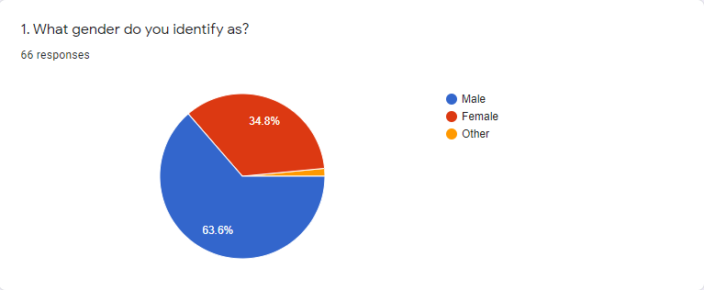Figure 1: Gender identification. N = 66

Q2 was another demographic question to identify the age group of each respondent. As one may see in figure 2 below, the age group varied which is crucial to identify the consumers preferences within all age groups.
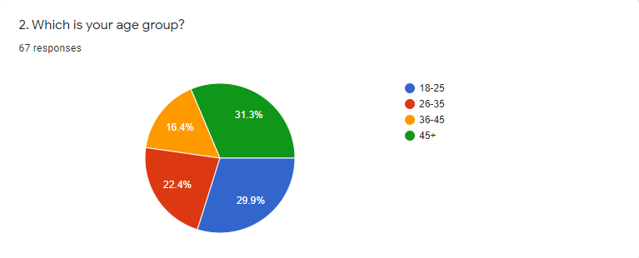
Figure 2: Age group identifiation. N = 67
Q3 was an open question to identify the profession of the participants. 49% of the responses work within the hospitality industry while the other 51% are wine enthusiasts and ex professionals within the hospitality industry. As stated in the written text, common professions of such respondents where restaurant or bar owners, food and beverage managers, restaurant managers, wine importers, sales representatives, restaurant supervisors, bar tenders and food and beverage servers. On the other hand, some professions within the 51% which are classified as wine enthusiasts are teachers, engineers, technicians, banking officers, company directors, nurses, physiotherapists and students. These respondents were all targeted to identify consumer preferences from hospitality professionals and also from wine enthusiasts which are potential customers.
Q4 was a crucial question to acknowledge the respondents’ approximate consumption of sparkling wine. As seen in previous studies and also in this survey, many people associate sparkling wine with special occasions (Verdonk, et al., 2016). A total of 34.3% responded that sparkling wine is consumed in special occasions only. An encouraging total of 11 respondents drink sparkling wine once every week. On the other hand, only nine persons have responded that they consume sparkling wine once a year. (See Figure 3).
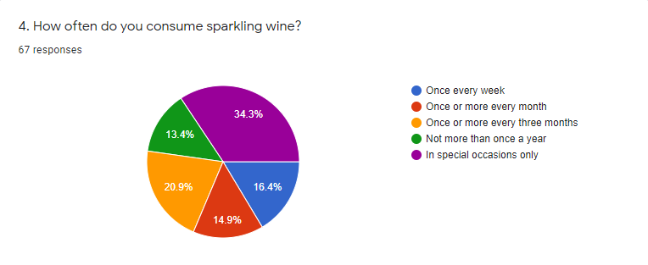
Figure 3: Consumption of sparkling wine. N = 67.

Q5 was added to the questionnaire to identify the style of sparkling wine consumers prefer to drink. Four choices were given for the participants to choose from. 27 participants prefer a dry sparkling wine while only eight participants prefer to drink a sweet sparkling wine. As for participants preffering semi-dry and semi-sweet styles, a percentage of 25.4% and 22.4% was identified respectively. Q2 may have played an important role for such preferences as the highest age group of participants was that of 45 years or older, meaning that such participants may be more familiar with different wine styles from prior consumption, thus, these consumers are more likely to have developed a greater appreciation for the complexity associated with sparkling wines. On the other hand, the younger, less educated generation are more likely to opt for a sweet, fruit-driven sparkling wine (Culbert, et al., 2016). 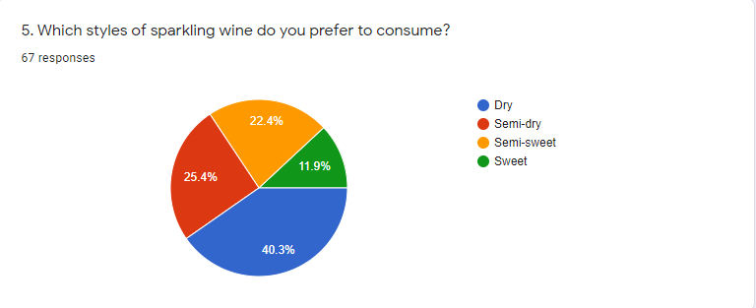Figure 4: Identifying the consumer preferences on styles of sparkling wine. N = 67.

Q6 was listed to identify the characteristics customers prefer to find in a sparkling wine which varies depending on personal taste. Specific answers where given for such question to guide the consumer on a specific preference keeping in mind that various characteristics are obtained depending on the production method and the grape variety chosen to produce sparkling wine. A total of 39.4% prefer to consume a sparkling wine with the main characteristics being a dry, aromatic sparkling, with notes of citrus and green fruit. A total of 24.2% opted for a sweet highly aromatic sparkling with notes of peach and tropical fruit. As mentioned earlier, such preferences may reflect the age of the consumers and their appreciation towards wine. A total of 15.2% have opted for a medium-dry sparkling wine with notes of citrus and green fruit.
An interesting outcome of Q6 is that only five respondents opted for a sparkling wine with characteristics of bread, biscuits, citrus and green fruit. These results indicate that the consumers are not looking for a sparkling wine with similar characteristics of Champagne.
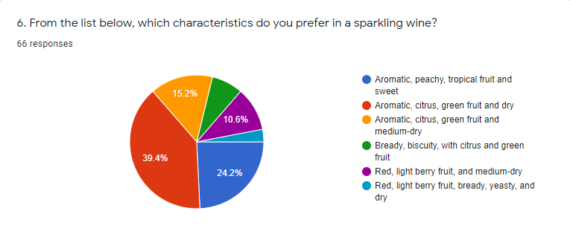
Figure 5: Identifying which characteristics respondents would prefer in a sparkling wine. N = 66.

Q7 was related to both sub-objectives. Identifying the respondents preferences regarding grape varieties is crucial to identify consumer prefences as well as the production method used to create such sparkling wine. Grape varieties which are highly aromatic and preserve freshness and the fruity aromas of the grape are likely to undergo their fermentation process in tanks (tank method). As can be seen below, the majority have opted for a Chenin Blanc (44.8%) and Moscato (35.8%). These results can also be related to the previous results regarding characteristics preferences of respondents. Furthermore, seven respondents have opted for a shiraz, four respondents opted for a chardonnay, and two respondents have chosen “other” and answered “A light sauvignon blanc” and “Glera, Pinot Noir, Chardonnay, Pinot Meunier”.
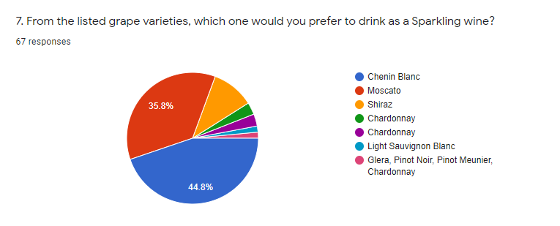
Figure 6: Consumer preferences regarding grape varietes. N = 67.

The next question was directly related to the sub research question regarding consumer preferences. As mentioned above, price is a significant factor which influences the consumer’s choice when buying sparkling wine. A price range was given to be chosen to make the question more direct. As may be seen below, the majority have chosen the usual price range being €8-€15 when buying a sparkling wine from a retail shop(61.2%). A promising 25.4% have opted for a price range of €16- €28 and 9% opted for a premium price of €29- €60. Thus, results indicate that respondents are willing to pay a moderate to premium price for a quality sparkling wine which meets their likings. Another positive outcome identified is that only three respondents have a usual price range of €2-€7 when purchasing a sparkling wine from a retail shop.
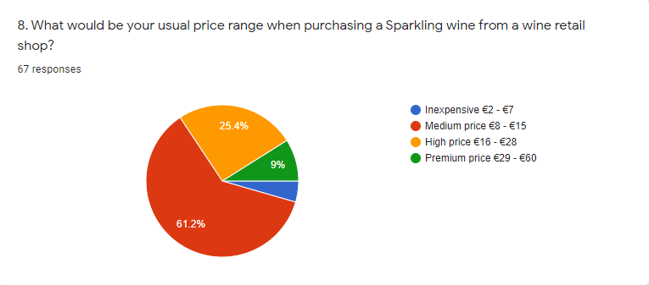
Figure 7: Identifying the respondent’s usual price range when purchasing a sparkling wine from a wine retail shop. N = 67.

Q9 was listed to identify from which country of origin the respondents prefer consuming sparkling wine. A total percentage of 40.3% of respondents prefer consuming French sparkling wine while another 40.3% of respondents prefer consuming Italian sparkling wine. As mentioned previously in the literature review, consumers prefer to rely on products coming from a country of origin with an established prestige and heritage as for the consumer it infers superior quality. Eight respondents prefer consuming sparkling wine from new world countries while only four respondents prefer consuming Maltese sparkling wine.
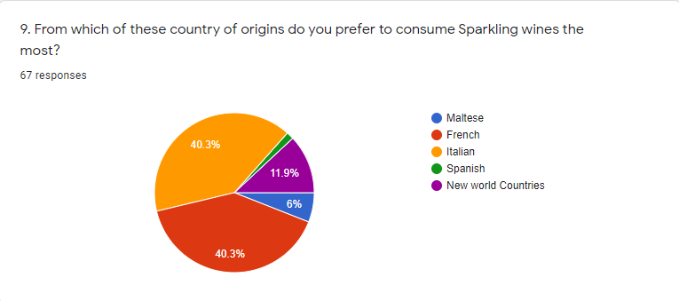
Figure 8: Identifying from which country of origins do the respondents prefer consuming sparkling wine the most. N = 67.
Q10 was introduced after the pilot study has been conducted to identify if a sparkling wine with similar characteristics as their favourite sparkling wine from other countries was to be produced locally, would the respondents buy it? A total majority of 60 respondents have responded that they would buy the local sparkling wine. A phenominal result which may encourage wineries to produce a sparkling wine meeting to the respondents’ desires. Only seven respondents would not buy the local sparkling wine even though the wine has similar characteristics of their favourite sparkling wine produced from other countries.
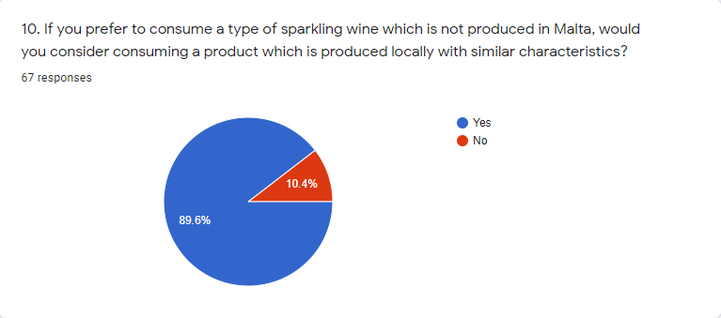
Figure 9: Identifying if the respondents would buy a local sparkling wine which has similar characteristics to their favourite sparkling wine produced internationally. N = 67.

The aim of Q11 was to identify what the respondents think regarding the quality of sparkling wines produced locally. As can be seen in the bar chart below, the majority have rated the local sparkling wines as a 3/5. 16 respondents have given a rating of 4/5 while only seven respondents have given a 5/5 rating. On the other hand, four respondents have rated the local sparkling wines as 1/5 and three respondents a 2/5 rating. The results of this question shows that there is room for improvement when it comes to quality of local sparkling wines.
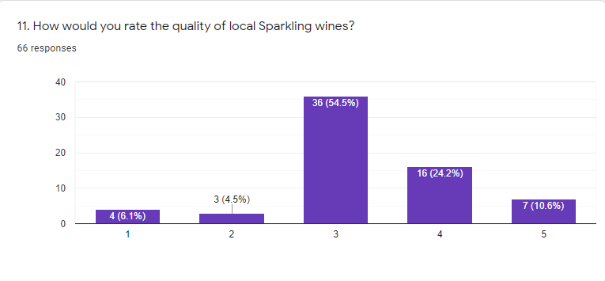
Figure 10: Identifying respondent’s perception regarding the quality of local sparkling wines. N = 66.

Conclusions and Recommendations

Conclusions

The results of the survey gave a very generous feedback regarding the main objective being the potential of producing more quality sparkling wines within the local wine industry. A specific target market was selected to identify the needs and preferences of respondents who work in the hospitality industry and also wine enthusiasts which are potential customers. Results gained from respondents were quite promising especially Q10 which was included in the survey after being recommended from the pilot study.
By the use of surveys, data was collected to identify the potential of producing more quality sparkling wines within the local wine industry. By asking specific questions, all research and sub-research questions have been accomplished.
Qs 1-3 were demographic questions to get to know the respondent. Such information gathered can give a better indication on the following answers chosen. As previously mentioned, studies show that a respondent older in age may have more appreciation towards wine than a younger respondent (Culbert, et al., 2016). Identifying the occupation of respondents is crucial as it affects mainly Q8 as one’s average price range vary depending on the monthly income. Verdonk states that the purchase of sparkling wine is influenced by taste are consistent with conventional economic theory of consumer behaviour which assumes that prices, incomes, and personal taste affect consumption (Verdonk, et al., 2016).
The results from Q4 were not a surprise. Culbert et al also states that sparkling wine is known to be associated mainly with special events where celebrations are held (Culbert, et al., 2016). 11 respondents have responded that they drink sparkling wine once every week which is definitely a promising outcome.
Qs 5-8 were all related to the O2 and 03. Identifying the characteristics which meet the respondents’ likings is crucial for a winery to indulge this information and may opt to produce a sparkling wine which meets the customers likings. From these questions, the majority opt for a dry Chenin Blanc with the major characteristics being citrus and green fruit aromas. Chenin Blanc is a highly acidic grape with the mentioned characteristics which may be perfect to grow in the Maltese climate. Acidity is crucial in sparkling wine which might be a challenge in the Maltese climate, however, using a grape variety which is highly acidic itself may be very beneficial to produce a quality end product. Q8 gives a clear indication that the majority of respondents prefer to pay from €8-€15 for a sparkling wine from a retail shop. By utilizing the tank method, capital expenditure for the winery will increase but the cost per bottle will decrease due to economies of scale compared to the encapsulated yeast method where second fermentation occurs in bottles. Furthermore, the process for producing a sparkling wine by using the tank method is much shorter, and therefore, will be cheaper to produce.
Question nine’s results were not surprising knowing that even previous studies state that consumers prefer to rely on products coming from a country of origin with an established prestige and heritage like France and Italy. However, the results of Q10 which was aimed to answer O1 are very promising. Knowing that if a sparkling wine with similar characteristics as their favourite sparkling wine from other countries was to be produced locally, a total majority would buy the local product. Kolyesnikova states that “local residents automatically accept local products. The challenge for wine marketers in emerging regions then is to understand their local residents’s consumer base” (Kolyesnikova, et al., 2008). The response of this question shall encourage wineries to produce a sparkling wine meeting the respondents likings knowing that the product has huge potential.
Q11 was the ultimate question to identify the respondents perspective regarding the quality of local sparkling wines. From the results, one shall notice that the majority rated the quality of local sparkling wines as a 3/5. These results indicate that there is a room for improvement. Moreover, these results should encourage the local wineries to produce a higher quality sparkling wine locally which meets the clients preferences.

Recommendations

The survey results gave worthy recommendations and feedback to identify the potential of producing more quality sparkling wines within the local industry. From the survey results, with relation to O2, one can conclude that if a dry sparkling wine was to be produced by the Chenin blanc grape variety with aromas and tasting notes of citrus and green fruit, such sparkling wine shall make a very good impact in the local wine industry. knowing that gaining good acidity levels may be difficult in the maltese climate, Chenin Blanc is the perfect grape to grow in such climate as it is a highly acidic grape (McKirdy & Grinberg, 2014).
The results of the survey indicate that the majority of respondents prefer to buy a wine between the range of €8-€15 from a retail shop. With relation to O3, By utilizing the charmat method to produce this sparkling wine, fruity aromas are retained from the grapes which will be beneficial to have fruity aromas and tasting notes in the end product (Culbert, et al., 2015). Furthermore, since there isn’t the need of aging and fermentation is conducted in tanks only, the charmat method is more feasible and so the end product can be sold at a more reasonable price. Since fermentantion is conducted in tanks, production will be in bulk and therefore the cost for production is low compared to other production methods.
From this study and previous studies, the author reccommends that the vineyards are located in a valley like Ramla Valley Estate by using the bush vine method. The hillsides of Ramla valley shelter the vines from the long hot summer days and the cool breezes gained from the nearby bay may be very beneficial for the crop to retain its acidity. By using the bush vine method, the grapes are sheltered from the sun by the leaves from the vines which will also help to retain good acidity levels and minimize the sugar levels obtained by the grape to eventually create a dry sparkling wine. Having a quality soil which retains sufficient water to prevent the need of irrigation or a good irrigation and draining system is highly recommended. Having water sources deep within the soil will force the vine roots to go deeper into the soil which will lead to a better quality and intensely concentrated grapes. With relation to O1, results from Q11 of the survey show that there is potential and demand to produce a higher quality sparkling wine within the local wine industry.
For future studies, interviews may be used to identify the wineries perspective on the potential of producing a more quality sparkling wine within the local wine industry. Furthermore, focus groups may also be used to identify consumer preferences with regards to sparkling wine.

Ethics
While conducting this long essay, the author has been ethical by not mentioning any names but referred to the participants by using their profession. With regards to the survey, an introduction was inserted to the survey to inform the potential respondents that all responses will remain anonymous as no identification details were requested.
The author learned using in-text citations and Harvard referencing to reference all the information gained from peer reviewed reports which can be seen in chapter six.

References

Anderson, A., 2001. Wine Making Sector Study. Institute For The promotion of Small E nterprise, issue 30th November 2001.
Benucci, I. & Esti, M., 2019. Novel Microencapsulated Yeast for the Production of Sparkling Wine By Traditional Method. Volume 12, pp. 1-9.
Bordiga, M. et al., 2013. Characterization of Muscat wines aroma evolution using comprehensive gaschromatogrophy followed by a post-analytic approach to 2D contour plots comparism. Food Chemistry, Volume 1-2, pp. 57-67.
Brehm, P., 2006. Vinification Methode Traditionelle:Vinification by encapsulated yeast: Champenoise style.
Caliari, V., Panceri, C. P., Rossier, J. P. & Luiz, M. B., 2015. Effect of the Traditional, Charmat and Asti method production on the. LWT - Food Science and Technology, 61(25th November), pp. 393-400.
Conde, B., Fuentes, S., Caron, M. & Xiao, D., 2017. Development of a Robotic and Computer Vision Method to Access foam Quality in Sparkling Wines. Food Control, 71(2016/07/20).
Culbert, J., Cozzolino, D., Ristic, R. & Wilkinson, K., 2015. Classification of Sparkling Wine Style and Quality by MIR Spectroscopy. molecules, Volume 20, pp. 8341-8356.
Culbert, J. et al., 2016. Beverages. Understanding consumer preferences for Australian sparkling wine vs French Champagne, 19(No.2), pp. 1-12.
De Magistris, T., Groot, E., Gracia, A. & Albisu, L. M., 2011. Do millennial generation’s wine preferences of the 'new world' differ from the 'old world': a pilot study.. International Journal of Wine Business Research, 23(No.2), pp. 145-160.
Garofalo, C. et al., 2016. Starter Cultures for Sparkling Wine. Fermentation, Issue 14th December 2016, pp. 1-16.
Hayward, L., Barton, A. & Mcsweeney, M. B., 2020. Investigating How the Disclosure of Production methods influences Consumers' Sensory Perceptions of Sparkling Wines. Beverages, 6(November 2020), p. 1.
Hollebeek, L. D., Jaeger, S. R., Brodie, R. J. & Balemi, A., 2007. The Influence of Involvment on Purchase intention for New World Wine. Food Quality and Preference, 18(No.8), pp. 1033-1049.
Kolyesnikova, N., Todd, T. H. & Duhan, D. F., 2008. Attitudes towards local wines. Consumer attitudes towards local wines in an emerging region: A segmentation approach, 20(No. 4), pp. 321-334.
Laseter, E., 2017. Explore Food and Wine. [Online]
[Accessed 23rd April 2021].
Lockshin, L. & Corsi, A. M., 2012. Consumer behaviour for Wine 2.0: a review since 2003 and future. Wine Economics and Policy, 1(No.1), pp. 2-23.
Loira, I. et al., 2018. Schizosaccharomyces pombe: A Promising biotechnology for Modulating Wine Composition. Fermentation, 70(4), pp. 1-12.
McKirdy, T. & Grinberg, D., 2014. VINEPAIR. [Online]
[Accessed 23rd April 2021].
Miquel, J., 2020. Vivino. [Online]
[Accessed 24th April 2021].
Mueller, S., Osidacz, P., Francis, I. L. & Lockshin, L., 2010. Combining discrete choice and informedsensory testing in a two-stage process: can it predict market share?. Food Quality and Preference, 21(No.7), pp. 22-32.
Onofri, L., Baotto, V. & Blanco, A. D., 2015. Who likes it “sparkling”? An empirical analysis of Prosecco consumers' profile. Agricultural and Food Economics, Issue DOI 10.1186/s40100-014-0026-x, pp. 1-15.
Perpetuini, G. et al., 2016. Biodiversity of autolytic ability in flocculent Saccharomyces cerevisiae strains suitable for traditional sparkling wine fermentation. Volume 33, pp. 303-312
Puckette, M., 2013. Wine Folly. [Online]
[Accessed 23rd April 2021].
Ranch, S. B., 2007. Wine Making Talk. [Online]
[Accessed 23rd April 2021].
Rossier, J. S., Maury, V., Gaillard, L. & Pfammatter, E., 2016. Use of Isotope Ratio Determination to assess the Production Method of Sparklling Wines. Food Authenticity And AdulterAtion, Volume doi:10.2533/chimia., pp. 338-344.
Stefenon, C. A. et al., 2010. Sugar levels in Charmat sparkling wines can affect the quality and resveratrol levels. Redox Report, 15(02 December 2013), pp. 243-249.
Teague, L., 2017. The Best French Bubblies Beyond. Issue 19th August 2017, pp. 1-3.
Torresi, S., Frangipane, M. T. & Anelli, G., 2011. Biotechnologies in sparkling wine production. Interesting approaches. Food Chemistry, pp. 1232-1233.
Veale, R. & Quester, P., 2009. Do Consumer Expectations Match Experience? Predicting the influence of price and country of origin perceptions of product quality. 18(2), pp. 134-144.
Verdonk, N. et al., 2016. Toward a model of sparkling wine preferences, 29(Issue No.1), pp. 58-70.

Appendices

Appendix 1. Survey Questions
Title and introduction:
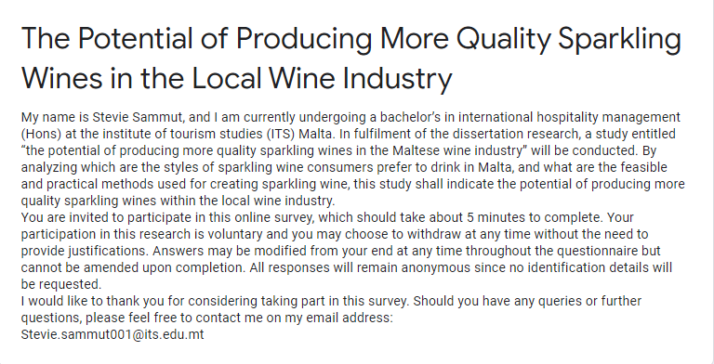
Questionnaire:



